Angry Bullet Game

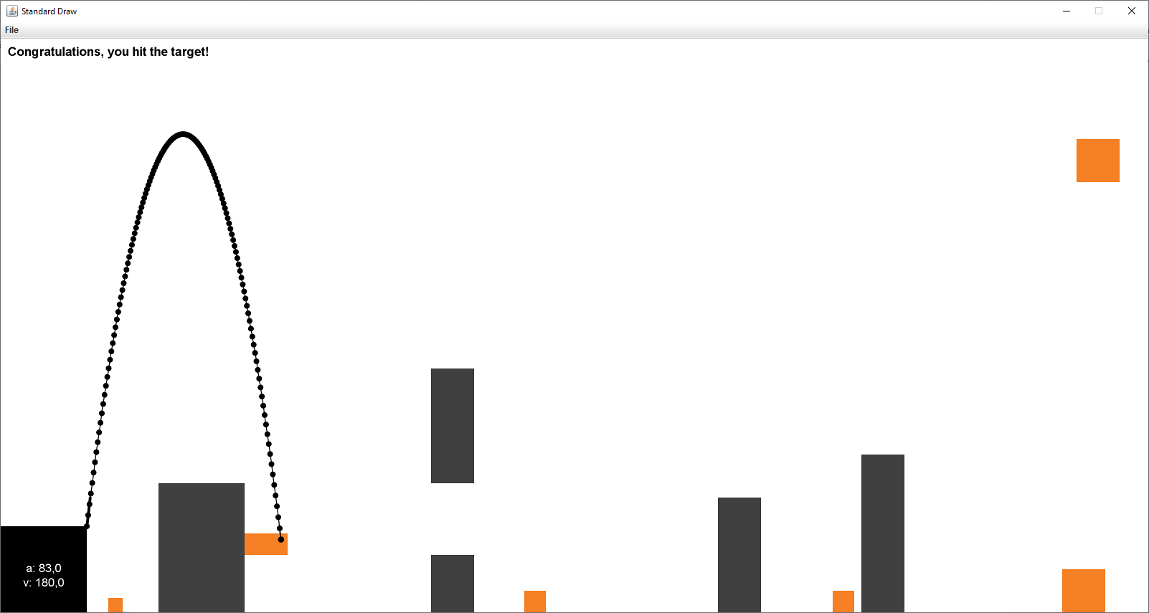
Sample Gameplay Screens

Figure 2. Case for hitting the target (orange box). Successful shot hits one of the orange targets.

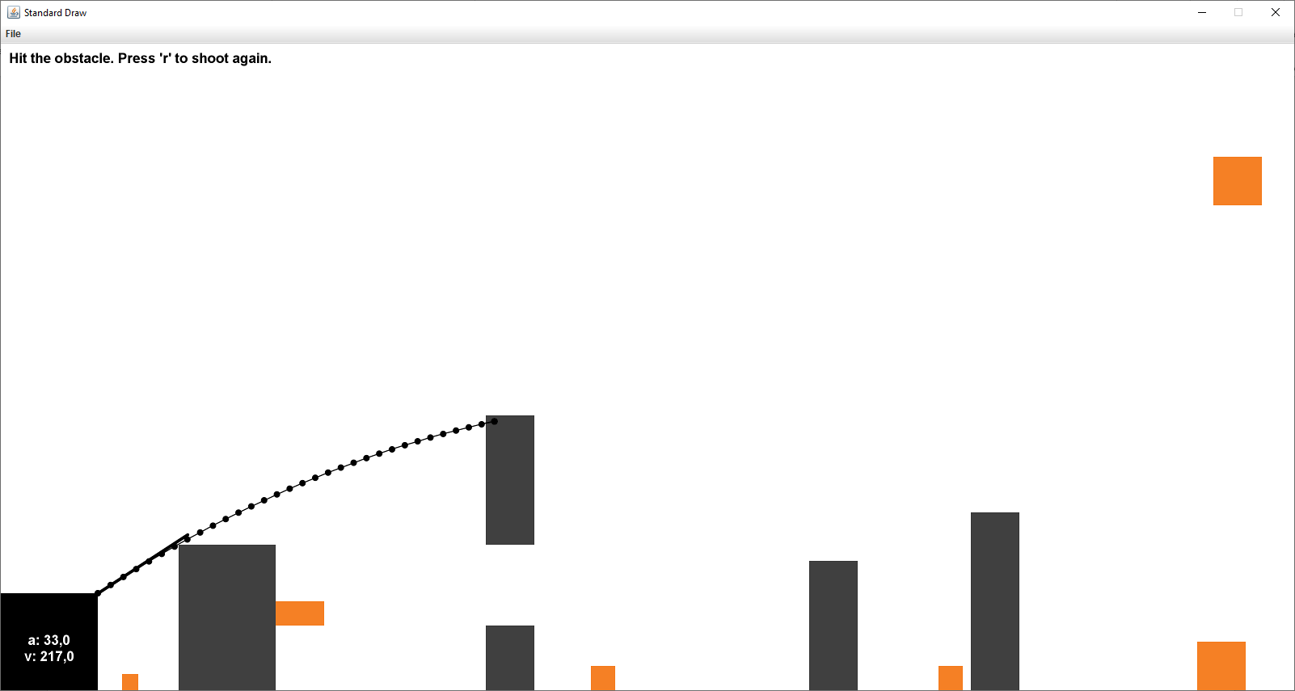

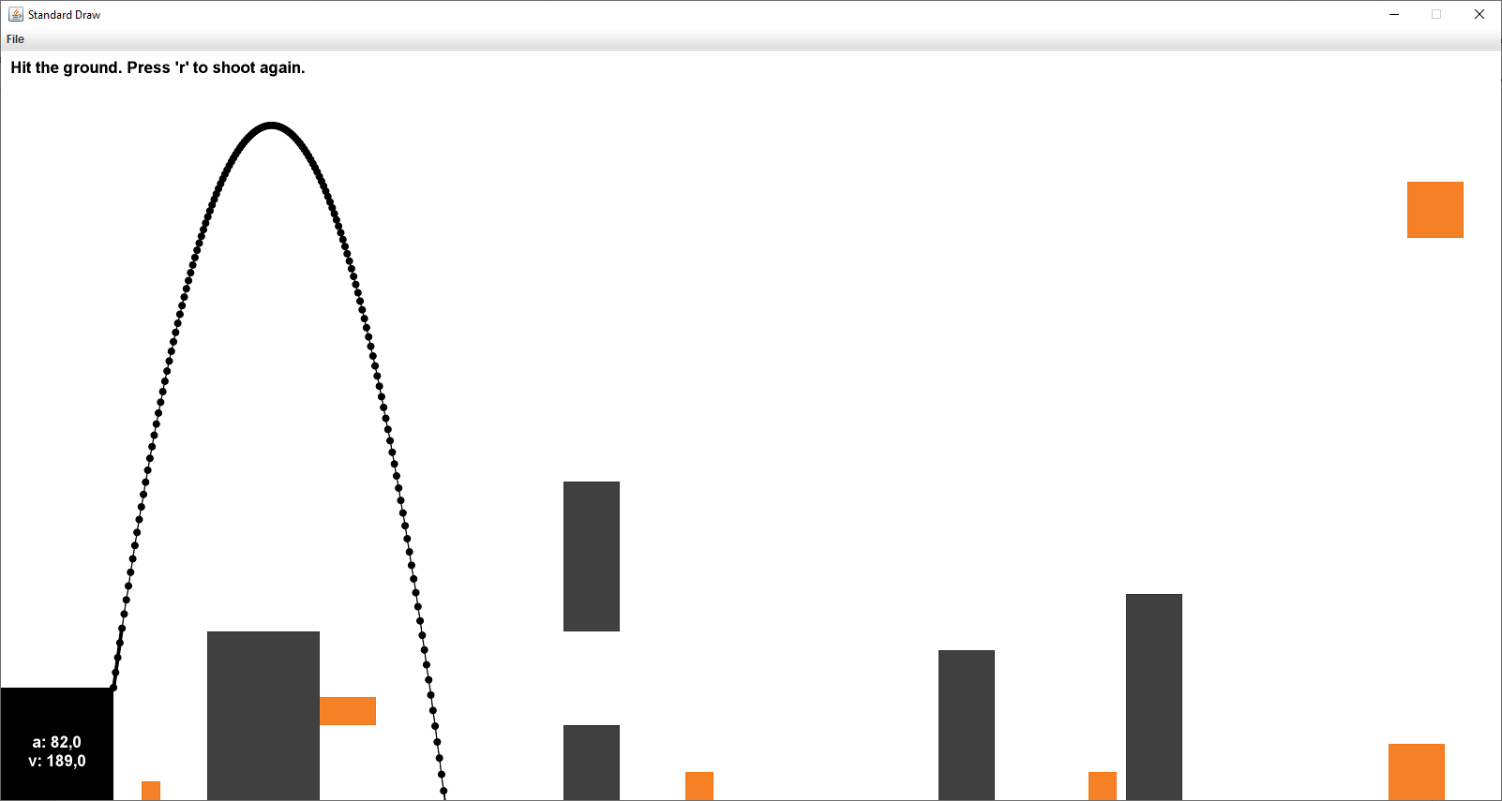
Figure 2. Case for hitting an obstacle.

Figure 3. Case for ground contact.

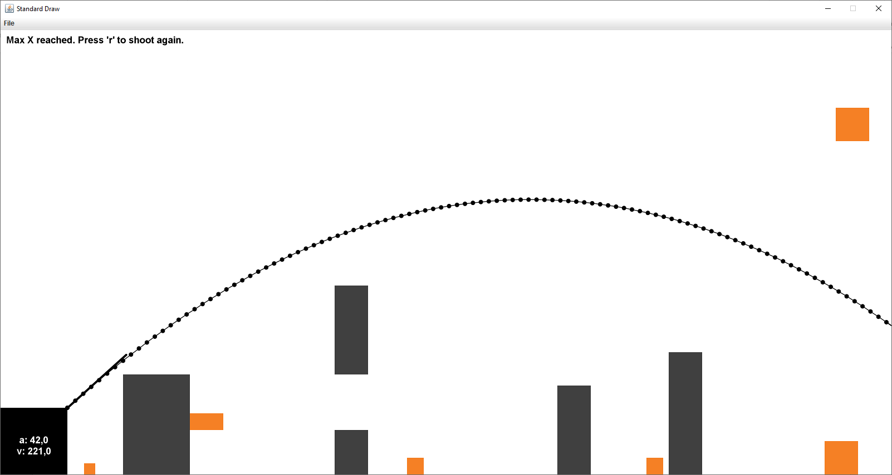

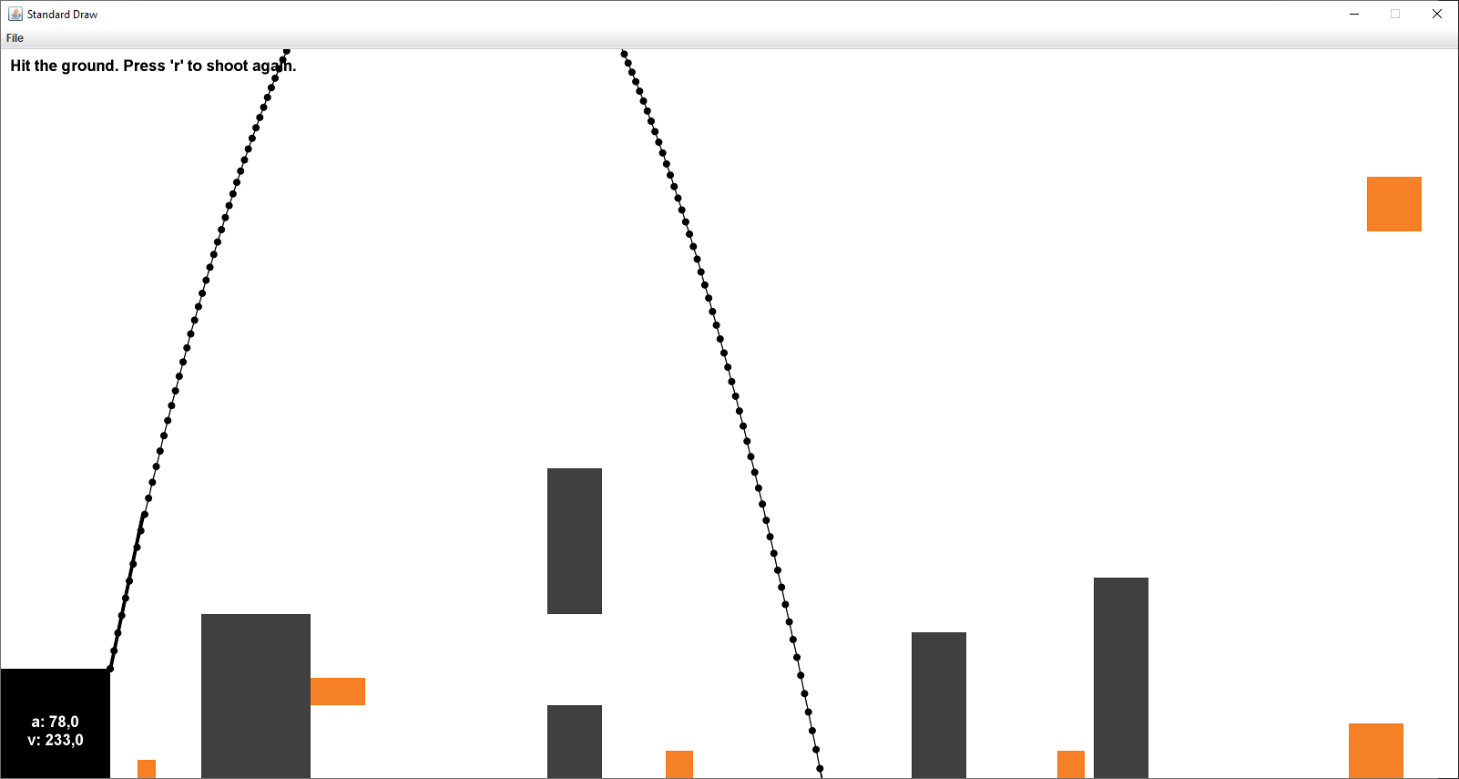
Figure 4. Case for Max X coordinate reached.

Figure 5. Bullet is allowed to travel through the upper part of the sky.

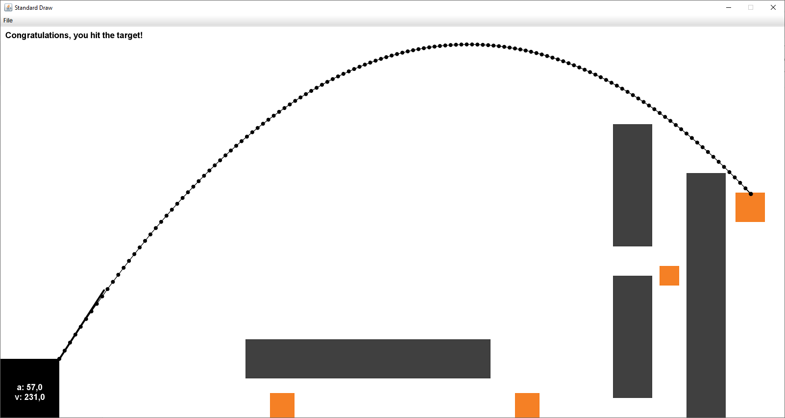

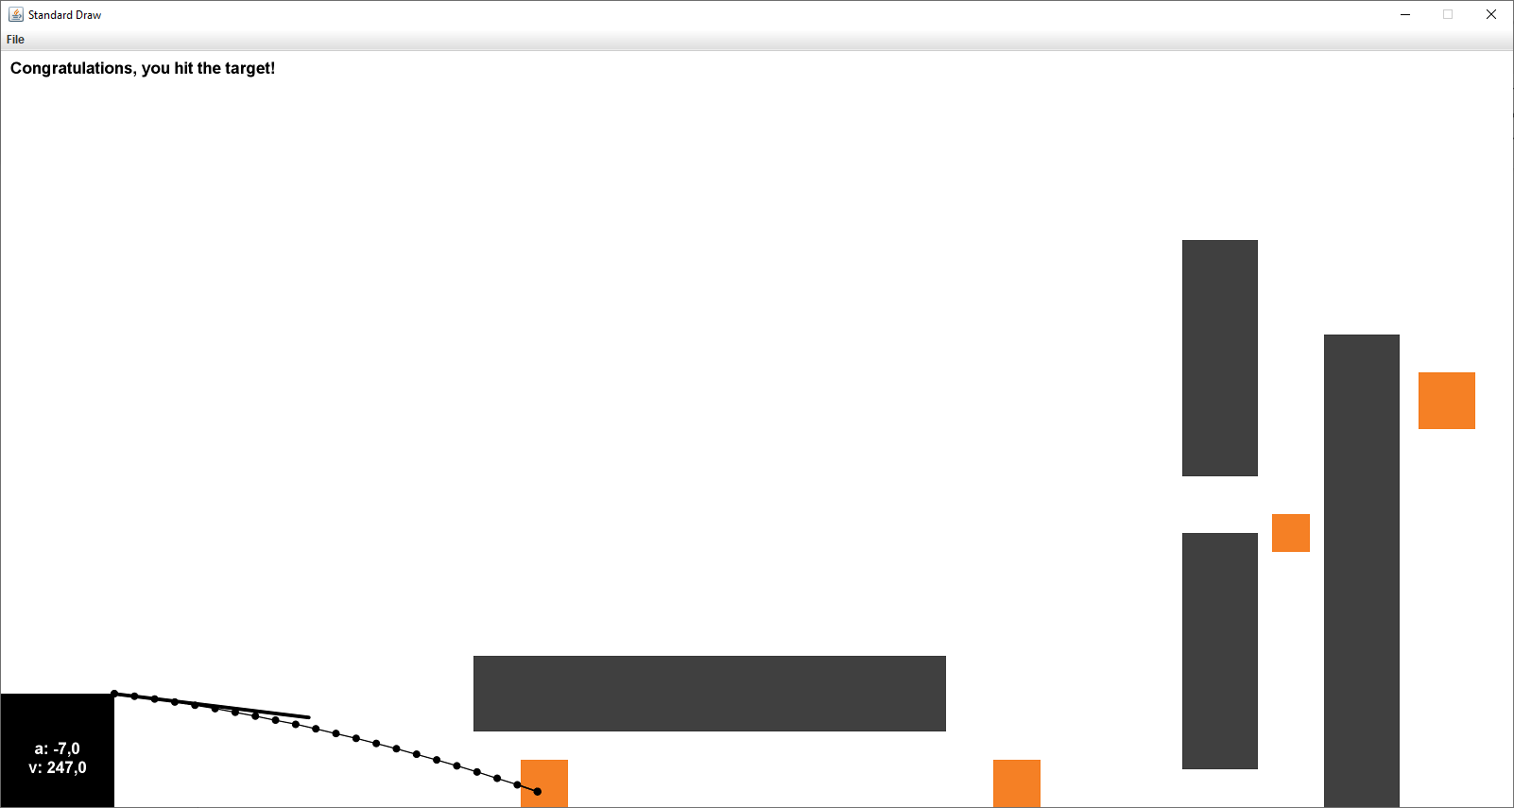
Figure 6. Custom obstacles and targets.

Figure 7. Custom obstacles and targets.

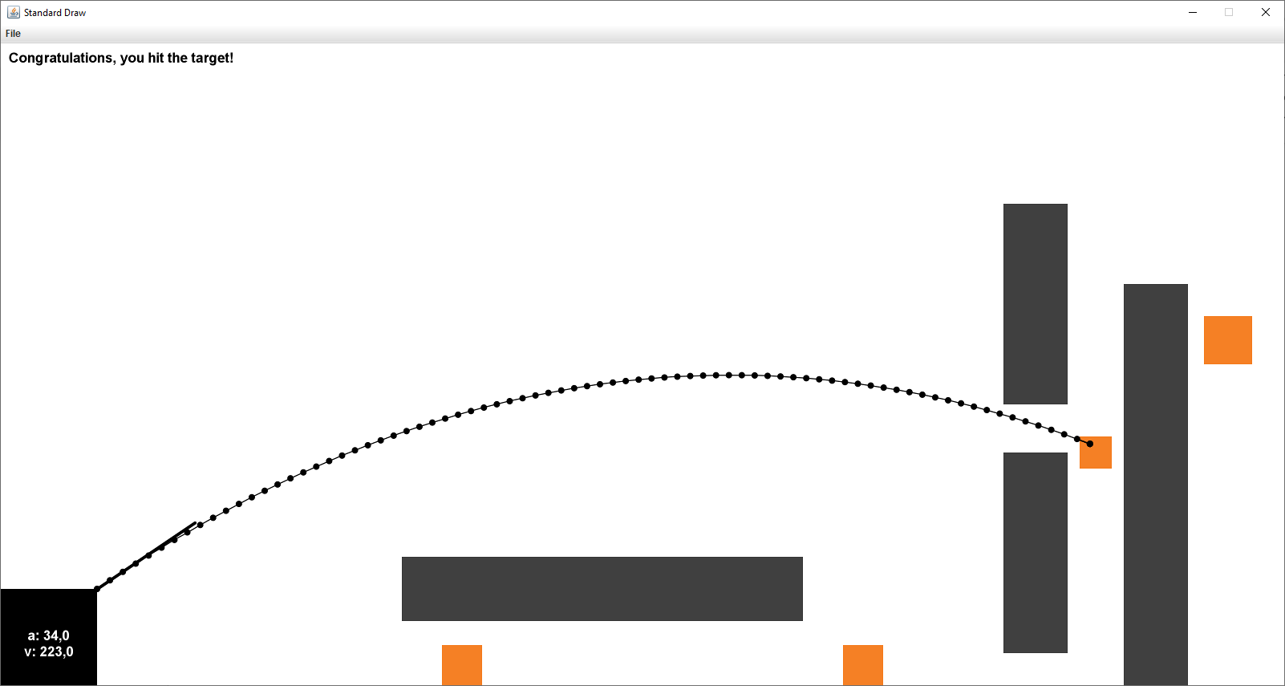

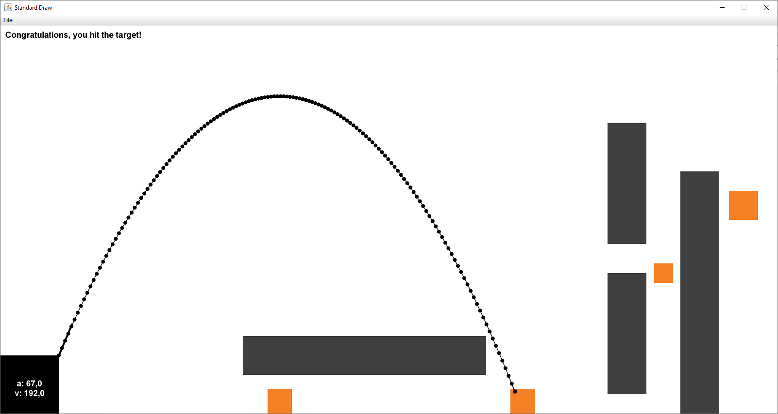
Figure 8. Custom obstacles and targets.

Figure 9. Custom obstacles and targets.

