CMPE160 Assignment 3

Ant Colony optimization

Hyperparameters used: iterations = 100, ants = 50, alpha = 0.6, beta = 10, initial pheromone = 0.1, Q = 0.0001.
Input01
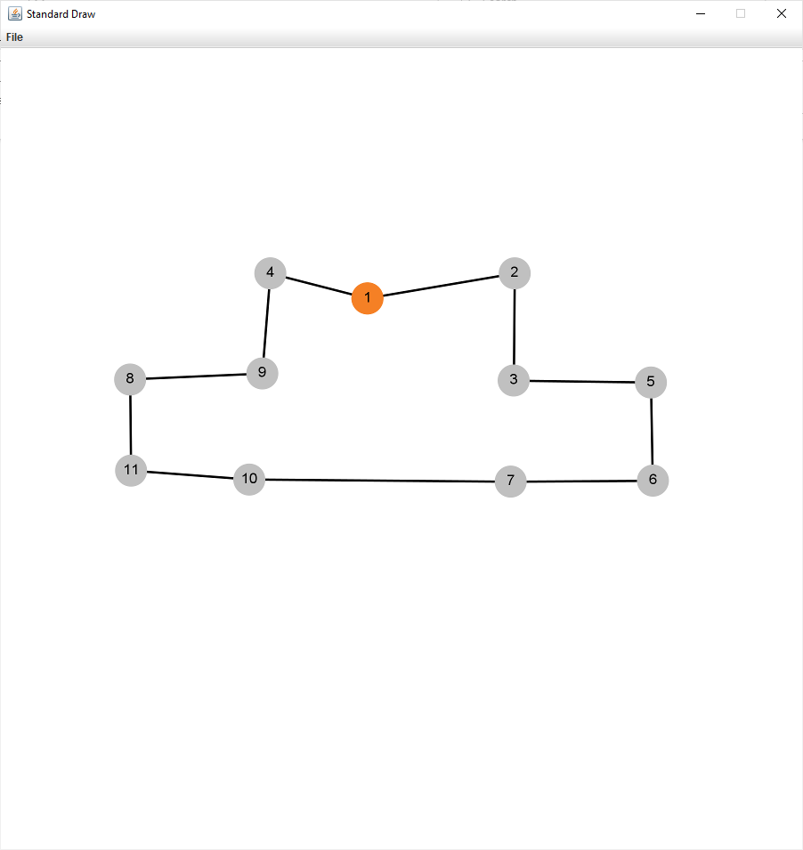
Method: Brute-Force Method
Shortest Distance: 1.7952913856772432
Shortest path: [1, 4, 9, 8, 11, 10, 7, 6, 5, 3, 2, 1]
Time it takes to find the shortest path: 0.28 seconds.

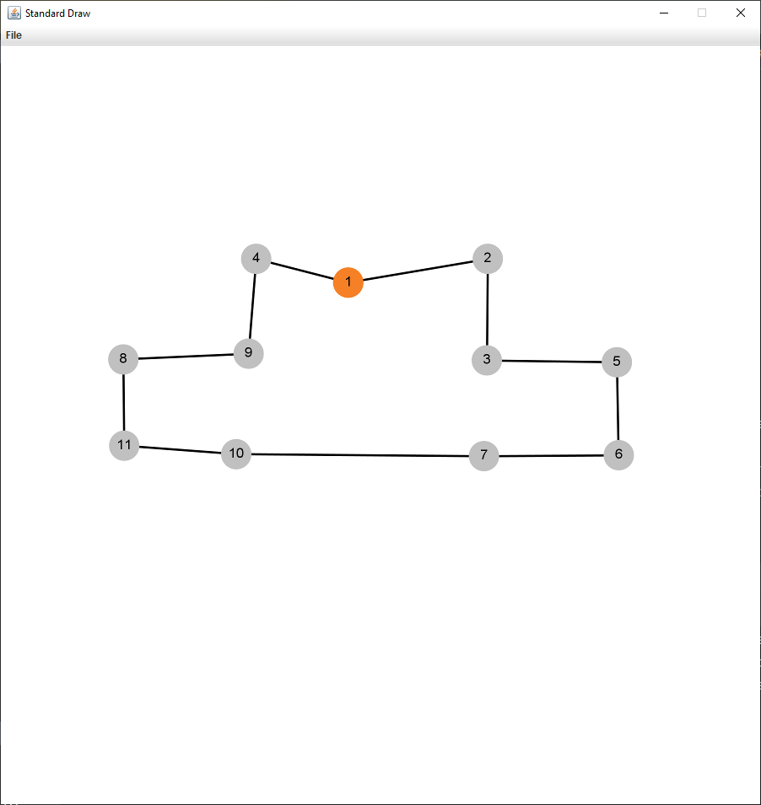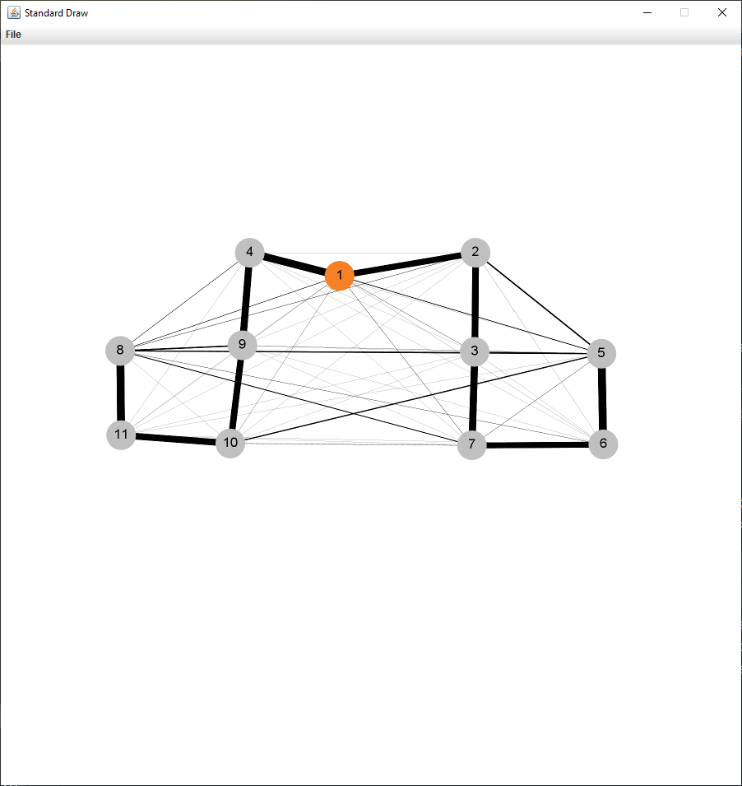
Method: Ant Colony Optimization Method
Shortest Distance: 1.795291385677243
Shortest path: [1, 4, 9, 8, 11, 10, 7, 6, 5, 3, 2, 1]
Time it takes to find the shortest path: 0.028 seconds.

Input02
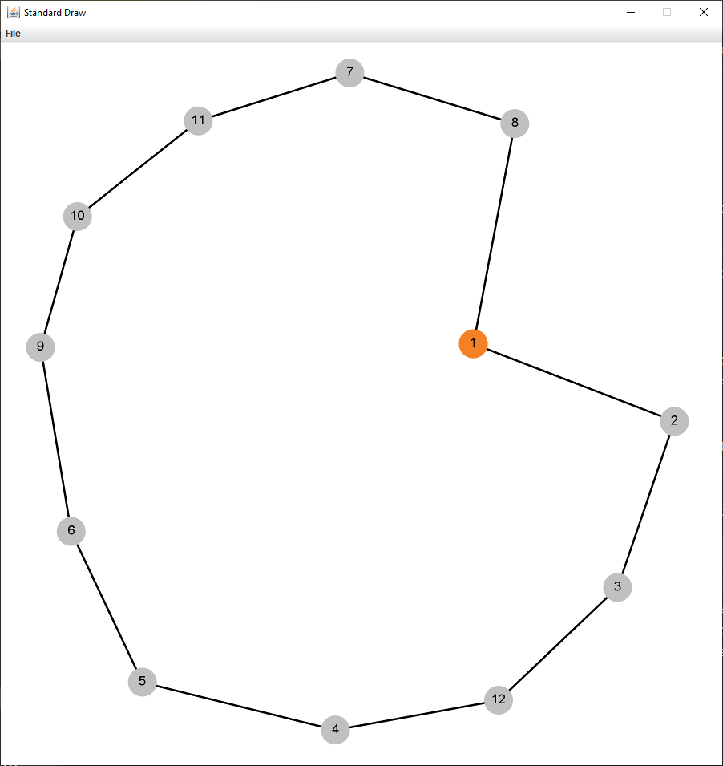
Method: Brute-Force Method
Shortest Distance: 2.935877143237598
Shortest path: [1, 8, 7, 11, 10, 9, 6, 5, 4, 12, 3, 2, 1]
Time it takes to find the shortest path: 2.365 seconds.

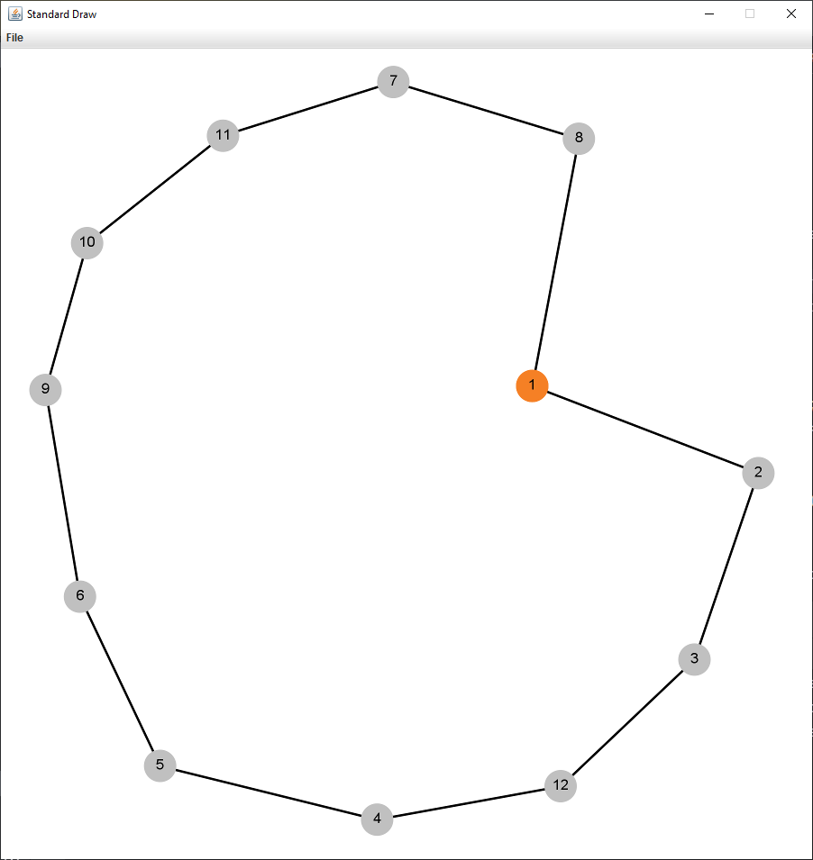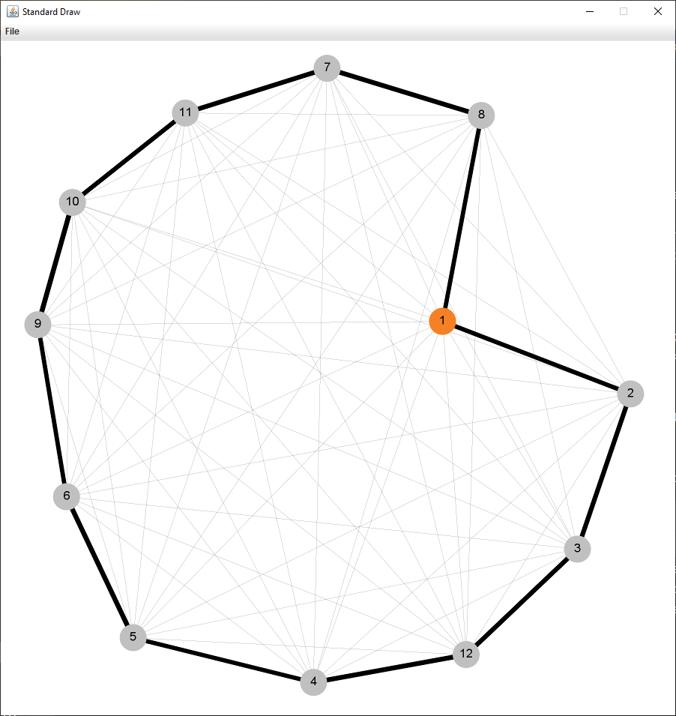
Method: Ant Colony Optimization Method
Shortest Distance: 2.9358771432375974
Shortest path: [1, 2, 3, 12, 4, 5, 6, 9, 10, 11, 7, 8, 1]
Time it takes to find the shortest path: 0.023 seconds.

Input03
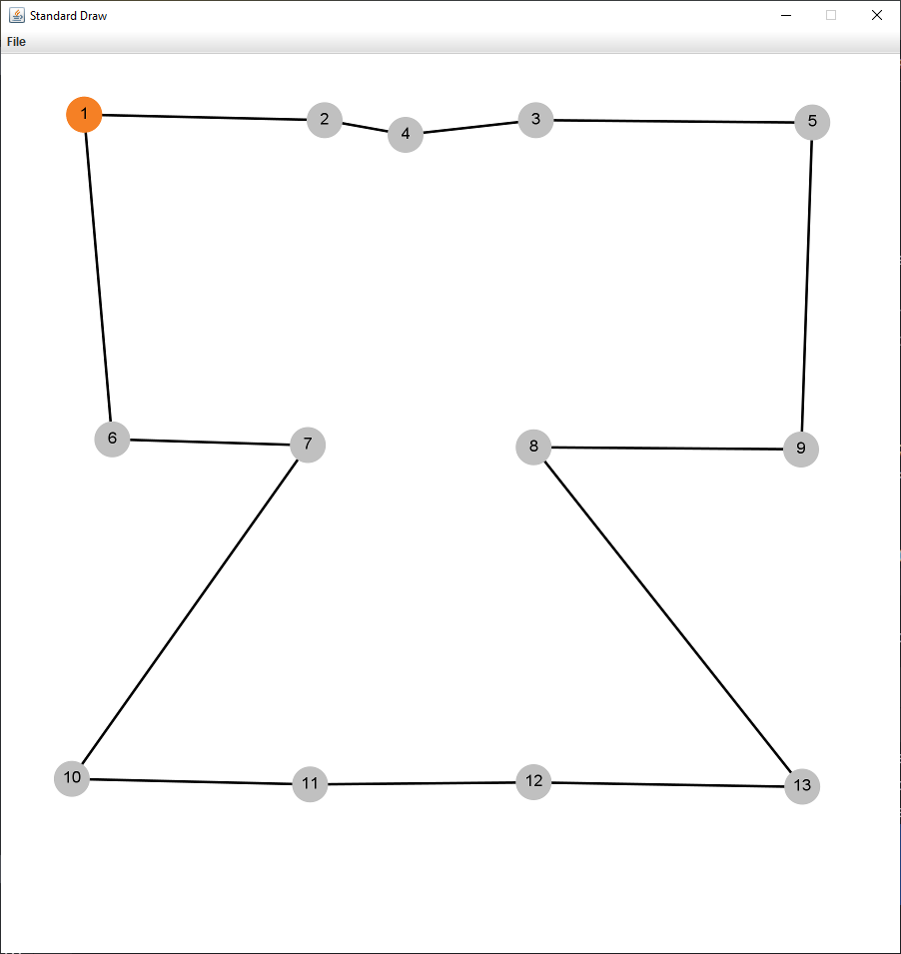
Method: Brute-Force Method
Shortest Distance: 3.802919361826042
Shortest path: [1, 2, 4, 3, 5, 9, 8, 13, 12, 11, 10, 7, 6, 1]
Time it takes to find the shortest path: 27.528 seconds.

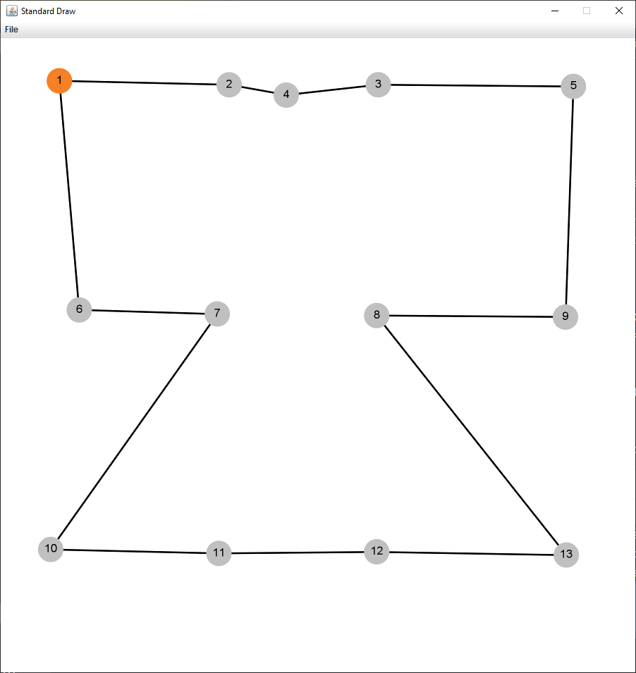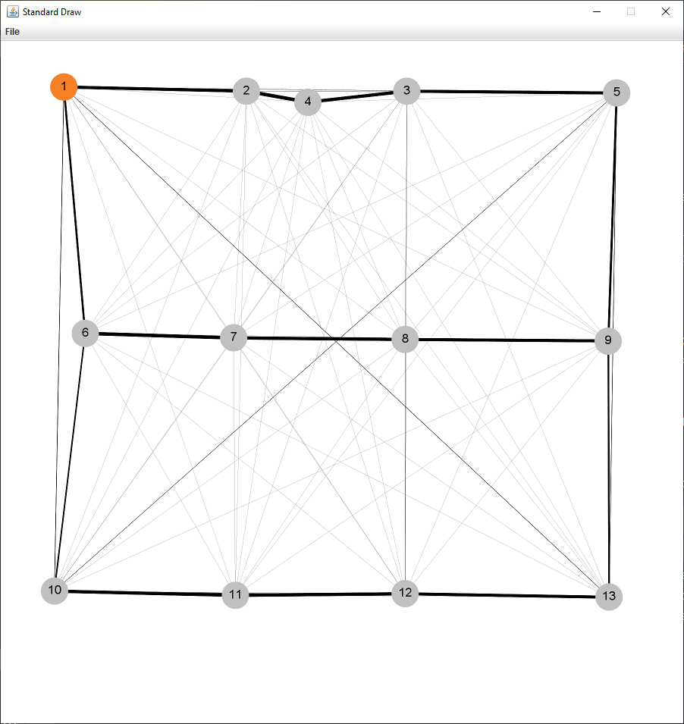
Method: Ant Colony Optimization Method
Shortest Distance: 3.802919361826042
Shortest path: [1, 2, 4, 3, 5, 9, 8, 13, 12, 11, 10, 7, 6, 1]
Time it takes to find the shortest path: 0.023 seconds.

Input04
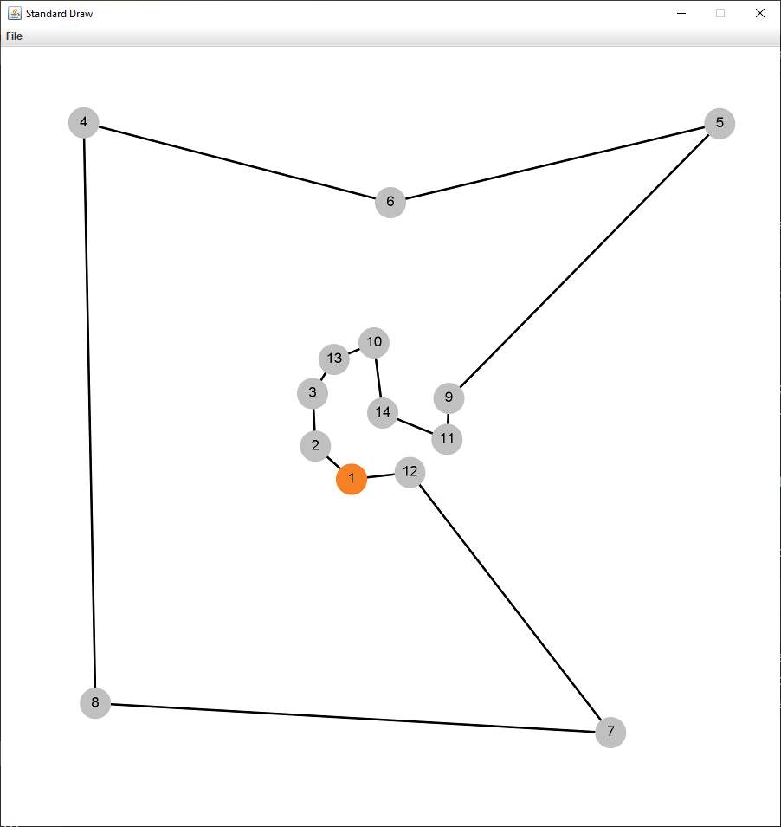
Method: Brute-Force Method
Shortest Distance: 3.710908906673479
Shortest path: [1, 2, 3, 13, 10, 14, 11, 9, 5, 6, 4, 8, 7, 12, 1]
Time it takes to find the shortest path: 419.192 seconds.

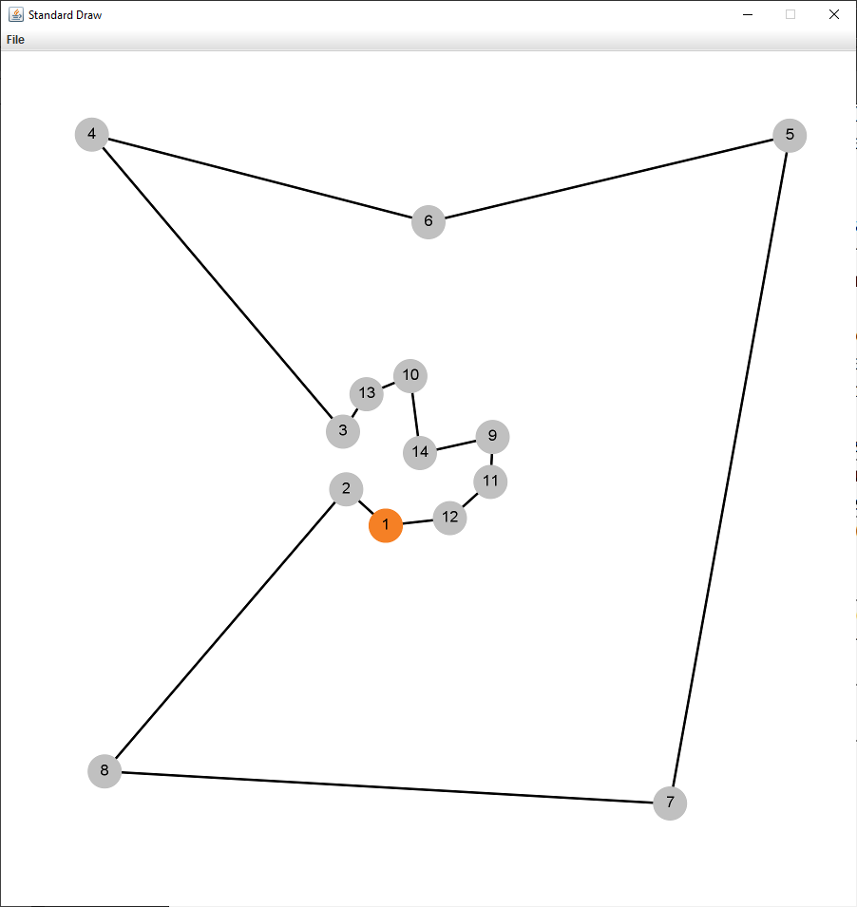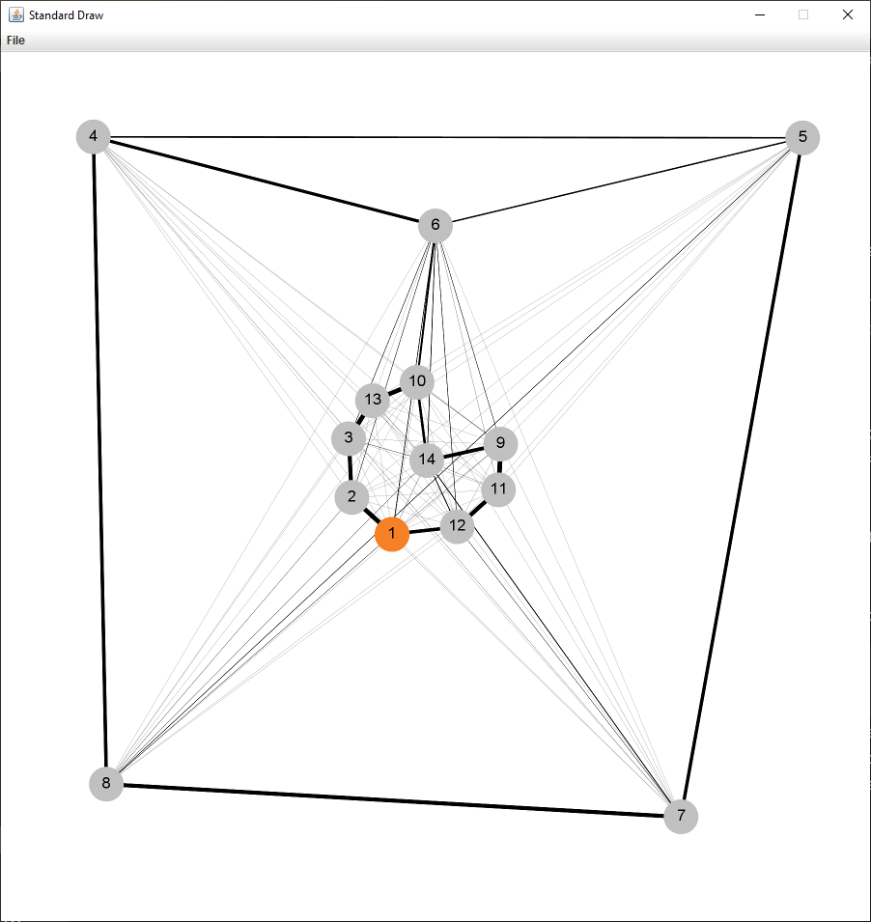
Method: Ant Colony Optimization Method
Shortest Distance: 3.7262922411806794
Shortest path: [1, 2, 8, 7, 5, 6, 4, 3, 13, 10, 14, 9, 11, 12, 1]
Time it takes to find the shortest path: 0.032 seconds.

Input05
Brute-Force Method: Too long to compute
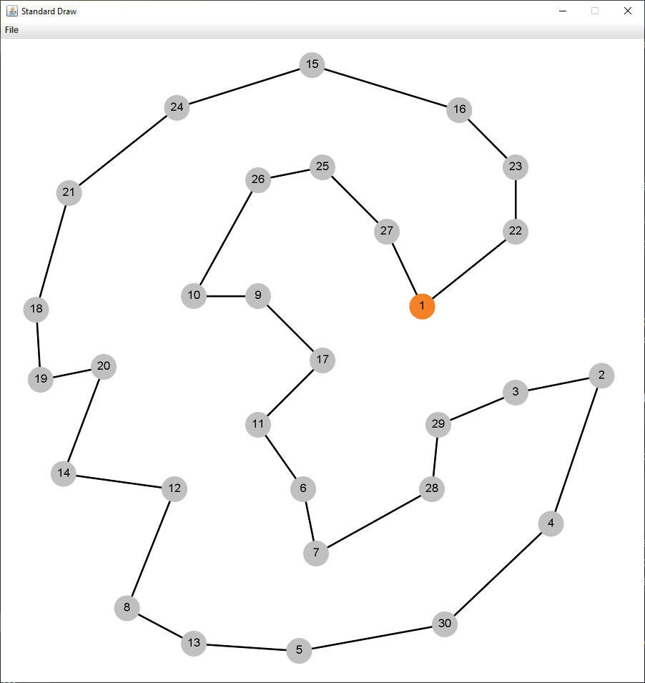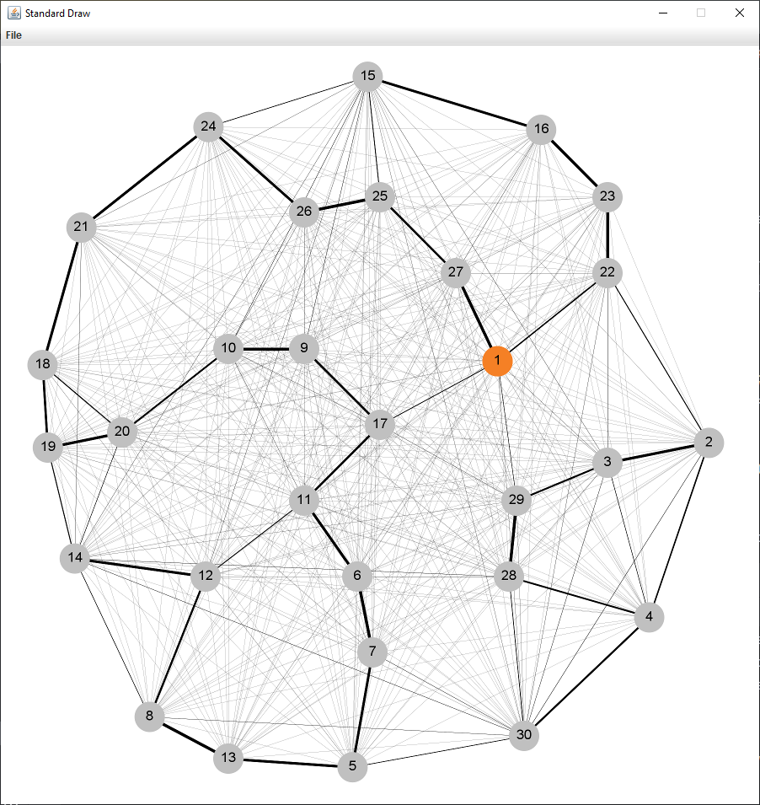
Method: Ant Colony Optimization Method
Shortest Distance: 4.771005206672136
Shortest path: [1, 22, 23, 16, 15, 24, 21, 18, 19, 20, 14, 12, 8, 13, 5, 30, 4, 2, 3, 29, 28, 7, 6, 11, 17, 9, 10, 26, 25, 27, 1]
Time it takes to find the shortest path: 0.052 seconds.

Comparison of methods.
Input file | Number of houses+migros | Brute-Force Time (seconds) | Ant Colony Time (seconds) | Speed-up factor
Input01 | 11 | 0.28  (Distance: 1.7952) | 0.028  (Distance: 1.7952) | 10 times faster
Input02 | 12 | 2.365  (Distance: 2.9358) | 0.023  (Distance: 2.9358) | 84 times faster
Input03 | 13 | 27.528  (Distance: 3.8029) | 0.023  (Distance: 3.8029) | 1197 times faster
Input04 | 14 | 419.192  (Distance: 3.7109) | 0.032  (Distance: 3.7262) | 13100 times faster
Input05 | 30 | Too long to compute | 0.052  (Distance: 4.7710) | Incalculably faster

Shortest Path vs. Iterations graph for Input05

Advantages and disadvantages of Ant Colony Optimization method
Advantages:
- Easy to implement and use.
- Computes quickly: for large data it can be 1000 times faster than brute-force method.
- Because of the hyperparameters, it is convenient to use for various purposes, so that the developer can solve the problem without increasing number of iterations and increasing time of compilation.
- Does not require a lot of memory or complicated data structures.
Disadvantages:
- ACO algorithm does not necessarily give the correct answer, for large data may give one of the best solutions but not the best.
- The developer has to “guess” or “brute-force” best parameters himself, because if the parameters are unsuitable the algorithm will be inefficient and inaccurate.
- If the problem requires larger number of ants and iterations, the algorithm will not be as quick.

External Resources
Implementing Ant colony optimization in python- solving Traveling salesman problem | by Induraj | Medium
Introduction to Ant Colony Optimization - GeeksforGeeks

