CMPE160 Assignment 2

Turkey Navigation

Algorithm description:
Used variables:
cityNumber – number of cities found in a file.
int source = 0 – index of starting city.
int target = 0 – index of destination city.
double[] distances - keeps the distance from the starting city to all other cities. Size: cityNumber.
int[] parents - keeps the id of the city which leads to the shortest path from a starting city. Size: cityNumber.
boolean[] visited - keeps currently visited cities. Size: cityNumber.
ArrayList<City> cities – an array of City class objects, stores input cities. Each object has unique ‘id’, and that id equals to City’s index in the above arrays. Each City object has an array ‘neighbours’, which stores distance between the connected cities.
Methods:
public static int minDistance(double[] distances, boolean visited[]) – find the closest unvisited city. It loops through and checks if current city is closer to the starting city than other checked cities, also verifying the condition if current city is not visited already.
Algorithm:
I tried to implement Dijkstra’s shortest path algorithm. According to this algorithm, I need the connections of every city and the value of that connection, which is the distance between them. Given a starting point, I mark that city as visited and set the distance as zero. Any other city is marked as unvisited and the distance to them is very large. Then, I go to every neighbor of the starting city, and update their distance. Also, in every neighboring city, I save a path through which I came from a starting city. After visiting every neighbor, I loop through array of distances and pick a city that is currently closest to a starting city and is yet unvisited. For this closest city, I repeat the algorithm. Note that this algorithm finds shortest path from starting city to every other city.
Initialize distances[] as ‘Double.MAX_VALUE’, at the beginning the distance from starting city to any city is unknown. Only the distance to a starting city is known and equals zero, thus distances[source] = 0;
Initialize visited[] as ‘false’, cities are not visited yet.
In a loop, do the following:
- Get an index of the currently closest city using ‘minDistance’ method.
- Mark this city as visited – ‘visited[closest] = true’.
- In a nested loop: check all the neighbors of this city and if a distance from starting city to some neighbor is shorter through this city, update the distance value and save the path.

Pseudocode:
FUNCTION minDistance(distances, visited)
min = MAX_VALUE
index = -1
FOR i = 0 to size of distances
IF visited[i] == false and distances[i] < min
min = distances[i]
index = i
ENDIF
ENDFOR
RETURN index
ENDFUNCTION minDistance

FOR i = 0 to cityNumber
distances[i] = MAX_VALUE
visited[i] = false
ENDFOR

distances[source] = 0
FOR i = 0 to cityNumber-1
closest = minDistance(distances, visited)
visited[closest] = true
FOR j = 0 to cityNumber
IF visited[j] == false AND cities[closest].neighbor[j] != 0
AND distances[closest] != MAX_VALUE
AND distances[closest] + neighbor[j] < distances[j]
distances[j] = distances[closest] + neighbor[j]
parents[j] = closest
ENDIF
ENDFOR
ENDFOR

References:
Find Shortest Paths from Source to all Vertices using Dijkstra’s Algorithm (geeksforgeeks.org)
What is PseudoCode: A Complete Tutorial - GeeksforGeeks
How to write Pseudocode: A beginner’s guide | by Ngunyi Macharia | Medium

Case 1: Tekirdag to Kars
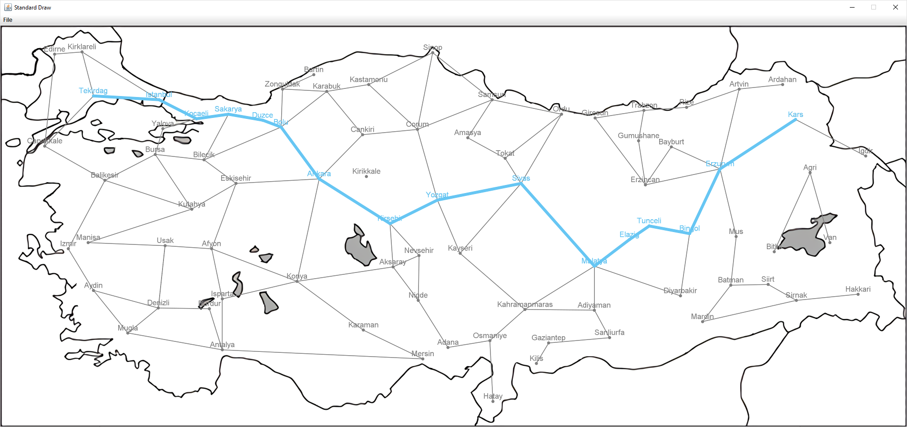
Enter starting city: Tekirdag
Enter destination city: Kars
Total Distance: 2263.87. Path: Tekirdag -> Istanbul -> Kocaeli -> Sakarya -> Duzce -> Bolu -> Ankara -> Kirsehir -> Yozgat -> Sivas -> Malatya -> Elazig -> Tunceli -> Bingol -> Erzurum -> Kars

Case 2: Antalya to Sinop
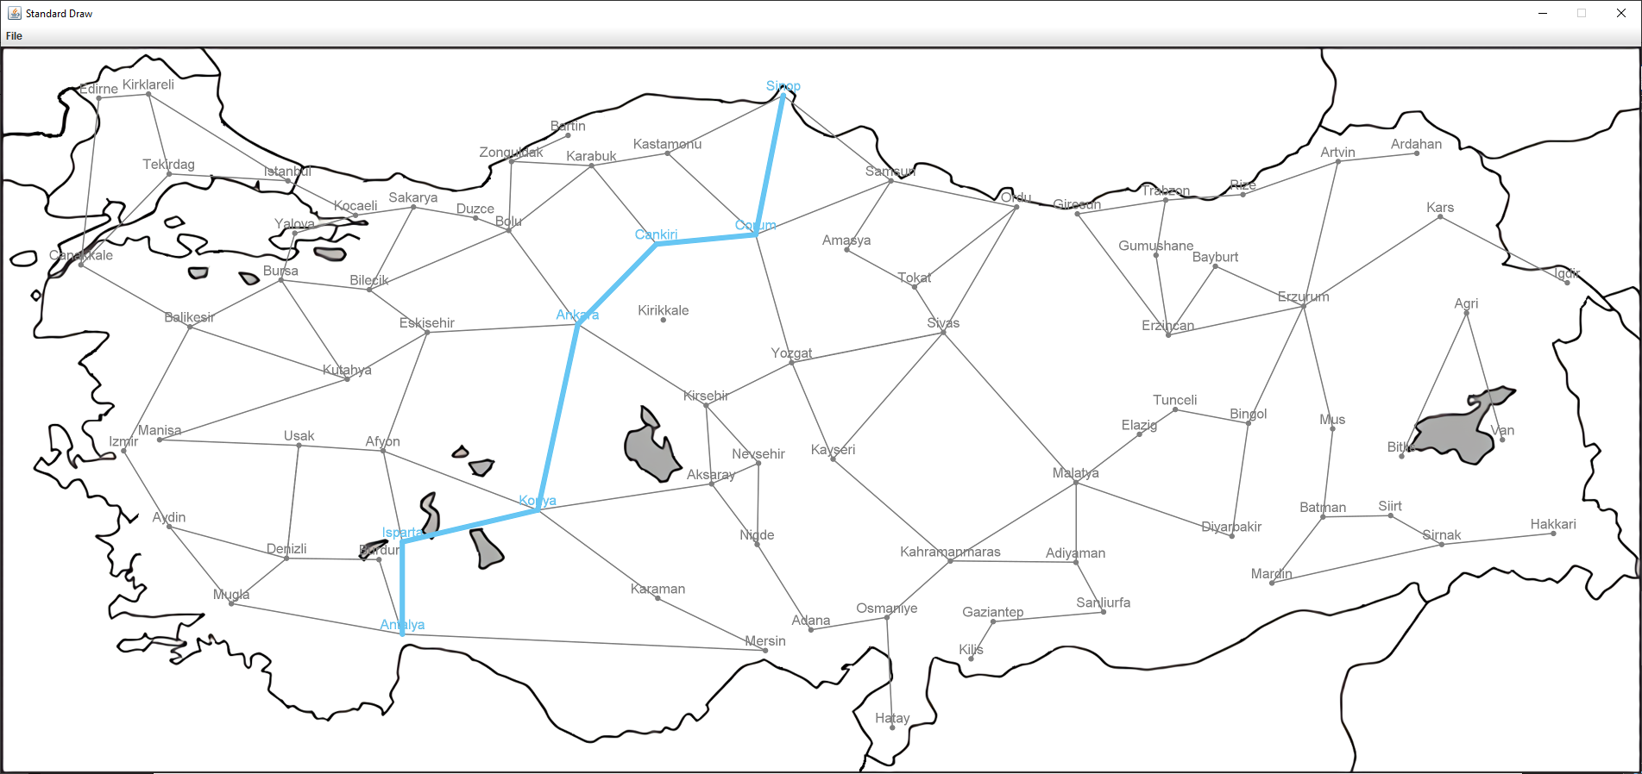
Enter starting city: Antalya
Enter destination city: Sinop
Total Distance: 1124.73. Path: Antalya -> Isparta -> Konya -> Ankara -> Cankiri -> Corum -> Sinop

Case 3: Invalid city names: User should be prompted again to enter a valid city name.
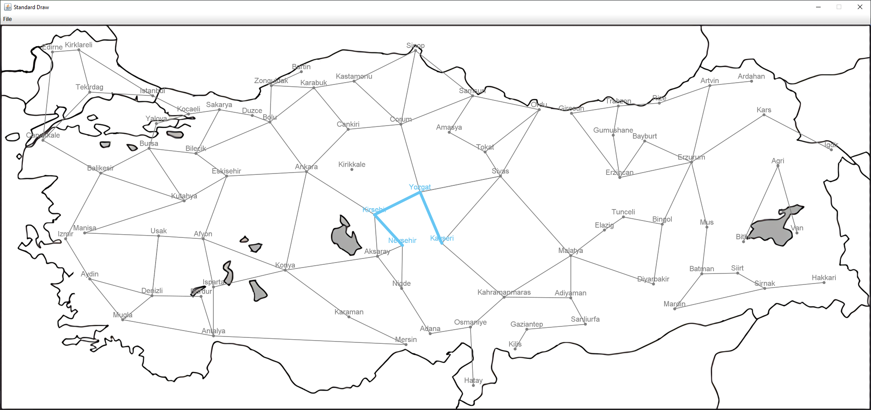

Enter starting city: Nevseh
City named 'Nevseh' not found. Please enter a valid city name.
Enter starting city: Nevsehir
Enter destination city: Kayser
City named 'Kayser' not found. Please enter a valid city name.
Enter destination city: Kayseri
Total Distance: 404.23. Path: Nevsehir -> Kirsehir -> Yozgat -> Kayseri

Case 4: Path to the same city.
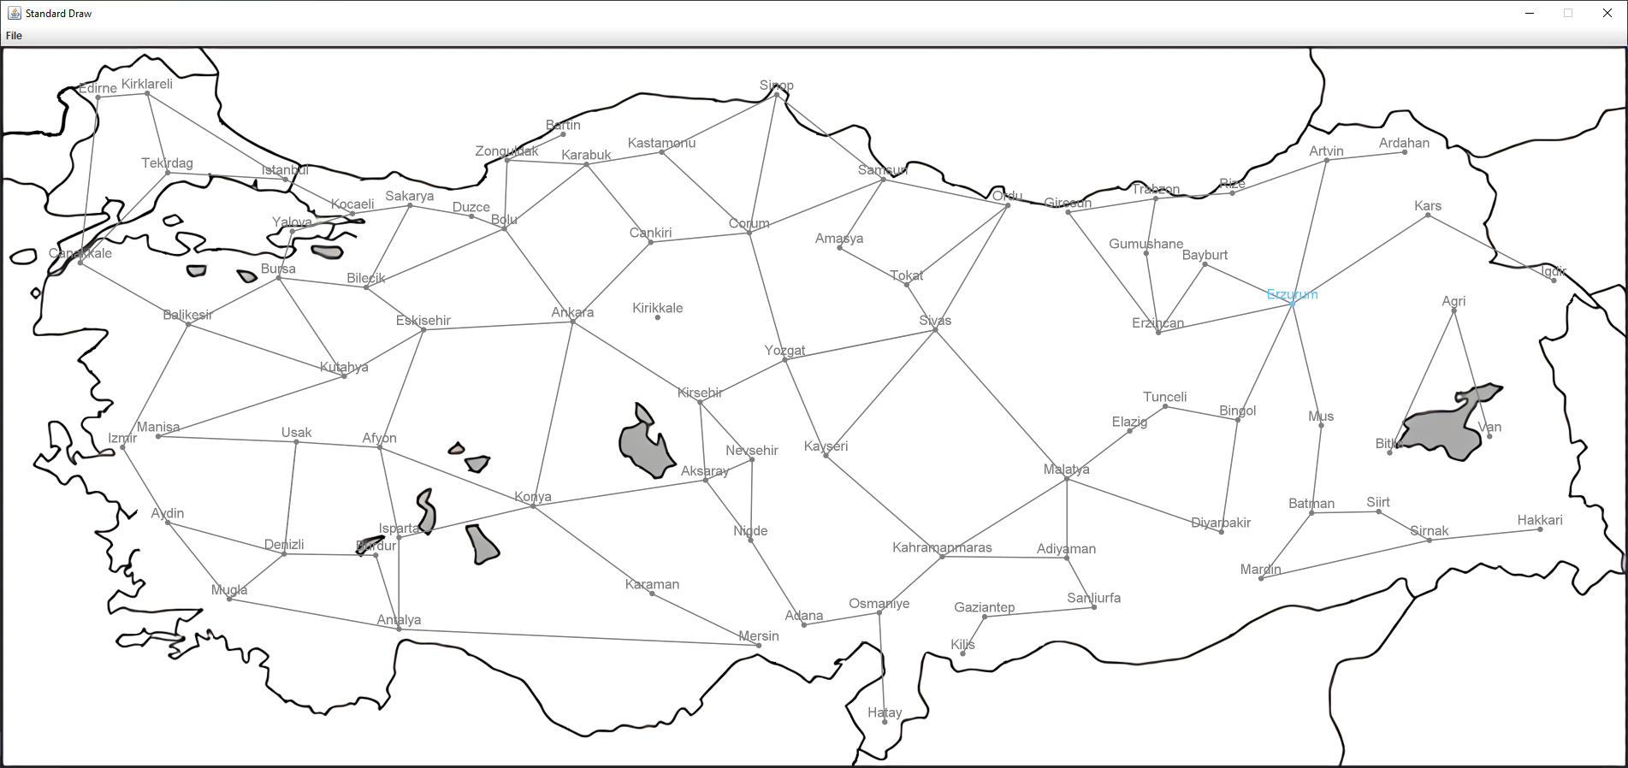
Enter starting city: Erzurum
Enter destination city: Erzurum
Total Distance: 0.00. Path: Erzurum

Case 5: Unreachable city pairs.
Enter starting city: Ankara
Enter destination city: Kirikkale
No path could be found.

Other cases:
Edirne to Giresun
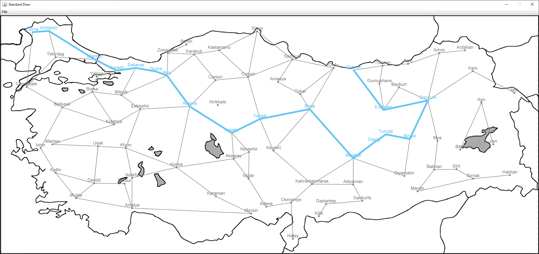
Enter starting city: Edirne
Enter destination city: Giresun
Total Distance: 2585.49. Path: Edirne -> Kirklareli -> Istanbul -> Kocaeli -> Sakarya -> Duzce -> Bolu -> Ankara -> Kirsehir -> Yozgat -> Sivas -> Malatya -> Elazig -> Tunceli -> Bingol -> Erzurum -> Erzincan -> Giresun

Canakkale to Hakkari
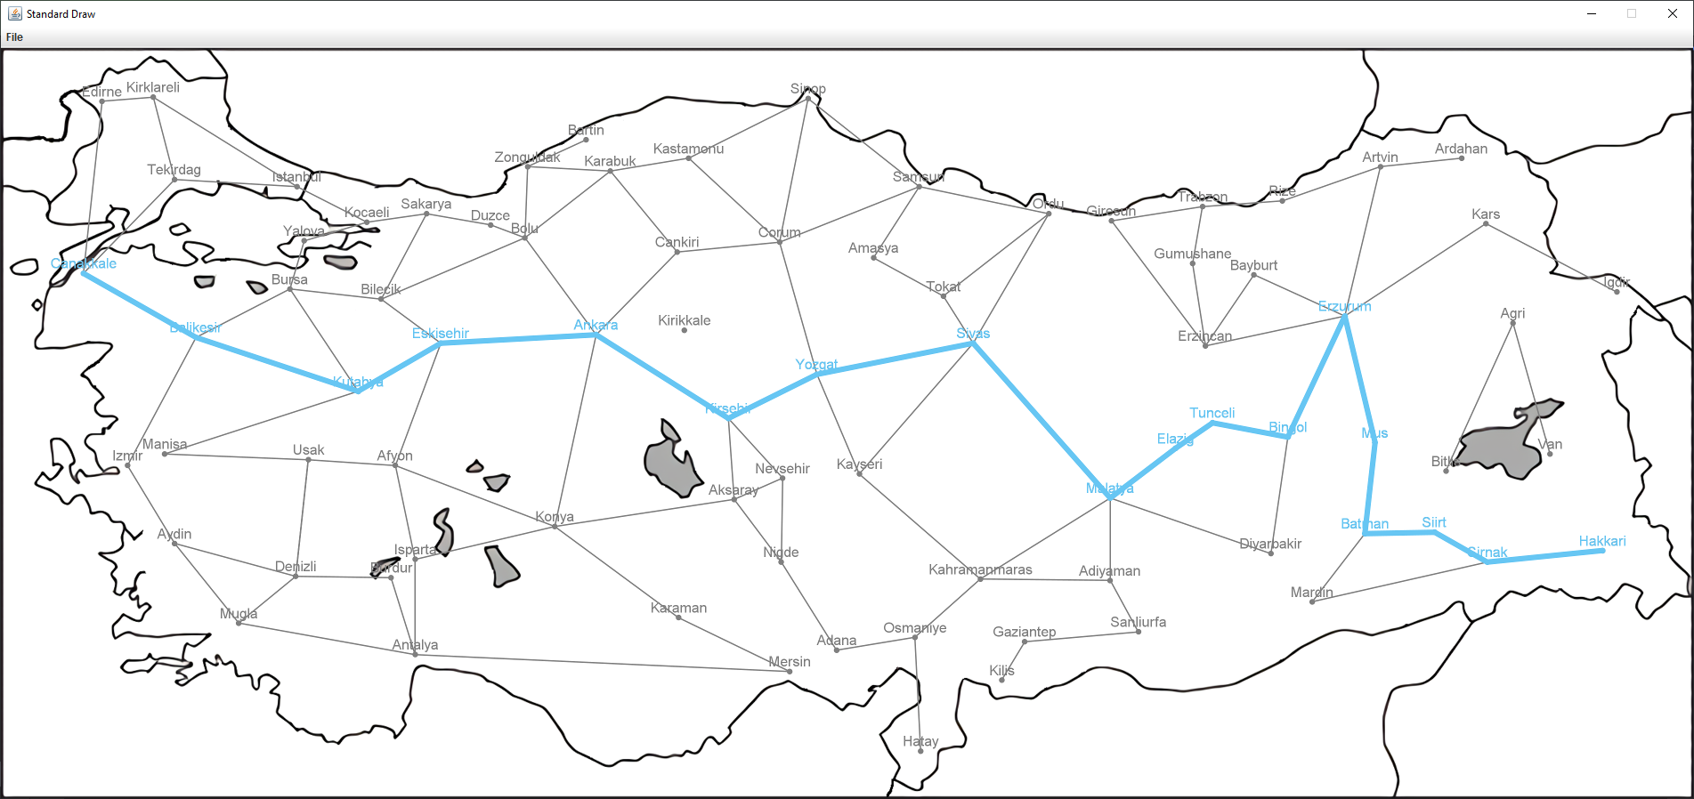
Enter starting city: Canakkale
Enter destination city: Hakkari
Total Distance: 2780.87. Path: Canakkale -> Balikesir -> Kutahya -> Eskisehir -> Ankara -> Kirsehir -> Yozgat -> Sivas -> Malatya -> Elazig -> Tunceli -> Bingol -> Erzurum -> Mus -> Batman -> Siirt -> Sirnak -> Hakkari

Ankara to Denizli
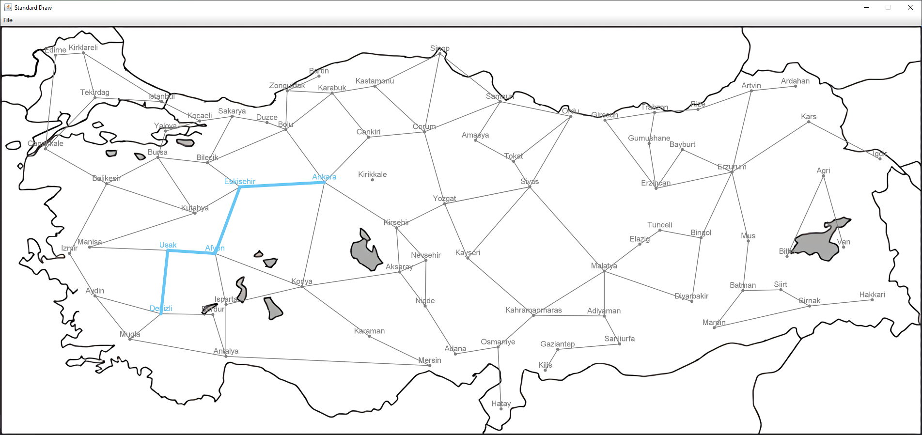
Enter starting city: Anka
City named 'Anka' not found. Please enter a valid city name.
Enter starting city: Ankara
Enter destination city: Deni
City named 'Deni' not found. Please enter a valid city name.
Enter destination city: Denizli
Total Distance: 689.10. Path: Ankara -> Eskisehir -> Afyon -> Usak -> Denizli

Istanbul to Istanbul
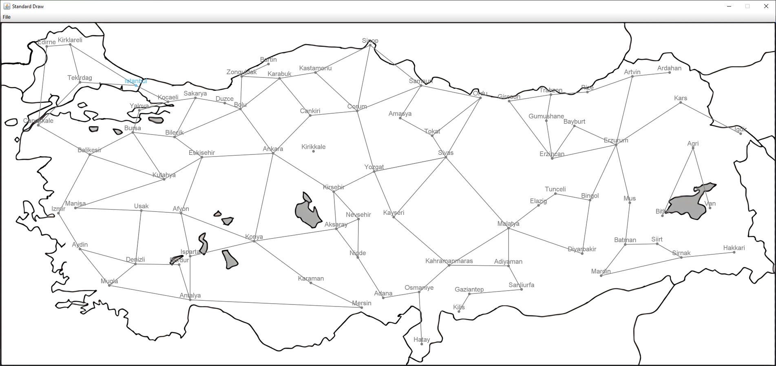
Enter starting city: Istanbul
Enter destination city: Istanbul
Total Distance: 0.00. Path: Istanbul

Izmir to Van
Enter starting city: Izmir
Enter destination city: Van
No path could be found.

