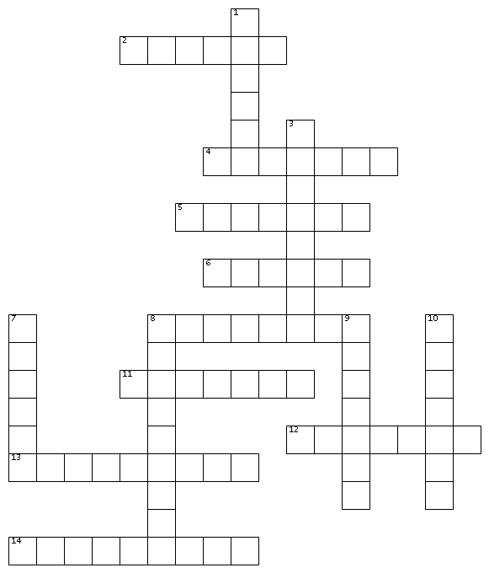

ACROSS
2. to go from one place to another
4. to grow or improve over time
5. to make something better
6. power used for work or electricity
8. becoming better over time
11. the usual weather in a place
12. something that causes difficulty
13. the process of learning in school or college
14. a group of people living in the same area
DOWN
1. to make something smaller or less
3. something useful like water or money
7. the time that has not happened yet
8. harmful waste in the environment
9. help given to a person or idea
10. to keep something safe from harm

