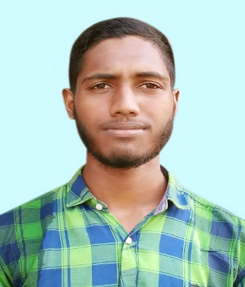Name : Delowar Sikder

Father’s Name : Md. Sultan Sikder

Mother’s Name : Sakina Begum

Email : delowarsikder099@gmail.com

Mobile : +8801839323114

Present Address : Dr. M.A. Rashid Hall_111 , KUET , Khulna-9203

Permanent Address : Village: Bamnikati, Post: Bamnikati, Postcode: 8621,

Polish Station: Bauphal, District: Patuakhali

Religious : Islam

Married status : Unmarried

Education Profile:

|  |  |  |  |
| --- | --- | --- | --- |
| Education | Institute | Passing year | Result |
| JSC | Kuripaika Secondary School,Patuakhali | 2011 | GPA-4.71 |
| SSC | Kuripaika Secondary School,Patuakhali | 2014 | GPA-5.00 |
| HSC | Amrita Lal Dey College ,Barisal | 2016 | GPA-5.00 |
| BSc in Eng. | Khulna University of Engineering &Technology ,(KUET) | 2k16 | CG-3.21(2-1)  CG-3.28(1-2)  CG-3.48(1-1) |