Hajee Mohammad Danesh Science and Technology University
Department of Computer Science and Engineering
Course: Web and Mobile Application Development Sessional
Software Requirements Specification (SRS)
University Event Management System
Prepared by: Deloyar Hossain &Abdur Rahman
Live Application: https://university-event-system-24640.web.app
Document Version: 1.0

1. Introduction

1.1 Purpose
This Software Requirements Specification (SRS) describes the functional and non-functional requirements of the University Event Management System, a web application intended to help university students discover and register for campus events, and to help organizers publish and manage those events. This document is intended for the developer, course instructor, and any reviewer who needs a formal statement of what the system is required to do.

1.2 Problem Statement
University students frequently miss seminars, workshops, cultural programs, and career events organized by different departments and clubs because event announcements are scattered across multiple pages, groups, and noticeboards, with no single place to discover events relevant to their interests. Organizers, in turn, lack a simple centralized tool to publish an event and track who has registered. The University Event Management System addresses this by providing one platform where organizers publish events and students discover, bookmark, and register for the ones that match their interests.

1.3 Scope
The system is a web-based single-page application, accessible through a browser, with three intended user roles: Student, Organizer, and Admin. Students can create an account, browse and search events, receive personalized recommendations based on selected interest categories, bookmark events, register for events, and receive notifications. Organizers can create events and view the list of students registered for their events. The current implemented version of the system covers the Student and Organizer roles end-to-end; the Admin role (user management) is defined in this specification as part of the intended scope but is not present in the current implementation — see Section 8 for implementation status.

1.4 Definitions, Acronyms and Abbreviations
Term | Meaning
SRS | Software Requirements Specification
UI | User Interface
UID | Unique Identifier assigned to a user by Firebase Authentication
CRUD | Create, Read, Update, Delete
ER Diagram | Entity-Relationship Diagram
DFD | Data Flow Diagram
SPA | Single Page Application

1.5 Overview
Section 2 gives an overall description of the product, its users, and constraints. Section 3 describes the system architecture. Section 4 lists functional requirements grouped by module. Section 5 lists non-functional requirements. Section 6 presents the use case diagram and use case descriptions. Section 7 presents activity diagrams. Section 8 presents sequence diagrams. Section 9 presents the data model (ER diagram) and Section 10 the data flow diagram. Section 11 records the implementation status relative to this specification.

2. Overall Description

2.1 Product Perspective
The system is a new, self-contained web application built on top of Firebase (Authentication, Firestore, and Hosting) rather than a custom backend server. Figure 1 shows the system context: the two active human actors (Student, Organizer) and the Admin actor interact with the University Event System, which in turn depends on Firebase for authentication and data storage.
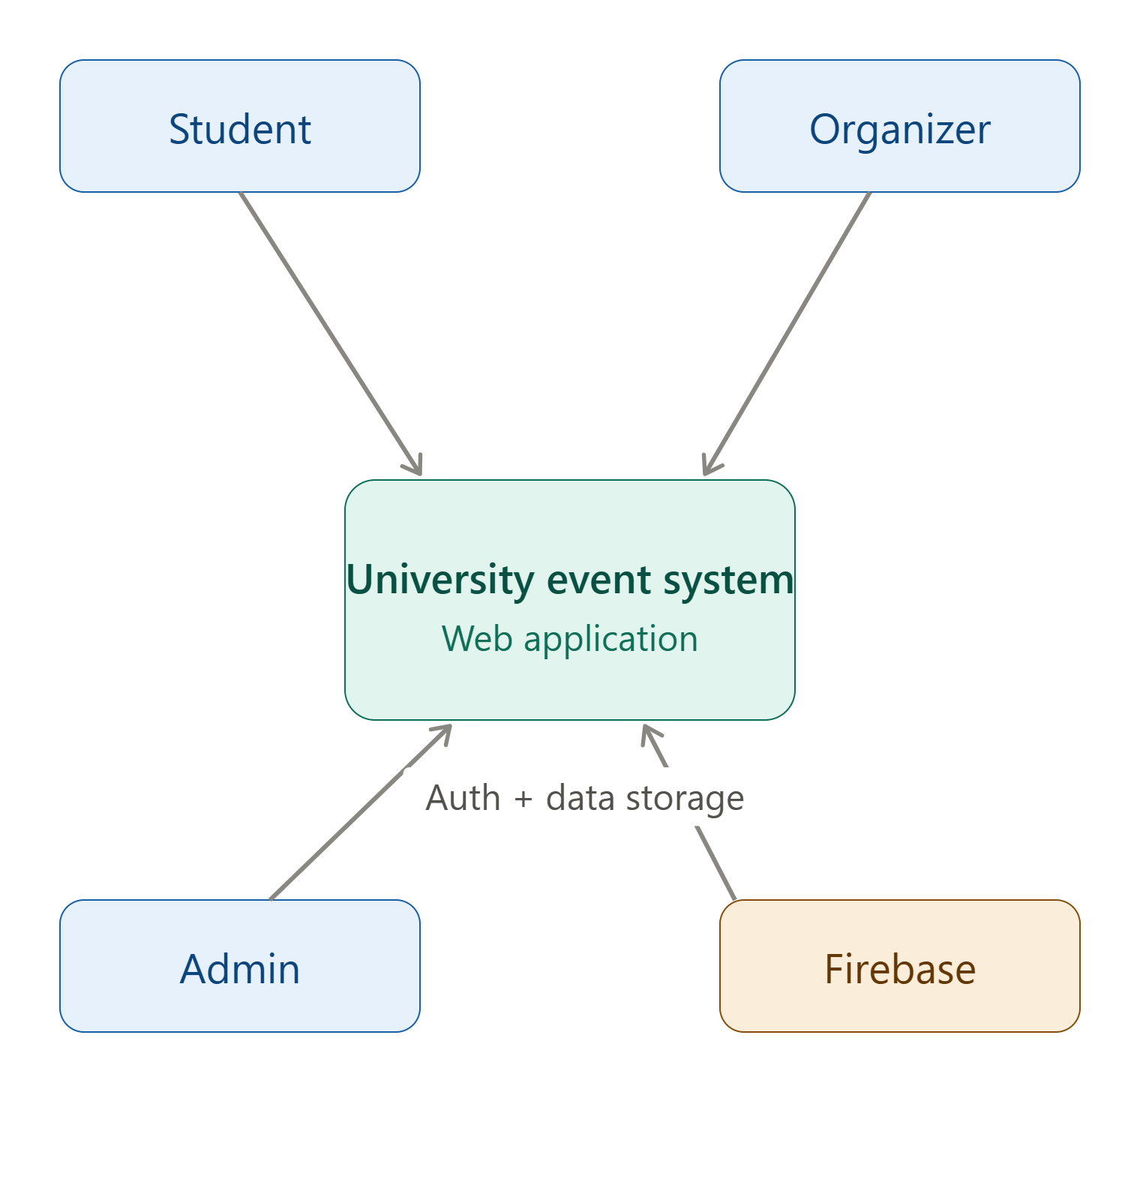
Figure 1: System Context Diagram

2.2 User Classes and Characteristics
Role | Description
Student | A university student who creates an account, sets interest categories, browses/searches events, bookmarks events, registers for events, and receives notifications.
Organizer | A staff member, club, or department representative who creates events, views the list of registered students for their own events.
Admin | (Planned role) Responsible for overall user account management and platform oversight, as shown in the use case and data-flow diagrams.

2.3 Operating Environment
- Client: any modern desktop or mobile web browser with JavaScript enabled and an internet connection.
- Server-side: Google Firebase (Authentication, Cloud Firestore, Firebase Hosting).
- Deployment: static SPA served over HTTPS via Firebase Hosting's global CDN.

2.4 Design and Implementation Constraints
- The system must use Firebase Authentication for identity management and Cloud Firestore as the primary data store, as decided at project setup.
- The frontend is built with React and must be deployable as a static site (no server-side rendering).
- All access control must be enforceable at the database layer through Firestore Security Rules, since the client is public and can be inspected or bypassed.

2.5 Assumptions and Dependencies
- Users have a valid email address and are able to complete email/password registration.
- The system depends on the continued availability of Google Firebase services.
- Event capacity/seat-limit enforcement (shown as a possible outcome in the registration sequence diagram) assumes an event document may optionally define a capacity; in the current data model this is not yet a required field — see Section 11.

3. System Architecture
Figure 2 shows the layered technical architecture: a React/Vite presentation layer, a routing and state layer, an application-logic layer, and a Firebase backend providing authentication, functions, messaging, hosting, and data storage.
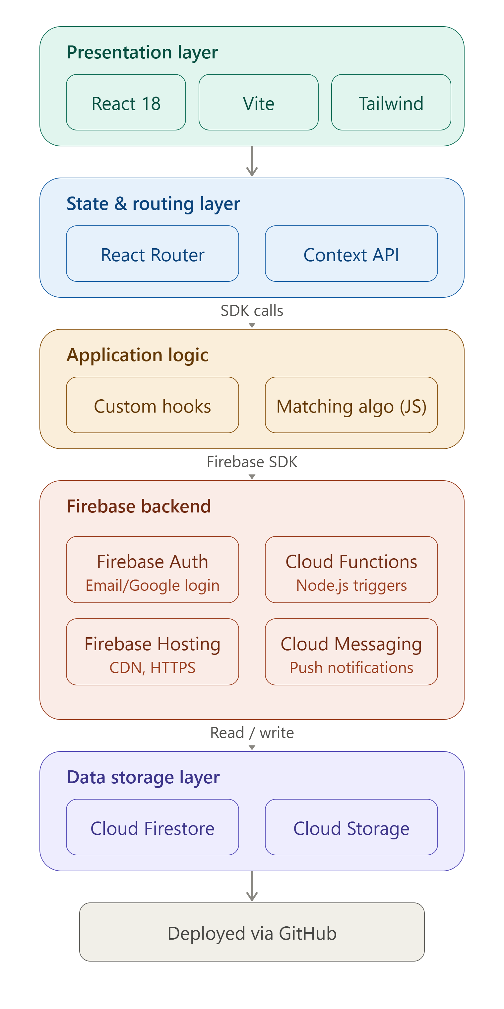
Figure 2: Technical Architecture Diagram
Figure 3 shows the deployment view: how a client device's browser reaches the application through Firebase Hosting's CDN, and how that application in turn communicates with the Firebase Authentication server, an optional Cloud Functions server for matching/notification logic, and the Firestore database server.
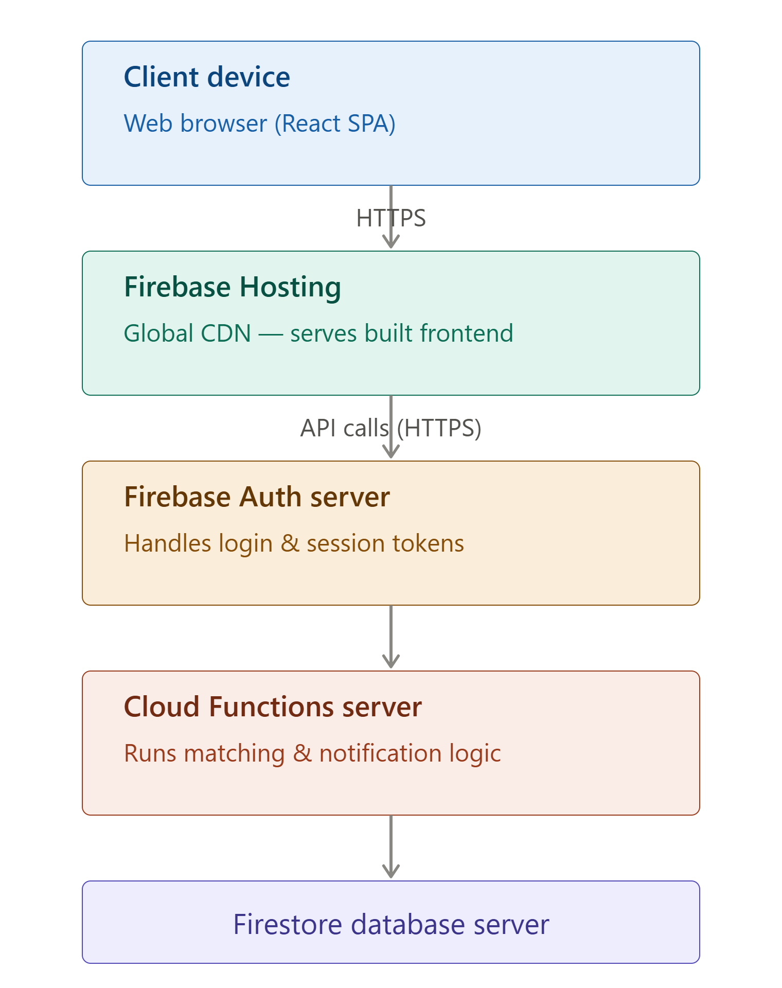
Figure 3: Deployment Diagram

4. Functional Requirements

4.1 Authentication (FR-1)
FR-1.1. The system shall allow a new user to register with full name, email, password, and a selected role (Student or Organizer).
FR-1.2. The system shall allow a registered user to log in with email and password.
FR-1.3. The system shall display an appropriate error message when login credentials are invalid.
FR-1.4. The system shall allow a logged-in user to log out.

4.2 Event Management (FR-2)
FR-2.1. The system shall allow a user with the Organizer role to create a new event with a title, description, date, time, venue, and category.
FR-2.2. The system shall prevent a user with the Student role from creating an event.
FR-2.3. The system shall display a list of all events to any visitor, including one who is not logged in.
FR-2.4. The system shall display full details of a single selected event.
FR-2.5. The system shall allow an Organizer to view only the events they personally created.
FR-2.6. The system shall allow an Organizer to view the list of students registered for a specific event they created.

4.3 Student Discovery (FR-3)
FR-3.1. The system shall allow a user to search events by title.
FR-3.2. The system shall allow a user to filter events by category.
FR-3.3. The system shall allow a logged-in student to bookmark an event for later viewing.
FR-3.4. The system shall allow a student to view a list of all events they have bookmarked.

4.4 Personalized Recommendation (FR-4)
FR-4.1. The system shall allow a student to select one or more interest categories on a profile page.
FR-4.2. The system shall visually highlight and prioritize events whose category matches the student's selected interests when the student views the event list.

4.5 Event Registration (FR-5)
FR-5.1. The system shall allow a logged-in student to register for an event.
FR-5.2. The system shall prevent a user with the Organizer role from registering for an event.
FR-5.3. The system shall indicate to a student whether they have already registered for a given event.

4.6 Notifications (FR-6)
FR-6.1. The system shall create a confirmation notification for a student immediately after they register for an event.
FR-6.2. The system shall notify every student whose interests match a newly created event's category.
FR-6.3. The system shall allow a user to view their list of notifications and mark individual notifications as read.

4.7 Administration (FR-7, planned)
FR-7.1. The system shall allow an Admin to manage user accounts.
FR-7.2. The system shall allow an Admin to trigger platform-wide notifications.
Note: FR-7 defines the intended Admin capability shown in the use case and data-flow diagrams. It is not present in the currently implemented version; see Section 11.

5. Non-Functional Requirements
Category | Requirement
Security | All create/update/delete operations on events, registrations, bookmarks, and notifications must be restricted by role and ownership at the database level using Firestore Security Rules, independent of any client-side checks.
Performance | The event list and event details pages should load within a few seconds under normal network conditions for a small-to-medium event catalogue.
Usability | Core actions (browse, search, filter, register, bookmark) should be reachable within two clicks from the navigation bar, and forms should give clear inline error messages.
Reliability | Data writes (event creation, registration, bookmarking) must be confirmed to the user only after the corresponding Firestore write succeeds; failures must be surfaced as an error message rather than silently ignored.
Scalability | The data model (separate collections per entity, queried by indexed fields such as organizerId, studentId, eventId) should scale to a moderately larger number of events and users without requiring a schema change.
Maintainability | Each page/feature is implemented as an isolated React component with its own Firestore queries, so a single feature can be modified without affecting unrelated pages.
Availability | The application depends on Google Firebase's published availability guarantees for Authentication, Firestore, and Hosting.

6. Use Case Model
Figure 4 shows the use case diagram covering all three actors (Student, Organizer, Admin) and the actions each can perform against the Event System.
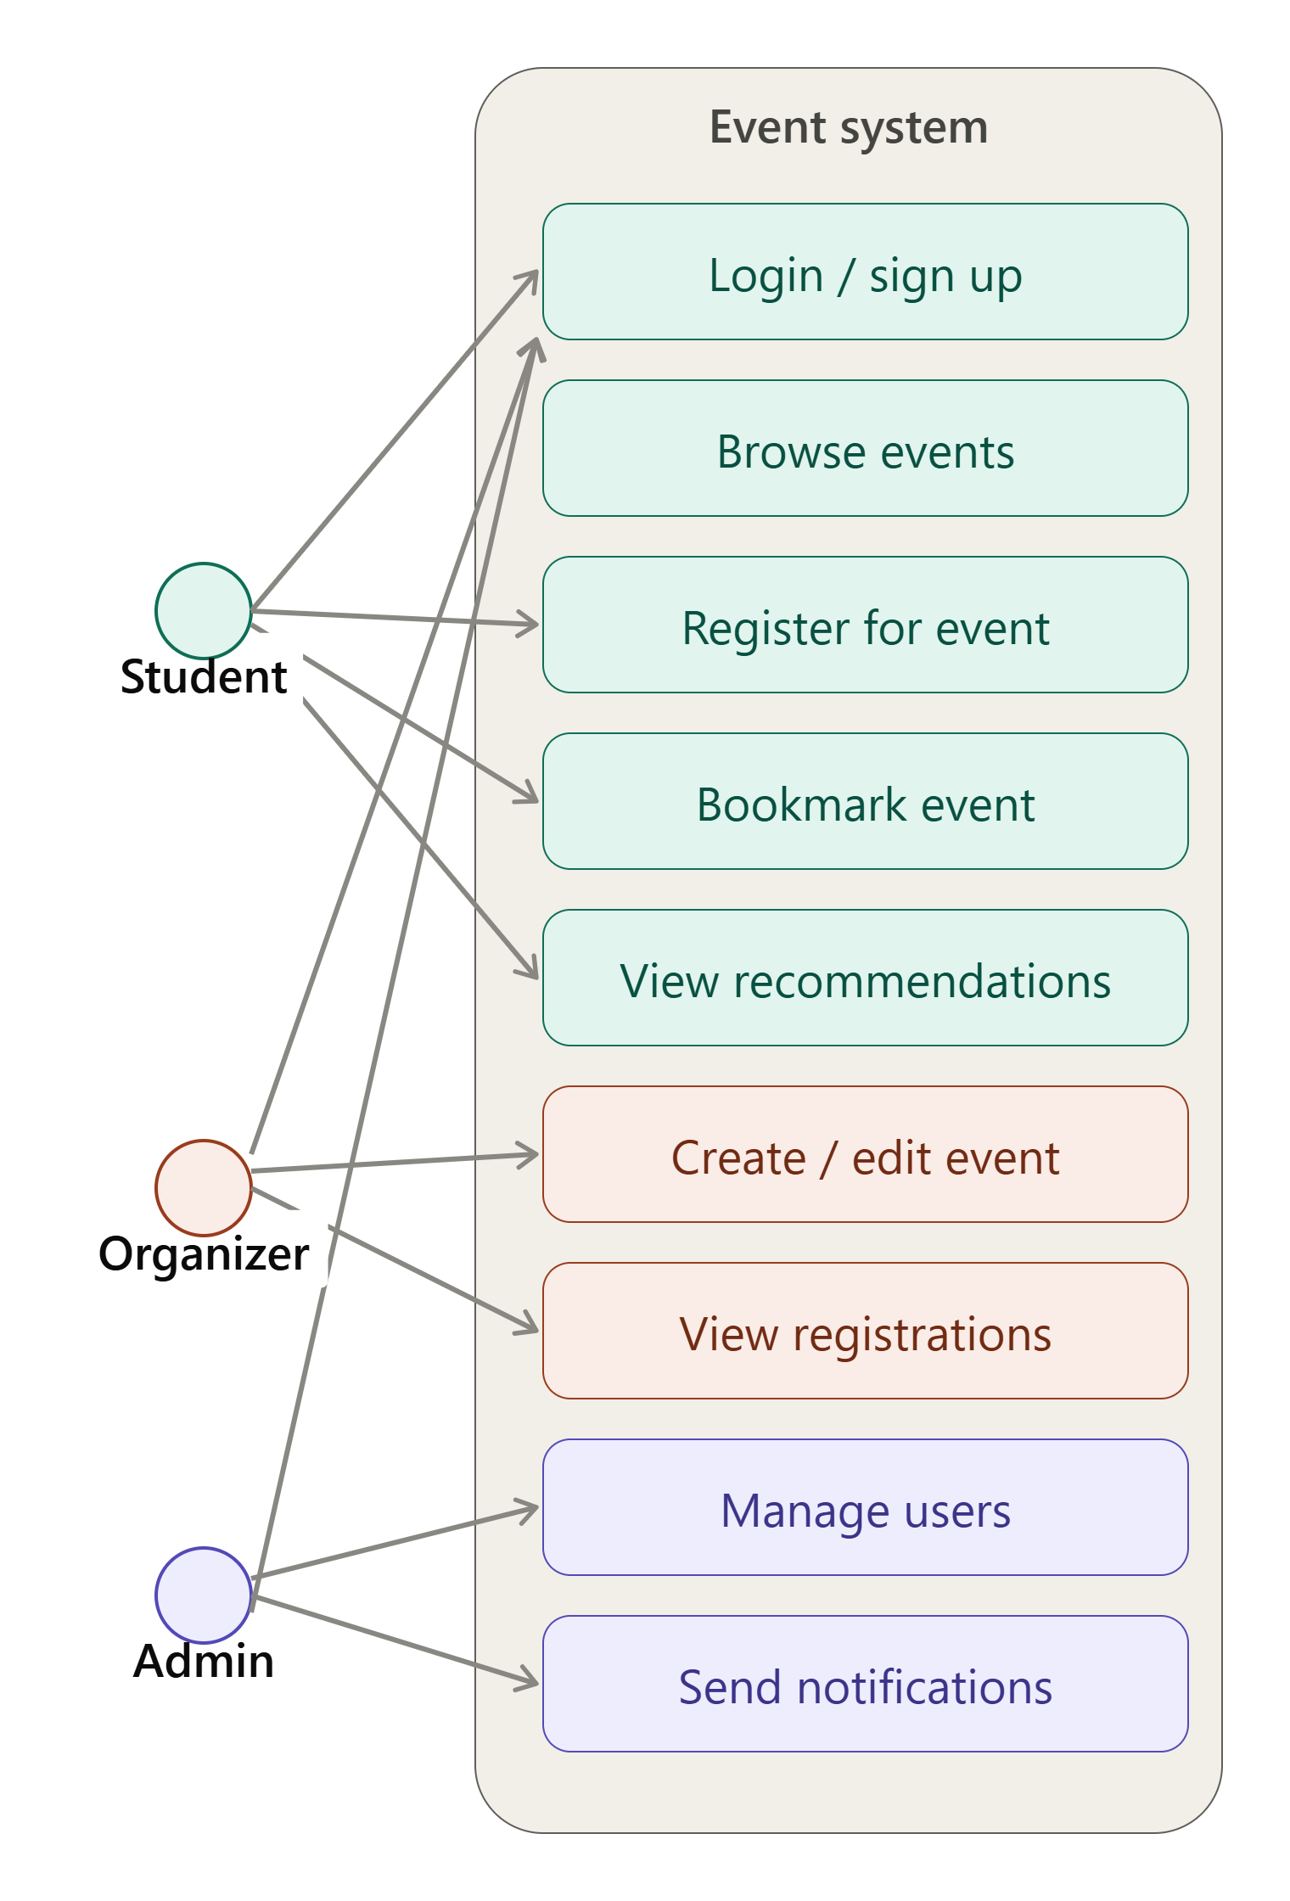
Figure 4: Use Case Diagram

6.1 Use Case Descriptions

UC-1: Register for an Event
Field | Description
Actor | Student
Precondition | Student is logged in and viewing an event's details.
Main Flow | 1. Student selects "Register". 2. System checks the student is not already registered. 3. System saves the registration. 4. System creates a confirmation notification.
Postcondition | A registration record exists linking the student and the event; the student sees a confirmation.
Alternate Flow | If the student is already registered, the system shows their registered status instead of the Register button.

UC-2: Create Event
Field | Description
Actor | Organizer
Precondition | Organizer is logged in.
Main Flow | 1. Organizer fills in event details (title, description, date, time, venue, category). 2. System validates the organizer's role. 3. System saves the event. 4. System notifies students whose interests match the event's category.
Postcondition | A new event document exists and is visible on the Events page; matched students have a new notification.
Alternate Flow | If the requester is not an Organizer, the system rejects the create operation.

UC-3: View Personalized Recommendations
Field | Description
Actor | Student
Precondition | Student is logged in and has set interest categories on their profile.
Main Flow | 1. Student opens the events/discovery page. 2. System fetches the student's interest profile. 3. System fetches all events and ranks them so that events matching the student's interests appear first.
Postcondition | The student sees a personalized, ranked list of events with matching events visually marked.

7. Activity Diagrams

7.1 Event Registration — Swimlane View
Figure 5 shows the registration process split across the Student, System, and Organizer swimlanes: the student logs in, browses events, selects and registers; the system checks availability and saves the registration and sends a confirmation; the organizer can then view the updated registration list.
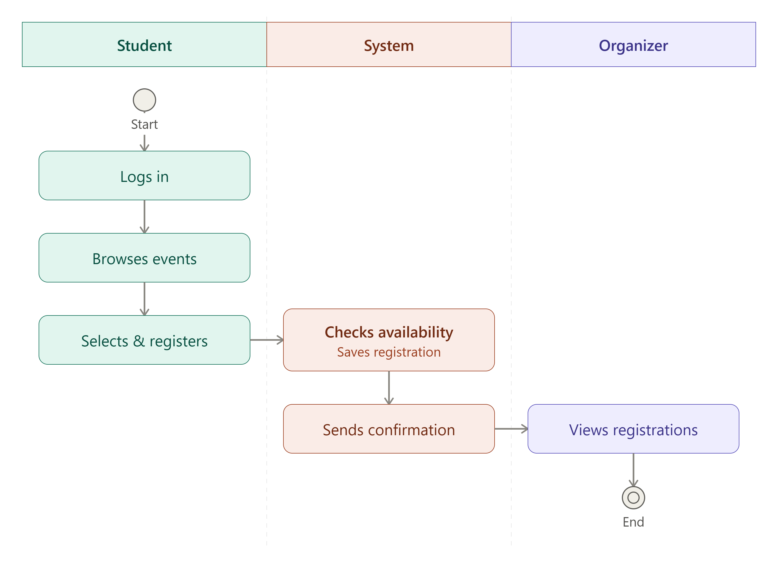
Figure 5: Activity Diagram (Swimlanes) — Event Registration

7.2 Event Registration — Detailed Flow
Figure 6 details the same process with an explicit decision point on seat availability.
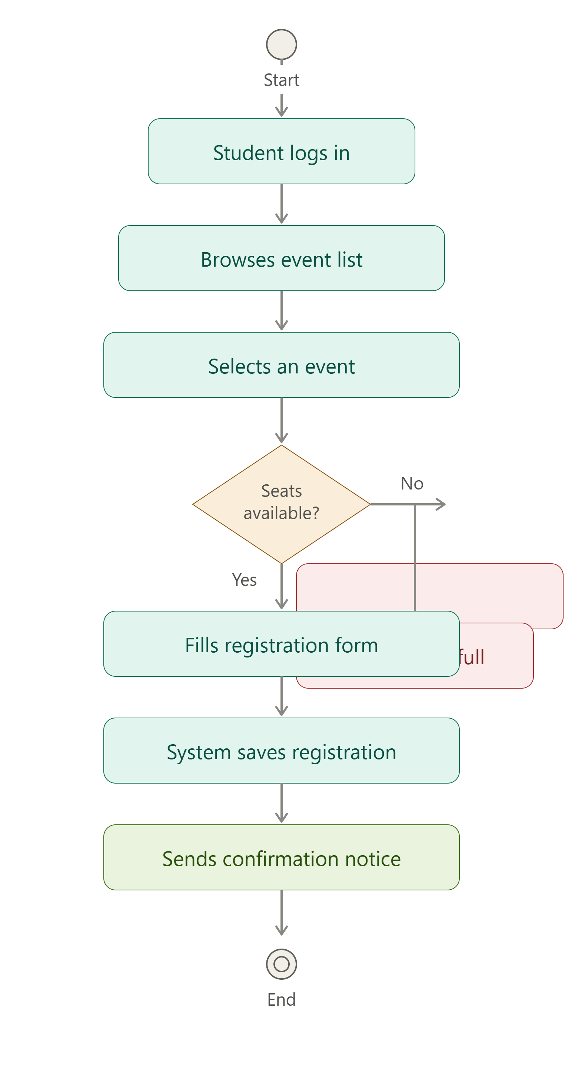
Figure 6: Activity Diagram — Event Registration Detail

8. Sequence Diagrams

8.1 Personalized Recommendation
Figure 7 shows the interaction between the Student, the System, the Recommendation engine, and Firestore when the discovery page loads: the student's interest profile is fetched, matched against the fetched event list, and a ranked, personalized list is returned.
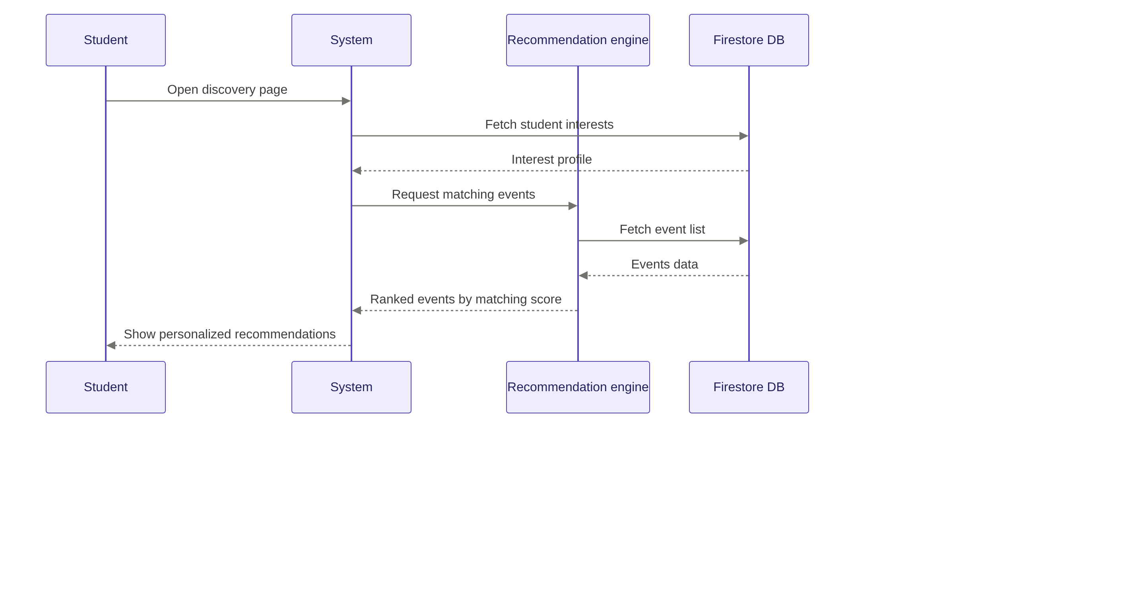
Figure 7: Sequence Diagram — Personalized Recommendation

8.2 Event Registration
Figure 8 shows the registration interaction, including the alternative outcomes when seats are available versus when the event is full.
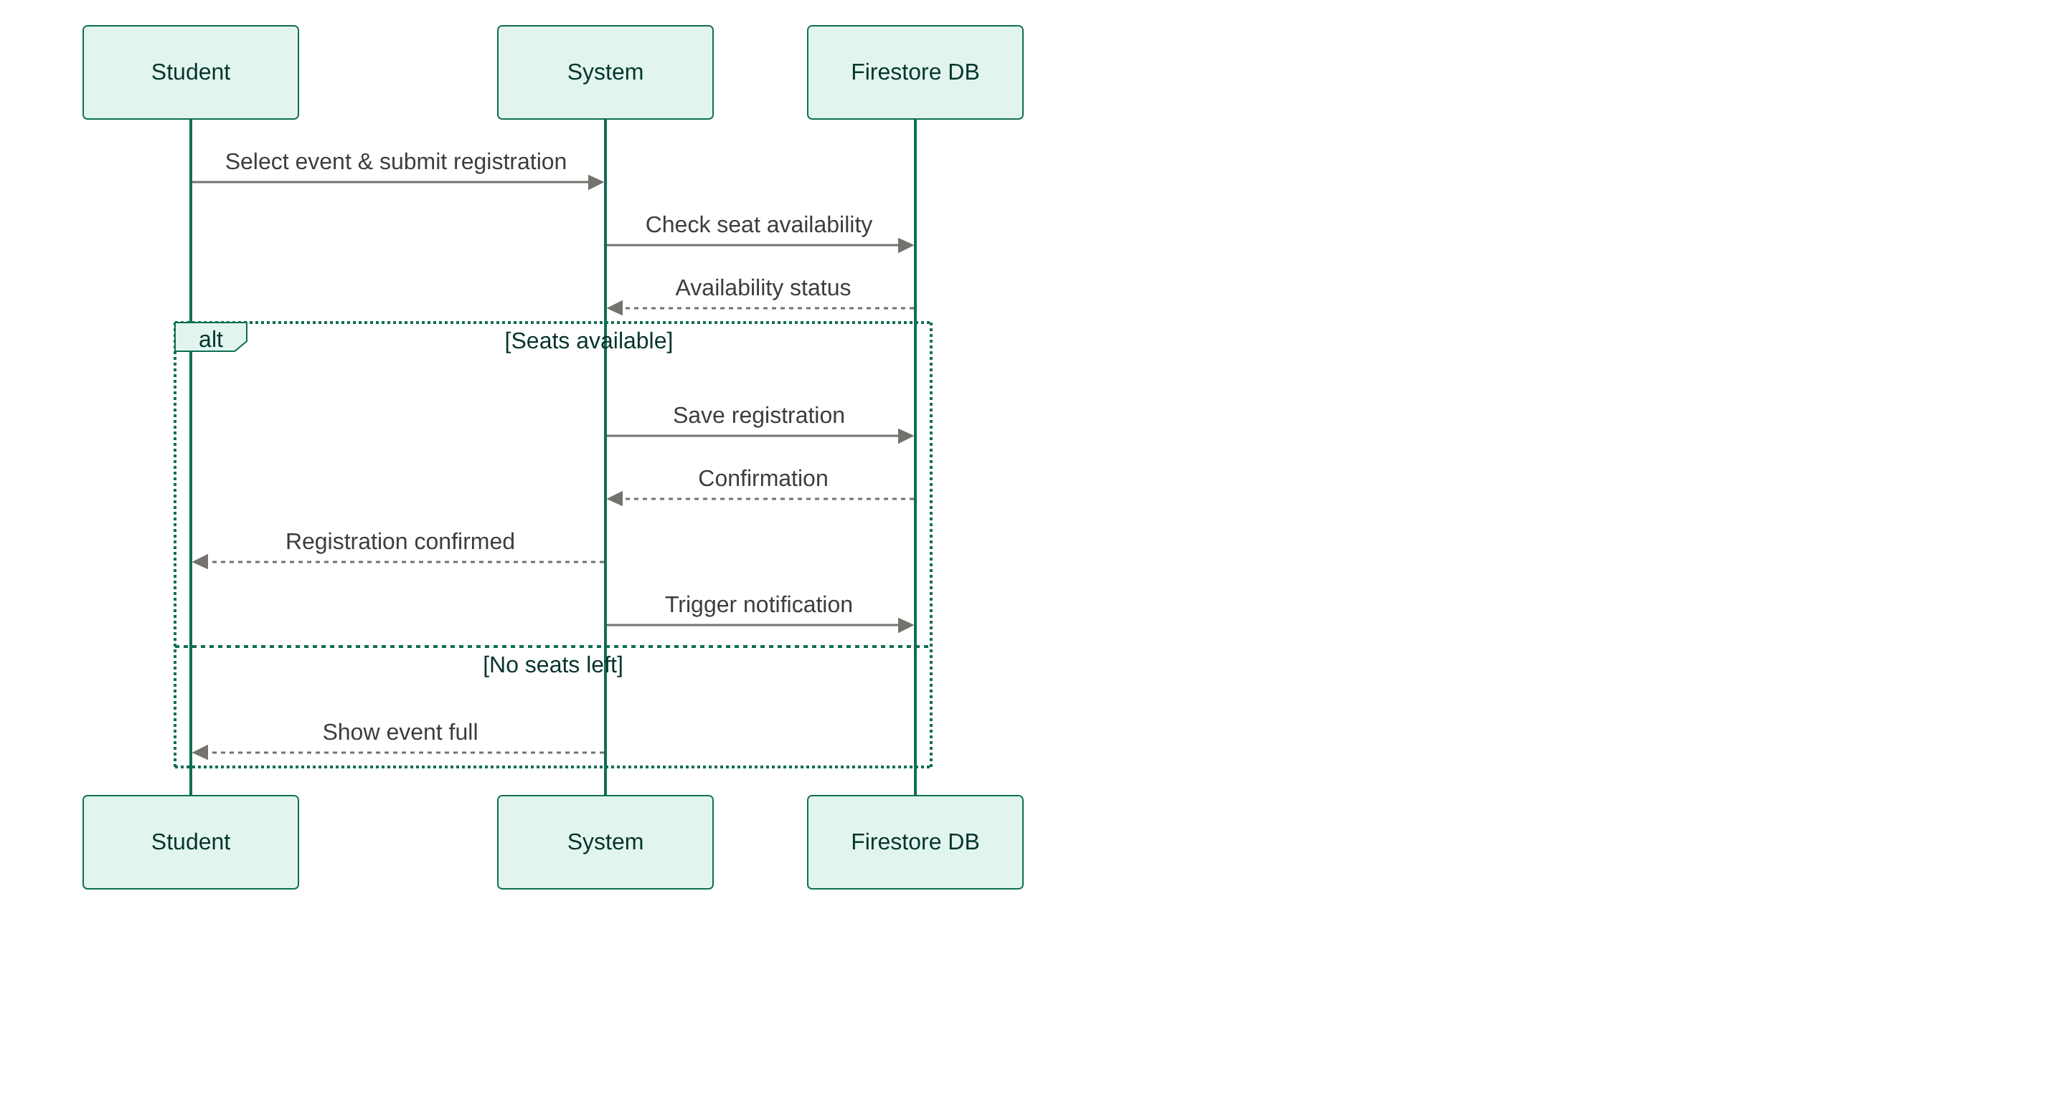
Figure 8: Sequence Diagram — Event Registration

9. Data Model (Entity-Relationship Diagram)
Figure 9 shows the full entity-relationship model as originally designed, including entities for User, Student, Organizer, Profile, Interest, Bookmark, Event, Classification, Registration, Recommendation, and Notification.
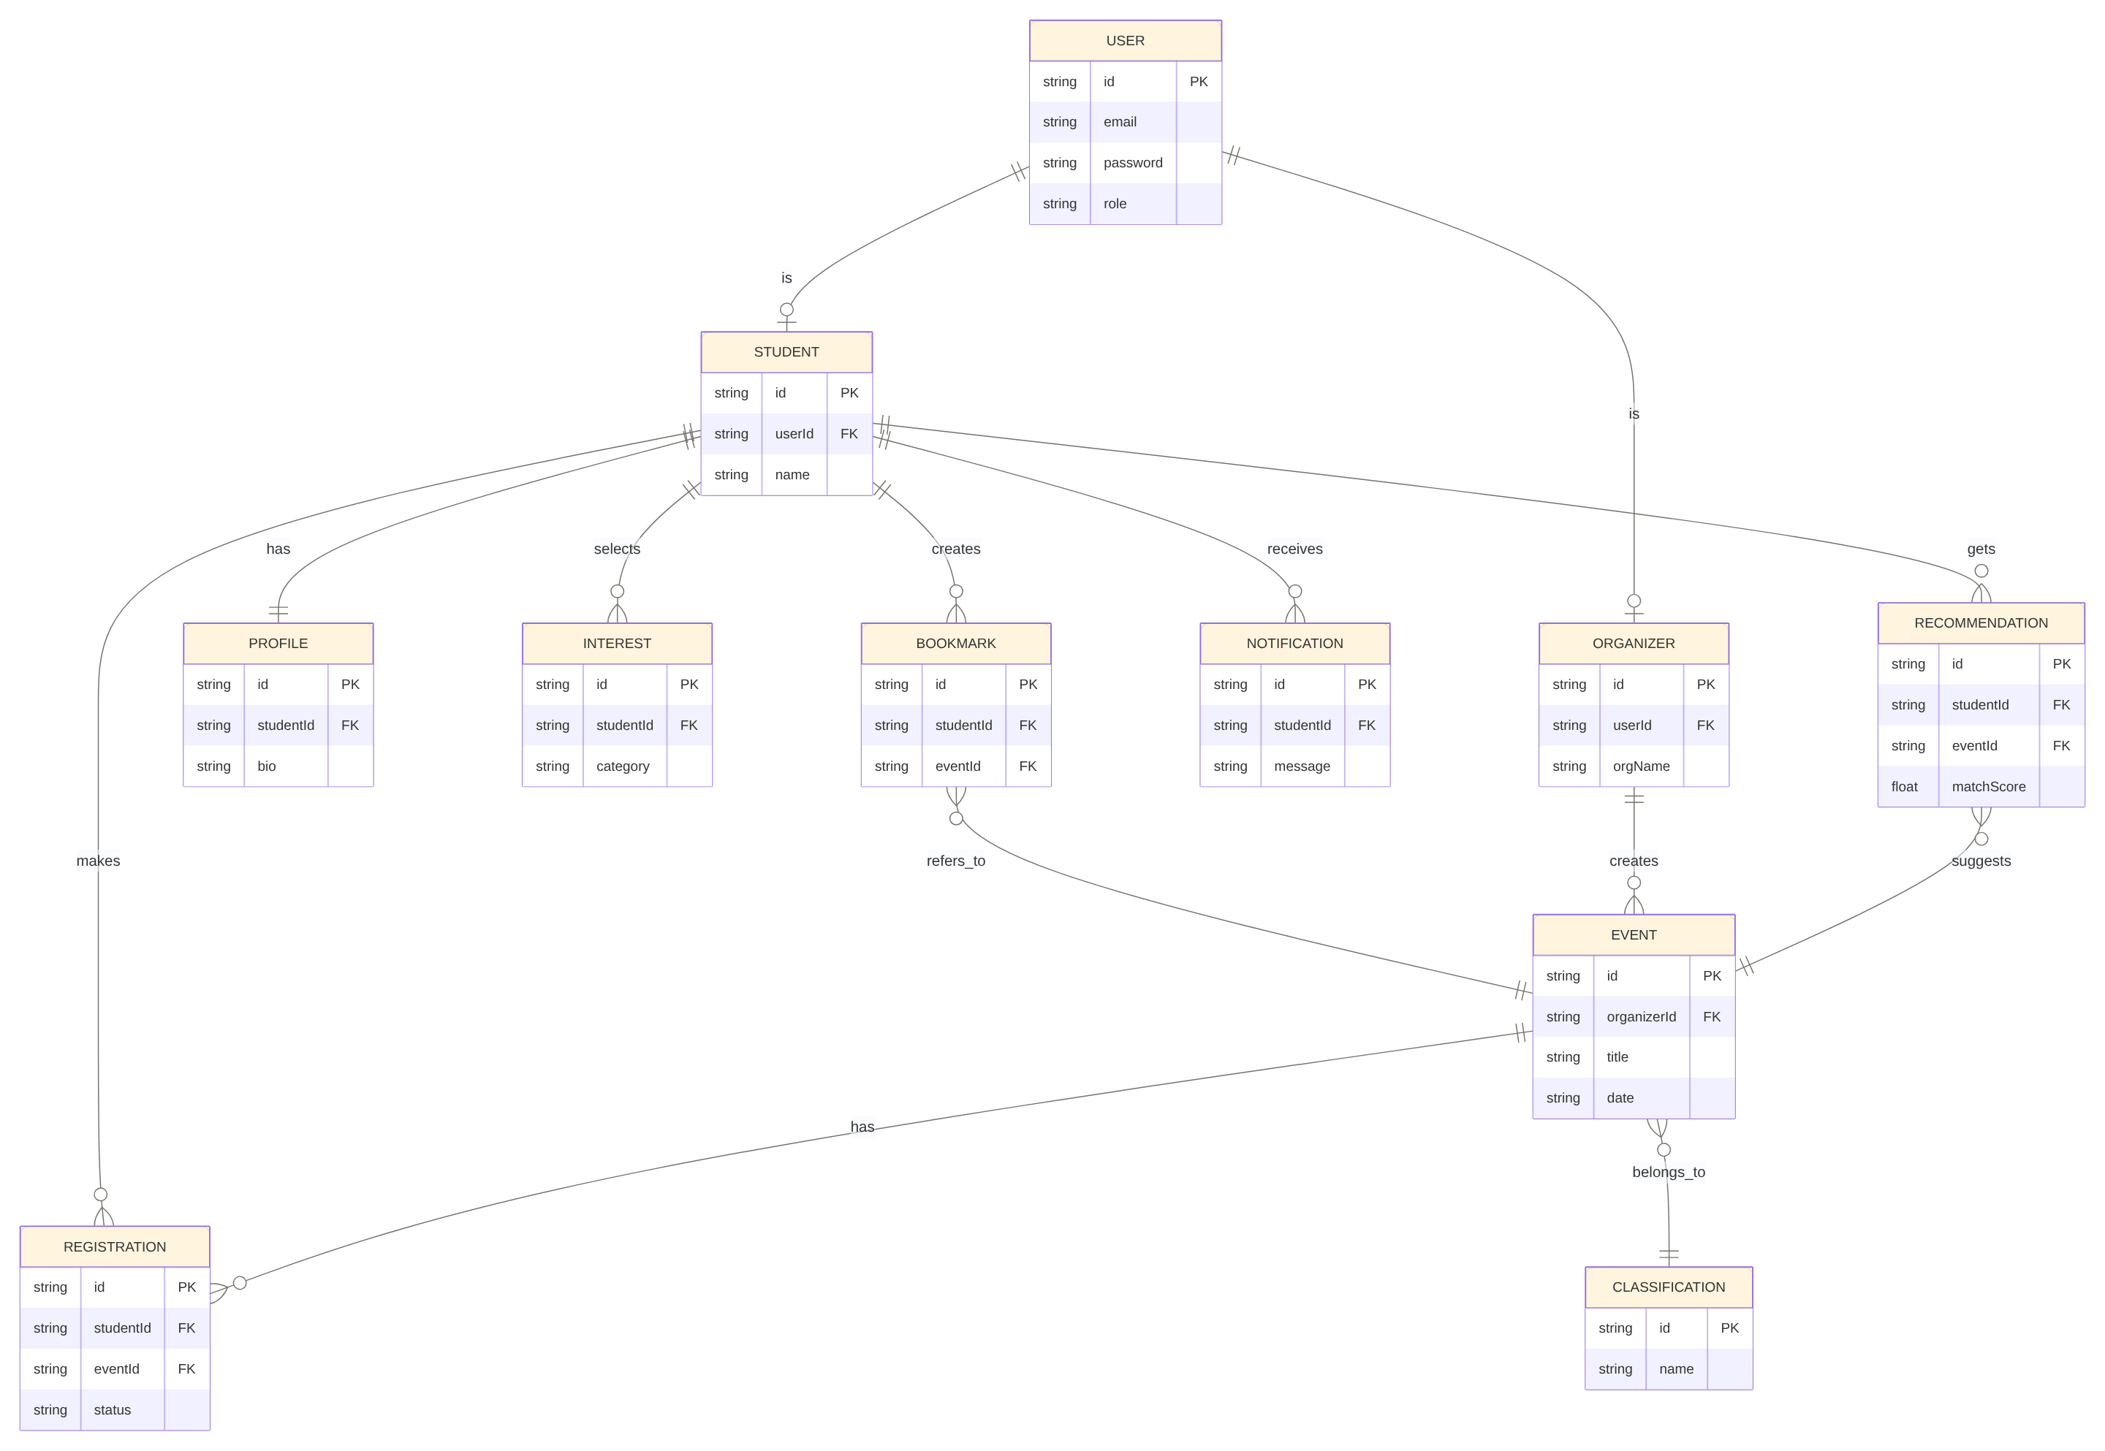
Figure 9: Entity-Relationship Diagram
Note: the current Firestore implementation consolidates some of these conceptual entities into fewer physical collections (for example, Profile and Interest are stored as fields on the User/Student document rather than as separate collections, and Recommendation is computed at query time rather than stored). The full field-level Firestore schema actually implemented is documented in the separate Coding Documentation.

10. Data Flow Diagram (Level 1)
Figure 10 shows the level-1 data flow: the Student, Organizer, and Admin actors interact with three processes — Registration, Event Management, and User Management — which read and write four data stores: Registrations, Events, Users, and Notifications.
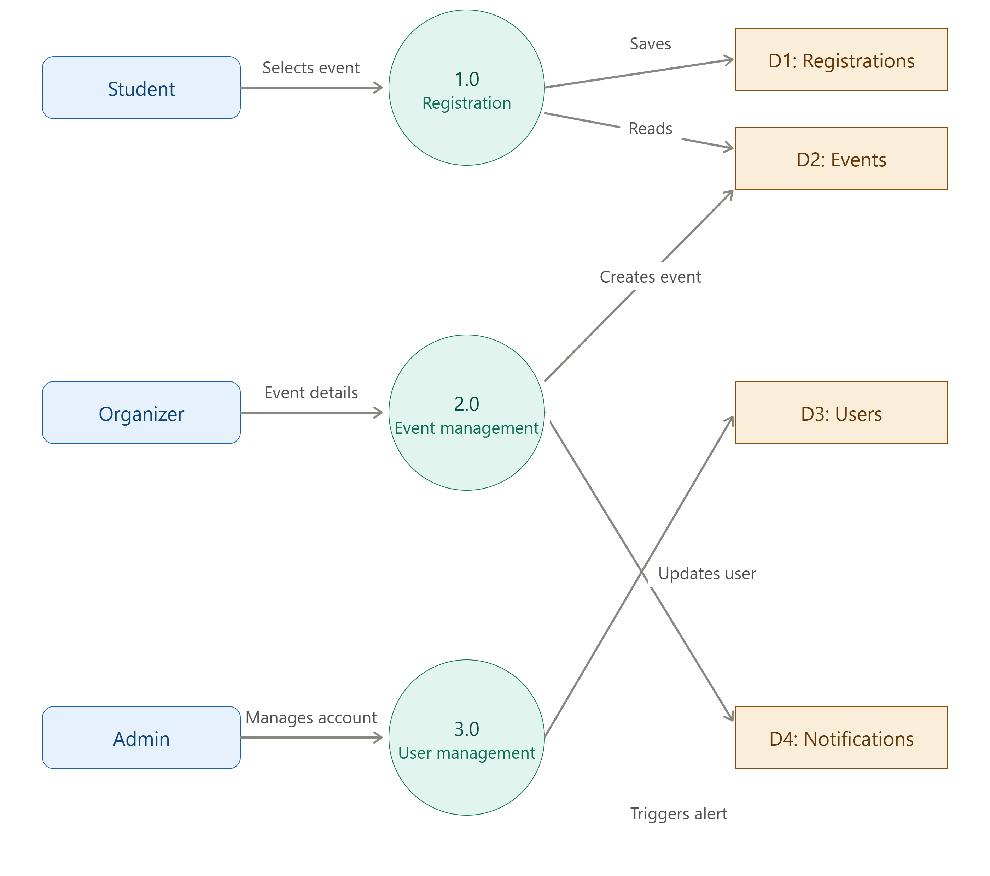
Figure 10: Data Flow Diagram, Level 1

11. Implementation Status
This SRS documents the full intended scope of the University Event Management System. As of the current submitted version, the following requirements are fully implemented and verified (see the separate Test Report):
- FR-1 (Authentication), FR-2 (Event Management, except event edit/delete), FR-3 (Student Discovery), FR-4 (Personalized Recommendation), FR-5 (Event Registration), and FR-6 (Notifications) are implemented and tested.
The following are part of this specification but not yet implemented in the current version:
- FR-7 (Admin role and user management) — no Admin account type or admin dashboard exists yet.
- Event capacity / seat-limit checking shown in the registration sequence and activity diagrams — the current events collection does not yet store a capacity field, so every registration currently follows the "seats available" path.
- Organizer edit/delete of an existing event — the security rules already permit it, but no UI has been built for it yet.
- Cloud Functions and Cloud Messaging (push notifications) shown in the architecture and deployment diagrams — notifications are currently generated by direct Firestore writes from the client rather than a server-side function, and delivery is in-app only, not push/SMS/email.

