How to make a new skin

1. Introduction.
2. MasterBitmap
3. Skin Editor (ASkinEditor).
4. Usage of masks.

1. Introduction.

To create a new skin, you should have the latest version of the ASkinEditor.exe and any graphics editor (Adobe Photoshop is recommended).

Most skins contain two files. The first one is an image of certain skin items collected together in the Bitmap format (the sorting of different items does not matter). Further the file will be referred to as MasterBitmap (there may be more image files but we will not consider such cases here). The other file (“Options.dat”) contains skin settings in the Ini- format. The settings reside either as general (“GlobalData” section) or as applicable for each separate type of control. Now it seems reasonable to single out two main parts – image file creation and skin creation in ASkinEditor.

To conclude, skin making means creation of a MasterBitmap file and further configuration of the Options.dat file in the ASkinEditor program.

2. MasterBitmap

Since we aim at understanding the keystones of skin creation, the simplest images will be used to make our first skin. More sophisticated cases will be provided later along with some helpful hints (such as MasterBitmap optimization, mask usage and so on).

I guess you should realize that your first skin will not be intended for any serious application. However, they will become better as you acquire experience ☺. Spend some time practicing to enjoy finally the skin created for your own projects all by yourself! ;)
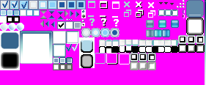
The pattern represents the content of the Master.bmp file for the WLM skin (this is the skin which will be discussed throughout the article).

MasterBitmap contains a set of all required images of various items of controls. Each image can hold information on how an item looks like in every specific state (0 – regular, 1 – active, 2 – pressed). Hence it appears that the width of each image must be multiple to the number of supported states.
The background must be Fuchsia-colored (since this color is transparent in AlphaSkins).


This is an example of a CheckBox drawing (checked) in three states. Three equally sizes drawings are joined together. The first one – for a regular state of control, the next – for a selected state and the last one is displayed at pressing. There
can be either two parts (if an image is not specified at clicking or
if it is the same as in the selected state of the control) or even one (if a control looks the same in all states).

Preparation of such items as forms, buttons, etc is not that challenging either. Use the following scheme to draw a control: draw a background first, then a frame window and the control content. The background can be translucent, have uniform, gradient or/and texture background (all the setting are specified in the skin editor and will be studied later). Now that the background is ready, corner and leg images from the MasterBitmap are superimposed onto it. Fuchsia colored pixels in the corners will make the control transparent there. Legs can be displayed either by replication or by stretching a source piece (display mode is specified in the skin editor).

Below are two images of the ToolBar - before and after the frame window is drawn:

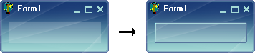

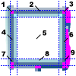
While drawing a frame window divide the base image into 9 parts (see
the figure on the right). Parts 1,3,7,9 (corners) are transferred as they
are, the legs of the window are filled by repeated or stretched (optional) parts 2,4,6,8 accordingly. Finally, the centre is filled by part
5 (this is true only for small sized controls such as buttons; part 5 is not applied when, say, a bar is drawn). Coordinates of images, width of legs and all other options are specified in the skin editor.

The background image for a control can be either included into the MasterBitmap file or kept in a different file (Jpeg and Bmp formats are acceptable).

As soon as all the necessary images have been drawn and located in the MasterBitmap, you should save it in the Bitmap format (the number of colors is of little importance, however it’s advisable to use 256 for optimization of the skin size).

Info : If the MasterBitmap file has been saved in PhotoShop, you are recommended to save it in a different program such as PaintBrush or IrfanView (it is a repeated practice that loading a Bmp-file saved in Photoshop causes an error in the flow read operation). Saving the image in any other program will help to avoid such issues.
3. Skin editor (ASkinEditor).
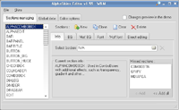
The program is intended to ensure a visual and intuitive modification of the skin options file (Options.dat). Downloading the program for the first time you should specify the folder the skins will be located in (the menu option: File/Select folder with skins). Once the folder with skins is specified, choose the skin to edit (the menu option: Skins/<the skin to be edited>). Now that the skin is chosen we can edit it.

To preview the skin being edited use the AskinDemo.exe program which is provided as a set with the skin editor. If the path is not specified, the program will ask you to find AskinDemo.exe. Use the checkbox “Changes preview in the demo” to preview the skin. After the skin is edited, it is automatically saved and the preview program is automatically updated with allowance for all recent changes.

To start skin operation, please, open the page “Global data”/”Main info” and make sure the MasterBitmap file is specified. This page can also contain the name of the skin creator, skin version and other information.

Now let’s go back to the first page “Sections managing” where we are enabled to add, edit and delete skin sections. Most sections (“FORM”, “BUTTON”, “PANEL” , etс) contain all options for drawing separate controls. The obvious advantage of such sections is that they can be substituted in the SkinData.SkinSection control option. Depending on the property setting a panel can be drawn as a button (“BUTTON” section) or as a form (“FORM” section). Moreover, you have an opportunity to add an unlimited number of your own sections to create proprietary controls. The rest of the sections are intended for drawing of separate parts of control (e.g. “DIVIDER”, “EXTRALINE”, “SCROLLBAR1H”).

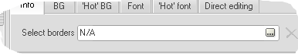
To change the section settings select it in the list on the left. The “Select borders” edit box on the page “Borders” permits to define the frame image coordinates in the MasterBitmap file along with other options required for frame drawing. You can omit to specify all these options which will result in drawing of a frameless control.

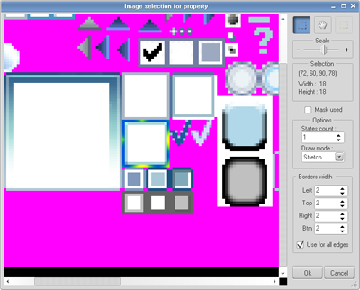
The “Image selection for property” form is drawn on pressing the button.

The best part of the form is filled with a large size drawing of MasterBitmap (the drawing scale is editable) where you can choose the image coordinates for a current section (on the model borders for the “TOOLBAR” section are chosen).

You must install the “Mask used” checkbox in case masks are used (in this particular case they are not used).

The “States count” specifies the control states number being determined by the drawing. Thus, to determine a regular, selected or pressed state for a button, you should draw them together in MasterBitmap, choose all the three states in the skin editor and set the StateCount to 3. The DrawMode specifies a mode of leg drawing – either by stretching the image the full length of a control leg or by repeating it.
The BorderWidth values determine the width of each leg – left, upper, right and lower accordingly.

Apart from frame specifying, we can determine the background and font settings. “BG” and “FONT” tabs specify the options for a regular state of control, while “Hot BG” and “Hot font” tabs – for active.

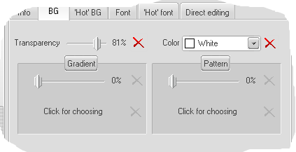
Let’s take a closer look at the “BG” tab:
We may prefer having a translucent background of a control. TRANSPARENCY specifies the transparency degree. COLOR defines the background color when neither fountain fill nor texture are specified. AlphaSkins provides a number of unique resolutions one of them being a possibility to combine texture with gradient. To set a percent degree of visibility of gradient and texture, use appropriate Trackbars. For choosing the texture choose the familiar window – “Image selection for property”. In this particular case “Fill type” is the only available option in addition to coordinates.

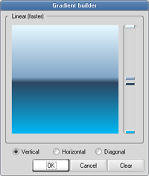
AlphaSkins enables us with another specific feature which is support of a large variety of colors and their hues in a fountain fill (something like the PhotoShop gradients, see the figure on the right).

For instance, a Mac Metal skin contains a large number of controls where the texture is drawn at one time with the gradient. Please, note that such mode will take more time for drawing…
The “Hot BG” tab is totally identical to the “BG” one.

To specify the font color and the color of caption bordering use the “Font” and “Hot font” tabs.

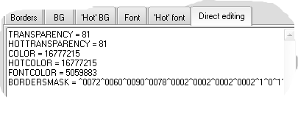
The “Direct editing” tab contain a textual description of a current section. A person skillful in working with this skin editor can take advantage of the possibility to edit, copy and delete the options manually (like a text) to speed up his/her work.
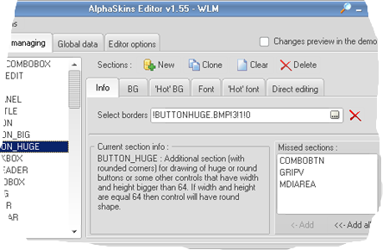
Pressing the “Info” tab button will display a short description of the selected section, and on the right a list of standard sections absent in the edited skin will become available.

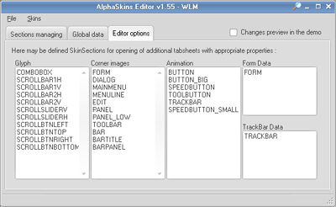
We have taken a review of the basic tabs available for all skin sections. However, there are complimentary tabs used for each particular section. For example, “Animation” tab is available for the button section and the “TRACKBAR”; it is used if you want to define images (glyphs) for all complimentary items of the control. Some other types of tabs can be found in other sections. All complimentary tabs and sections they are available in are listed on the “Editor options” page (here you can add names of your own section if any complimentary tabs are needed).

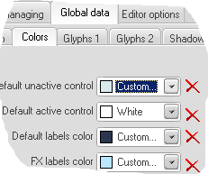
There is a special section - “GLOBALINFO” – accumulating the data common for the whole skin. This data can be found and edited on the “Global data” page. Since we are already familiar with the “Main info” tab, let’s have a look at the “Colors” tab where we can define a number of colors common for the skin:
“Default inactive control” is a color for inactive control not supported by skins; it can be applied in
outside components to specify the color similar to the skin color to the uttermost.
“Default edit control” is a color of an edit control not supported by the skin
“Default labels color” is a color of captions
“FX labels color” is a text color in the TsLabelFX component.

Tabs Glyphs1 and Glyphs2 contain options for drawing Checkboxes and Radiobuttons icons, system icons for forms and others common for the whole application. At opening an icon selection window (window “Image selection for property”) the drawing coordinates, “Mask used” and “States count” become available.

The “Shadows” tab allows to define setting of the shadow common for the skin. At this stage the shadow is applicable only for the TsLabelFX component; later this option will be available in other package components as well.


After having learned everything about the skin editor the last thing to be mentioned is a built-in magnifier which enables a preview of small sized items. Its call button is located on the form title and can be displayed at a click of the mouse left button.

Ultimately, below is a step-by-step process of a new skin creation :

- Create a directory with a new skin name in a folder with skins
- Create an Options.dat file(or copy it from an existing skin)
- Create a new Master.bmp file (or copy it from an existing skin)
- Run AskinEditor.exe, select the new skin and define the MasterBitmap to use.
- Press the “Information” button in the skin editor and add all sections to the suggested skin (you can choose not to add the unused ones).
- Each time the Master.bmp file is filled with a new control drawing, define its coordinates and drawing options in the corresponding sections.
- To preview the skin use the AskinDemo.exe displaying when the “Changes preview in the demo” is enabled.
- Please, feel free to contact the support service in case of any question and for troubleshooting (e-mail to support@alphaskins.com)

The skin editor is provided with a skin making wizard that will help to fulfill points 1-5 (it is located in the menu option File/Make new skin).

4. Masks Usage.

One of the most outstanding options of the AlphaSkins is a possibility to use masks for drawing various items. The option gives much advantage in drawing the controls enabling smoothing, partial transparency and other effects. Masks in Alphacontrols 4 are alphacanal emulation and can be defined as an independent area in the MasterBitmap which is supposed to be of the same size with a corresponding drawing and be located right under it. A mask can only be grey-toned. The darker the pixels are, the less transparent the corresponding pixel on the drawing is. It follows thence that a pixel with a white mask will be absolutely transparent while a pixel with a black mask – absolutely opaque. Below you can see a mask of a button frame from the WLM skin and its final form after the mask has been applied.
