 | Registry Date/Time Demo  Object Vision Associates, Inc.

To most Windows’ users the Registry is a mystery. It’s the central database in Windows that stores and maintains configuration information for the Windows operating system and other properly installed software products. Most power users and IT professionals’ access the Registry database from software programs like Microsoft’s REGEDIT.EXE and REGEDT32.EXE. Whether their use is one of personal choice or of necessity neither of these tools exhibit a seldom used and interesting feature of the Windows NT/2000/XP Registry. Did you know that a time/date stamp is applied to each and every key in the Registry indicating when a Registry Key or one of its data values was created or is modified? The Registry Date/Time Demo was written to reveal this functionality and also to demonstrate how one software program can send Window’s messages to control another.

The program and source files contained in REGDATE.ZIP include:

regdate.exe Demonstration program
regdate.dpr Delphi program file
regdate.res Resource file
properties.pas Source code
properties.dfm Properties form file
regedit.pas Source code
readme.doc This document

This demo will not modify your Registry in any way. It does however “hijack” Microsoft’s Registry Editor throughout the demonstration.

Usage: Simply start REGDATE.EXE (the Registry Editor will automatically start if it isn’t running already) and open the Registry key you’re interested in.

The Registry Date/Time Demo displays several properties associated to the selected key including number of sub-keys, longest sub-key name length, number of data values, longest data value name length, longest data value length and the time and date of the last write to the key in GMT (System Time) and Local time.

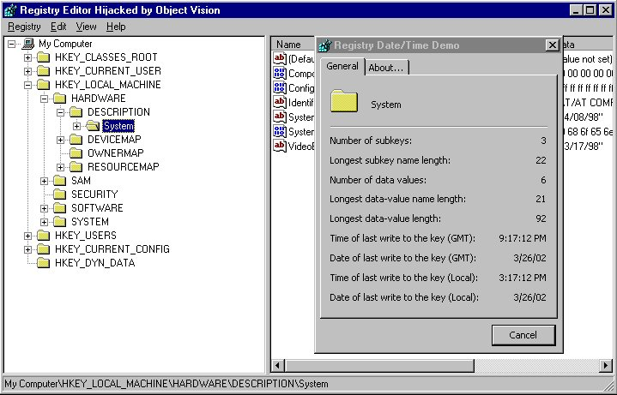

DISCLAIMER

The information and code provided hereunder (collectively referred to as “Software”) is provided as is without warranty of any kind, either expressed or implied, including but not limited to the implied warranties of merchantability and fitness for a particular purpose. In no event shall Object Vision Associates or its suppliers be liable for any damages whatsoever including direct, indirect, incidental, consequential, loss of business profits or special damages, even if Object Vision Associates or its suppliers have been advised of the possibility of such damages. Some states do not allow the exclusion or limitation of liability for consequential or incidental damage so the foregoing limitation may not apply. Furthermore it is understood that the use of this product is for educational purposes only and that the user accepts full responsibilities resulting from its intended use.

SOFTWARE USAGE AND DISTRIBUTION

This Software may be copied and distributed royalty-free subject to the following conditions:

1. You must copy all Software without modification and must include all pages, if the Software is distributed without inclusion in your software product. If you are incorporating the Software in conjunction with and as a part of your software product, which adds substantial value, you may modify and include portions of the Software.

2. You must place all copyright notices and other protective disclaimers and notices contained on the Software on all copies of the Software and your software product.

3. Unless the Software is incorporated in your software product, which adds substantial value, you may not distribute this Software for profit.

4. You may not use Object Vision’s name, logo, or trademarks to market your software product.

5. You agree to indemnify, hold harmless, and defend Object Vision Associates and its suppliers from and against any claims or lawsuits, including attorneys' fees that arise or result from the use or distribution of your software product and any modifications to the Software.

Forward and questions or comment to: support@object-vision.com or mail to:

Object Vision Associates, Inc.
P.O. Box 23388
Belleville, Illinois 62223

