Computing electrostatic potential, energy of interaction and forces between two sets of atoms.
This example demonstrates the how to calculate the electrostatic potential, energy of interaction, force between two sets of atoms using ‘frc’ option. Scheme is shown in Figure 1. In the parameter file we need to add command “site(argument)”, specifically in this case site(a,p,f). This makes DelPhi to report the potentials and electrostatic field components at the positions of the subsets of atoms in the frc file.
This calculation needs two sets of pdb files, one is “atoms.pdb” which contains coordinates of all atoms which contribute to the electrostatic potential and another is “atom-1.pdb” which contains the dummy atom to specify the coordinate at which the electrostatic potential and electric fields are required to be
computed. The charge and size information for all the atoms present in file atoms.pdb have to be provided in charge and size files atoms.crg and atoms.siz respectively. In present case, we attempt to calculate electrostatic potential and electrostatic field at the origin due to a system of two atoms A1 and A2 whose charges are q 1 = 10e c and q 2 = 20e c respectively, the size of both atoms is 1.0 Å, and coordinates of A1 and A2 are (5.0, 5.0, 0.0) and (5.0, 0.0, 0.0) respectively. Here charges are in unit of charge of a proton i.e. e_{c} and distances and coordinates are in Å.

A schematic representation of the system is shown in Figure 1. The analytical expression for such a simplistic system is known (see Eqn. 1). Therefore, we can benchmark DelPhi results against the analytical value. Since, DelPhi unit of energy is 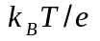, we shall convert the analytical energy also in for comparison. Using Boltzmann constant k_{B} = 1.38 × 10 –23 JK^{–1}, absolute temperature T = 297.33K, elementary charge e_{c} = 1.6 × 10 –19 C, and external dielectric constant 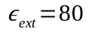, the potential computed from Eqn. 25 comes to be 38.035 , while potential computed from DelPhi is 38.1317 , which shows a relative 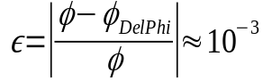showing an excellent agreement to analytical value. Similarly, analytical values of the X- and Y- components of electric field E_{x} and E_{y} at position of A3 (see coordinates in atom-1.pdb) due to system of charges A1 and A2 are –6.613 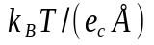 and –0.993 , while values computed from DelPhi are –6.7208 and –1.0031 , respectively, which are also in good agreement to analytical values. All the required
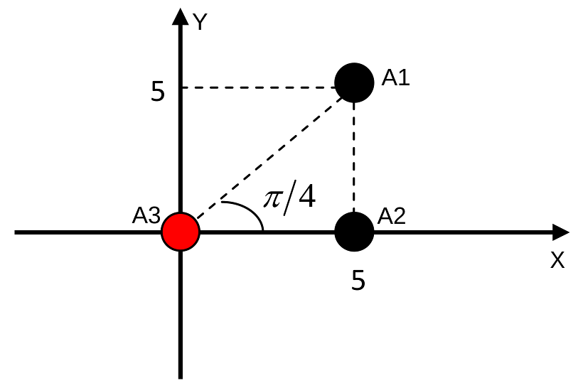
Figure 1: The schematic representation of setup of example systemfor electrostatic potential, energy of interaction and forces between two sets of atoms (A3 due to A1 and A2)
files are provided in the directory Example_3.1.4/

 | 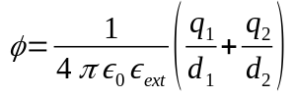 | (1)

We can run DelPhi for this example using command:

$DELPHI_EXE param_frc.prm > delphi_frc.log

The output frc file i.e. atoms.frc contains necessary lines with all the information regarding potential and components of electric field. They can be further used to calculate energy of interaction and force between two atoms. Note that the user can change grid size and scale according to their need.

