(I) Saltation energy of a charged sphere
Here we refer energy of interaction between equilibrated mobile ions and permanent charges of the solute as "saltation energy". In case of a charged sphere one can calculate the energy of interaction between the charged sphere and surrounding ions using Eqn. 5.
 | 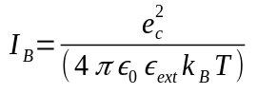 | (1)
 | 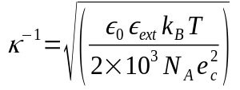 | (2)
 | 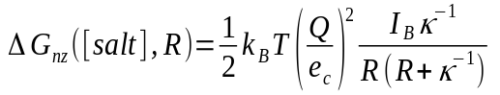 | (3)
 | 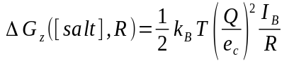 | (4)
 |  | (5)

where I_{B} is Bjerrum length, c is ionic strength in M, k_{B} is Boltzman constant, T is absolute temperature, e_{c} is the electronic charge, κ^{–1} is Debye length, ɛ₀ is the electric permititivity of free space, ɛ_{ext} is the external dielectric constant of the medium, R is the radius of charged sphere, ∆G_{nz} ([salt], R) is electrical energy of charged sphere in solvent with salt, ∆G_{z}(R) is the electrical energy of charged sphere in solvent without salt, ∆∆G_{nz} ([salt]) is the saltation energy of charged sphere. Thus, using the following parameters R=10 Å, internal and external dielectric constants 1 and 80, respectively, and varying salt concentration from 0.02 M until 0.2 M, the analytical and numerical (using DelPhi) solutions are calculated and plotted against logarithm of salt concentration (Figure 1). For example, with salt concentration 0.02 M and external dielectric constant 80 the analytical and numerical (using DelPhi) solutions for the saltation energy of the charged sphere are -2.77 kT and -2.92 kT, respectively.

These calculations are done by using prepared files in the folder Example_3.1.2/Ex1/. To run these examples on your own machine, execute python script Run-saltation-charged-sphere.py as:

python3 Run-saltation-charged-sphere.py

On Running this script, the above mentioned analytical and DelPhi calculations are performed and plot
(plot-salt-ele-sphere.png) and csv(saltation_charged_sphere.csv) file containing results are created. As is shown in the Figure 1, the calculated “saltation energy” is in excellent agreement with the analytical solution.

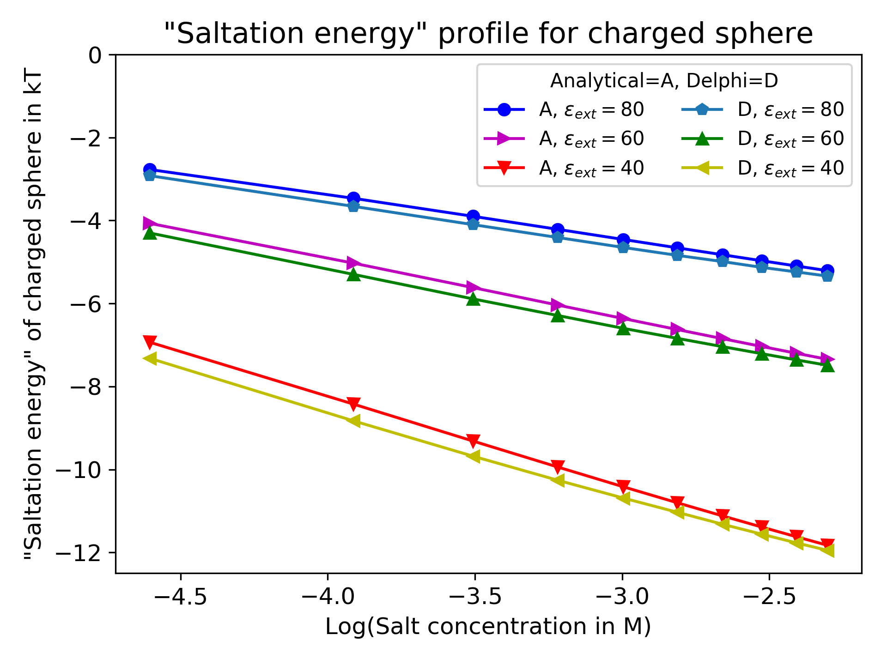Figure 1: Analytical and DelPhi result for the saltation energy of the charged sphere in different salt concentration and different external dielectric constants.

