(II) Saltation energy of a protein
In present case, we will discuss about computing the "saltation energy" of a real protein (barnase-barstar complex; PDB Id: 1BRS). This example is given as Example_3.1.2/Ex2/ in the example suit. As discussed in the previous section, to compute the saltation energy at a given salt concentration, we are required to obtain the total grid energy for the molecular system at non-zero salt concentration and zero salt concentration, followed by taking their difference. Again, in this case we have computed saltation energy for this system at varying salt concentrations from 0.02M until 0.2M in steps of 0.02M and same way for three different external dielectric (80, 60, and 40) mediums. The python script Run-saltation-protein.py provided in the directory creates parameter files for the DelPhi run, executes it and parses results to obtain saltation energy which is then written to file saltation_protein.csv. In addition it also plots saltation energy vs. log([salt]) where [salt] is salt concentration in M.
User may have to define the environment variable $DELPHI_EXE to match the full path of the DelPhi executable file in the shell. This python script can be executed as below:

python3 Run-saltation-protein.py

The results of saltation of barnase-barstar complex is shown in Figure 1.
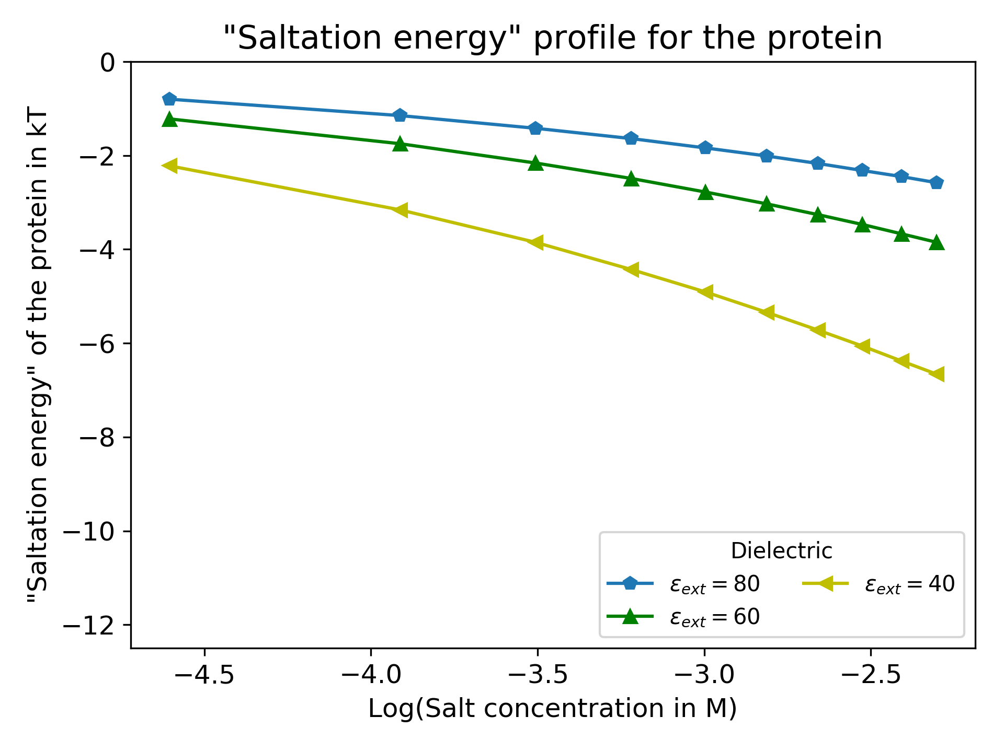Figure 1: The saltation energy computed using DelPhi of the barnase-barstar complex (PDB Id: 1BRS) in different salt concentration and different external dielectric constants

