Calculating Salt dependence of binding energy using traditional 2-dielectric model
Charges of salt ions introduce extra sources of electric field and affect the electrostatic potentials between the molecules. This example is designed to capture this salt dependence of binding energy using traditional 2-dielectric model. The required files for this example are provided in folders Example_3.1.7/ and Example_3.1.7/saltation/. The electrostatic component of binding energy using traditional 2-dielectric approach via difference of grid energies is used. In order to calculate the salt dependence of binding energy we are needed to compute binding energy twice, once at zero salt concentration and second time at desired non-zero salt concentration. The difference of binding energy between non-zero salt case and zero-salt case is the required salt dependence of the binding energy at given salt concentration. However, to find out the relationship between the change in binding energy due to varying salt concentration, here binding energy is calculated at multiple salt concentrations starting from 0.02M to 0.2M in steps of 0.02M and difference from zero-salt binding energy is recorded. The salt dependence of binding energy is plotted against the logarithm of the salt concentration, in addition the linear fit in the two quantities are also performed and coefficients of fit are reported in Figure 1.
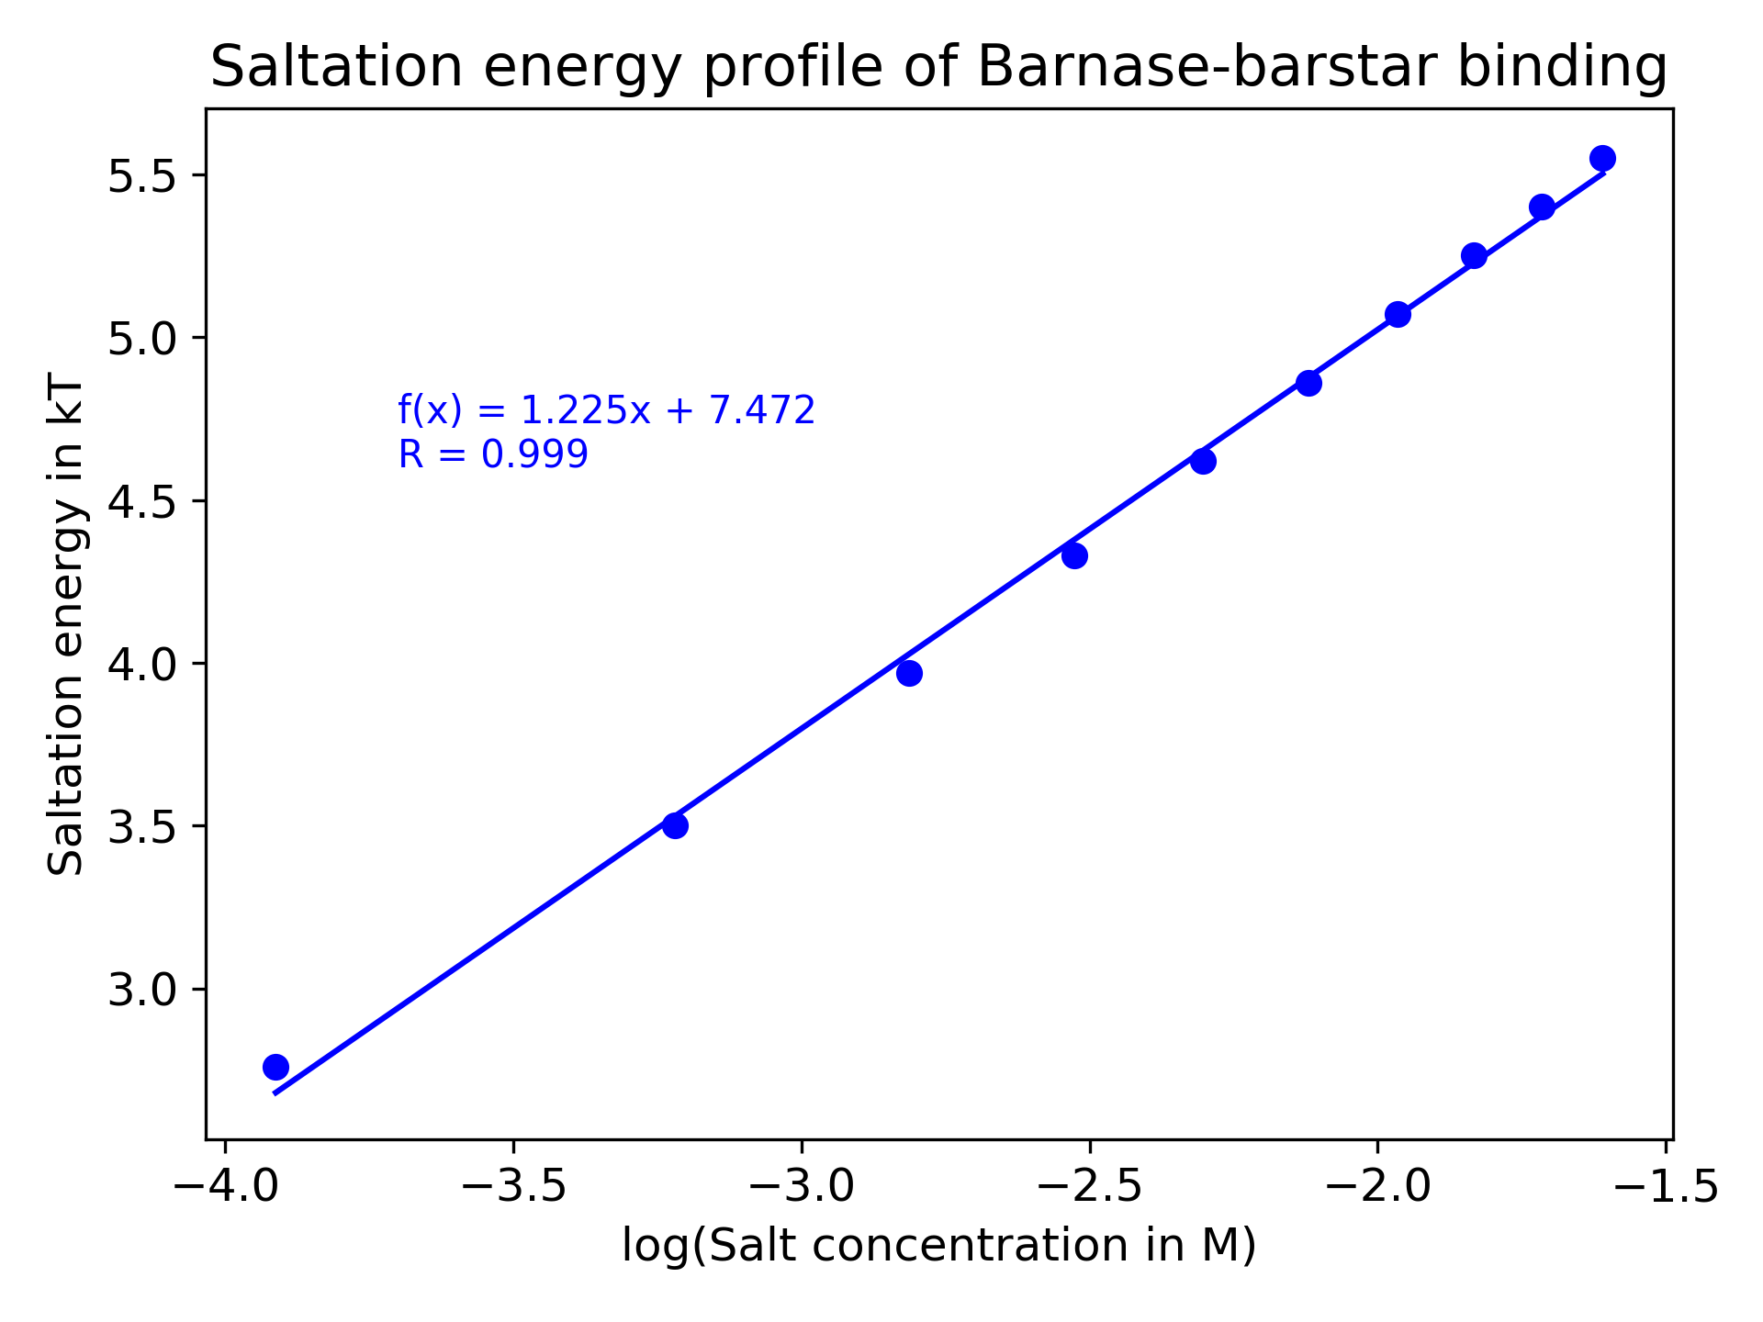
Figure 1: The salt dependence of binding energy of barnase-barstarusing 2-dielectric approach implemented in DelPhi.
Performing these calculations requires three different DelPhi runs for each binding case and there are 11 such cases (1 zero-salt and 10 non-zero salts varying from 0.02 M to 0.2 M in steps of 0.02 M), requiring total 33 DelPhi runs. Therefore, to facilitate running these DelPhi calculations a bash script RUN_DELPHI_SALTATION.sh is provided in the directory Example_3.1.7/saltation/ this script creates parameter files for DelPhi, runs DelPhi and stores log files on the fly. In addition, the bash script also parses relevant energy outputs from the log files for each run to compute salt dependence of binding energy and saves these results in file saltation_using_M1_for_biniding.dat. However, if environment variable DELPHI_EXE is already not set then users are needed to set the absolute path of DelPhi executable file in the environment variable DELPHI_EXE before running it as below:

bash RUN_DELPHI_SALTATION.sh

After successfully running the bash script, the plot can be generated by running python script plot-saltation.py as:

python3 plot-saltation.py

