1 - Getting started

1.1 - Installing g++

1.1.1 - Check if g++ is installed:

The following command returns the g++ version. If not installed, will return 'not found'

$ g++ -v

If not found, go to next topic.

1.1.2 - Installing g++ :

If g++ version was not found, run the following command:

$ sudo apt install g++

Than the following command again and check if it returns the g++ version.

$ g++ -v

1.2 - Creating first C++ program

1.2.1 - Preparing the directories:

The following command will prepare the directories to store our first project and open it on VSCode:

$ cd ~/Desktop
$ mkdir CMakeLearning
$ mkdir CMakeLearning/1st_Module
$ mkdir CmakeLearning/1st_Module/1st_Example CMakeLearning/1st_Module/2nd_Example
$ mkdir CmakeLearning/1st_Module/3rd_Example CMakeLearning/1st_Module/4th_Example
$ mkdir CMakeLearning/1st_Module/5th_Example
$ mkdir CMakeLearning/2nd_Module
$ mkdir CmakeLearning/2nd_Module/1st_Example CMakeLearning/2nd_Module/2nd_Example
$ mkdir CmakeLearning/2nd_Module/3rd_Example
$ mkdir CMakeLearning/3rd_Module
$ mkdir CmakeLearning/3rd_Module/1st_Example CMakeLearning/3rd_Module/2nd_Example
$ mkdir CmakeLearning/3rd_Module/3rd_Example CMakeLearning/3rd_Module/4th_Example
$ mkdir CMakeLearning/4th_Module
$ mkdir CmakeLearning/4th_Module/1st_Example CMakeLearning/4th_Module/2nd_Example
$ mkdir CmakeLearning/4th_Module/3rd_Example CMakeLearning/4th_Module/4th_Example
$ mkdir CmakeLearning/4th_Module/5th_Example CMakeLearning/6th_Module/2nd_Example
$ mkdir CmakeLearning/4th_Module/7th_Example CmakeLearning/4th_Module/8th_Example
$ code ./CMakeLearning

1.2.2 - 1st example - Starting with g++:

Lets create a single electonics calculator. Lets create an empty C++ in the 1st example folder inside 1st module:

$ cd CMakeLearning/1st_Module/1st_Example
$ touch main.cpp

In the main.cpp, lets write the following code:

1  2  3  4  5  6  7  8  9  10  11  12  13  14  15  16  17  18  19  20  21  22 | #include <iostream>  using namespace std;  int main(int argc, char* argv[])  {  double current, voltage, power, resistence;  cout << "What is the resistence in Ohms? " << endl;  cin >> resistence;  cout << "What is the voltage in Volts? " << endl;  cin >> voltage;  current = voltage / resistence;  power = voltage * current;  cout << "Current [A]: " << current << endl;  cout << "Power [W]: " << power << endl;  return 0;  }

Lets generate an executable giving directly the arguments to g++ and run the generated executable.
Lets run the following commands:

$ g++ main.cpp -o electronics_calculator_1_1
$ ./electronics_calculator_1_1

Than we have the following output:

rafael:~/Desktop/CMakeLearning/1st_Module1st_Example$ ./electronics_calculator_1_1
What is the resistence in Ohms?
1000
What is the voltage in Volts?
200
Current [A]: 0.2
Power [W]: 40

1.2.3 - 2nd example:

Lets increase our last code and make it more modular. Lets create an empty C++ file and open the 2nd module directory (you may do it in VSCode terminal) and write the C++ code into it:

$ cd ../2nd_Example
$ touch main.cpp

1  2  3  4  5  6  7  8  9  10  11  12  13  14  15  16  17  18  19  20  21  22  23  24  25  26  27  28  29  30  31  32  33  34 | #include <iostream>  using namespace std;  double Current(double volt, double ohms){  return volt / ohms;  }  double Power(double volt, double ampere){  return volt * ampere;  }  void PrintResult(string variable_name, double value){  cout << variable_name << ": " << value << endl;  }  int main(int argc, char* argv[])  {  double current, voltage, power, resistence;  cout << "What is the resistence in Ohms? " << endl;  cin >> resistence;  cout << "What is the voltage in Volts? " << endl;  cin >> voltage;  current = Current(voltage, resistence);  power = Power(voltage,current);  PrintResult("Current [A]", current);  PrintResult("Power [W]", power);  return 0;  }

$ g++ main.cpp -o electronics_calculator_1_2
$ ./electronics_calculator_1_2

Than we have the following output:

rafael:~/Desktop/CMakeLearning/1st_Module/2nd_Example$./electronics_calculator_1_2
What is the resistence in Ohms?
1000
What is the voltage in Volts?
200
Current [A]: 0.2
Power [W]: 40

1.2.4 - 3rd example:

Lets go one more step ahead and write functions in different files. This increase the modularity capacity of our code. Lets go to 3rd example folder and create the files:

$ cd ../3rd_Example
$ touch main.cpp Current.cpp Power.cpp Print.cpp

Next steps is create the code according to each file. Note that we need to declare the functions identifiers inside main.cpp, If not, the functions calls will not e recognized.

1  2  3  4  5  6  7  8  9  10  11  12  13  14  15  16  17  18  19  20  21  22  23  24  25  26  27  28  29  30  31 | // main.cpp  #include <iostream>  using namespace std;  double Current(double volt, double ohms);  double Power(double volt, double ampere);  void PrintResult(string result_type, double result_value);  int main(int argc, char* argv[])  {  double current, voltage, power, resistence;  cout << "What is the resistence in Ohms? " << endl;  cin >> resistence;  cout << "What is the voltage in Volts? " << endl;  cin >> voltage;  current = Current(voltage, resistence);  power = Power(voltage,current);  PrintResult("Current [A]", current);  PrintResult("Power [W]", power);  return 0;  }

1  2  3  4  5 | // Current.cpp  double Current(double volt, double ohms){  return volt / ohms;  }

1  2  3  4  5 | // Power.cpp  double Power(double volt, double ampere){  return volt * ampere;  }

1  2  3  4  5  6  7 | //Print.cpp  #include <iostream>  void PrintResult(std::string result_type, double result_value){  std::cout << result_type << ": " << result_value << std::endl;  }

We need to say g++ what files are being used, at the following way. So we can run the executable file and the output is shown below.

$ g++ main.cpp Current.cpp Power.cpp Print.cpp -o electronics_calculator_1_3
$ ./electronics_calculator_1_3

Output:

rafael:~/Desktop/CMakeLearning/1st_Module/3rd_Example$./electronics_calculator_1_3
What is the resistence in Ohms?
1000
What is the voltage in Volts?
200
Current [A]: 0.2
Power [W]: 40

1.2.5 - 4th example - Starting with Make tool:

Last topic there was need to declare the functions names inside main.cpp file. This is because the compiler need to know that file is using those functions and they are in some place, so during compiling process it is found. This is not a good practice because if any change are made, other change dependencys may be needed too. Because of this, we declare the funcions names in .h files.
The compiler generates a binary file .o for each .cpp file. So we have main.o, Current.o, Power.o, and Print.o. Without .h files, the compiler can find where each file call each declared function during the link process. When we use .h it is need to attribute them to the correct files and who will do it for us is the tool Make.
Make is a build system, a software that automate the linking process. It is a good tool for small projects. Now we will rewrite our code with .h files and use the Make tool. Lets move to 4th example folder.

$ cd ../4th_Example
$ touch main.cpp Current.cpp Power.cpp Print.cpp Current.h Power.h Print.h

1  2  3 | // Current.h  double Current(double volt, double ohms);

1  2  3  4  5 | // Current.cpp  double Current(double volt, double ohms){  return volt / ohms;  }

1  2  3 | // Power.h  double Power(double volt, double ampere);

1  2  3  4  5 | // Power.cpp  double Power(double volt, double ampere){  return volt * ampere;  }

1  2  3  4  5  6  7 | //Print.h  #include <iostream>  using namespace std;  void PrintResult(string result_type, double result_value);

1  2  3  4  5  6  7 | //Print.cpp  #include <iostream>  void PrintResult(std::string result_type, double result_value){  std::cout << result_type << ": " << result_value << std::endl;  }

1  2  3  4  5  6  7  8  9  10  11  12  13  14  15  16  17  18  19  20  21  22  23  24 | //main.cpp  #include "Current.h"  #include "Power.h"  #include "Print.h"  int main(int argc, char* argv[])  {  double current, voltage, power, resistence;  cout << "What is the resistence in Ohms? " << endl;  cin >> resistence;  cout << "What is the voltage in Volts? " << endl;  cin >> voltage;  current = Current(voltage, resistence);  power = Power(voltage,current);  PrintResult("Current [A]", current);  PrintResult("Power [W]", power);  return 0;  }

Now we need to say to the linker compiler automatization tool (Make) which files each binary file (.o) it deppends. First of all, we need to install it, than create and edit the recipe file (makefile) and run the compilation.

$ sudo apt-install make
$ touch makefile

1  2  3  4  5  6  7  8  9  10  11  12  13  14 | electronics_calculator_1_4: main.o Current.o Power.o Print.o  g++ main.o Current.o Power.o Print.o -o electronics_calculator_1_4  main.o: main.cpp  g++ -c main.cpp  Current.o: Current.cpp  g++ -c Current.cpp  Power.o: Power.cpp  g++ -c Power.cpp  Print.o: Print.cpp  g++ -c Print.cpp

So we run the make command and we will have the following output:

$ make

Output:

rafael:~/Desktop/CMakeLearning/1st_Module/4th_Example$./electronics_calculator_1_4
What is the resistence in Ohms?
1000
What is the voltage in Volts?
200
Current [A]: 0.2
Power [W]: 40

1.2.6 - 5th example - make tool and multiple folders and files:

Now we will try our last development scenario using Make tool. All of this were showed to understand the linking process and demonstrate how bigger projects need an andvanced tool for compile process.
Here we gonna split our projects in folders and rewrite al the files acording to the needed changes.

$ cd ../5th_Example
$ mkdir obj inc src
$ cd src
$ touch main.cpp Current.cpp Power.cpp Print.cpp
$ cd ../inc
$ touch Current.h Power.h Print.h
$ cd ..
$ makefile

The following code shows the new file configurations. In fact, only main.cpp includes has changes:

1  2  3 | // Current.h  double Current(double volt, double ohms);

1  2  3  4  5 | // Current.cpp  double Current(double volt, double ohms){  return volt / ohms;  }

1  2  3 | // Power.h  double Power(double volt, double ampere);

1  2  3  4  5 | // Power.cpp  double Power(double volt, double ampere){  return volt * ampere;  }

1  2  3  4  5  6  7 | //Print.h  #include <iostream>  using namespace std;  void PrintResult(string result_type, double result_value);

1  2  3  4  5  6  7 | //Print.cpp  #include <iostream>  void PrintResult(std::string result_type, double result_value){  std::cout << result_type << ": " << result_value << std::endl;  }

1  2  3  4  5  6  7  8  9  10  11  12  13  14  15  16  17  18  19  20  21  22  23  24 | //main.cpp  #include "../inc/Current.h"  #include "../inc/Power.h"  #include "../inc/Print.h"  int main(int argc, char* argv[])  {  double current, voltage, power, resistence;  cout << "What is the resistence in Ohms? " << endl;  cin >> resistence;  cout << "What is the voltage in Volts? " << endl;  cin >> voltage;  current = Current(voltage, resistence);  power = Power(voltage,current);  PrintResult("Current [A]", current);  PrintResult("Power [W]", power);  return 0;  }

The following makefile shows how we describe each file path configuration for linker process. Note if we type de command make clear the executable will be erased.

1  2  3  4  5  6  7  8  9  10  11  12  13  14  15  16  17 | electronics_calculator_1_5: main.o Current.o Power.o Print.o  g++ obj/main.o obj/Current.o obj/Power.o obj/Print.o -o electronics_calculator_1_5  main.o: src/main.cpp  g++ -c src/main.cpp -o obj/main.o  Current.o: src/Current.cpp  g++ -c src/Current.cpp -o obj/Current.o  Power.o: src/Power.cpp  g++ -c src/Power.cpp -o obj/Power.o  Print.o: src/Print.cpp  g++ -c src/Print.cpp -o obj/Print.o  clear:  rm -rf electronics_calculator_1_5

Output:

rafael:~/Desktop/CMakeLearning/1st_Module/5th_Example$./electronics_calculator_1_5
What is the resistence in Ohms?
1000
What is the voltage in Volts?
200
Current [A]: 0.2
Power [W]: 40

2 - Getting started with CMake

2.1 - Installing CMake

2.1.1 - Check if CMake is installed:

The following command returns the CMake version. If not installed, will return 'not found'

$ cmake --version

If not found, go to next step:

2.1.2 - Installing CMake:

If g++ version was not found, run the following command:

$ sudo apt install cmake

Than the following command again and check if it returns the CMake version.

$ cmake --version

2.2 – Before project using CMake

The first need to know are informations about the following topics:

- File CMakeLists.txt
This is a mandatory file in the project top level folder. Will keep all information of compilation.

- Directory to store the generated build files (normally called build).
This directory will store all the CMake files and is a good practice keep it in the top level of the
project.

Thiese topics are in the example of the next topic.

2.3 – CMake examples

2.3.1 – 1st Example: Preparing and understand the environment

We gonna create the files with the already knew functions and run the following command inside build folder: cmake .. that initializes automatically all the configurations of CMake tool. The double dots argument say that our CmalkeLists.txt file is in the parent folder Notice that we are not compiling the program here, only preparing the environment.

1  2  3 | // Current.h  double Current(double volt, double ohms);

1  2  3  4  5 | // Current.cpp  double Current(double volt, double ohms){  return volt / ohms;  }

1  2  3 | // Power.h  double Power(double volt, double ampere);

1  2  3  4  5 | // Power.cpp  double Power(double volt, double ampere){  return volt * ampere;  }

1  2  3  4  5  6  7 | //Print.h  #include <iostream>  using namespace std;  void PrintResult(string result_type, double result_value);

1  2  3  4  5  6  7 | //Print.cpp  #include <iostream>  void PrintResult(std::string result_type, double result_value){  std::cout << result_type << ": " << result_value << std::endl;  }

1  2  3  4  5  6  7  8  9  10  11  12  13  14  15  16  17  18  19  20  21  22  23  24 | //main.cpp  #include "Current.h"  #include "Power.h"  #include "Print.h"  int main(int argc, char* argv[])  {  double current, voltage, power, resistence;  cout << "What is the resistence in Ohms? " << endl;  cin >> resistence;  cout << "What is the voltage in Volts? " << endl;  cin >> voltage;  current = Current(voltage, resistence);  power = Power(voltage,current);  PrintResult("Current [A]", current);  PrintResult("Power [W]", power);  return 0;  }

$ cd ../../2nd_Module/1st_Example
$ mkdir build
$ touch CmakeLists.txt
$ touch main.cpp Current.cpp Power.cpp Print.cpp
$ touch Current.h Power.h Print.h
$ cd build
$ cmake ..

If we go through build folder befor cmake .. command, we will se the following fodlers:

$ ls -la build/
drwxrwxr-x 3 rafael rafael 4096 jun 20 00:27 .
drwxrwxr-x 3 rafael rafael 4096 jun 20 00:27 ..
-rw-rw-r-- 1 rafael rafael 13959 jun 20 00:27 CMakeCache.txt
drwxrwxr-x 4 rafael rafael 4096 jun 20 00:27 CMakeFiles
-rw-rw-r-- 1 rafael rafael 1704 jun 20 00:27 cmake_install.cmake
-rw-rw-r-- 1 rafael rafael 4228 jun 20 00:27 Makefile

Makefile is used by make tool to build the project and CMakeCache.txt store all variables and important stuffs for next steps of build.
As our CMakeLists.txt file is empty, nothing is compiled and no one executable file is generated.

2.3.2 – 2nd Example: Generating the First Executable using CMake

On this example, we gonna generate our first executable using CMake tool. First of all we will copy all the files from the last example to this example repository and erase all build folder files. If you have any doubt about .cpp and .h project files content, check it out in the last topic.

$ cp -r ../* ../../2nd_Example/
$ cd ../../2nd_Module/2nd_Example/build
$ rm -rf *

Now lets edit our CMakeLists.txt file, and lets run cmake .. and make commands to generate our executable. Then lets execute it and see the output (all these steps are shown below):

1  2  3  4  5  6  7  8  9  10  11  12  13 | # Specify the minimum CMake version installed to run this project  cmake_minimum_required(VERSION 3.16.3)  # Creates the project named Electronics_Calculator without version especification  project(Electronics_Calculator)  # Creates the executable electronics_calculator_2_2 using the listed files  add_executable(electronics_calculator_2_2  main.cpp  Current.cpp  Power.cpp  Print.cpp  )

$ cmake ..
$ make
$ ./electronics_calculator_2_2

Output:

rafael:~/Desktop/CMakeLearning/2nd_Module/5th_Example$./electronics_calculator_2_2
What is the resistence in Ohms?
1000
What is the voltage in Volts?
200
Current [A]: 0.2
Power [W]: 40

Although it works fine, there is no sense of hierarchy here. In big projects this could be a problem. The solution will me shown in the next example, where we will create the first library.

2.3.2 – 2nd Example: Generating the First Library using CMake

If we are working in a big project, the solution of last example could not be the best practice because of the no sense of hierarchy. This is solved creating libraries. As we can see, the main.cpp depends of Power.cpp, Current.cpp and Print.cpp.
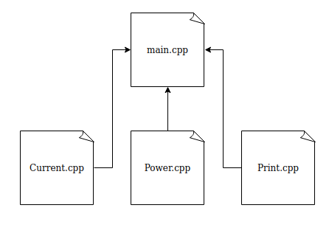

Next step it will be created two libraries according to their functionality: OhmsLaw and PrintOnScreen. This make our project more portable because we can use these libraries in other projects. The following commands copy the files from 2nd Example (check in 2.3.1 topic their content).

$ cp -r ../* ../../3rd_Example/
$ cd ../../2nd_Module/3rd_Example/build
$ rm -rf *

The following code creates the libraries and link them to the executable. Running cmake .. and make commands will generate the output as we can see below:

1  2  3  4  5  6  7  8  9  10  11  12  13  14  15  16  17  18  19  20  21  22  23  24  25  26  27 | # Specify the minimum CMake version installed to run this project  cmake_minimum_required(VERSION 3.16.3)  # Creates the project named Electronics_Calculator without version especification  project(Electronics_Calculator)  # Creates library with ohms law calculator purpose  add_library(OhmsLaw  Current.cpp  Power.cpp  )  # Creates library with Printing purpose  add_library(PrintOnScreen  Print.cpp  )  # Creates the executable electronics_calculator_2_3 using the listed files  add_executable(electronics_calculator_2_3  main.cpp  )  # Link the executable to the created libraries  target_link_libraries(electronics_calculator_2_3  OhmsLaw  PrintOnScreen  )

Output:

rafael:~/Desktop/CMakeLearning/2nd_Module/5th_Example$./electronics_calculator_2_3
What is the resistence in Ohms?
1000
What is the voltage in Volts?
200
Current [A]: 0.2
Power [W]: 40

The libraries are generated and saved on build folder. We can create more than 1 target if the dependencies are kept.

3 – Managing projects files and folders

3.1 - Managing the project repository

When the work project is too big (most of real and profissional cases) it does not make sense storage all the files in the same folder. At this sectioon will be displayed a good directory practice for the Electronics Calculator project. Of course each project is unique. Smaller or specific projects could have diferent aproaches.

3.1.1 - 1st Example - Managing directories - .cpp files

First of all lets understand the best way of source files managment. The next picture show an idea of a good practice directory organization for the Electronics Calculator project.

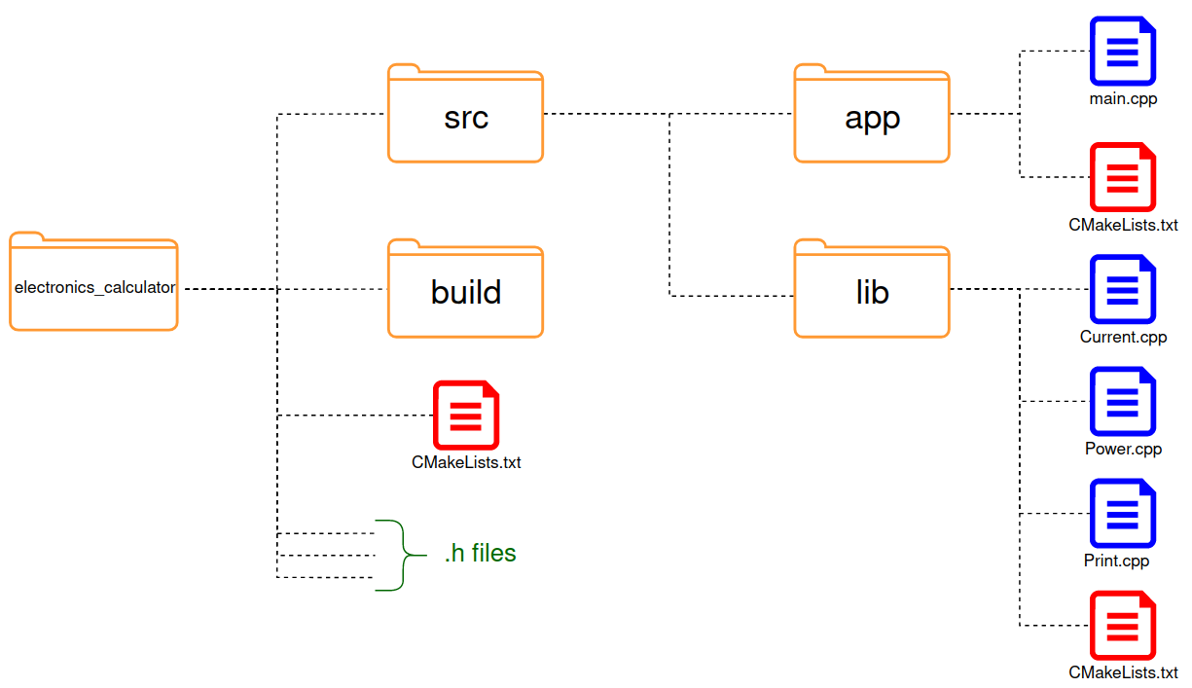
In the CMakeLists.txt of root level, it is used the CMake command include_subdirectory(). It is responsable to include the CMakeLists.txt files from app and lib folders in the root CMakeLists.txt. At this way, all code writed in the low level files will be read by top level file. You will notice that way, if a change is needed only the relative files and folders will be changed as the targets files (executable or librarys) will be generated in your relative output folder. The whole project is shown below:

$ cd ../../3rd_Module/1st_Example/
$ cp ../../2nd_Module/3rd_Example/* .
$ mkdir build
$ mkdir src
$ mkdir src/app src/lib
$ touch src/lib/CMakeLists.txt
$ touch src/app/CMakeLists.txt
$ mv Current.cpp Power.cpp Print.cpp src/lib/
$ mv main.cpp src/app/
$ cd build

1  2  3 | // Current.h  double Current(double volt, double ohms);

1  2  3 | // Power.h  double Power(double volt, double ampere);

1  2  3  4  5  6  7 | // Print.h  #include <iostream>  using namespace std;  void PrintResult(string result_type, double result_value);

1  2  3  4  5  6  7  8  9  10  11  12  13  14  15  16  17  18  19 | # CMakeLists.txt (root)  cmake_minimum_required(VERSION 3.16.3)  # Creates a project Named Calculator_Project with 1.0.0 version  project(Electronics_Calculator VERSION 3.1.0)  # CMake should go to these directories and find another CMakeLists.txt  add_subdirectory(src/lib)  # CMake should go to these directories and find another CMakeLists.txt  add_subdirectory(src/app)  # Links the executable calculator ( defined at add_executable()  target_link_libraries(  electronics_calculator_3_1  OhmsLaw  PrintOnScreen  )

1  2  3  4  5 | // Current.cpp  double Current(double volt, double ohms){  return volt / ohms;  }

1  2  3  4  5 | // Power.cpp  double Power(double volt, double ampere){  return volt * ampere;  }

1  2  3  4  5  6  7 | // Print.cpp  #include <iostream>  void PrintResult(std::string result_type, double result_value){  std::cout << result_type << ": " << result_value << std::endl;  }

1  2  3  4  5  6  7  8  9  10  11  12 | # CMakeLists.txt (lib)  # Creates a library with Ohms Law functions named OhmsLaw  add_library(OhmsLaw  Current.cpp  Power.cpp  )  # Creates a library with print functions named Print  add_library(PrintOnScreen  Print.cpp  )

1  2  3  4  5  6  7  8  9  10  11  12  13  14  15  16  17  18  19  20  21  22 | #include "../../Current.h"  #include "../../Power.h"  #include "../../Print.h"  int main(int argc, char* argv[])  {  double current, voltage, power, resistence;  cout << "What is the resistence in Ohms? " << endl;  cin >> resistence;  cout << "What is the voltage in Volts? " << endl;  cin >> voltage;  current = Current(voltage, resistence);  power = Power(voltage,current);  PrintResult("Current [A]", current);  PrintResult("Power [W]", power);  return 0;  }

1  2  3  4  5  6  7  8  9  10  11  12 | # CMakeLists.txt (app)  # Creates the executable electronics_calculator_2_3 using the listed files  add_executable(electronics_calculator_3_1  main.cpp  )  # Link the executable to the created libraries  target_link_libraries(electronics_calculator_3_1  OhmsLaw  PrintOnScreen  )
Note: as the add_executable() to our executable target (electronics_calculator_3_1) is inside a subfolder, the executable will be generated there, but you can choose the local where the executable file will be generated by using the following function. Here, we are saying to generate at build top level folder.

set_target_properties(
electronics_calculator_3_1
PROPERTIES RUNTIME_OUTPUT_DIRECTORY ${CMAKE_BINARY_DIR}
)

Because of it, to run the executable we need to execute directly in the app folder output (after rum cmake ..).

$ cmake ..
$ make
$ ./src/app/electronics_calculator_3_1

Output:

rafael:~/Desktop/CMakeLearning/3rd_Module/1st_Example$./electronics_calculator_3_1
What is the resistence in Ohms?
1000
What is the voltage in Volts?
200
Current [A]: 0.2
Power [W]: 40

3.1.2 - 2nd Example - Managing directories - .h files

You might want to know about the header files (.h). Of course they need to be kept inside a logical folder according to the whole project. This make the maintence easier. Here is the project of 1st example refreshed w.h files in the new folders:

$ cd ../../2nd_Example/
$ cp -r ../1st_Example/* .
$ rm -rf build/ *
$ mkdir inc
$ mkdir inc/app inc/lib

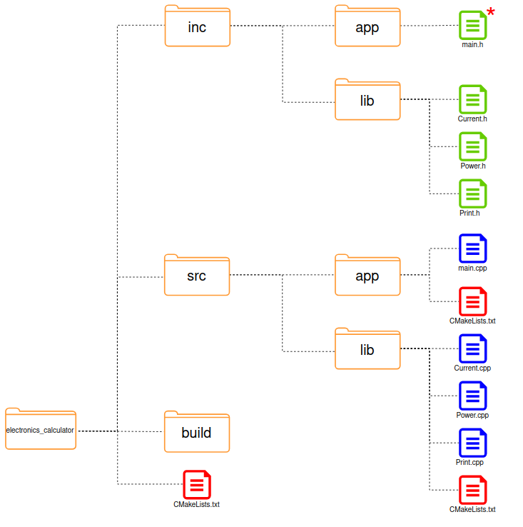
* main.h is not applicable here but it was kept in the picture for best understanding purpose.

Another good practice is include the declaration of header files inside their program file (for exemple: Current.cpp includes Curent.h) using #include directive. This inclusion avoid any different kinds of inconsistences during function calls and declarations só it will be done in this example, as we can see bellow:

TODO: Insert codes

3.1.3 - 3rd Example - Managing directories – CMake take care of .h path files

If .cpp and .h files of a process are both in the same file, CMake will easly find it during the build process, else, if the #include directive does not point the exact .h path file, the process will return an error (as in the last example).
This diffuses the development because in case of any directory change, it requires all #includes directives refresh. It is possible CMake take care of the process of path pointing using:

target_include_directories(<target> <scope> <dir1> <dir2. ...)

<target> : the library or executable that will use the directory
<scope>: PRIVATE: directory will be visible only in the folder of the target
INTERFACE: directory will be visible only in the folder of the target
PUBLIC: directory will be visible only in the folder of the target
<dirn>: Directory that will be setted in the target property.

The directive target_include_directory() sets the following given target property: INTERFACE_INCLUDE_DIRECTORIES, so any dependent file of this target will inherit the value of this property. This is the reason that in the following example, we may include the libraries .h files without insert the target_include_directory() in the root CMakeLists.txt. Once uppon a time the target electronics_calculator_3_3 is inherting the INTERFACE_INCLUDE_DIRECTORIES from it dependencies (OhmsLaw and PrintOnScreen) through the directive target_link_libraries().

$ cd ../../3rd_Example/
$ cp -r ../2nd_Example/* .
$ rm -rf build/ *

1  2  3 | // Current.h  double Current(double volt, double ohms);

1  2  3 | // Power.h  double Power(double volt, double ampere);

1  2  3  4  5  6  7 | //Print.h  #include <iostream>  using namespace std;  void PrintResult(string result_type, double result_value);
1  2  3  4  5  6  7  8  9  10  11  12  13  14  15  16  17  18  19  20  21  22 | #include "lib/Current.h"  #include "lib/Power.h"  #include "lib/Print.h"  int main(int argc, char* argv[])  {  double current, voltage, power, resistence;  cout << "What is the resistence in Ohms? " << endl;  cin >> resistence;  cout << "What is the voltage in Volts? " << endl;  cin >> voltage;  current = Current(voltage, resistence);  power = Power(voltage,current);  PrintResult("Current [A]", current);  PrintResult("Power [W]", power);  return 0;  }

1  2  3  4  5  6  7  8  9  10  11  12 | # CMakeLists.txt (app)  # Creates the executable electronics_calculator_3_2 using the listed files  add_executable(electronics_calculator_3_3  main.cpp  )  # Link the executable to the created libraries  target_link_libraries(electronics_calculator_3_3  OhmsLaw  PrintOnScreen  )

1  2  3  4  5  6  7 | // Current.cpp  #include "lib/Current.h"  double Current(double volt, double ohms){  return volt / ohms;  }

1  2  3  4  5  6  7 | // Power.cpp  #include "lib/Power.h"  double Power(double volt, double ampere){  return volt * ampere;  }

1  2  3  4  5  6  7 | //Print.cpp  #include "lib/Print.h"  void PrintResult(std::string result_type, double result_value){  std::cout << result_type << ": " << result_value << std::endl;  }

1  2  3  4  5  6  7  8  9  10  11  12  13  14  15 | # CMakeLists.txt (lib)  # Creates a library with Ohms Law functions named OhmsLaw  add_library(OhmsLaw  Current.cpp  Power.cpp  )  # Creates a library with print functions named Print  add_library(PrintOnScreen  Print.cpp  )  target_include_directories(OhmsLaw PUBLIC ../../inc)  target_include_directories(PrintOnScreen PUBLIC ../../inc)

1  2  3  4  5  6  7  8  9  10  11  12  13  14  15  16  17  18  19 | # CMakeLists.txt (root)  cmake_minimum_required(VERSION 3.16.3)  # Creates a project Named Calculator_Project with 1.0.0 version  project(Electronics_Calculator VERSION 3.3.0)  # CMake should go to these directories and find another CMakeLists.txt  add_subdirectory(src/lib)  # CMake should go to these directories and find another CMakeLists.txt  add_subdirectory(src/app)  # Links the executable electronics_calculator_3_3 ( defined at add_executable()  target_link_libraries(  electronics_calculator_3_3  OhmsLaw  PrintOnScreen  )

3.1.4 - 4th Example - Another aproach of progect manegment

Instead of sort de folders by includes and source files, we may do it by app vs libs apps. This allow us to have each library with its specific file. All the code is shown bellow after all commands for directory configuration:

$ cd ../../4th_Example/
$ mkdir build app app/inc app/src lib lib/PrintOnScreen lib/PrintOnScreen/inc
$ mkdir lib/PrintOnScreen/src lib/OhmsLaw lib/OhmsLaw/inc lib/OhmsLaw/src
$ cp ../3rd_Example/inc/lib/Print.h lib/PrintOnScreen/inc/
$ cp ../3rd_Example/inc/lib/Current.h lib/OhmsLaw/inc/
$ cp ../3rd_Example/inc/lib/Power.h lib/OhmsLaw/inc/
$ cp ../3rd_Example/src/lib/Print.cpp lib/PrintOnScreen/src/
$ cp ../3rd_Example/src/lib/Current.cpp lib/OhmsLaw/src/
$ cp ../3rd_Example/src/lib/Power.cpp lib/OhmsLaw/src/
$ cp ../3rd_Example/src/app/main.cpp app/src
$ touch CMakeLists.txt lib/OhmsLaw/src/CMakeLists.txt
$ touch lib/PrintOnScreen/src/CMakeLists.txt touch app/src/CMakeLists.txt
$ touch app/inc/main.h

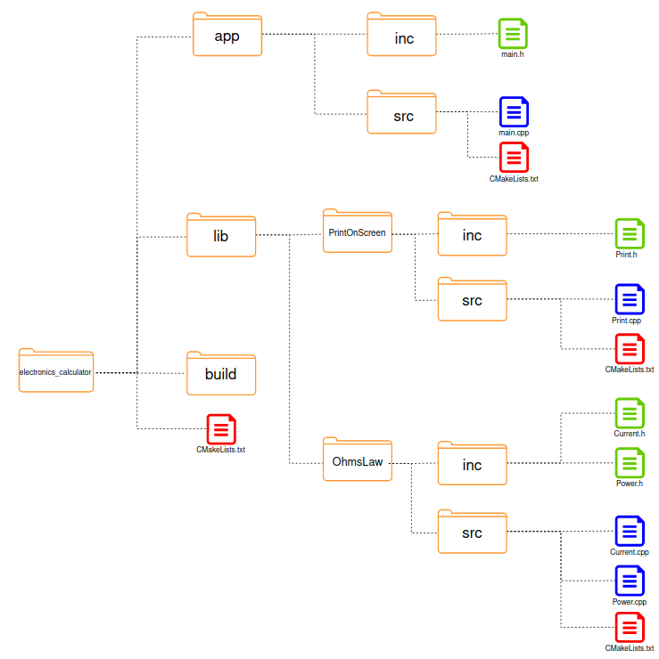
1  2  3  4  5 | // main.h  #include "Current.h"  #include "Power.h"  #include "Print.h"

1  2  3  4  5  6  7  8  9  10  11  12  13  14  15  16  17  18  19  20  21 | // main.cpp  #include "main.h"  int main(int argc, char* argv[])  {  double current, voltage, power, resistence;  cout << "What is the resistence in Ohms? " << endl;  cin >> resistence;  cout << "What is the voltage in Volts? " << endl;  cin >> voltage;  current = Current(voltage, resistence);  power = Power(voltage,current);  PrintResult("Current [A]", current);  PrintResult("Power [W]", power);  return 0;  }

1  2  3  4  5  6  7  8  9  10 | # CMakeLists.txt (app)  # Creates the executable electronics_calculator_3_4 that uses main.cpp file  add_executable(  electronics_calculator_3_4  main.cpp  )  # Set app/include as private because only will be used here  target_include_directories(electronics_calculator_3_4 PRIVATE ../inc)

1  2  3 | // Current.h  double Current(double volt, double ohms);

1  2  3  4  5  6  7 | // Current.cpp  #include "Current.h"  double Current(double volt, double ohms){  return volt / ohms;  }

1  2  3 | // Power.h  double Power(double volt, double ampere);

1  2  3  4  5  6  7 | // Power.cpp  #include "Power.h"  double Power(double volt, double ampere){  return volt * ampere;  }

1  2  3  4  5  6  7  8  9  10 | # CMakeLists.txt (OhmsLaw)  # Creates a library with Ohms Law functions named OhmsLaw  add_library(OhmsLaw  Current.cpp  Power.cpp  )  # Set lib/OhmsLaw/inc as PUBLIC because will be used here and in the main.cpp  target_include_directories(OhmsLaw PUBLIC ../inc)

1  2  3  4  5  6  7 | //Print.h  #include <iostream>  using namespace std;  void PrintResult(string result_type, double result_value);

1  2  3  4  5  6  7 | //Print.cpp  #include "Print.h"  void PrintResult(std::string result_type, double result_value){  std::cout << result_type << ": " << result_value << std::endl;  }
1  2  3  4  5  6  7  8  9 | # CMakeLists.txt (PrintOnScreen)  # Creates a library with print functions named Print  add_library(PrintOnScreen  Print.cpp  )  # Set lib/PrintOnScreen/inc as PUBLIC because will be used here and in the main.cpp  target_include_directories(PrintOnScreen PUBLIC ../inc)

1  2  3  4  5  6  7  8  9  10  11  12  13  14  15  16  17  18  19 | # CMakeLists.txt (root)  cmake_minimum_required(VERSION 3.16.3)  # Creates a project Named Calculator_Project with 1.0.0 version  project(Electronics_Calculator VERSION 3.4.0)  # CMake should go to these directories and find another CMakeLists.txt  add_subdirectory(app/src)  add_subdirectory(lib/OhmsLaw/src)  add_subdirectory(lib/PrintOnScreen/src)  # Links the executable electronics_calculator_3_4 ( defined at add_executable() )  # to OhmsLaw and PrintOnScreen libraries  target_link_libraries(  electronics_calculator_3_4  OhmsLaw  PrintOnScreen  )

$ cd build
$ cmake ..
$ make
$ ,/app/src/electronics_calculator_3_4

Output:

rafael:~/Desktop/CMakeLearning/3rd_Module/4th_Example$./electronics_calculator_3_4
What is the resistence in Ohms?
1000
What is the voltage in Volts?
200
Current [A]: 0.2
Power [W]: 40

4 Data manipulation

4.1.1 - 1st Example - Running CMake in script mode using cmake -P

The script command run the CMakeLists.txt withou generate any build file. At this way, if any build function is used inside CMakeLists.txt, the cmake -P <fileName> will return an error.

$ cd ../../../4th_Module/1st_Example
$ touch CMakeLists.txt lib/OhmsLaw/src/CMakeListsNG.txt
$ touch CMakeLists.txt lib/OhmsLaw/src/CMakeListsOK.txt

1  2  3  4  5 | # CMakeListsNG.txt  cmake_minimum_required(VERSION 3.16.3)  project(PojectName VERSION 4.1.0)

1  2  3 | # CMakeListsOK.txt  cmake_minimum_required(VERSION 3.16.3)

Then run:

$ cmake -P CMakeListsNG.txt

Output:

rafael:~/Desktop/CMakeLearning/4th_Module/1st_Example$ cmake -P CMakeListsNG.txt
CMake Error at CMakeLists.txt:4 (project):
project command is not scriptable

Then run:

$ cmake -P CMakeListsOK.txt

Output:

rafael:~/Desktop/CMakeLearning/4th_Module/1st_Example$ cmake -P CMakeListsOK.txt
rafael:~/Desktop/CMakeLearning/4th_Module/1st_Example$

4.1.2 - 2nd Example - Running CMake in script mode using an easier way

- Inside the CMakeLists.txt file, run the command which cmake in the terminal (it will give the location of the cmake executable - my case: /usr/bin/cmake);

- Open the CMakeListsFile and past the following command: #!/usr/bin/cmake -P

- Give the execution permission to the CMakeLists.txt file running the following command: chmod +x CMakeLists.txt

- Now you can either use ./CMakeLists.txt or cmake -P CMakeLists.txt to run the CMakeLists.txt file in the script mode.

$ cd ../2nd_Example
$ touch CMakeLists.txt

1  2  3 | #!/usr/bin/cmake -P  cmake_minimum_required(VERSION 3.16.3)

$ cmake -P CMakeLists.txt

Output:

rafael:~/Desktop/CMakeLearning/4th_Module/2nd_Example$ cmake -P CMakeLists.txt
rafael:~/Desktop/CMakeLearning/4th_Module/1st_Example$

Or run:

$ ./CMakeLists.txt

Output:

rafael:~/Desktop/CMakeLearning/4th_Module/2nd_Example$ ./CMakeLists.txt
rafael:~/Desktop/CMakeLearning/4th_Module/2nd_Example$

4.2 - 3rd Example - Printing messages on the terminal

The message() command it is used to print messages on the terminal. As we can see bellow, this command expects a mode of display (STATUS, DEBUG, WARNING or FATAL_ERROR - check all types here). In this example you will see some example messages:

$ cd ../3rd_Example
$ touch CMakeLists.txt

1  2  3  4  5  6  7  8  9 | cmake_minimum_required(VERSION 3.16.3)  message("Hello world from 0 Rafael Del Pino")  message(STATUS "Hello world 1 from Rafael Del Pino")  message(WARNING "Hello world 2 from Rafael Del Pino")  message(VERBOSE "Hello world 3 from Rafael Del Pino")  message(SEND_ERROR "Hello world 4 from Rafael Del Pino")  message(FATAL_ERROR "Hello world 5 from Rafael Del Pino")  message("This will not be printed!")

Run:

$ cmake -P CMakeLists.txt

Output:

rafael:~/Desktop/CMakeLearning/4th_Module/3rd_Example$ ./CMakeLists.txt
Hello world from 0 Rafael Del Pino
-- Hello world 1 from Rafael Del Pino
CMake Warning at CMakeLists.txt:7 (message):
Hello world 2 from Rafael Del Pino

CMake Error at CMakeLists.txt:9 (message):
Hello world 4 from Rafael Del Pino

CMake Error at CMakeLists.txt:10 (message):
Hello world 5 from Rafael Del Pino

4.4 - 4th Example - Variables and print variables on terminal

The following command is used to create and set a variable value. Each field is defined in the set() function bellow:

set(<variable_name> <variable_value>)

All CMake variables are of string type and for use them you need to access it by using the following way: ${variable_name}. When using set() function, there are two possobilities of initialization:

# NAME is a string with "Rafael Del Pino" value
set (NAME "Rafael Del Pino")

# NAME is a list with [Rafael][Del][Pino] string items
set (NAME Rafael Del Pino)

A CMake list is a semicolon (;) separated items. A string may be considered a list of one unique item of string type. Lists can be operated using list() command and strings may be operated using string() command. The following example will show a single variable utilization application:

$ cd ../3rd_Example
$ touch CMakeLists.txt

1  2  3  4  5  6  7  8  9  10  11  12  13 | cmake_minimum_required(VERSION 3.16.3)  set (NAME Rafael)  set (OCCUPATION Engineer)  message ("My name is ${NAME} and I am an ${OCCUPATION}")  # NAME is a string: "Rafael Del Pino" value  set (NAME "Rafael Del Pino")  message ("My name is ${NAME} and I am an ${OCCUPATION}")  # NAME is a list: [Rafael][Del][Pino] string items  set (NAME Rafael Del Pino)  message ("My name is ${NAME} and I am an ${OCCUPATION}")

Run:

$ cmake -P CMakeLists.txt

Output:

rafael:~/Desktop/CMakeLearning/4th_Module/4th_Example$ cmake -P CMakeLists.txt
My name is Rafael and I am an Engineer
My name is Rafael Del Pino and I am an Engineer
My name is Rafael;Del;Pino and I am an Engineer

4.5 - 4th Example - Different ways to use variables

The most common variable usage: set a variable and print it on screen:

set (NAME Rafael)
message (${NAME})

As we know, variables are list of strings, so we can use the value of variable to reference the name of a seccond one, and print it:

1  2  3  4  5 | set (NAME Rafael)  set (Rafael Pino)  message (${NAME}) # Print Rafael  message (${${NAME}}) # Print Pino

This also works:

1  2  3  4  5 | set (NAME "Rafael")  set (Rafael Pino)  message (${NAME}) # Print Rafael  message (${${NAME}}) # Print Pino

It is possible concatenate variable names and get its value, as shown bellow:

1  2  3  4  5  6 | set (NAME Rafael)  set (Rafael Pino)  set (NAMERafaelPino FullName)  # Print value of value inside NAME+${NAME}+${${NAME}} (same as ${NAMERafaelPino} )  message (${NAME${NAME}${${NAME}}})

A full usage variable example was made to best understand:

$ cd ../4th_Example
$ touch CMakeLists.txt

1  2  3  4  5  6  7  8  9  10  11  12  13  14  15  16  17  18  19  20  21  22  23  24  25  26 | cmake_minimum_required(VERSION 3.16.3)  message ("1st demonstration:") # Print demonstration ID  set (NAME Rafael) # Set Variable NAME with value Rafael  message (${NAME}) # Print value inside NAME  message ("")  message ("2nd demonstration:") # Print demonstration ID  set (NAME "Rafael") # Set Variable NAME with value Rafael  set (Rafael Pino) # Set Variable Rafael with value Pino  message (${NAME}) # Print value inside NAME  message (${${NAME}}) # Print value of value inside NAME (same as ${Rafael} )  message (NAME ${NAME} ${${NAME}}) # Print a list of string values  message (NAME${NAME}${${NAME}}) # Print a list of string values  message ("NAME ${NAME} ${${NAME}}") # Print one string with values  message ("")  message ("3rd demonstration:") # Print demonstration ID  set (NAME Rafael) # Set Variable NAME with value Rafael  set (Rafael Pino) # Set Variable Rafael with value Pino  set (NAMERafaelPino FullName) # Set Variable NAMERafaelPino with value FullName  # Print value of value inside NAME+${NAME}+${${NAME}} (same as ${NAMERafaelPino} )  message (${NAME${NAME}${${NAME}}})

Run:

$ cmake -P CMakeLists.txt

Output:

rafael:~/Desktop/CMakeLearning/4th_Module/4th_Example$ cmake -P CMakeLists.txt
1st demonstration:
Rafael

2nd demonstration:
Rafael
Pino
NAMERafaelPino
NAMERafaelPino
NAME Rafael Pino

3rd demonstration:
FullName

4.6.1 - 5th Example - Lists declaration

There are different ways of initialize a variable (as we know, variable is a list of strings). All of the above codes will output the same result (all of them are VARIABLE list). The code is sotred on 5th_Example folder CMakeLists.txt file:

$ cd ../5th_Example
$ touch CMakeLists.txt

1  2  3 | set (VARIABLE_1 11 22 33 44) # VARIABLE = 11;22;33;44  message (${VARIABLE_1}) # Print the list values  message ("${VARIABLE_1}") # Put togheter the list items and print

1  2  3 | set (VARIABLE_2 11;22;33;44) # VARIABLE = 11;22;33;44  message (${VARIABLE_2}) # Print the list values  message ("${VARIABLE_2}") # Put togheter the list items and print

1  2  3 | set (VARIABLE_3 "11" "22" "33" "44") # VARIABLE = 11;22;33;44  message (${VARIABLE_3}) # Print the list values  message ("${VARIABLE_3}") # Put togheter the list items and print

Run:

$ cmake -P CMakeLists.txt

Output:

rafael:~/Desktop/CMakeLearning/4th_Module/5th_Example$ cmake -P CMakeLists.txt
11223344
11;22;33;44

We have a couple of frequently list operations:

list(<subcommand> <name_of_list> ...)
list(<subcommand> <name_of_list> ... <return_variable>)

<subcommand> : the list operation: APPEND, INSERT, FILTER, GET, JOIN (most used)
<name_of_list>: Target list to be operated
<return_variable> : If the operation returns a value, the last argument will be the output result.

4.6.2 - 6th Example - Lists operation (without return parameter)

In the 6th example file a variable (as we know, a list of strings) is being created and some without return parameter list operation example are used to best understanding:

$ cd ../6th_Example
$ touch CMakeLists.txt

1  2  3  4  5  6  7  8  9  10  11  12  13  14  15  16  17  18  19  20  21  22  23  24  25  26  27  28  29  30  31  32  33  34  35  36  37  38  39  40  41 | cmake_minimum_required(VERSION 3.16.3)  set (VARIABLE a b c;d "e;f" 16.09 "Hello world") # VARIABLE = 11;22;33;44  message (${VARIABLE}) # Print the list values  message ("${VARIABLE}\n") # Join the list items and print  list (APPEND VARIABLE 01.08 EFDP)  message (${VARIABLE}) # Print the list values  message ("${VARIABLE}\n") # Join the list items and print  list (REMOVE_AT VARIABLE 2 -2) # Remove 3rd (0+2) and last-second element (-2)  message (${VARIABLE}) # Print the list values  message ("${VARIABLE}\n") # Join the list items and print  list (REMOVE_ITEM VARIABLE 16.09) # Remove 16.09 value  message (${VARIABLE}) # Print the list values  message ("${VARIABLE}\n") # Join the list items and print  list (INSERT VARIABLE 2 EFDP) # Insert value at 0+2 position  message (${VARIABLE}) # Print the list values  message ("${VARIABLE}\n") # Join the list items and print  list (REVERSE VARIABLE ) # Mirror list order  message (${VARIABLE}) # Print the list values  message ("${VARIABLE}\n") # Join the list items and print  list (REMOVE_DUPLICATES VARIABLE) # Remove duplicate values  message (${VARIABLE}) # Print the list values  message ("${VARIABLE}\n") # Join the list items and print  list (SORT VARIABLE) # Sort list values  message (${VARIABLE}) # Print the list values  message ("${VARIABLE}\n") # Join the list items and print

Run:

$ cmake -P CMakeLists.txt

Output:

rafael:~/Desktop/CMakeLearning/4th_Module/6th_Example$ cmake -P CMakeLists.txt
abcdef16.09Hello world
a;b;c;d;e;f;16.09;Hello world

abcdef16.09Hello world01.08EFDP
a;b;c;d;e;f;16.09;Hello world;01.08;EFDP

abdef16.09Hello worldEFDP
a;b;d;e;f;16.09;Hello world;EFDP

abdefHello wordlEFDP
a;b;d;e;f;Hello world;EFDP

abEFDPdefHello worldEFDP
a;b;EFDP;d;e;f;Hello world;EFDP

EFDPHello worldfedEFDPba
EFDP;Hello world;f;e;d;EFDP;b;a

EFDPHello worldfedba
EFDP;Hello world;f;e;d;b;a

EFDPHello wordlabdef
EFDP;Hello wordl;a;b;d;e;f

4.6.3 - 7th Example - Lists operation (with return parameter)

In the next example file a variable (as we know, a list of strings) is being created with a return parameter list operation:

$ cd ../7th_Example
$ touch CMakeLists.txt

1  2  3  4  5  6  7  8  9  10  11  12  13  14  15  16  17  18  19 | cmake_minimum_required(VERSION 3.16.3)  set (VARIABLE EFDP;"Hello world";f;e;d;b;a)  message (${VARIABLE}) # Print the list values  message ("${VARIABLE}\n") # Join the list items and print  list (GET VARIABLE 2 5 6 list_get) # list_get = VARIABLE index 2;5;6  list (JOIN VARIABLE --- list_join) # add "---" between each list item  list (SUBLIST VARIABLE 2 3 list_sublist) # list_sublist = VARIABLE index 2 to 4  list (FIND VARIABLE f variable_find) # find index of f  list (LENGTH VARIABLE variable_lengh) # show variable lengh  # Output printing  message(" list_get: " ${list_get})  message(" list_join: " ${list_join})  message(" list_sublist: " ${list_sublist})  message(" variable_find: " ${variable_find})  message("variable_lengh: " ${variable_lengh})

Run:

$ cmake -P CMakeLists.txt

Output:

rafael:~/Desktop/CMakeLearning/4th_Module/6th_Example$ cmake -P CMakeLists.txt
EFDP"Hello world"fedba
EFDP;"Hello world";f;e;d;b;a

list_get: fba
list_join: EFDP---"Hello world"---f---e---d---b---a
list_sublist: fed
variable_find: 2
variable_lengh: 7

4.7 - 8th Example - Strings

Similar to list commands, the string() command also offers a lot of subcommands and we gonna see their operation in the next CMakeLists.txt example. The following commands allow find and replace the substring of any string. If substring is not found, it will return -1 value.

$ cd ../8th_Example
$ touch CMakeLists.txt

1  2  3  4  5  6  7  8  9  10  11  12  13  14  15  16  17  18  19  20  21  22  23  24  25  26  27  28  29  30  31  32  33  34  35  36 | cmake_minimum_required(VERSION 3.16.3)  set (VARIABLE "Rafael Oliveira Del Pino 31")  message ("${VARIABLE}\n")  # With return parameter operations  # Find index of string "Oliveira" and stores on variable_find  string (FIND ${VARIABLE} "Oliveira" variable_find)  # Replace "Rafael" by "Rafa" and stores replaced on variable_replace  string (REPLACE "Rafael" "Rafa" variable_replace ${VARIABLE})  # Replace all letters to lower case and stores replaced on variable_toLower  string (TOLOWER ${VARIABLE} variable_toLower)  # Replace all letters to lower case and stores replaced on variable_toUpper  string (TOUPPER ${VARIABLE} variable_toUpper)  # Compare strings and returns 1 if equal or 0 if not equal  string (COMPARE EQUAL ${variable_toUpper} "RAFAEL OLIVEIRA DEL PINO 31" variable_compareEqual)  message("variable_find: " ${variable_find})  message("variable_replace: " ${variable_replace})  message("variable_toLower: " ${variable_toLower})  message("variable_toUpper: " ${variable_toUpper})  message("variable_compareEqual: " ${variable_compareEqual})  # without return parameter operations  # Insert string before  string (PREPEND VARIABLE "Name/Age: ")  message (${VARIABLE})  # Insert string after  string (APPEND VARIABLE " years old.")  message (${VARIABLE})

Run:

$ cmake -P CMakeLists.txt

Output:

rafael:~/Desktop/CMakeLearning/4th_Module/8th_Example$ cmake -P CMakeLists.txt
Rafael Oliveira Del Pino 31

variable_find: 7
variable_replace: Rafa Oliveira Del Pino 31
variable_toLower: rafael oliveira del pino 31
variable_toUpper: RAFAEL OLIVEIRA DEL PINO 31
variable_compareEqual: 1
Name/Age: Rafael Oliveira Del Pino 31
Name/Age: Rafael Oliveira Del Pino 31 years old.

5 Data manipulation

5.1 - 1st Example - If

