HVAC-DES:
Heating-Ventilation-and-Air-Conditioning Diagnostic Expert System

Joseph Del Rocco
University of Central Florida
Spring 2011

1. Abstract 5
2. Project Description 6
2.1. Expert System 6
2.2. External Expert 6
3. Feasibility Analysis 7
4. Requirements Specification 11
4.1. Problem Overview 11
4.2. User Profile 11
4.3. Project Goals 12
4.4. System Inputs and Outputs, Reliability, Error Checking 12
4.5. Hardware Constraints, Speed of Execution, External Interfaces 13
4.6. Maintainability, Organization 14
4.7. Security 14
4.8. Tool Selection 14
4.9. Expert Selection 14
4.10. Priority & Flexible Criteria 14
5. System Design + Modified Structure Chart (MSC) 16
6. System Implementation + Knowledge Diagrams (KD) 17
6.1. Listing of Rules 23
6.2. Listing of Patterns 24
7. Verification 25
8. Validation 26
8.1. Sample Test Cases 26
9. Conclusion 32
Appendix A: External Expert Interview Record 33
Appendix B: Knowledge Base 34
Appendix C: Presentation 55
Appendix D: User’s Manual 58
Appendix E: Development Diagrams 60

1. Abstract

Heating, ventilation and air-conditioning (HVAC) is ingrained in modern living. Although it is certainly possible to survive without HVAC systems, a vast majority of people (and businesses) around the world depend on them to evenly condition the air. This is especially relevant throughout certain locales where, for example in “hot” climates, during the summer months, the temperature reaches dangerously high and uncomfortable levels. Of course this applies to the inverse as well, “cold” climates during the winter months. Additionally, there are many examples of businesses that depend on air-conditioning 100% of the time for their “product,” i.e. computer-bases services that cool rooms with rack-mounted hardware, small food and vitamin stores that regulate the overall temperature in the store, etc. Without proper HVAC service, these businesses would suffer considerably.
Given that HVAC systems are relatively essential, as well as expensive, ranging anywhere from several hundreds of dollars to hundreds of thousands of dollars, it is not difficult to see that maintenance and repair of these systems is also important. And while expensive, large commercial HVAC systems can be monitored with powerful, real-time, automated monitoring systems, in general this solution is not appropriate for residents or small-businesses. The average individual may perform the minimum amount of preventative maintenance, like changing an air-filter or flushing a drain-line, but for the most part they do not need (nor want) an all-encompassing (expensive) monitoring system. At the same time however, they may also not be technically competent enough to diagnose and repair the system themselves.
Assuming that most owners of residential and small-business HVAC units seek the help of certified technicians when their unit is “not working,” we believe that there is an existing and growing demand for some type of affordable, yet reliable, diagnostics solution for these end users.
The Heating-Ventilation-and-Air-Conditioning Diagnostic Expert System (HVAC-DES) has been proposed in response to this very demand, a diagnostic system that can be utilized by the average individual to diagnose problems with residential and small-business HVAC units to hopefully reach a diagnosis before hiring a technician. We believe this program is “intelligent” enough to guide an average individual through the process of diagnosing the most common failure modes of HVAC units in a user-friendly manner. HVAC-DES was constructed as an expert system specifically to emulate how the certified technician (expert) reaches her diagnostic conclusion, and because of an expert system’s ability to present a vast amount of knowledge in a streamlined, easy-to-use fashion.
This document formally addresses all aspects of HVAC-DES at the time of its first release. Feasibility analysis, design specifications, system implementation, verification and validation (V&V), a user’s manual and the knowledge base (KB) itself have been provided. A modified structure chart (MSC) and various knowledge diagrams (KD) have also been provided. HVAC-DES was written entirely in CLIPS and is intended to be used with the appropriate compatible CLIPS shell, which is also provided by us. More information about CLIPS itself can be found here, http://clipsrules.sourceforge.net/.

2. Project Description

As mentioned above, the Heating-Ventilation-and-Air-Conditioning Diagnostic Expert System (HVAC-DES) is a program that enables the average individual to diagnose a standard residential or small-business HVAC unit. We differentiate between these units versus large, expensive commercial units, because commercial units are often not only more complicated to diagnose, but also because of the fact that there are more appropriate (automated) diagnostic solutions available for these types of units.

2.1. Expert System
HVAC-DES is an expert system. We decided on using an expert system for various reasons:

- It is well known that classification is a common use for expert systems, and that diagnostics itself is a form of classification. So the medium lends itself naturally to the problem of diagnostics. Various types of hardware (similar or otherwise) have been diagnosed with expert systems.
- Feasibility analysis was conducted and the results suggested that an expert system was an appropriate solution to the problem of HVAC diagnostics. The results can be found in Section 3 of this document.
- Within the paradigm of expert systems, it is common for domain knowledge to be separated from the functionality of how to exercise that knowledge. For example with diagnostics, there is a difference between what is being diagnosed, and how to do the diagnosing. The “how” portion has already been wrapped up in many powerful expert system shells available on the market today. Thus, implementing HVAC-DES as an expert system allows us to concentrate on providing as much domain knowledge as possible (within the development time frame), without addressing the infrastructure details behind pattern-matching and inference network systems. Furthermore, by decoupling the domain knowledge, we can update it more easily in the future to include additional knowledge. “Buckets” of rules can be added here and there to make the program more robust.
- We wanted a program that not only seemed intelligent, but also modeled the diagnostic procedures of an HVAC certified technician. Therefore we wanted the program to be interactive, but didn’t want to burden the user of the system with entering every possible reading before calculating a final diagnosis. Expert systems are good at handling cases where the set of all possible input data are incomplete.

2.2. External Expert
Our expert, Joseph John Del Rocco, has ~35 years of combined experience diagnosing, repairing and maintaining HVAC systems and refrigeration equipment, managing technicians and mechanical engineers of said equipment, and overseeing day-to-day operations of most facilities equipment in general. He also has formal knowledge in the domain of HVAC repair and maintenance management. In addition to this, Joseph owned and operated his own successful HVAC repair business for ~10 years. This combined experience accounts for just about all of the knowledge built into HVAC-DES. Although it is often desirable to interview more than one expert when building an expert system, we feel that we at least found one of the most competent, accessible experts out there.
Multiple interviews were conducted with our external expert, over a total of 8 hours. An interview record can be found in Appendix A.

3. Feasibility Analysis

Here we provide the results of a feasibility analysis conducted prior to the development of HVAC-DES. The results were calculated via the standard measure of uncertainty equations introduced by Buchanan and Shortliffe for the well-known expert system MYCIN. Note that the final results (shown below), suggest that an expert system is an appropriate solution to the problem of HVAC diagnostics.

Will human problem-solving knowledge be replicated? - YES (0.85)
Yes, the most common way to service a residential HVAC unit is to have a technician (hopefully an expert) take a look at it. For more expensive commercial units, there are sometimes monitoring systems in place, but ultimately a technician of some sort will diagnose and repair at least some aspect of it.

Is this the right kind of problem? – YES (0.6)
I would say NO to this if every time a technician serviced an HVAC unit his work was perfect and the price was cheap. But we all know that’s not the case most of the time. At least for residential units, when a technician is called to service your AC, sometimes they are not that knowledgeable and even less often are they cheap. So I think this is exactly the sort of thing someone could use. By capturing an expert’s knowledge, we can save them hassle and money. However, on the other hand, even if we give people a robust knowledge-based system chock full of expertise, the user of the system may still be too incompetent to take necessary readings needed by the system or be able to locate and provide visual inspection of certain parts requested by the system. Remember, a program is only as smart as the people who use it. If the user cannot provide the requested information properly, then perhaps it is better to just call a technician to service it for them in the first place.

Is the problem-solving knowledge heuristic in nature? – YES (0.3)
For the most part, the HVAC diagnosis process is pretty linear, so much so that it has been taught for years to many technicians around the world. There are technical degrees for this sort of thing, they teach to first check such-n-such, then such-n-such, and so forth. You could probably obtain a layout of the complete diagnostic decision tree. However, on the other hand, an expert technician that has done this before many times knows how to ask the right questions and skip steps. They don’t need to ask every question or follow the decision tree all the way through, so yes.

Does the knowledge or expertise often change? – YES (0.3)
The basic diagnostic principles are almost always the same, however as newer units arrive, there may be just enough differences to throw a conventional program off, and therefore a knowledge-based solution is better because the knowledge could be updated with newer limits, and tweaks to the rules.

Is the domain of expertise well understood? – YES (0.95)
Yes I think these things have been around long enough that are very well understood by the experts. Even as newer systems come out, the specific readings and wire combinations and tonnage may change, but the principles are the same.

Are the input data incomplete or incorrect? – NO (0.2)
This one is complicated, because it depends on how the data is coming into the system. If the program is automated to take data in all the time from sensors, then I would say yes, because we know that sensors can fail or err. However if the program is being fed inputs, then theoretically the values should always be note or measured and inputted into the system correctly. But this of course depends on the competency level of the individual using the program. If they are an engineer of some sort, then it will be no problem to locate a particular part of the unit and measure it with the appropriate tool, such as an amp-probe, multi-meter, etc. But if the user of the system is your average Joe, then they may not know how to obtain certain data, or worse, may enter incorrect data. So overall, I think that the data will most likely be complete and correct, but I can’t say that with high confidence.

Cannot this problem be solved adequately any other way? – YES (0.6)
I believe a conventional program would be too limiting here, there are so many different types of units, and so many combinations of states, that a standard linear program might be too slow and not as intelligent. Now it is possible for someone to research for themselves how to fix the unit, or even just try random things like changing the filter, checking the power, etc., but ultimately it would be best for an expert to look at it. So yes, there really aren’t a lot of alternative ways of fixing a broken HVAC unit.

Can this pass the telephone test? – YES (0.3)
Though it is possible to explain some of the diagnostic process over the phone, it would be best to present some workflow diagrams. Also it would be best to see the units hands-on or at least some detailed images of what one is looking at. Also there are many different types and sizes of unit, so it would be best to see some differences in the units otherwise

Does a problem really exist? – YES (0.9)
If you’re trying to cool or heat the air and the machine doesn’t do it then it’s clearly a problem that should be fixed. Even if there are other problems such as leaking water, it still needs to be looked at. An expert, and therefore an expert system, can help with pinpointing the problems.

Is the development project financially justified? – YES (0.75)
For the most part, residential HVAC is inherent in modern living. People can’t wait to get their AC fixed, especially in Florida where it can get dangerously hot, or when it’s so humid that it is hard to sleep. The same could be said for heating in cold climates. Commercial HVAC systems are almost essential to business, especially when there are many patrons in the business. But of course we can all live without any kind of conditioning, there are many alternatives for heat and windows can be opened, etc., so it is not absolutely necessary.

Will management provide the time? – YES (0.9)
In this case I think we are given enough time to work on our project, so yes.

Will management provide the appropriate tools and training? – YES (0.9)
This comes from what we’ve learn in class and the chapters in the book. I think we’ve learned enough to understand (conceptually) what needs to be done in our projects. Maybe a class dedicated to common CLIPS usage, tips, and pitfalls would be helpful, as many are unfamiliar with the language and the flow of such a program, but of course this is not absolutely necessary.

Will management provide an expert? – YES (0)
I chose not to weight this value, because it doesn’t seem relevant here. We chose our own experts, and we wouldn’t have chosen one that couldn’t help us, so this question does not really affect my project feasibility analysis.

Is the expert willing to devote time to the project? – YES (0.95)
Yes, I think most fathers would want to help their sons with anything they can. I’ve already met with him about the project twice and he is always willing to answer questions, even if they are repeats.
Is the expert competent? – YES (0.95)
He’s been working with HVAC systems his entire professional career, 30-some years. He owned his own AC/Heating repair business for 12 years. In addition, he attended trade school for this type of work and has completed many training courses over the years to help stay up-to-date.

Is the expert articulate? – YES (0.8)
Not so much articulate as logical. He knows how to explain things clearly from start to finish and even over-explain them sometimes.

Is the expert in physical proximity? – YES (0.8)
He lives here in Orlando and I can show up almost anytime. It takes about 15 minutes to get to his house from where I live. I also see him regularly at least a few times a month.

Below is a screenshot of the feasibility analysis program running with the confidence factors specified above for the HVAC diagnosis problem, with final answer of YES and a CF of approximately 0.79.

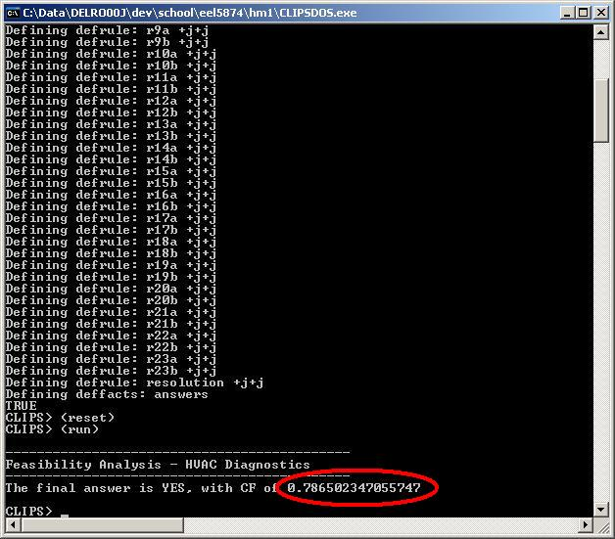

Below we provide the uncertainty equations used to calculate the above confidence factor (CF).

(deffunction inc-evidence (?cf_old ?cf_new)
(+ ?cf_old (* ?cf_new (- 1 ?cf_old)))
)
(deffunction dec-evidence (?cf_old ?cf_new)
(* -1 (inc-evidence (* -1 ?cf_old) (* -1 ?cf_new)))
)
(deffunction mrg-evidence (?cf_old ?cf_new)
(/ (+ ?cf_old ?cf_new) (- 1 (min (abs ?cf_old) (abs ?cf_new))))
)
(deffunction apply-evidence (?v_old ?v_new ?cf_old ?cf_new)
(if (eq ?cf_new 0) then (return ?cf_old))
(if (eq ?v_new NO) then (bind ?cf_new (* -1 ?cf_new)))
(if (and (> ?cf_new 0) (> ?cf_old 0))
then (return (inc-evidence ?cf_old ?cf_new)))
(if (and (< ?cf_new 0) (< ?cf_old 0))
then (return (dec-evidence ?cf_old ?cf_new))
else (return (mrg-evidence ?cf_old ?cf_new)))
)

4. Requirements Specification

4.1. Problem Overview
For the most part, heating, ventilation and air-conditioning (HVAC) is ingrained in modern living. We believe that most individuals will not wait to have their AC fixed during summer months, especially in hot climates where there temperature can be dangerous. The same can be said for heating systems during the winter months in colder climates. Although it is certainly possible to survive without HVAC systems by utilizing fireplaces, screened windows, fans, etc., a vast majority of people around the world make use of HVAC systems for evenly conditioning the air in their homes, without the need to tend a fire, toggle a fan, etc. Additionally, HVAC systems are almost essential to brick-and-mortar businesses, as patrons will not return if they are uncomfortable, rack-mounted computer hardware cannot be cooled properly, perishables cannot be kept from perishing, etc.
Given that HVAC systems are relatively essential, and the fact that they are not cheap, ranging from several hundreds of dollars for bare minimum conditioners that service a single room, to hundreds of thousands of dollars for the most powerful commercial systems, it is not difficult to see that the maintenance and repair of these systems is also important.
Expensive commercial HVAC systems can be monitored with efficient real-time programs uniquely tailored to a specific brand and model. They are capable of measuring every possible pressure, temperature and energy at a high update rate (seconds or milliseconds), displaying results to the monitoring engineers and triggering warnings/alarms as necessary. These systems can even recommend preventative maintenance measures and anticipate costly damage scenarios, by quickly taking action to prevent further downstream damage (i.e. fires, leaks, etc.) They can also isolate points of failure and recommend repair actions for each specific type of failure.
In general, these types of monitoring systems are not typically available, or even desired, for residential HVAC setups. The average individual may perform the minimum amount of preventative maintenance, like changing an air-filter or flushing a drain-line, but for the most part they do not need an all encompassing (expensive) monitoring system for their home. Additionally, the average individual may not be technically competent enough to repair the system if it does fail. Thus they will typically seek a certified technician to repair their system when service is needed. But the following questions may arise, “Who should I hire? Is the technician honest? Is the technician competent? Is their recommendation my only option? How much do repairs of this kind typically cost? Is the technician positive that this is exactly what is wrong with my system?”
HVAC-DES has been proposed in response to these very questions, a diagnostic system that can be utilized by the average individual to diagnose problems with residential HVAC setups and hopefully reach a diagnosis before attempting to hire a technician. At the very least, it gives the average individual a head-start on what could be wrong with their system. Furthermore, since the average individual is not technically capable of diagnosing these systems themselves, an “intelligent” program is necessary. One that is easy to use and can correctly diagnose many common, and hopefully some not-so-common, failures. This program should account for vast differences in brands and models and should not confuse or overwhelm the average user. Finally, and possibly most important, this program should contain a vast amount of knowledge, ideally collected from experts that have diagnosed many HVAC systems over many years.

4.2. User Profile
The intended user of HVAC-DES is almost anyone seeking help with basic diagnostics of a residential HVAC system. Experience diagnosing these systems should not be required, however basic familiarity with household tools is assumed, including some form of screwdriver to open the unit, a multi-meter, as voltage and ohms readings are needed for proper diagnostics, and the ability to toggle the power to the HVAC unit when necessary. Regarding the diagnostics of air-conditioning specifically, the use of gages will likely be required to read the head (high) pressure and back (low) pressure of the HVAC system, but the average individual may not own a set of pressure gages, nor be comfortable hooking them up to the lines. In this case only should the user require additional skills and equipment. Note that all other aspects of cooling, heating, and leaking diagnostics should be able to be performed without gages. A suitable set of gages can cost anywhere between $40 and $80, and can be used for many years.
Basic computer skills are assumed as well; the user of HVAC-DES should not need to execute any commands in a command shell, but they can be required to locate the program and click on the appropriate icon to start the program. Once the program is launched, the user is expected to follow the directions generated by HVAC-DES and answer any questions completely. Most questions should be yes/no, though some may require specific readings. As the questions are intended for user with potentially no experience diagnosing HVAC systems, they should be focused and simple to answer. Therefore it is acceptable to not account for an “I don’t know” response. It is assumed that if a user cannot answer the basic questions, then they cannot proceed with HVAC-DES.
The ideal user of HVAC-DES would have some basic familiarity with diagnostics in general and also some basic engineering knowledge, though neither of these should be required.

4.3. Project Goals
HVAC-DES should be able to diagnose most, if not all commonly-encountered problems of HVAC systems, and hopefully some atypical ones as well. The focus of the HVAC-DES should be to properly diagnose; repair and maintenance advice is not required to be provided. Because of the vast differences between each brand and model of residential HVAC system available on the market today, repair instructions could become complicated and highly specific. So the focus is to diagnose only, and to do so “intelligently” by asking as few questions as possible.
This version of HVAC-DES is intended to be used as a basic first-attempt “filter” for diagnosing residential HVAC issues, as the user can always just default to contacting a certified technician as they would have done anyway; future releases may include additional functionality making the program more robust. If the system cannot diagnose an issue because it is highly specialized or overly-complicated, in the sense that even an expert would have trouble doing so, then it is appropriate for HVAC-DES to default to a diagnosis similar to the following, “You have indicated X, Y, Z, etc. Based on the information given, the system should be working; other than an exhaustive search of every wire and capacitor in the system, you might want to consider contacting a certified technician.”
Ideally, HVAC-DES should be as easy to use as possible, meaning simple directions, pictures when possible, simple to answer questions, as few questions as possible, etc. At the very least, the user should not be required to type language-specific commands into a shell to start or progress the program; HVAC-DES should be launched from an icon like any other modern program.

4.4. System Inputs and Outputs, Reliability, Error Checking
HVAC-DES should at the very least display a single line statement for the diagnoses, followed by a brief explanation, i.e. what the statement means and hopefully why it happened. There is no requirement on explanation length, but as this information can be easily gathered from experts, there should be no problems with providing at least a few lines per diagnosis. Obviously some diagnoses will require more explanation than others. For instance if the diagnosis is, “the air filter is dirty and needs to be replaced,” then a lengthy explanation would be unnecessary, however if the diagnosis is something to the effect of, “the compressor is in a locked-rotor-amperage state,” then at the very least we require that an explanation of what that means be provided, and hopefully some direction of what to do about it, as this is generally not common knowledge.
The program is required to diagnose the following common problems in HVAC systems, though of course more if possible: no power to unit (breaker trip), incorrect thermostat configuration, thermostat calibration issues, bad thermostat, clogged drain-line, frosted coil, system low on freon, bad heating contactor, bad condenser contactor, bad compressor, bad evaporator fan, bad condensing unit fan, bad heating elements, etc. As mentioned in Section 2.3, if the system cannot diagnose a particular complex problem, due to lack of knowledge in the knowledge base or its complexity, then it is acceptable to “drop through” to a default rule that admits such and recommends a technician. However if the system does provide a diagnosis, that diagnosis should be valid and correct nearly 100% of the time, barring extraneous circumstances due to highly specific HVAC hardware.
The user of HVAC-DES should be required to answer basic questions with clearly defined answers, i.e. “Is the fan running (y/n)?” If the user answers “no” and the fan is running, then it is ok for the system to report an incorrect diagnosis. In this regard, we defer to the adage, “garbage in = garbage out.”
The use of uncertainty management is not necessary for HVAC-DES for several reasons:
(1) Most common problems of HVAC systems can be boiled down to a final yes or no answer, i.e. the fan is or is not running, the drain-pan is or is not overflowing, the filter is or is not clean, etc. We are not attempting to solve issues of thermal performance, only the state of failure of various components in the system.
(2) Diagnosing these common problems is relatively straight forward, checking one component of the system at a time and progressing, either the component will have this state or that state as asked by the program; the questions should be designed in such a way as to accommodate for this. As mentioned above in Section 2.2, there should be no questions that allow for answers like “I don’t know” or “maybe.” The only possible error that could be accumulated would be from the user herself; note that HVAC-DES is not required to account for semantic errors, meaning the user answered the basic question incorrectly (though error checking of input syntax is required). It is not impossible for error to come from the few points at which a measurement is taken. However, this is unlikely because diagnostics of this kind does not require exact measurements. Rather, the system should ask questions like, “Check the voltage, do you have ~120v?” Modern digital multi-meters are pretty accurate, even a gross error of a few percent is tolerable in the above question (voltage between roughly 116v and 124v), if the voltage was, for example, less than 100v, or more likely, closer to zero, then the user should be expected to answer, “No.”
(3) For simple systems where there are little to no unknowns about the domain, certainty measurements can be a hindrance. For instance with HVAC diagnostics specifically, if the final diagnosis is, “compressor is bad (.73 confidence),” this doesn’t really help the user that much. The compressor may be bad, and then again it may not be a quarter of the time. So what do they do, call a technician and pay a large amount of money to replace the compressor only to find that the compressor didn’t fix the problem? Because diagnosis of HVAC systems is relatively simple, the system should be able to determine matter-of-factly that the compressor is bad or not. We can check the power upstream of it, we can ohm check its internal circuits, we can check the pressure before and after it compresses, we can hear how it’s running, so why wouldn’t we be able to determine if it is bad or not? For more complex systems where there are many unknowns and results can only be determined by a function of many inputs that behave differently under various conditions, then it may be harder to determine all the cases and so certainty measures can help provide probabilistic results.
(4) Uncertainty management is largely subjective. You can interview many experts and they may all give you different answers for the amounts of certainty. You can attempt to normalize these results, but some of them may be more technically correct than others; and it is unlikely that all of these experts are taking into account the same considerations when providing these measures of certainty. Furthermore, the standard functions for calculating uncertainty measures is not mathematically sound and even Shortliffe and Buchanan themselves, authors of the commonly referenced uncertainty measurement, disagreed on the overall effectiveness of the results.

4.5. Hardware Constraints, Speed of Execution, External Interfaces
HVAC-DES is expected to run on a standard Windows operating system, x86-architecture, though multi-platform support is always encouraged. Because the program is interactive, there are no “real-time” constraints, only that when the system asks a question and the user replies, there should be no significant delays (longer than a second or two). Even with a fair amount of expert knowledge, the system should not slow down when interactive, as the diagnosis of HVAC systems is largely a linear process and therefore only a handful of rules should match upon the advent of a new fact in the system.
This version of HVAC-DES should not require loading of or reading from external knowledge bases. All expert knowledge should be embedded into the program, though it can be separated into files for organizational purposes.

4.6. Maintainability, Organization
The HVAC-DES program and knowledge base should be written in such a way as to be extended easily. We have provided a modified structure chart in Section 4 that depicts the basic overall architecture. Organizing as such will allow future developers to systematically add features and knowledge to the system. Not doing so will only encourage bugs and make the system harder to modify.

4.7. Security
This version of HVAC-DES has no security restrictions. The knowledge provided should be common knowledge to any HVAC diagnostic expert. Future versions may include copyrighted knowledge of specific brands and models of units and therefore may require a license to use the product. It may also be commercial product itself and therefore require a license to install it legally. Future versions will also be wrapped up into an installer and provided with a corresponding MD5 hash checksum, to ensure users acquire the proper, unaltered version.

4.8. Tool Selection
There are no requirements on the language or expert system shell used to implement HVAC-DES, provided that the above hardware constraints are adhered to and that the knowledge base can indeed be modified, i.e. it should not be provided to us in a binary format. The prototype included in this document has been written in CLIPS, version 6.3. The developer of HVAC-DES can choose to extend this prototype or completely rewrite it in another system, though it should be kept in mind that development of an entire pattern matching system from scratch can be quite complicated and since there are a number of existing solutions already, it would be best to utilize one of them. If the developer feels they can accomplish this in the time allotted and provide an efficient, bug-free system, then they are welcome to do so.

4.9. Expert Selection
The developer of HVAC-DES should employ as many experienced experts as they can find. Interviewing multiple experts will broaden the scope of the knowledge base. It will also help to confirm diagnoses. The developer should also plan on spending at least 6 hours in person with an expert, as it takes time to elaborate certain diagnostic routines and fully understand what each is asking of the other. Additional time may come from emails, phone calls, etc.

4.10. Priority & Flexible Criteria
Ideally, HVAC-DES should be a graphical program that displays pictures or even plays recorded audio to the user in order to make the experience of using the program as pleasant as possible. “Pictures are worth a thousand words,” as they say, and can quickly point users to the particular component of an HVAC system that they may be trying to find. Pictures of individual diagnoses can help users confirm or deny results provided by the system, i.e. a frosted coil, or burnt heating element. Sounds can also help, as we are interested in the specific “hum” that a compressor makes, or whether or not a particular fan is running, which can also be determined by sound.
The key word above is “ideally.” Although we would like the developer of HVAC-DES to provide all these things and make the program feature rich, what is most important is the basic diagnosing of common problems of residential HVAC systems. It is imperative that the developer provide at least this functionality, and so it is the number one priority. All additional features should only be attempted after the basic functionality is complete and thoroughly tested. A feature-rich, faulty program is not nearly as useful as a basic, solid, bug-free program.
The software development paradigm known as “Tracer Bullets” from The Pragmatic Programmer [Hunt & Thomas, 2003] is encouraged, in the sense that a skeleton of the basic functionality and simple knowledge base be developed first, thoroughly tested and provided to us for review so that we may verify the overall look-and-feel of the program. If approved, then the knowledge base can be expanded upon to grow the diagnostic capabilities.
Note the remark provided in Section 4 about common diagnostics between cooling and heating. We value this as an important requirement, to help keep the knowledge base clean, maintainable and reuseable.
Regarding Section 2.4, the developer is required to check for syntax errors – this is a non-negotiable requirement. Any solid program should provide this level of functionality. Although as stated, the developer is not required to account for semantic errors.
Regarding Section 2.5, additional platforms would be Apple OSX and Linux. If the final implementation is console based, then this shouldn’t be a problem, provided the existing shell exists on the other platforms.
Regarding Section 2.9, it is acceptable to only include one expert’s opinion, though more is preferred. If time only allows for one, it is understandable for this version of HVAC-DES.
At the moment we do not require any repair advice, but future versions might and it would be nice if a pricing system could be integrated, so that users could compare what the average cost of replacing a particular part is before attempting it themselves or hiring a technician.

5. System Design + Modified Structure Chart (MSC)

HVAC-DES consists of three main sub-categories of diagnostic coverage, cooling (air-conditioning), heating and water leakage. This organization comes directly from our external expert, who conveyed to us the frequency and commonality of these three problem areas. This is the reason we chose not to address additional problems related to dirty or broken ductwork, ventilation smoke, etc.
Here we provide a modified structure chart depicting the overall structure of the knowledge base of HVAC-DES. Organizing chunks of rules related to particular diagnostic routines makes future development easier, as new blocks of logic can be inserted into the hierarchy systematically.
First, note the various high-level goals of the system, to diagnose one of three major problems, unit not cooling, unit not heating, or unit leaking. Breaking-out the diagnostic options makes the system more focused and “intelligent,” as rules pertaining to the heating circuit do not need to be considered if the user is strictly interested in diagnosing a leaking problem, etc.
Next, note that a subset of knowledge is shared between cooling and heating diagnostics. We feel this is very important; the diagnostic routines for checking thermostat settings, line voltage and the evaporator fan are exactly the same when diagnosing either a cooling or heating problem. And so the knowledge base was structured in such a way as to take advantage of this. Developing the same knowledge twice would only bloat the system unnecessarily and become a potential source for error in future updates.
Although not depicted below, HVAC-DES is wrapped-up in a loop that first displays a menu and then allows the user to select the type of diagnostic sub-category to investigate. This allows a user to try various diagnostic routines before exiting the program.

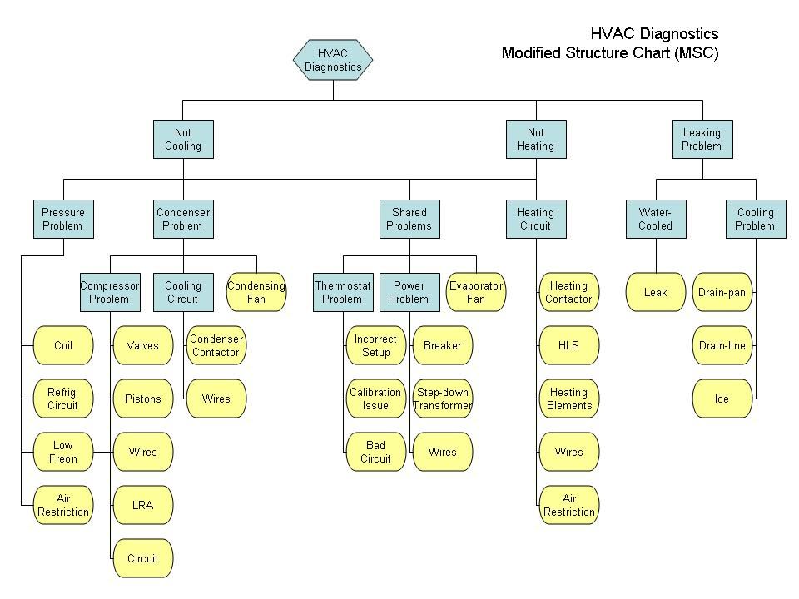

6. System Implementation + Knowledge Diagrams (KD)

Here we provide a screenshot of the final implementation of HVAC-DES, as well as the knowledge diagrams (KD) that helped with the development of the entire knowledge base. All of the essential functionality defined by the requirements specification has been implemented. Although some minor changes to the original prototype logic took place, no changes were incorporated that compromised the already tested functionality.
Note that several knowledge diagrams are provided below, one for each high-level sub-category of HVAC-DES. In order to present them as clearly as possible, we have dedicated an entire page to each. A listing of the rules and patterns referenced throughout these diagrams can be found after the KDs themselves.

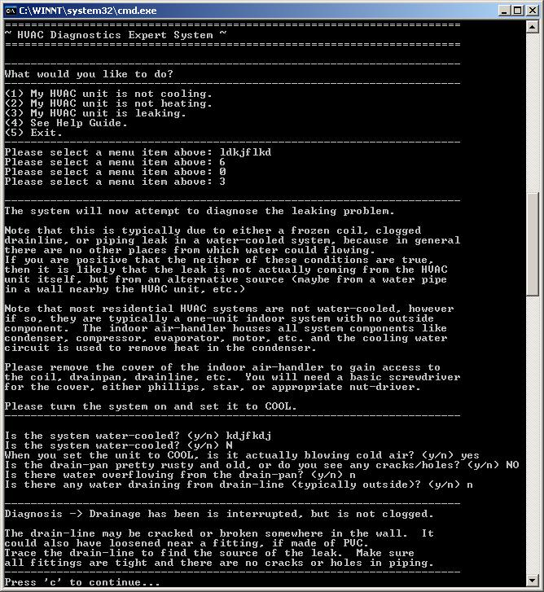

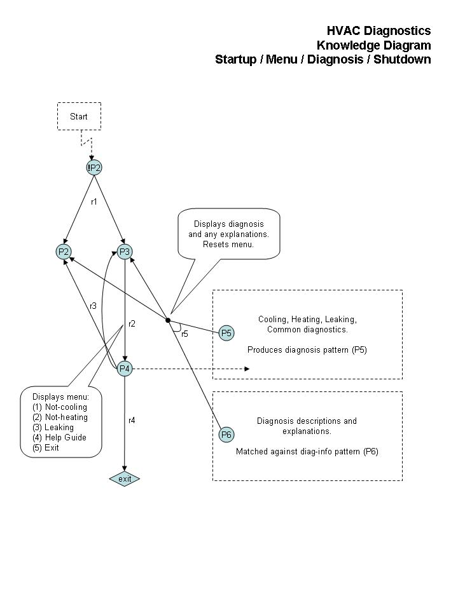

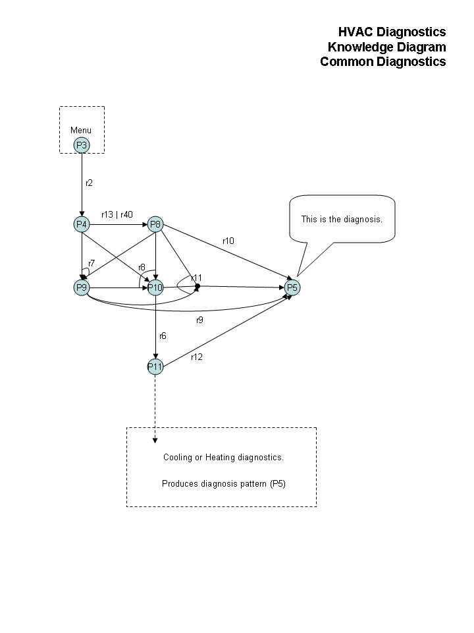

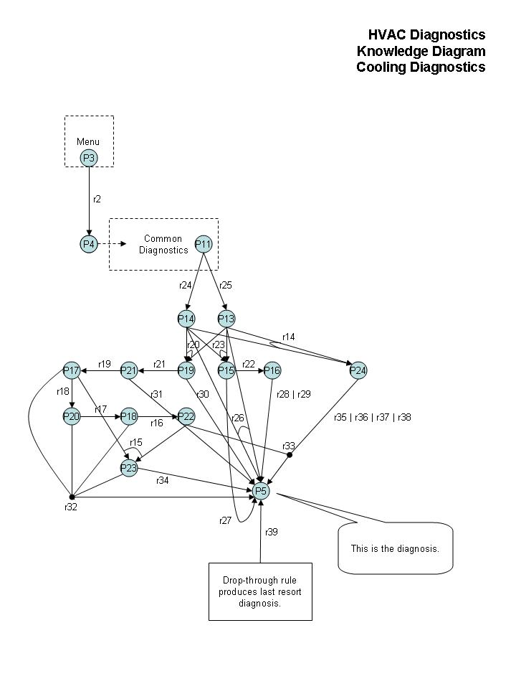

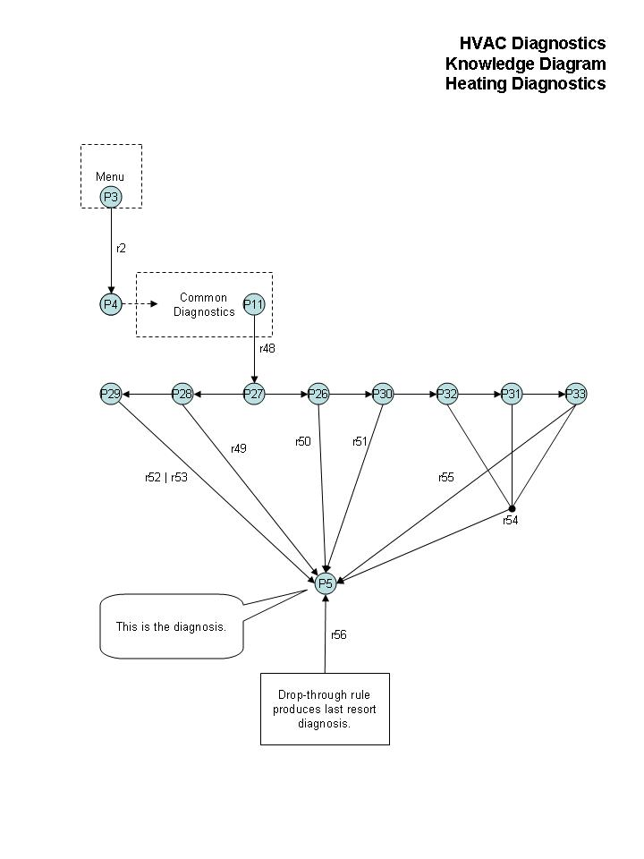
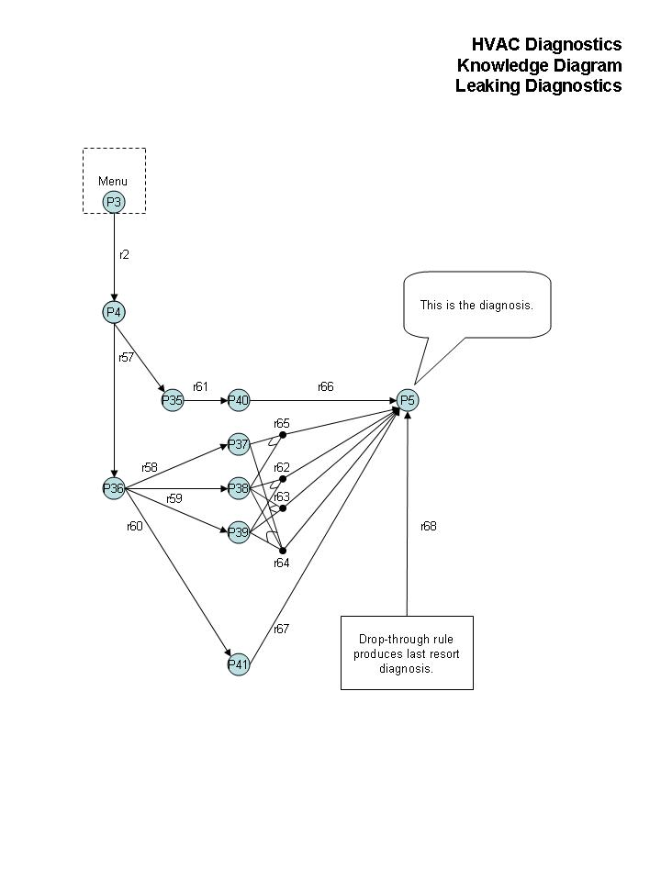

6.1. Listing of Rules

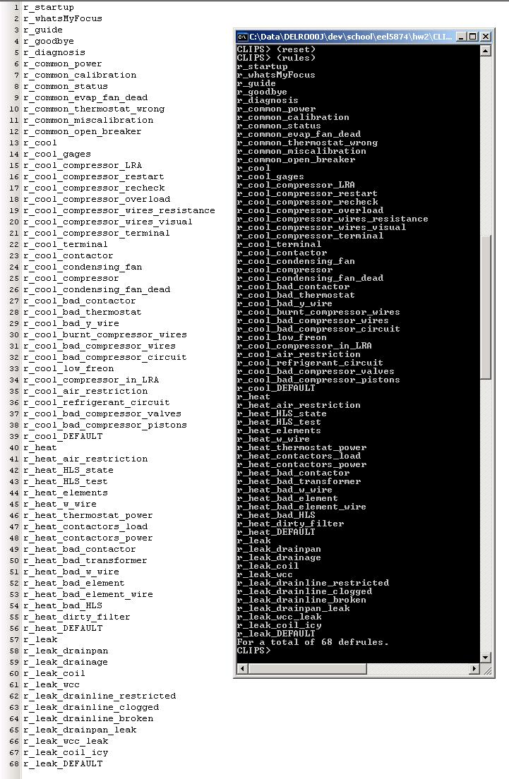

6.2. Listing of Patterns

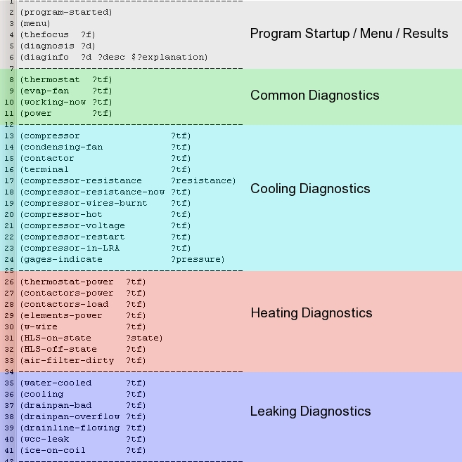

7. Verification

Verification of HVAC-DES was performed over several steps:

- CLIPS reports syntax errors due to incorrect language syntax upon loading of files, so syntax errors of this nature found in rules and functions due to “fat-fingering” or poor copy/paste efforts, were caught upfront by the shell itself. However, because CLIPS is a pattern-matching system with weak type-checking, the incorrect spelling of any particular pattern could easily be missed and cause downstream errors, circular rules, dead-end rules, etc. We elaborate on this below.
- Because the knowledge base of HVAC-DES is relatively small (< 40 patterns and < 70 rules), each pattern was searched for manually throughout the code to ensure its proper usage. Also, a visual inspection of the code was performed several times to help ensure the proper spelling of patterns. Ideally this is something that should be performed by a tool which could at the very least list all the patterns in the system, making it easier for the developer to verify near duplicates, not to mention verify the flow of the logic as well. No automated tools were used to verify HVAC-DES, though they are being considered for the next release, especially if the knowledge base grows beyond a manageable size.
- Diagrams were constructed during the interview process for most of the knowledge base, and they were followed rigorously during development. Each block of rules was tested as it was implemented (therefore incrementally). This helped to ensure that each block of rules was relatively sound as the correct responses and logic flows would not have been reached if there were circular rules, conflicting rules, missing rules, etc. In some few cases, bugs were found due to conflicting rules, and they were fixed immediately.
- A listing of all rules was printed out incrementally, and at the end of the project, and visually compared against the diagrams to ensure that there was a single rule for each rule specified in the design diagrams. This helped to ensure the absence of redundant rules.
- After significant amounts of incremental and final testing, no loops or dead-end rules have been found in the final version of HVAC-DES.

8. Validation

Validation of HVAC-DES was performed over several steps as well:

- The entire diagnostic tree represented in the design diagrams was tested (probed) both incrementally and at the end of the project. By this we mean that we made sure that every possible diagnosis could be reached by testing most of the combinations of inputs (as many necessary to reach each expected diagnosis). We realize this is only possible with a reasonably-sized search space and manageable list of diagnoses.
- Simulated “field tests” were performed by the expert, who utilized the system to diagnose mock problems. The expert was completely unaware of how the system was developed, so as an impartial third-party he was helpful in validating the results. The only issues reported, were the lack of depth of knowledge in certain cases (a known problem due to lack of development time). For instance, if the expert considered a scenario that the system had no knowledge of, then it would drop-through to the “default rule” and report as such.

8.1. Sample Test Cases

Test Case 1: HVAC Unit Is Not Actually Leaking
----------------------------------------------------------------------
Is the system water-cooled? (y/n) n
When you set the unit to COOL, is it actually blowing cold air? (y/n) n
Is there ice or frost on the evaporator coil? (y/n) n
----------------------------------------------------------------------
Diagnosis -> HVAC unit is probably not leaking.
There may be another source of water that is pooling near or around the unit making it look like it's leaking. Look for water damage nearby and inspect pipes in the area.
It is also possible that you missed something when answering. Run leaking diagnostics again and check carefully to make sure.
----------------------------------------------------------------------

Test Case 2: HVAC Unit Is Not Actually Leaking
----------------------------------------------------------------------
Is the system water-cooled? (y/n) n
When you set the unit to COOL, is it actually blowing cold air? (y/n) y
Is the drain-pan pretty rusty and old, or do you see any cracks/holes? (y/n) n
Is there water overflowing from the drain-pan? (y/n) n
Is there any water draining from drain-line (typically outside)? (y/n) y
----------------------------------------------------------------------
Diagnosis -> HVAC unit is probably not leaking.
There may be another source of water that is pooling near or around the unit making it look like it's leaking. Look for water damage nearby and inspect pipes in the area.
It is also possible that you missed something when answering. Run leaking diagnostics again and check carefully to make sure.
----------------------------------------------------------------------

Test Case 3: Drain-Line Is Broken
----------------------------------------------------------------------
Is the system water-cooled? (y/n) n
When you set the unit to COOL, is it actually blowing cold air? (y/n) y
Is the drain-pan pretty rusty and old, or do you see any cracks/holes? (y/n) n
Is there water overflowing from the drain-pan? (y/n) n
Is there any water draining from drain-line (typically outside)? (y/n) n
----------------------------------------------------------------------
Diagnosis -> Drainage has been is interrupted, but is not clogged.
The drain-line may be cracked or broken somewhere in the wall. It could also have loosened near a fitting, if made of PVC. Trace the drain-line to find the source of the leak. Make sure all fittings are tight and there are no cracks or holes in piping.
----------------------------------------------------------------------

Test Case 4: Water Cooling Circuit Leak
----------------------------------------------------------------------
Is the system water-cooled? (y/n) y
When you set the unit to COOL, is it actually blowing cold air? (y/n) n
Inspect the water cooling circuit (piping) within the air-handler. Water in this piping is under pressure, so any leak should be obvious. Look for a cracked pipe or leaking joint.
Did you discover a leak along the water cooling circuit? (y/n) y
----------------------------------------------------------------------
Diagnosis -> Water cooling circuit is leaking.
Turn the HVAC unit off immediately and repair the tubing or piping as necessary.
----------------------------------------------------------------------

Test Case 5: Thermostat Setup Incorrectly
----------------------------------------------------------------------
Is the thermostat set to COOL? (y/n) y
Is the temperature set BELOW ambient temperature? (y/n) n
----------------------------------------------------------------------
Diagnosis -> The thermostat is not setup properly.
For heating, make sure it is set to HEAT and the temperature is set ABOVE ambient temperature. For cooling, make sure it is set to COOL and temperature is set BELOW ambient.
----------------------------------------------------------------------

Test Case 6: Thermostat Setup Incorrectly
----------------------------------------------------------------------
Is the thermostat set to HEAT? (y/n) n
Is the temperature set ABOVE ambient temperature? (y/n) y
----------------------------------------------------------------------
Diagnosis -> The thermostat is not setup properly.
For heating, make sure it is set to HEAT and the temperature is set ABOVE ambient temperature. For cooling, make sure it is set to COOL and temperature is set BELOW ambient.
----------------------------------------------------------------------
Test Case 7: Compressor in Locked-Rotor-Amperage State, Causing it to Overheat
----------------------------------------------------------------------
Is the thermostat set to COOL? (y/n) y
Is the temperature set BELOW ambient temperature? (y/n) y
Set the thermostat temperature to the respective extreme, really high if heating, really low if cooling.
Does the evaporator fan come on (allow for delay)? (y/n) y
Is unit blowing conditioned air now (allow for delay)? (y/n) n
Does the unit have incoming power (~240v single phase)? (y/n) y
Is condenser fan running (outside unit cooling condensing unit)? (y/n) y
The compressor is typically located within the outside unit and has a very distinct, loud hum when running. You can have someone turn the HVAC system on for you while you listen outside, or often there is a separate breaker located outside near the condensing unit that can be flipped on/off.
Can you hear the compressor running (typically outside)? (y/n) n
Cut the line voltage to the condensing unit. Inspect the compressor terminal connection. Gain access by removing the terminal cover at the condensing unit. If the unit is outside, you may even have to remove the grill and fan as well to access it. Inspect the compressor terminal wires specifically (typically 3).
Do any of the terminal wires look burnt? (y/n) n
Whether the compressor terminal wires are burnt or not, you still have to make sure that you have power across all the wires (typically 3). Check power across the (C)ommon to (R)un circuit and check power across the (C)ommon to (S)tart circuit.
Do you have proper voltage to the compressor (~240)? (y/n) y
With the power still off for the condensing unit, check resistance across the compressor wires by removing the ends not connected to the compressor, and then ohm check them. Check the resistance across all, (C)ommon to (R)un, (C)ommon to (S)tart, (R)un to (S)tart.
What is the result of the ohm check across the wires?
(1) Resistance between all the wires.
(2) No resistance between (R)un and (S)tart.
(3) No resistance between (C)ommon and either (R)un or (S)tart.
Please select a menu item above: 3
The compressor's internal overload may have triggered, which happens when the windings are hotter than they should be.
Is the compressor very hot? (y/n) y
Cool the compressor down - either wait for it to cool naturally (if in shaded area), or take a hose and run it over the compressor for a bit. It should be cool enough to touch.
Once the compressor has cooled down, check both scenarios for resistance again, across (C)ommon with (S)tart or (R)un.
Is there resistance now? (y/n) y
It is very likely that the internal overload is triggering.
Reconnect the compressor and feed line voltage to it again (assuming thermostat still set to cool). The compressor may start now.
Does the compressor start now? (y/n) n
The compressor could be in a locked-rotor-amperage (LRA) state, which occurs when the compressor is trying to start but the rotor is locked for some reason. The compressor keeps drawing amperage, but is not actually compressing anything, and thus the amperage builds up.
If in LRA state, you can typically hear an atypical loud hum coming from the compressor before it shuts off prematurely.
Is the compressor in LRA? (y/n) y
Diagnosis -> Compressor rotor is locked (LRA state).
If the unit is in a locked-rotor amperage (LRA) state, then you can apply what is called a 'starter-kit', to give the compressor an edge when starting. Basically it is a tiny capacitor that delays the power circuit by a very small amount in an attempt shift the voltage wave by just enough that it knocks the compressor with a little more juice when starting.
If a starter-kit has already been applied by this point, or if the compressor still doesn't start, then you may have to replace it.
----------------------------------------------------------------------

Test Case 8: Thermostat Calibrated Incorrectly
----------------------------------------------------------------------
Is the thermostat set to COOL? (y/n) y
Is the temperature set BELOW ambient temperature? (y/n) y
Set the thermostat temperature to the respective extreme, really high if heating, really low if cooling.
Does the evaporator fan come on (allow for delay)? (y/n) y
Is unit blowing conditioned air now (allow for delay)? (y/n) y
----------------------------------------------------------------------
Diagnosis -> The thermostat is likely miscalibrated.
If the unit is heating only when you set the temperature much higher than ambient, or cooling only when temp. set much lower than ambient, then it probably just needs to be recalibrated (depending on the type of thermostat). If it is an older and mechanical one (with mercury), then a special wrench can be purchased for very little money, and the thermostat can simple be adjusted with it. If the thermostat is newer and electronic, then it may not be possible to recalibrate it. Search online for recalibrating your specific thermostat. If you find nothing, then spend the money to buy a new one; they are much cheaper then the price of a new HVAC system.
----------------------------------------------------------------------

Test Case 9: Condenser Fan
----------------------------------------------------------------------
Is the thermostat set to COOL? (y/n) y
Is the temperature set BELOW ambient temperature? (y/n) y
Set the thermostat temperature to the respective extreme, really high if heating, really low if cooling.
Does the evaporator fan come on (allow for delay)? (y/n) y
Is unit blowing conditioned air now (allow for delay)? (y/n) n
Does the unit have incoming power (~240v single phase)? (y/n) y
Is condenser fan running (outside unit cooling condensing unit)? (y/n) n
The compressor is typically located within the outside unit and has a very distinct, loud hum when running. You can have someone turn the HVAC system on for you while you listen outside, or often there is a separate breaker located outside near the condensing unit that can be flipped on/off.
Can you hear the compressor running (typically outside)? (y/n) y
----------------------------------------------------------------------
Diagnosis -> Something wrong with condensing-unit (outdoor) fan.
It could be that the motor is bad, a blown capacitor, bad wire, etc. Note that it is not the condensing contactor, as you have indicated that the compressor is running. Check the fan relay and either repair or replace the fan.
----------------------------------------------------------------------

Test Case 10: Power Problem (Upstream of HVAC Unit)
----------------------------------------------------------------------
Is the thermostat set to HEAT? (y/n) y
Is the temperature set ABOVE ambient temperature? (y/n) y
Set the thermostat temperature to the respective extreme, really high if heating, really low if cooling.
Does the evaporator fan come on (allow for delay)? (y/n) y
Is unit blowing conditioned air now (allow for delay)? (y/n) n
Does the unit have incoming power (~240v single phase)? (y/n) n
----------------------------------------------------------------------
Diagnosis -> A circuit breaker to the HVAC unit is open.
Check the main breaker box. If you are positive that breakers to other appliances have power, then reset the breaker to HVAC unit. Note there may be another breaker closer to the unit itself, either inside or outside near the air-handler or condensing unit (if exists), so make sure both have been reset. If there is still no power, then one of those breakers needs to be replaced, if not both.
----------------------------------------------------------------------

Test Case 11: Bad Compressor (Internal Wiring)
----------------------------------------------------------------------
Is the thermostat set to COOL? (y/n) y
Is the temperature set BELOW ambient temperature? (y/n) y
Set the thermostat temperature to the respective extreme, really high if heating, really low if cooling.
Does the evaporator fan come on (allow for delay)? (y/n) y
Is unit blowing conditioned air now (allow for delay)? (y/n) n
Does the unit have incoming power (~240v single phase)? (y/n) y
Is condenser fan running (outside unit cooling condensing unit)? (y/n) y
The compressor is typically located within the outside unit and has a very distinct, loud hum when running. You can have someone turn the HVAC system on for you while you listen outside, or often there is a separate breaker located outside near the condensing unit that can be flipped on/off.
Can you hear the compressor running (typically outside)? (y/n) n
Cut the line voltage to the condensing unit. Inspect the compressor terminal connection. Gain access by removing the terminal cover at the condensing unit. If the unit is outside, you may even have to remove the grill and fan as well to access it. Inspect the compressor terminal wires specifically (typically 3).
Do any of the terminal wires look burnt? (y/n) n
Whether the compressor terminal wires are burnt or not, you still have to make sure that you have power across all the wires (typically 3). Check power across the (C)ommon to (R)un circuit and check power across the (C)ommon to (S)tart circuit.
Do you have proper voltage to the compressor (~240)? (y/n) y
With the power still off for the condensing unit, check resistance across the compressor wires by removing the ends not connected to the compressor, and then ohm check them. Check the resistance across all, (C)ommon to (R)un, (C)ommon to (S)tart, (R)un to (S)tart.
What is the result of the ohm check across the wires?
(1) Resistance between all the wires.
(2) No resistance between (R)un and (S)tart.
(3) No resistance between (C)ommon and either (R)un or (S)tart.
Please select a menu item above: 2
----------------------------------------------------------------------
Diagnosis -> Compressor's internal electrical circuit is bad.
Either the start winding is damaged or the internal overload is not functioning properly. The compressor itself should be replaced.
----------------------------------------------------------------------

9. Conclusion

To summarize, the Heating-Ventilation-and-Air-Conditioning Diagnostic Expert System (HVAC-DES) is a knowledge-based program that emulates the expertise of a certified HVAC technician. It is intended to be used by residents and small-business owners to diagnose problems with their HVAC unit as needed. It is not intended for large, expensive commercial units, because of the more appropriate, automated diagnostic options. HVAC-DES is an interactive program that requires the user to follow simple directions and specify various measurements and results. We feel there is an existing and growing need for such a program given the costs associated with purchasing or repairing an HVAC unit by a certified technician. Furthermore, HVAC-DES helps to balance the trust issue with technicians, in that the user can easily confirm or deny professional diagnoses.
The scope of knowledge of HVAC-DES is more broad than deep (though deep in some areas), and there is a vast amount of knowledge that could be added to the knowledge base at a later date. Our expert estimates that roughly “10 times” as much knowledge could be provided, not including diagnostics of very specific brands and models of units, or less common hardware. Regardless, HVAC-DES does meet the essential requirement of diagnosing the most common occurring problems. It also successfully navigates the issue of diagnosing different brands and models generically, which is a major advantage for consumers, given the number of different HVAC setups out there.
HVAC-DES was written almost entirely in CLIPS and intended for CLIPS shell version 6.3. The knowledge base was constructed in such a way as to be easily extended in the future, by organizing rules into groups for particular diagnoses. Thus, extending HVAC-DES should be a straightforward task, as little to no existing rules will need to change.
We feel that the modified structure chart (MSC) and diagrams drafted during expert interviews were very helpful in the construction of HVAC-DES; without these it is doubtful that we would have provided as sound a product. We feel that the knowledge diagrams (KD), on the other hand, were not as useful. They could have been easily generated by an appropriate tool, a tool that could also probably perform automated verification, thus lessening the importance of these diagrams overall.
Many test cases were evaluated during the verification and validation of HVAC-DS, and every possible diagnosis was validated specifically, some of them by the expert himself. Although the interface to the program is not ideal at this point, we feel that at-least the quality of results is sound.
Overall we feel that this product will meet the needs of the target users. We also feel that this project in general was great experience for our company, as it forced us to operate in a new programming paradigm and language, making us more knowledgeable and robust. Also the feasibility analysis method we applied can easily be extended to meet future project decisions, either knowledge-bases or otherwise.
Future work should include, (1) wrapping up this program with a friendly (windowed, graphical) user interface, (2) extending the knowledge base to include additional diagnoses, (3) extending the program to account for specific types of hardware not considered in the scope of this program, (4) possibly adding a detailed repair section on various sub-components of HVAC units, and (5) possibly a database of parts and labor costs to provide rough estimates for the repair work if a certified technician is hired.

Appendix A: External Expert Interview Record

Below is a high-level record of the interviews that took place with our external expert during the development of HVAC-DES. During the interview, either diagrams were drafted (provided in Appendix E) or brief notes were taken. Additional small phone interviews (less than 10 minutes) were conducted, but are not recorded here. As seen below, we dedicated at least 8 hours with our expert on this topic, almost all of that in person.

[02/18/2011] Friday (90 minutes):
- met over dinner
- explained expert systems in general to the expert
- discussed different ways to break down the diagnostics from expert’s point-of-view
- discussed different diagnostics sub-problems to focus on
[03/05/2011] Saturday (120 minutes):
- discussed which problems to focus on
- discussed potential causes of water leaks on HVAC systems
- discussed diagnosing a water leakage problem in-depth
- recorded notes on laptop (no diagnostic diagram originally – this was drafted later)
[03/13/2011] Sunday (120 minutes):
- discussed diagnosing a heating problem in-depth
- decided to focus on electric heat (not heat pumps for the time being)
- discussed purpose of Heating Limit Switch
- constructed diagnostic diagram during interview
- simplified indoor fan (no repair provided by HVAC-DES)
- simplified heating contact (no repair provided by HVAC-DES)
[03/19/2011] Saturday (30 minutes):
- discussed various issues entirely over the phone
- discussed handling of thermostat that is calibrated incorrectly
- discussed how a relay can fail
- discussed how the evaporator fan can not come on
- discussed why the HLS might not be open
- TELEPHONE TEST passed!
[03/20/2011] Sunday (120 minutes):
- discussed cooling diagnostics in-depth
- discussed role of condenser, versus evaporator
- concluded that expert has more knowledge than we can integrate at this time…
- briefly discussed additional knowledge that we chose to leave out (10x as much)

Appendix B: Knowledge Base

Here we provide the final CLIPS code of the knowledge base at release time, although this code is also viewable within the “HVAC.clp” file provided as part of the system. The final system contains 68 rules and 4 functions. It also comes with an embedded user’s guide. As depicted in the MSC (included in this document), the logic is organized into three main sub-systems of diagnostics, cooling (air-conditioning), heating and leaking.

;;====================================================================
;; Joseph Del Rocco
;; EEL5874 - Expert Systems & Knowledge Engineering
;; Spring 2011
;;
;; Term Project: HVAC Diagnostics Expert System
;;
;; Use with CLIPS Version 6.3
;; To execute, simply (load) this file, (reset) and (run).
;;====================================================================

;;-------------------------------------
;; UTILITY FUNCTIONS
;;-------------------------------------

(deffunction restart-program ()
(reset)
(assert (program started))
(assert (menu))
(run)
)

(deffunction ask-question (?question $?allowed-values)
(printout t ?question)
(bind ?answer (read))
(if (lexemep ?answer) then (bind ?answer (lowcase ?answer)))
(while (not (member ?answer ?allowed-values)) do
(printout t ?question)
(bind ?answer (read))
(if (lexemep ?answer) then (bind ?answer (lowcase ?answer))))
?answer
)

(deffunction ask-yes-or-no (?question)
(bind ?response (ask-question ?question yes no y n))
(if (or (eq ?response yes) (eq ?response y)) then TRUE else FALSE)
)

(deffunction ask-continue ()
(ask-question "Press 'c' to continue..." c C)
)

;;-------------------------------------
;; SYSTEM BANNERS (MENU, HELP, etc.)
;;-------------------------------------

(defrule r_startup ""
(not (program started))
=>
(printout t crlf)
(printout t "======================================================================" crlf)
(printout t "~ HVAC Diagnostics Expert System ~" crlf)
(printout t "======================================================================" crlf)
(assert (program started))
(assert (menu))
)

(defrule r_whatsMyFocus ""
?m <- (menu)
=>
(printout t crlf)
(printout t "----------------------------------------------------------------------" crlf)
(printout t "What would you like to do?" crlf)
(printout t "----------------------------------------------------------------------" crlf)
(printout t "(1) My HVAC unit is not cooling." crlf)
(printout t "(2) My HVAC unit is not heating." crlf)
(printout t "(3) My HVAC unit is leaking." crlf)
(printout t "(4) See Help Guide." crlf)
(printout t "(5) Exit." crlf)
(printout t "----------------------------------------------------------------------" crlf)
(bind ?i (ask-question "Please select a menu item above: " 1 2 3 4 5))
(retract ?m)
(assert (thefocus (nth$ ?i (create$ cool heat leak guide end))))
)

(defrule r_guide ""
(thefocus guide)
=>
(printout t crlf)
(printout t "----------------------------------------------------------------------" crlf)
(printout t "Intended Target Audience: " crlf)
(printout t "----------------------------------------------------------------------" crlf)
(printout t "The intended user of this system is anyone seeking help with basic " crlf)
(printout t "diagnostics of residential HVAC systems. Experience doing so is not " crlf)
(printout t "intended to be required of the user of this system. That having been " crlf)
(printout t "said though, it will be helpful if the user of this system has basic " crlf)
(printout t "mechanical knowledge or familiarity with multi-meters, pressure gages," crlf)
(printout t "screwdrivers, etc. The reason for this is because this system may ask" crlf)
(printout t "you for the status or measurement of various components located inside" crlf)
(printout t "an air-handler, requiring the use of at least a screwdriver to gain " crlf)
(printout t "access to them as well as a multi-meter or gages to measure them. " crlf)
(printout t "----------------------------------------------------------------------" crlf)
(printout t "What This Program Does: " crlf)
(printout t "----------------------------------------------------------------------" crlf)
(printout t "This expert system attempts to diagnose common malfunctions that occur" crlf)
(printout t "with residential HVAC systems. Though there are many brands & models " crlf)
(printout t "of systems on the market today, the core operational concepts and " crlf)
(printout t "diagnostic routines are roughly the same. It will ask you various " crlf)
(printout t "questions, some more specific than others, and eventually give you a " crlf)
(printout t "final answer as to the most likely diagnosis and recommended fix for " crlf)
(printout t "your system. " crlf)
(printout t "----------------------------------------------------------------------" crlf)
(printout t "What This Program Does NOT Do: " crlf)
(printout t "----------------------------------------------------------------------" crlf)
(printout t "This expert system will not delve into the detailed specifics of how " crlf)
(printout t "to repair an isolated component,such as a compressor, once a problem " crlf)
(printout t "is diagnosed. If the expert system thinks that your compressor is bad" crlf)
(printout t "it will report so but will not necessarily tell you how to repair it " crlf)
(printout t "specifically. There are several reasons for this: " crlf)
(printout t " (1) The goal here is to diagnose the problem. " crlf)
(printout t " (2) Repair can often be as detailed a topic as diagnostics. " crlf)
(printout t " (3) In general, most HVAC components should be replaced outright. " crlf)
(printout t " (4) Sub-components vary enough to warrant detailed repair FAQs. " crlf)
(printout t "----------------------------------------------------------------------" crlf)
(printout t "Discrepancies w/ Your HVAC System: " crlf)
(printout t "----------------------------------------------------------------------" crlf)
(printout t "Note there may be discrepancies between what is stated in this program" crlf)
(printout t "and your own HVAC system, simply because there are many different " crlf)
(printout t "models and configurations on the market today, and from many different" crlf)
(printout t "vendors. So it is definitely possible that the configuration of a " crlf)
(printout t "particular sub-system unique to your HVAC unit has not been accounted " crlf)
(printout t "for and is therefore not mentioned specifically. " crlf)
(printout t "To address this, the expert has made a valiant effort to try and " crlf)
(printout t "tackle diagnostics generically across all residential HVAC systems. " crlf)
(printout t "Keep this in mind and accomodate as necessary. " crlf)
(printout t "For Example: " crlf)
(printout t "If the expert system asks you to check the power circuits associated " crlf)
(printout t "with say 5 heating elements, but you find that your system has as many" crlf)
(printout t "as 8 or as few as 3 heating element circuits, then adjust accordingly." crlf)
(printout t "You should expect to check all of them, as a problem with any of them " crlf)
(printout t "will affect the heating efficiency of your system. " crlf)
(printout t "----------------------------------------------------------------------" crlf)
(ask-continue)
(restart-program)
)

(defrule r_goodbye ""
(thefocus end)
=>
(printout t crlf)
(printout t "======================================================================" crlf)
(printout t "Thank You for using the JDR HVAC Diagnostics Expert System." crlf)
(printout t "======================================================================" crlf)
(printout t "University of Central Florida - EEL5874 - Spring 2011" crlf)
(printout t crlf)
(printout t "Programmed by:" crlf)
(printout t "Joseph A. Del Rocco" crlf)
(printout t "University of Central Florida" crlf)
(printout t crlf)
(printout t "Expert knowledge provided by:" crlf)
(printout t "Joseph J. Del Rocco" crlf)
(printout t "Walt Disney Company - Engineering" crlf)
(printout t "======================================================================" crlf)
(printout t crlf)
(exit)
)

(defrule r_diagnosis ""
(diagnosis ?d)
(diaginfo ?d ?desc $?explanation)
=>
(printout t crlf)
(printout t "----------------------------------------------------------------------" crlf)
(printout t "Diagnosis -> " ?desc crlf)
(printout t crlf)
(foreach ?i $?explanation (printout t ?i crlf))
(printout t "----------------------------------------------------------------------" crlf)
(ask-continue)
(restart-program)
)

;;-------------------------------------
;; COMMON DIAGNOSTICS
;;-------------------------------------

(defrule r_common_power ""
(or (thefocus heat) (thefocus cool))
(working-now FALSE)
=>
(assert (power (ask-yes-or-no "Does the unit have incoming power (~240v single phase)? (y/n) ")))
)

(defrule r_common_calibration ""
(or (thefocus heat) (thefocus cool))
(thermostat TRUE)
=>
(printout t crlf)
(printout t "----------------------------------------------------------------------" crlf)
(printout t "Set the thermostat temperature to the respective extreme, really high" crlf)
(printout t "if heating, really low if cooling." crlf)
(printout t "----------------------------------------------------------------------" crlf)
(printout t crlf)
(assert (evap-fan (ask-yes-or-no "Does the evaporator fan come on (allow for delay)? (y/n) ")))
)

(defrule r_common_status ""
(or (thefocus heat) (thefocus cool))
(thermostat TRUE)
(evap-fan TRUE)
=>
(assert (working-now (ask-yes-or-no "Is unit blowing conditioned air now (allow for delay)? (y/n) ")))
)

;;------------

(defrule r_common_evap_fan_dead ""
(or (thefocus heat) (thefocus cool))
(evap-fan FALSE)
=>
(assert (diagnosis evap_fan_dead))
)

(defrule r_common_thermostat_wrong ""
(or (thefocus heat) (thefocus cool))
(thermostat FALSE)
=>
(assert (diagnosis thermostat_wrong))
)

(defrule r_common_miscalibration ""
(or (thefocus heat) (thefocus cool))
(thermostat TRUE)
(evap-fan TRUE)
(working-now TRUE)
=>
(assert (diagnosis thermostat_calibration))
)

(defrule r_common_open_breaker ""
(or (thefocus heat) (thefocus cool))
(power FALSE)
=>
(assert (diagnosis open_breaker))
)

;;-------------------------------------
;; COOLING DIAGNOSTICS
;;-------------------------------------

(defrule r_cool ""
(thefocus cool)
=>
(printout t crlf)
(printout t "----------------------------------------------------------------------" crlf)
(printout t "The system will now attempt to diagnose the problem of not cooling." crlf)
(printout t crlf)
(printout t "Note that this could be due to any number of conditions including a" crlf)
(printout t "bad compressor, bad condensing fan or coil, low freon charge, dirty" crlf)
(printout t "evaporator coil, bad contactor on condensing unit, etc." crlf)
(printout t crlf)
(printout t "Note that many residential systems are 2-unit systems. The inside" crlf)
(printout t "unit ('air-handler') houses the evaporator fan, coil, drainpan, filter" crlf)
(printout t "drain-line, heating circuit, step-down transformer, thermostat connex," crlf)
(printout t "etc. This is the unit that moves the air throughout the house. The" crlf)
(printout t "outside unit ('condensing unit') houses the compressor, condensing" crlf)
(printout t "coil, a cooling fan, etc. If your HVAC system is only 1-unit, all" crlf)
(printout t "of these components will be in that one unit obviously." crlf)
(printout t crlf)
(printout t "Note that in general, almost all residential HVAC thermostats will use" crlf)
(printout t "the following color convention for thermostat control wires:" crlf)
(printout t " (Y)ellow = cool" crlf)
(printout t " (W)hite = heat" crlf)
(printout t " (G)reen = fan" crlf)
(printout t "Of course there may be additional wires as well, but the ones above" crlf)
(printout t "are very common. Keep this in mind during diagnostics." crlf)
(printout t crlf)
(printout t "Note that you might have to wait a bit for the evaporator fan to turn" crlf)
(printout t "on if the system has a sequencer (turns the fan on after some delay)." crlf)
(printout t "Consider this delay before answering the evap. fan-related questions." crlf)
(printout t "This applies the condensing fan as well." crlf)
(printout t crlf)
(printout t "Please turn the system on and set it to COOL." crlf)
(printout t "----------------------------------------------------------------------" crlf)
(printout t crlf)
(bind ?set (ask-yes-or-no "Is the thermostat set to COOL? (y/n) "))
(bind ?temp (ask-yes-or-no "Is the temperature set BELOW ambient temperature? (y/n) "))
(if (and (eq ?set TRUE) (eq ?temp TRUE)) then (assert (thermostat TRUE)) else (assert (thermostat FALSE)))
)

(defrule r_cool_gages ""
(thefocus cool)
(compressor TRUE)
(condensing-fan TRUE)
=>
(printout t crlf)
(printout t "----------------------------------------------------------------------" crlf)
(printout t "When set to cool, if both the condensing fan and the compressor are" crlf)
(printout t "running, then the best way to diagnose is to apply the gages and read" crlf)
(printout t "the head pressure (HP) and back pressure (BP). These pressures alone" crlf)
(printout t "can indicate a lot to an HVAC diagnostic expert." crlf)
(printout t crlf)
(printout t "Connect the gages where possible, typically on the condensing unit." crlf)
(printout t "Read the HP and BP pressures. Note that the pressures below pertain" crlf)
(printout t "to an HVAC system charged with freon-22 particularly, whereas a system" crlf)
(printout t "with freon-410A runs at higher pressures." crlf)
(printout t crlf)
(printout t "Which of the following conditions is true? " crlf)
(printout t "----------------------------------------------------------------------" crlf)
(printout t "(1) HP > ~400" crlf)
(printout t "(2) HP = ~200-250, BP starts normal, then runs to 0 or vacuum" crlf)
(printout t "(3) HP < ~200, BP = ~40-50 (assuming high ambient temperature)" crlf)
(printout t "(4) HP < ~150, BP = ~80-100" crlf)
(printout t "(5) HP = BP" crlf)
(printout t "----------------------------------------------------------------------" crlf)
(bind ?i (ask-question "Please select a menu item above: " 1 2 3 4 5))
(assert (gages-indicate (nth$ ?i (create$ restriction refrigerant-circuit freon compressor-valves compressor-mechanical))))
)

(defrule r_cool_compressor_LRA ""
(thefocus cool)
(or (compressor-resistance good) (compressor-restart FALSE))
=>
(printout t crlf)
(printout t "----------------------------------------------------------------------" crlf)
(printout t "The compressor could be in a locked-rotor amperage (LRA) state, which" crlf)
(printout t "occurs when the compressor is trying to start but the rotor is locked" crlf)
(printout t "for some reason. The compressor keeps drawing amperage, but is not" crlf)
(printout t "actually compressing anything, and thus the amperage builds up." crlf)
(printout t crlf)
(printout t "If in LRA state, you can typically hear an atypical loud hum coming" crlf)
(printout t "from the compressor before it shuts off prematurely." crlf)
(printout t "----------------------------------------------------------------------" crlf)
(printout t crlf)
(assert (compressor-in-LRA (ask-yes-or-no "Is the compressor in LRA? (y/n) ")))
)

(defrule r_cool_compressor_restart ""
(thefocus cool)
(compressor-resistance-now TRUE)
=>
(printout t crlf)
(printout t "----------------------------------------------------------------------" crlf)
(printout t "It is very likely that the internal overload is triggering." crlf)
(printout t crlf)
(printout t "Reconnect the compressor and feed line voltage to it again (assuming" crlf)
(printout t "thermostat still set to cool). The compressor may start now." crlf)
(printout t "----------------------------------------------------------------------" crlf)
(printout t crlf)
(assert (compressor-restart (ask-yes-or-no "Does the compressor start now? (y/n) ")))
)

(defrule r_cool_compressor_recheck ""
(thefocus cool)
(compressor-hot TRUE)
=>
(printout t crlf)
(printout t "----------------------------------------------------------------------" crlf)
(printout t "Cool the compressor down - either wait for it to cool (if in shade)," crlf)
(printout t "or take a hose and run it over the compressor for a bit. It should be" crlf)
(printout t "cool enough to touch, not even warm." crlf)
(printout t crlf)
(printout t "Once the compressor has cooled-down, check for resistance again across" crlf)
(printout t "(C)ommon with (S)tart or (R)un, both scenarios." crlf)
(printout t "----------------------------------------------------------------------" crlf)
(printout t crlf)
(assert (compressor-resistance-now (ask-yes-or-no "Is there resistance now? (y/n) ")))
)

(defrule r_cool_compressor_overload ""
(thefocus cool)
(compressor-resistance overload)
=>
(printout t crlf)
(printout t "----------------------------------------------------------------------" crlf)
(printout t "The compressor's internal overload may have triggered, which happens" crlf)
(printout t "when the windings are hotter than they should be." crlf)
(printout t "----------------------------------------------------------------------" crlf)
(printout t crlf)
(assert (compressor-hot (ask-yes-or-no "Is the compressor very hot? (y/n) ")))
)

(defrule r_cool_compressor_wires_resistance ""
(thefocus cool)
(compressor-voltage TRUE)
=>
(printout t crlf)
(printout t "----------------------------------------------------------------------" crlf)
(printout t "With the power still off for the condensing unit, check resistance" crlf)
(printout t "across the compressor wires by removing the ends not connected to the" crlf)
(printout t "compressor, and then ohm check them. Check the resistance across all," crlf)
(printout t "(C)ommon to (R)un, (C)ommon to (S)tart, (R)un to (S)tart." crlf)
(printout t crlf)
(printout t "What is the result of the ohm check across the wires? " crlf)
(printout t "----------------------------------------------------------------------" crlf)
(printout t "(1) Resistance between all the wires." crlf)
(printout t "(2) No resistance between (R)un and (S)tart." crlf)
(printout t "(3) No resistance between (C)ommon and either (R)un or (S)tart." crlf)
(printout t "----------------------------------------------------------------------" crlf)
(bind ?i (ask-question "Please select a menu item above: " 1 2 3))
(assert (compressor-resistance (nth$ ?i (create$ good bad overload))))
)

(defrule r_cool_compressor_wires_visual ""
(thefocus cool)
(compressor FALSE)
(condensing-fan TRUE)
=>
(printout t crlf)
(printout t "----------------------------------------------------------------------" crlf)
(printout t "Cut the line voltage to the condensing unit." crlf)
(printout t crlf)
(printout t "Inspect the compressor terminal connection. Gain access by removing" crlf)
(printout t "the terminal cover at the condensing unit. If the unit is outside," crlf)
(printout t "you may even have to remove the grill and fan as well to access it." crlf)
(printout t crlf)
(printout t "Inspect the compressor terminal wires specifically (typically 3)." crlf)
(printout t "----------------------------------------------------------------------" crlf)
(printout t crlf)
(assert (compressor-wires-burnt (ask-yes-or-no "Do any of the terminal wires look burnt? (y/n) ")))
)

(defrule r_cool_compressor_terminal ""
(thefocus cool)
(compressor-wires-burnt FALSE)
=>
(printout t crlf)
(printout t "----------------------------------------------------------------------" crlf)
(printout t "Whether the compressor terminal wires are burnt or not, you still have" crlf)
(printout t "to make sure that you have power across all the wires (typically 3)." crlf)
(printout t "Check power across the (C)ommon to (R)un circuit and check power" crlf)
(printout t "across the (C)ommon to (S)tart circuit." crlf)
(printout t "----------------------------------------------------------------------" crlf)
(printout t crlf)
(assert (compressor-voltage (ask-yes-or-no "Do you have proper voltage to the compressor (~240)? (y/n) ")))
)

(defrule r_cool_terminal ""
(thefocus cool)
(contactor FALSE)
=>
(printout t crlf)
(printout t "----------------------------------------------------------------------" crlf)
(printout t "Remove the thermostat cover. Check the terminal of the (Y)ellow" crlf)
(printout t "cooling wire sending the signal to the contactor in the condensing" crlf)
(printout t "unit. We already know there is no charge on the wire itself." crlf)
(printout t "----------------------------------------------------------------------" crlf)
(printout t crlf)
(assert (terminal (ask-yes-or-no "Is the (Y)ellow wire terminal energized (~24v)? (y/n) ")))
)

(defrule r_cool_contactor ""
(thefocus cool)
(condensing-fan FALSE)
(compressor FALSE)
=>
(printout t crlf)
(printout t "----------------------------------------------------------------------" crlf)
(printout t "There is a contactor (relay) in the condensing unit (outside unit)" crlf)
(printout t "that you can gain access to via a panel somewhere on the unit" crlf)
(printout t "typically near where the power and freon lines are connected. This" crlf)
(printout t "contactor receives a (24v) signal from the thermostat and closes the" crlf)
(printout t "points that feed the (240v) power to the compressor and fan motor." crlf)
(printout t "----------------------------------------------------------------------" crlf)
(printout t crlf)
(assert (contactor (ask-yes-or-no "Is the condensing contactor energized (~24v)? (y/n) ")))
)

(defrule r_cool_condensing_fan ""
(thefocus cool)
(power TRUE)
=>
(assert (condensing-fan (ask-yes-or-no "Is condensor fan running (outside unit cooling condensing unit)? (y/n) ")))
)

(defrule r_cool_compressor ""
(thefocus cool)
(power TRUE)
=>
(printout t crlf)
(printout t "----------------------------------------------------------------------" crlf)
(printout t "The compressor is typically located within the outside unit and has a" crlf)
(printout t "very distinct, loud hum when running. You can have someone turn the" crlf)
(printout t "HVAC system on for you while you listen outside, or often there is a" crlf)
(printout t "separate breaker located outside near the condensing unit that can be" crlf)
(printout t "flipped on/off." crlf)
(printout t "----------------------------------------------------------------------" crlf)
(printout t crlf)
(assert (compressor (ask-yes-or-no "Can you hear the compressor running (typically outside)? (y/n) ")))
)

;;------------

(defrule r_cool_condensing_fan_dead ""
(thefocus cool)
(compressor TRUE)
(condensing-fan FALSE)
=>
(assert (diagnosis condensing_fan_dead))
)

(defrule r_cool_bad_contactor ""
(thefocus cool)
(contactor TRUE)
=>
(assert (diagnosis bad_contactor))
)

(defrule r_cool_bad_thermostat ""
(thefocus cool)
(terminal FALSE)
=>
(assert (diagnosis bad_thermostat))
)

(defrule r_cool_bad_y_wire ""
(thefocus cool)
(terminal TRUE)
=>
(assert (diagnosis bad_y_wire))
)

(defrule r_cool_burnt_compressor_wires ""
(thefocus cool)
(compressor-wires-burnt TRUE)
=>
(assert (diagnosis burnt_compressor_wires))
)

(defrule r_cool_bad_compressor_wires ""
(thefocus cool)
(compressor-voltage FALSE)
=>
(assert (diagnosis bad_compressor_wires))
)

(defrule r_cool_bad_compressor_circuit ""
(thefocus cool)
(or (compressor-resistance bad) (compressor-hot TRUE) (compressor-resistance-now FALSE) (compressor-in-LRA FALSE))
=>
(assert (diagnosis bad_compressor_circuit))
)

(defrule r_cool_low_freon ""
(thefocus cool)
(or (compressor-restart TRUE) (gages-indicate freon))
=>
(assert (diagnosis low_freon))
)

(defrule r_cool_compressor_in_LRA ""
(thefocus cool)
(compressor-in-LRA TRUE)
=>
(assert (diagnosis compressor_in_LRA))
)

(defrule r_cool_air_restriction ""
(thefocus cool)
(gages-indicate restriction)
=>
(assert (diagnosis air_restriction))
)

(defrule r_cool_refrigerant_circuit ""
(thefocus cool)
(gages-indicate refrigerant-circuit)
=>
(assert (diagnosis refrigerant_circuit))
)

(defrule r_cool_bad_compressor_valves ""
(thefocus cool)
(gages-indicate compressor-valves)
=>
(assert (diagnosis bad_compressor_valves))
)

(defrule r_cool_bad_compressor_pistons ""
(thefocus cool)
(gages-indicate compressor-mechanical)
=>
(assert (diagnosis bad_compressor_pistons))
)

(defrule r_cool_DEFAULT ""
(declare (salience -1000))
(thefocus cool)
=>
(assert (diagnosis cool_DEFAULT))
)

;;-------------------------------------
;; HEATING DIAGNOSTICS
;;-------------------------------------

(defrule r_heat ""
(thefocus heat)
=>
(printout t crlf)
(printout t "----------------------------------------------------------------------" crlf)
(printout t "The system will now attempt to diagnose the problem of not heating." crlf)
(printout t crlf)
(printout t "Note that this could be due to any number of conditions including a" crlf)
(printout t "burnt out heating element or fuseable link, bad heating contactor," crlf)
(printout t "problem with the fan, severly dirty/clogged filter, bad HLS, etc." crlf)
(printout t "This expert system will diagnose all the most common cases. If this" crlf)
(printout t "program cannot identify the problem and the unit is still not heating," crlf)
(printout t "then you'll need to consider contacting a certified technician." crlf)
(printout t crlf)
(printout t "Note that in general, almost all residential HVAC thermostats will use" crlf)
(printout t "the following color convention for thermostat control wires:" crlf)
(printout t " (Y)ellow = cool" crlf)
(printout t " (W)hite = heat" crlf)
(printout t " (G)reen = fan" crlf)
(printout t "Of course there may be additional wires as well, but the ones above" crlf)
(printout t "are very common. Keep this in mind during diagnostics." crlf)
(printout t crlf)
(printout t "Note that you might have to wait a bit for the evaporator fan to turn" crlf)
(printout t "on if the system has a sequencer (turns the fan on after some delay)." crlf)
(printout t "Consider this delay before answering the evap. fan-related questions." crlf)
(printout t crlf)
(printout t "Please turn the system on and set it to HEAT." crlf)
(printout t "----------------------------------------------------------------------" crlf)
(printout t crlf)
(bind ?set (ask-yes-or-no "Is the thermostat set to HEAT? (y/n) "))
(bind ?temp (ask-yes-or-no "Is the temperature set ABOVE ambient temperature? (y/n) "))
(if (and (eq ?set TRUE) (eq ?temp TRUE)) then (assert (thermostat TRUE)) else (assert (thermostat FALSE)))
)

(defrule r_heat_air_restriction ""
(thefocus heat)
(HLS-on-state toggle)
=>
(assert (air-filter-dirty (ask-yes-or-no "Is the air-filter very dirty (or other air restriction)? (y/n) ")))
)

(defrule r_heat_HLS_state ""
(thefocus heat)
(HLS-off-state FALSE)
=>
(printout t crlf)
(printout t "----------------------------------------------------------------------" crlf)
(printout t "Turn the HVAC unit back on (set to heat)." crlf)
(printout t "Stick a temperature probe in the exhaust duct downstream of elements." crlf)
(printout t crlf)
(printout t "What is the state of the HLS? " crlf)
(printout t "----------------------------------------------------------------------" crlf)
(printout t "(1) HLS opens immediately when unit starts heating." crlf)
(printout t "(2) HLS opens prematurely before temperature gets hot (> 150F)." crlf)
(printout t "(3) HLS seems to be cycling on/off regularly when temp is very high." crlf)
(printout t "(4) HLS stays closed (doesn't interrupt heating circuit)." crlf)
(printout t "----------------------------------------------------------------------" crlf)
(bind ?i (ask-question "Please select a menu item above: " 1 2 3 4))
(assert (HLS-on-state (nth$ ?i (create$ bad bad toggle good))))
)

(defrule r_heat_HLS_test ""
(thefocus heat)
(w-wire TRUE)
=>
(printout t crlf)
(printout t "----------------------------------------------------------------------" crlf)
(printout t "Somewhere along the heating circuit exists a high limit switch (HLS)." crlf)
(printout t "In fact there may be more than one, though this is rare. This switch" crlf)
(printout t "is a bi-metal switch that is designed to open the heating circuit if" crlf)
(printout t "the heating air gets too hot, which protects the elements from over-" crlf)
(printout t "heating and the unit from putting out air that is too hot. Check to" crlf)
(printout t "see if the HLS is open all the time or opening prematurely in general." crlf)
(printout t crlf)
(printout t "Turn the unit off, remove one wire from the HLS and check resistence" crlf)
(printout t "across it with an ohm-meter. You should get no resistence if the HLS" crlf)
(printout t "is closed, which is the expected state when the unit is off." crlf)
(printout t "----------------------------------------------------------------------" crlf)
(printout t crlf)
(assert (HLS-off-state (ask-yes-or-no "Is the HLS open when the HVAC unit is off? (y/n) ")))
)

(defrule r_heat_elements ""
(thefocus heat)
(contactors-load TRUE)
=>
(printout t crlf)
(printout t "----------------------------------------------------------------------" crlf)
(printout t "Check power at the heating elements themselves." crlf)
(printout t "----------------------------------------------------------------------" crlf)
(printout t crlf)
(assert (elements-power (ask-yes-or-no "Is each heating element energized (~240v)? (y/n) ")))
)

(defrule r_heat_w_wire ""
(thefocus heat)
(thermostat-power TRUE)
=>
(assert (w-wire (ask-yes-or-no "Is the (W)hite heating wire to unit energized (~24v)? (y/n) ")))
)

(defrule r_heat_thermostat_power ""
(thefocus heat)
(contactors-power FALSE)
=>
(printout t crlf)
(printout t "----------------------------------------------------------------------" crlf)
(printout t "Remove the cover to the thermostat so you can check the power there to" crlf)
(printout t "see if it is routing power back to the heating circuit." crlf)
(printout t "----------------------------------------------------------------------" crlf)
(printout t crlf)
(assert (thermostat-power (ask-yes-or-no "Is the thermostat energized (~24v)? (y/n) ")))
)

(defrule r_heat_contactors_load ""
(thefocus heat)
(contactors-power TRUE)
=>
(assert (contactors-load (ask-yes-or-no "Is there power on load side of each heating contactor (~24v)? (y/n) ")))
)

(defrule r_heat_contactors_power ""
(thefocus heat)
(power TRUE)
=>
(printout t crlf)
(printout t "----------------------------------------------------------------------" crlf)
(printout t "Inspect the heating contactors on the heating circuits, which are" crlf)
(printout t "relays that control power to the heating elements. There could be any" crlf)
(printout t "number of these in the unit (one per element, one total, 2, etc. You" crlf)
(printout t "need to inspect each one." crlf)
(printout t "----------------------------------------------------------------------" crlf)
(printout t crlf)
(assert (contactors-power (ask-yes-or-no "Is each heating contactor energized (~24v)? (y/n) ")))
)

;;------------

(defrule r_heat_bad_contactor ""
(thefocus heat)
(contactors-load FALSE)
=>
(assert (diagnosis bad_heating_contactor))
)

(defrule r_heat_bad_transformer ""
(thefocus heat)
(thermostat-power FALSE)
=>
(assert (diagnosis bad_transformer))
)

(defrule r_heat_bad_w_wire ""
(thefocus heat)
(w-wire FALSE)
=>
(assert (diagnosis bad_w_wire))
)

(defrule r_heat_bad_element ""
(thefocus heat)
(elements-power TRUE)
=>
(assert (diagnosis bad_element))
)

(defrule r_heat_bad_element_wire ""
(thefocus heat)
(elements-power FALSE)
=>
(assert (diagnosis bad_element_wire))
)

(defrule r_heat_bad_HLS ""
(thefocus heat)
(or (HLS-off-state TRUE) (HLS-on-state bad) (air-filter-dirty FALSE))
=>
(assert (diagnosis bad_HLS))
)

(defrule r_heat_dirty_filter ""
(thefocus heat)
(air-filter-dirty TRUE)
=>
(assert (diagnosis dirty_filter))
)

(defrule r_heat_DEFAULT ""
(declare (salience -1000))
(thefocus heat)
=>
(assert (diagnosis heat_DEFAULT))
)

;;-------------------------------------
;; LEAKING WATER DIAGNOSTICS
;;-------------------------------------

(defrule r_leak ""
(thefocus leak)
=>
(printout t crlf)
(printout t "----------------------------------------------------------------------" crlf)
(printout t "The system will now attempt to diagnose the leaking problem." crlf)
(printout t crlf)
(printout t "Note that this is typically due to either a frozen coil, clogged" crlf)
(printout t "drainline, or piping leak in a water-cooled system, because in general" crlf)
(printout t "there are no other places from which water could flowing." crlf)
(printout t "If you are positive that the neither of these conditions are true," crlf)
(printout t "then it is likely that the leak is not actually coming from the HVAC" crlf)
(printout t "unit itself, but from an alternative source (maybe from a water pipe" crlf)
(printout t "in a wall nearby the HVAC unit, etc.)" crlf)
(printout t crlf)
(printout t "Note that most residential HVAC systems are not water-cooled, however" crlf)
(printout t "if so, they are typically a one-unit indoor system with no outside" crlf)
(printout t "component. The indoor air-handler houses all system components like" crlf)
(printout t "condenser, compressor, evaporator, motor, etc. and the cooling water" crlf)
(printout t "circuit is used to remove heat in the condenser." crlf)
(printout t crlf)
(printout t "Please remove the cover of the indoor air-handler to gain access to" crlf)
(printout t "the coil, drainpan, drainline, etc. You will need a basic screwdriver" crlf)
(printout t "for the cover, either phillips, star, or appropriate nut-driver." crlf)
(printout t crlf)
(printout t "Please turn the system on and set it to COOL." crlf)
(printout t "----------------------------------------------------------------------" crlf)
(printout t crlf)
(assert (water-cooled (ask-yes-or-no "Is the system water-cooled? (y/n) ")))
(assert (cooling (ask-yes-or-no "When you set the unit to COOL, is it actually blowing cold air? (y/n) ")))
)

(defrule r_leak_drainpan ""
(thefocus leak)
(cooling TRUE)
=>
(assert (drainpan-bad (ask-yes-or-no "Is the drain-pan pretty rusty and old, or do you see any cracks/holes? (y/n) ")))
)

(defrule r_leak_drainage ""
(thefocus leak)
(cooling TRUE)
=>
(assert (drainpan-overflow (ask-yes-or-no "Is there water overflowing from the drain-pan? (y/n) ")))
(assert (drainline-flowing (ask-yes-or-no "Is there any water draining from drain-line (typically outside)? (y/n) ")))
)

(defrule r_leak_coil ""
(thefocus leak)
(cooling FALSE)
=>
(assert (ice-on-coil (ask-yes-or-no "Is there ice or frost on the evaporator coil? (y/n) ")))
)

(defrule r_leak_wcc ""
(declare (salience 1000))
(thefocus leak)
(water-cooled TRUE)
=>
(printout t crlf)
(printout t "----------------------------------------------------------------------" crlf)
(printout t "Inspect the water cooling circuit (piping) within the air-handler." crlf)
(printout t "Water in this piping is under pressure, so any leak should be obvious." crlf)
(printout t "Look for a cracked pipe or leaking joint." crlf)
(printout t "----------------------------------------------------------------------" crlf)
(printout t crlf)
(assert (wcc-leak (ask-yes-or-no "Did you discover a leak along the water cooling circuit? (y/n) ")))
)

;;------------

(defrule r_leak_drainline_restricted ""
(thefocus leak)
(drainpan-overflow TRUE)
(drainline-flowing TRUE)
=>
(assert (diagnosis drainline_restricted))
)

(defrule r_leak_drainline_clogged ""
(thefocus leak)
(drainpan-overflow TRUE)
(drainline-flowing FALSE)
=>
(assert (diagnosis drainline_clogged))
)

(defrule r_leak_drainline_broken ""
(thefocus leak)
(drainpan-overflow FALSE)
(drainline-flowing FALSE)
(drainpan-bad FALSE)
=>
(assert (diagnosis drainline_broken))
)

(defrule r_leak_drainpan_leak ""
(thefocus leak)
(drainpan-overflow FALSE)
(drainpan-bad TRUE)
=>
(assert (diagnosis drainpan_leaking))
)

(defrule r_leak_wcc_leak ""
(thefocus leak)
(wcc-leak TRUE)
=>
(assert (diagnosis wcc_leak))
)

(defrule r_leak_coil_icy ""
(thefocus leak)
(ice-on-coil TRUE)
=>
(assert (diagnosis ice_on_coil))
)

(defrule r_leak_DEFAULT ""
(declare (salience -1000))
(thefocus leak)
=>
(assert (diagnosis leak_DEFAULT))
)

;;-------------------------------------
;; DIAGNOSTIC EXPLANATIONS
;;-------------------------------------

(deffacts diaginfo
;--------------------------------------------------------------------
; COMMON COMMON COMMON COMMON COMMON COMMON COMMON COMMON COMMON
;--------------------------------------------------------------------
(diaginfo thermostat_wrong "The thermostat is not setup properly."
"For heating, make sure it is set to HEAT and the temperature is set"
"ABOVE ambient temperature. For cooling, make sure it is set to COOL"
"and temperature is set BELOW ambient."
)
(diaginfo thermostat_calibration "The thermostat is likely miscalibrated."
"If the unit is heating only when you set the temperature much higher"
"than ambient, or cooling only when temp. set much lower than ambient,"
"then it probably just needs to be recalibrated (depending on the type"
"of thermostat). If it is an older and mechanical one (with mercury),"
"then a special wrench can be purchased for very little money, and the"
"thermostat can simple be adjusted with it. If the thermostat is"
"newer and electronic, then it may not be possible to recalibrate it."
"Search online for recalibrating your specific thermostat. If you find"
"nothing, then spend the money to buy a new one; they are much cheaper"
"then the price of a new HVAC system."
)
(diaginfo evap_fan_dead "There is something wrong with the evaporator (indoor) fan."
"It could be that the motor is bad, a blown capacitor, a relay on the"
"circuit to the fan, bad wire, etc. Check the fan relay and either"
"repair or replace the fan."
""
"It is possible that there are additional problems with the HVAC unit,"
"however evaporator fan operation is absolutely necessary for not only"
"pushing conditioned air, but also preventing the high limit switch"
"form opening prematurely when heating."
)
(diaginfo open_breaker "A circuit breaker to the HVAC unit is open."
"Check the main breaker box. If you are positive that breakers to"
"other appliances have power, then reset the breaker to HVAC unit."
"Note there may be another breaker closer to the unit itself, either"
"inside or outside near the air-handler or condensing unit (if exists),"
"so make sure both have been reset. If there is still no power, then"
"one of those breakers needs to be replaced, if not both."
)

;--------------------------------------------------------------------
; COOLING COOLING COOLING COOLING COOLING COOLING COOLING COOLING
;--------------------------------------------------------------------
(diaginfo condensing_fan_dead "Something wrong with condensing-unit (outdoor) fan."
"It could be that the motor is bad, a blown capacitor, bad wire, etc."
"Note that it is not the condensing contactor, as you have indicated"
"that the compressor is running. Check the fan relay and either"
"repair or replace the fan."
)
(diaginfo bad_contactor "Bad contactor for condensing unit."
"You have indicated that both the condensing unit fan and compressor"
"are not running, yet there is power being sent from the thermostat"
"to the contactor, thus it must be bad. Replace the contactor."
)
(diaginfo bad_thermostat "Bad thermostat circuit."
"You have indicated that the main power breaker is on and that there"
"is enough power to run the evaporator fan. However the condensing"
"contactor is not energized and now we know the (Y) terminal in the"
"thermostat is not energized. So there must be something wrong with"
"the thermostat circuit itself. You will probably have to replace"
"the thermostat completely."
)
(diaginfo bad_y_wire "Thermostat cooling wire (Y) is bad."
"The (Y)ellow cooling wire must be bad if the (Y) terminal is powered"
"but there is no power to the contactor in the condensing unit."
"Trace the wire, looking for damage, and replace section damaged or"
"entire wire if possible."
)
(diaginfo burnt_compressor_wires "Compressor terminal wires are burnt."
"This is a common scenario in hot climates because the combination"
"of high amperage drawn (surged) by the compressor when starting,"
"together with the hot weather, can cause the terminal wires to"
"overheat. Replace the wires as necessary."
)
(diaginfo bad_compressor_wires "At-least one of the compressor terminal wires are bad."
"One of the main three compressor wires (C)ommon, (S)tart or (R)un are"
"bad. They may not be burnt, but they are not delivering proper"
"voltage to the compressor. Replace the wires."
)
(diaginfo bad_compressor_circuit "Compressor's internal eletrical circuit is bad."
"Either the start winding is damaged or the internal overload is not"
"functioning properly. The compressor itself should be replaced."
)
(diaginfo low_freon "The HVAC system is probably low on freon."
"This can cause the compressor's windings to run hotter than they"
"normally would, triggering an internal overload. At the very least,"
"the gages will show pressures lower than normal readings."
"Apply gages and restore system to proper freon level. If this"
"happens again, especially within less than six months, then the"
"system likely has a freon leak and needs to be properly leak"
"checked."
)
(diaginfo compressor_in_LRA "Compressor rotor is locked (LRA state)."
"If the unit is in a locked-rotor amperage (LRA) state, then you can"
"apply what is called a 'starter-kit', to give the compressor an edge"
"when starting. Bascially it is a tiny capacitor that delays the"
"power circuit by a very small amount in an attempt shift the voltage"
"wave by just enough that it knocks the compressor with a little more"
"juice when starting."
""
"If a starter-kit has already been applied by this point, or if the"
"compressor still doesn't start, then you may have to replace it."
)
(diaginfo air_restriction "Something is restricting the air-flow dramatically."
"Typically this is due to a dirty condenser coil, which needs to be"
"cleaned. In some cases it may be due to a very dirty air filter."
"It can also be due to bent fins on the condensor coil which also"
"restricts air-flow across it, though this is less common, but can"
"happen if someone has bumped it."
""
"Replace the air-filter and clean the condenser coil CAREFULLY. Do"
"not bend any of the coil fins when doing so. You can buy cleaner to"
"break down the algae and dirt, and then use a hose to spray it down"
"with pressure."
)
(diaginfo bad_compressor_valves "Compressor valves are worn or leaking."
"The compressor will have to be replaced, as these are internal to the"
"compressor itself."
)
(diaginfo bad_compressor_pistons "Compressor pistons are not actually compressing."
"This is a mechanical failure of the compressor. The motor may be"
"running, so you hear the hum, but mechanically the pistons are not"
"compressing for whatever reason internal to the compressor itself."
)
(diaginfo refrigerant_circuit "Restriction in refrigerant circuit."
"This is a big job, you might consider having a certified technician"
"repair this problem for you. Typcially either the capilary tubes"
"or the expansion valve need to be replaced, but gaining access to"
"them can be quite difficult. Often the system will have to drained"
"of freon (not released into the air due to environmental standards),"
"then the evaporator coil will most likely have to be removed as well."
)
(diaginfo cool_DEFAULT "HVAC system should be cooling."
"You have indicated that the unit has power, the evaporator fan is"
"blowing, the condensor fan is running, the compressor is running, the"
"freon charges are appropriate, etc. These are the most common"
"scenarios that cause an HVAC system to not cool properly."
""
"Other than an exhaustive search of each wire and capacitor in the"
"system, you might want to consider contacting a certified technician."
)

;--------------------------------------------------------------------
; HEATING HEATING HEATING HEATING HEATING HEATING HEATING HEATING
;--------------------------------------------------------------------
(diaginfo bad_transformer "The step-down transformer is bad."
"Each HVAC unit has a step-down transformer that converts the 240v"
"main power down to 24v for the thermostat, because theremostat does"
"not need that much power and it would be dangerous to power it so."
"If the thermostat is not energized, then this is likely the issue."
"Note that if your thermostat takes a battery, that the battery is"
"typically only used for a digital display, not the powering of the"
"thermostat itself."
)
(diaginfo bad_w_wire "Thermostat heating wire (W) or thermostat circuit is bad."
"The thermostat is energized, but there is no power to the (W)hite"
"heating wire. There are only two possibilities here, either the"
"wire itself is bad (most likely), or the thermostat circuit is bad."
"Check the terminal to determine the difference. If wire bad, then"
"completely replace if possible. If terminal is not energized, then"
"you will likely have to replace the entire thermostat."
)
(diaginfo bad_heating_contactor "Bad heating contactor relay."
"Replace each heating contactor that is bad. These are just relays"
"so it is much easier, cheaper to just replace them outright. They"
"could have burnt points, bad coil, etc."
)
(diaginfo bad_element "Bad heating element or fuseable link."
"A heating element or its fuseable link is bad."
"Replace whichever is bad, do this for each heating element. This can"
"happen if the element itself breaks or corrodes due to dirt, hair,"
"moisture, etc."
)
(diaginfo bad_element_wire "Wire bad between heating contactor relay and heating element."
"If possible, trace the wire and look for traces of damage along it."
"If possible, replace the wire completely."
)
(diaginfo bad_HLS "The heating limit switch (HLS) is bad."
"It could be opening prematurely or too late for any number of reasons,"
"but given what you've indicated, it should be replaced."
)
(diaginfo dirty_filter "The air-filter is clogged or something else is restricting air flow."
"Ensure the air-filter is not dirty enough to restrict air-flow. A"
"little dirt is ok, and actually will filter the air better, but too"
"much will restrict air flow. This may cause the temperature to get"
"too hot, triggering the HLS. Replace filter if necessary."
""
"Though this is rare, you should also make sure nothing else is"
"restricting air flow, including debris in the ducts, a dead animal,"
"etc. Air should be flowing through the system across the elements."
)
(diaginfo heat_DEFAULT "HVAC unit should be heating."
"You have indicated that the unit has power, the fan is blowing, the"
"heat circuits are complete, the thermostat is powered and configured"
"properly, all of the heating elements and fuseable links are good and"
"the high limit switch (HLS) is not opening prematurely. These are"
"the most common scenarios that cause an HVAC unit to not heat"
"properly."
""
"Other than an exhaustive search of each wire and capacitor in the"
"system, you might want to consider contacting a certified technician."
)

;--------------------------------------------------------------------
; LEAKING LEAKING LEAKING LEAKING LEAKING LEAKING LEAKING LEAKING
;--------------------------------------------------------------------
(diaginfo wcc_leak "Water cooling circuit is leaking."
"Turn the HVAC unit off immediately and repair the tubing or piping"
"as necessary."
)
(diaginfo drainline_clogged "Drain-line is clogged."
"The drainline is most likely clogged."
"Flush it (clear it) by using an air-tank or pressurized water line."
"Yearly preventative maintenance includes pouring a little cleaner"
"or bleach down the drainline once a year."
)
(diaginfo drainline_restricted "Drain-line is resticted, but not clogged completely."
"The drainline is likely gunked-up with something that is restricting"
"the flow, perhaps some algae, rust, dirt or small dead animal."
"Flush it (clear it) by using an air-tank or pressurized water line."
"Yearly preventative maintenance includes pouring a little cleaner"
"or bleach down the drainline once a year."
)
(diaginfo drainline_broken "Drainage has been is interrupted, but is not clogged."
"The drain-line may be cracked or broken somewhere in the wall. It"
"could also have loosened near a fitting, if made of PVC."
"Trace the drain-line to find the source of the leak. Make sure"
"all fittings are tight and there are no cracks or holes in piping."
)
(diaginfo drainpan_leaking "It is possible the drain-pan is leaking."
"This can happen when the pan is very rusty (if metal), or if there"
"is an actual hole in the pan. Have it replaced or repair it."
)
(diaginfo ice_on_coil "Evaporator Coil is frozen over."
"This can happen if the system is not cooling efficiently or at all."
"Turn the HVAC unit off immediately and defrost the coil. Be"
"careful if attempting to remove the ice manually, as you could bend"
"the fins on the coil. Replace the air filter if it is wet and not"
"washable. NOTE: You should now diagnose the cooling problem."
)
(diaginfo leak_DEFAULT "HVAC unit is probably not leaking."
"There may be another source of water nearby that is pooling near or"
"around the unit making it look like it's leaking."
"Look for water damage nearby and inspect pipes in the area."
""
"It is also possible that you missed something when answering."
"Run leaking diagnostics again and check carefully to make sure."
)
)

Appendix C: Presentation

The presentation below was given April 18th, 2011, at the University of Central Florida. It gives an overview of HVAC-DES as well as an in-depth look into the knowledge base structure. This presentation also covered what the “ideal” system could entail if more development time was available. During the presentation, a real-time demo of HVAC-DES was given.

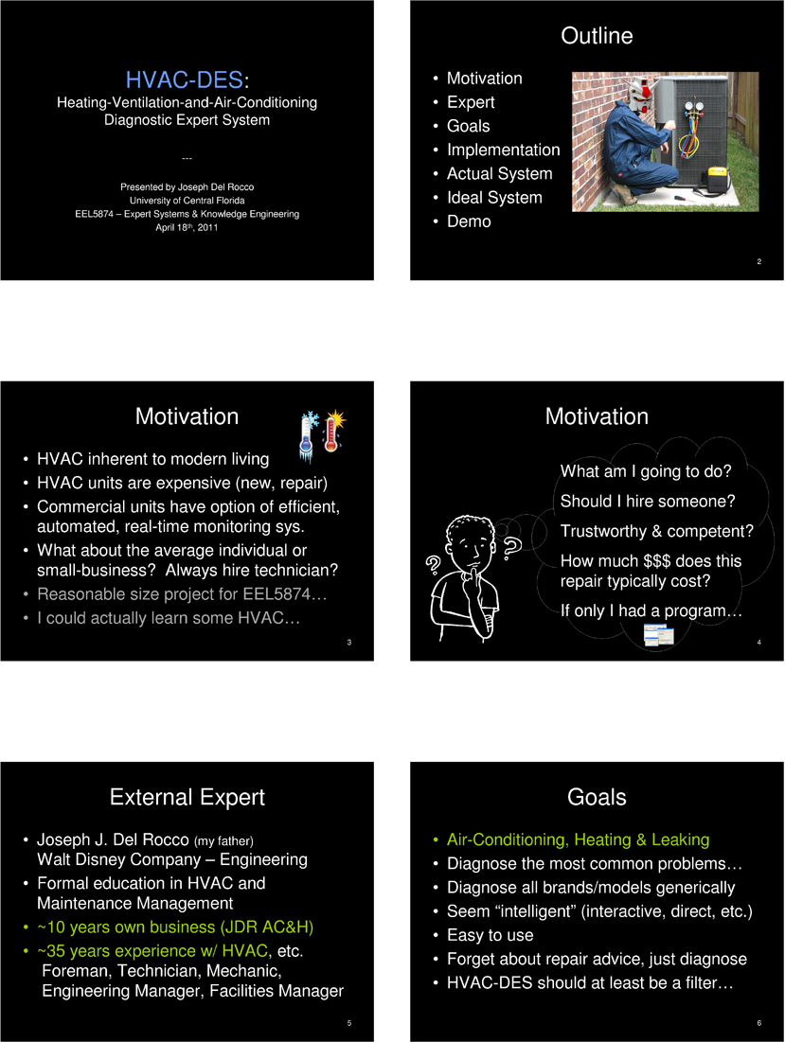

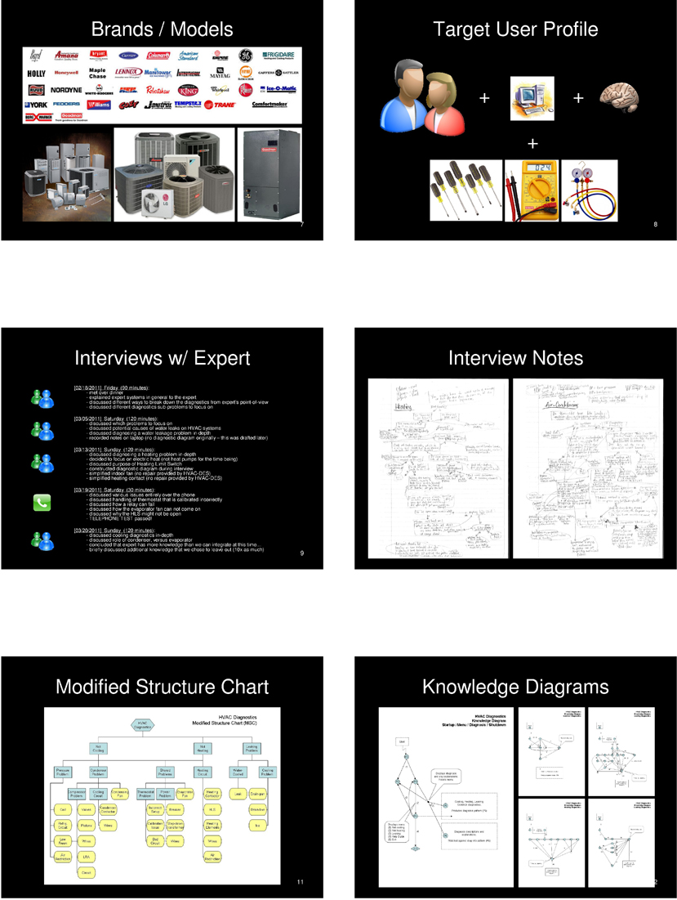

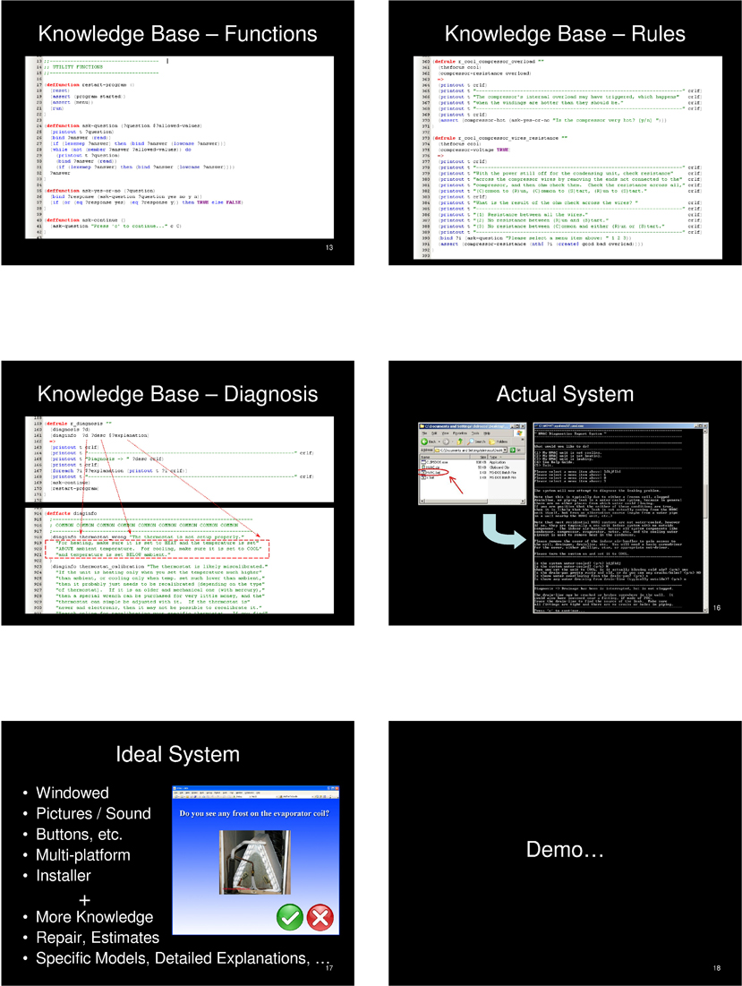

Appendix D: User’s Manual

The embedded “Help Guide,” as provided within HVAC-DES itself, is depicted below. It was written specifically to be short enough for users to easily digest, while still understanding the basics of the program. We are of the opinion that documentation that is too lengthy is often overlooked. A “Start-up Guide” follows below.

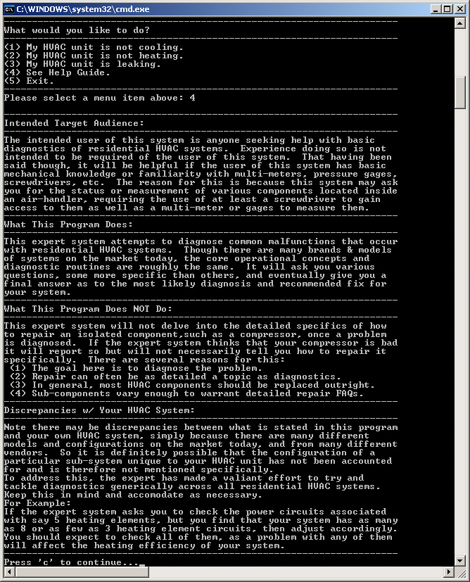

Provided Files
HVAC-DES is composed entirely of the files depicted below. The executable file “CLIPSDOS” is the DOS version of the CLIPS shell as provided by Gary Riley and the team that maintains CLIPS (more information is available at http://clipsrules.sourceforge.net/). The file “HVAC.clp,” contains the entire knowledge base of HVAC-DES at its release, and is composed in the CLIPS language. “HVAC.bat” is intended to be run by the user to start HVAC-DES, and “x.bat” is used internally (i.e. not intended to be run by the user at any time).

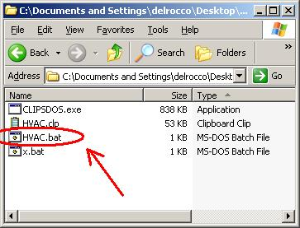

To start HVAC-DES, double-click HVAC.bat. This will handle loading the program into the CLIPS shell, and opens a console window for the user to interact with the program.

Menu
Once HVAC-DES is running scroll to the bottom of the console window. Here you will find the program menu. Select a menu choice by typing the appropriate number and hitting the enter key. Other than the menu item “Exit,” the program will always return to the menu when finished with a particular task. This provides you with the opportunity to run several diagnostics before exiting the program. If one of the diagnostics tasks is chosen, the program will display an explanation followed by some directions. Follow the directions as provided by HVAC-DES at this point to progress through the program.
Note that there is also a “Help Guide” built into HVAC-DES. Use it to view an explanation of the system. Finally, select the menu item that corresponds to “Exit” when you are ready to terminate the program.

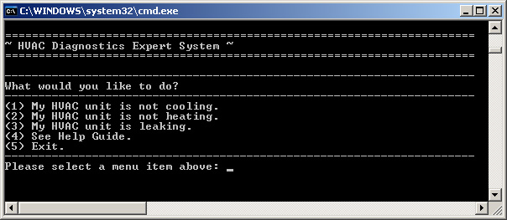

Appendix E: Development Diagrams

Diagrams crafted during development are provided below. They account for the three major sub-systems of diagnostics in HVAC-DES, cooling, heating and leaking. Because of its simplicity, no diagram of the main loop was ever created. While the knowledge base doesn’t follow these diagrams 100% accurately, they are still very closely representative of the final logic. Note the discovery of common logic shared by the cooling and heating sub-systems. Heating was developed first, so the common logic is depicted in the heating diagram and merely referenced by the cooling diagram.

