Clinical Efficacy Analysis: Sleep Dataset BZAN 6350
Delruba
2026-05-01
# 1. Data Collection & Understanding
data(sleep)
str(sleep)
## 'data.frame': 20 obs. of 3 variables:
## $ extra: num 0.7 -1.6 -0.2 -1.2 -0.1 3.4 3.7 0.8 0 2 ...
## $ group: Factor w/ 2 levels "1","2": 1 1 1 1 1 1 1 1 1 1 ...
## $ ID : Factor w/ 10 levels "1","2","3","4",..: 1 2 3 4 5 6 7 8 9 10 ...
summary(sleep)
## extra group ID
## Min. :-1.600 1:10 1 :2
## 1st Qu.:-0.025 2:10 2 :2
## Median : 0.950 3 :2
## Mean : 1.540 4 :2
## 3rd Qu.: 3.400 5 :2
## Max. : 5.500 6 :2
## (Other):8
# 2. Data Cleaning & Preparation
sleep$group <- as.factor(sleep$group)
sleep$ID <- as.factor(sleep$ID)
# 3. Exploratory Data Analysis (EDA)
library(ggplot2)
## Warning: package 'ggplot2' was built under R version 4.5.3
# Boxplot comparing extra sleep by drug group
ggplot(sleep, aes(x = group, y = extra, fill = group)) +
geom_boxplot(alpha = 0.7) +
geom_jitter(width = 0.2) +
labs(title = "Extra Sleep Hours by Drug Group",
x = "Drug Group", y = "Hours of Extra Sleep") +
theme_minimal()
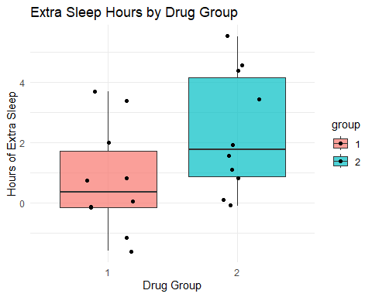
# Line plot to show individual patient response
ggplot(sleep, aes(x = group, y = extra, group = ID, color = ID)) +
geom_line() +
geom_point() +
labs(title = "Individual Patient Responses to Soporific Drugs",
x = "Drug Group", y = "Extra Sleep") +
theme_light()
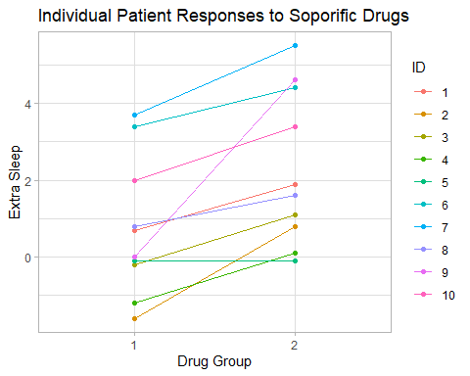
# 4. Data Modeling (Paired T-test)
# Perform paired t-test
group1 <- sleep$extra[sleep$group == 1]
group2 <- sleep$extra[sleep$group == 2]
# Perform the Paired T-test using the vectors
t_test_result <- t.test(group1, group2, paired = TRUE)
# Print results
print(t_test_result)
##
## Paired t-test
##
## data: group1 and group2
## t = -4.0621, df = 9, p-value = 0.002833
## alternative hypothesis: true mean difference is not equal to 0
## 95 percent confidence interval:
## -2.4598858 -0.7001142
## sample estimates:
## mean difference
## -1.58
# 5. Model Validation (Checking Normality of Differences)
diffs <- sleep$extra[sleep$group == 2] - sleep$extra[sleep$group == 1]
shapiro.test(diffs) # Shapiro-Wilk test for normality
##
## Shapiro-Wilk normality test
##
## data: diffs
## W = 0.82987, p-value = 0.03334
qqnorm(diffs); qqline(diffs)
