Project-Urban Food Delivery Analysis and Prediction BZAN 6351
Delruba
2026-04-27
#Load Libraries
library(tidyverse)
## Warning: package 'ggplot2' was built under R version 4.5.3
## Warning: package 'dplyr' was built under R version 4.5.3
## ── Attaching core tidyverse packages ──────────────────────── tidyverse 2.0.0 ──
## ✔ dplyr 1.2.0 ✔ readr 2.1.6
## ✔ forcats 1.0.1 ✔ stringr 1.6.0
## ✔ ggplot2 4.0.2 ✔ tibble 3.3.1
## ✔ lubridate 1.9.4 ✔ tidyr 1.3.2
## ✔ purrr 1.2.1
## ── Conflicts ────────────────────────────────────────── tidyverse_conflicts() ──
## ✖ dplyr::filter() masks stats::filter()
## ✖ dplyr::lag() masks stats::lag()
## ℹ Use the conflicted package (<http://conflicted.r-lib.org/>) to force all conflicts to become errors
library(ggplot2)
library(caret)
## Warning: package 'caret' was built under R version 4.5.3
## Loading required package: lattice
##
## Attaching package: 'caret'
##
## The following object is masked from 'package:purrr':
##
## lift
library(dplyr)
#Load dataset
data <- read.csv("C:/Users/delru/Downloads/Food_Delivery_Times.csv")
## Quick check
head(data)
## Order_ID Distance_km Weather Traffic_Level Time_of_Day Vehicle_Type
## 1 522 7.93 Windy Low Afternoon Scooter
## 2 738 16.42 Clear Medium Evening Bike
## 3 741 9.52 Foggy Low Night Scooter
## 4 661 7.44 Rainy Medium Afternoon Scooter
## 5 412 19.03 Clear Low Morning Bike
## 6 679 19.40 Clear Low Evening Scooter
## Preparation_Time_min Courier_Experience_yrs Delivery_Time_min
## 1 12 1 43
## 2 20 2 84
## 3 28 1 59
## 4 5 1 37
## 5 16 5 68
## 6 8 9 57
str(data)
## 'data.frame': 1000 obs. of 9 variables:
## $ Order_ID : int 522 738 741 661 412 679 627 514 860 137 ...
## $ Distance_km : num 7.93 16.42 9.52 7.44 19.03 ...
## $ Weather : chr "Windy" "Clear" "Foggy" "Rainy" ...
## $ Traffic_Level : chr "Low" "Medium" "Low" "Medium" ...
## $ Time_of_Day : chr "Afternoon" "Evening" "Night" "Afternoon" ...
## $ Vehicle_Type : chr "Scooter" "Bike" "Scooter" "Scooter" ...
## $ Preparation_Time_min : int 12 20 28 5 16 8 12 5 20 29 ...
## $ Courier_Experience_yrs: num 1 2 1 1 5 9 1 6 6 1 ...
## $ Delivery_Time_min : int 43 84 59 37 68 57 49 46 35 73 ...
summary(data)
## Order_ID Distance_km Weather Traffic_Level
## Min. : 1.0 Min. : 0.590 Length:1000 Length:1000
## 1st Qu.: 250.8 1st Qu.: 5.105 Class :character Class :character
## Median : 500.5 Median :10.190 Mode :character Mode :character
## Mean : 500.5 Mean :10.060
## 3rd Qu.: 750.2 3rd Qu.:15.018
## Max. :1000.0 Max. :19.990
##
## Time_of_Day Vehicle_Type Preparation_Time_min
## Length:1000 Length:1000 Min. : 5.00
## Class :character Class :character 1st Qu.:11.00
## Mode :character Mode :character Median :17.00
## Mean :16.98
## 3rd Qu.:23.00
## Max. :29.00
##
## Courier_Experience_yrs Delivery_Time_min
## Min. :0.000 Min. : 8.00
## 1st Qu.:2.000 1st Qu.: 41.00
## Median :5.000 Median : 55.50
## Mean :4.579 Mean : 56.73
## 3rd Qu.:7.000 3rd Qu.: 71.00
## Max. :9.000 Max. :153.00
## NA's :30
#Data Cleaning
colSums(is.na(data))
## Order_ID Distance_km Weather
## 0 0 0
## Traffic_Level Time_of_Day Vehicle_Type
## 0 0 0
## Preparation_Time_min Courier_Experience_yrs Delivery_Time_min
## 0 30 0
data <- na.omit(data)
#Remove dulicate
data <- distinct(data)
#Ensure Correct data type
data$Weather <- as.factor(data$Weather)
data$Traffic_Level <- as.factor(data$Traffic_Level)
data$Time_of_Day <- as.factor(data$Time_of_Day)
data$Vehicle_Type <- as.factor(data$Vehicle_Type)
#Exploratory Data Analysis
#Delivery Time Distribution
ggplot(data, aes(x = Delivery_Time_min)) +
geom_histogram(binwidth = 5, fill = "blue", color = "White") +
ggtitle("Distribution of Delivery Time")
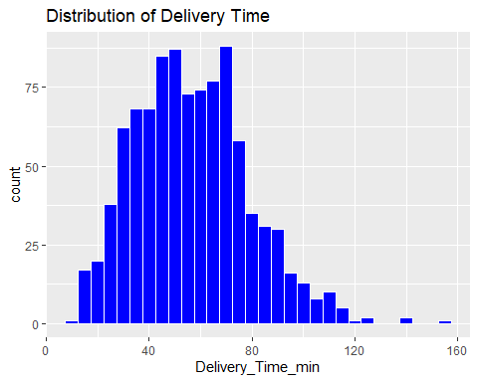
#Distance vs Delivery Time
ggplot(data, aes(x = Distance_km, y = Delivery_Time_min)) +
geom_point(alpha = 0.5) +
geom_smooth(method = "lm", color = "red") +
ggtitle("Distance vs Delivery Time")
## `geom_smooth()` using formula = 'y ~ x'
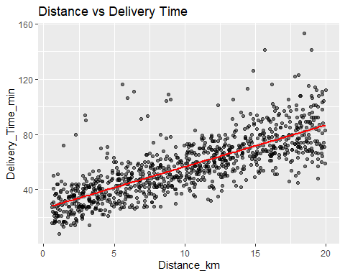
#Traffic Impact
ggplot(data, aes(x = Traffic_Level, y = Delivery_Time_min)) +
geom_boxplot(fill = "orange") +
ggtitle("Traffic Level vs Delivery Time")
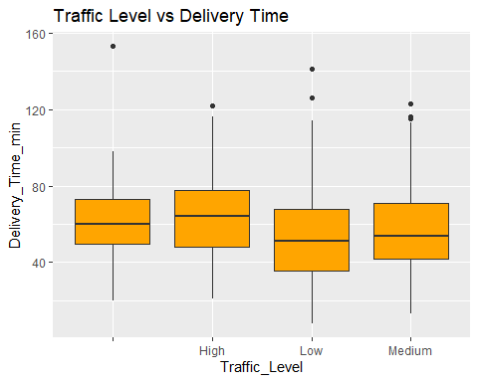
#Weather Impact
ggplot(data, aes(x = Weather, y = Delivery_Time_min)) +
geom_boxplot(fill = "skyblue") +
ggtitle("Weather vs Delivery Time")
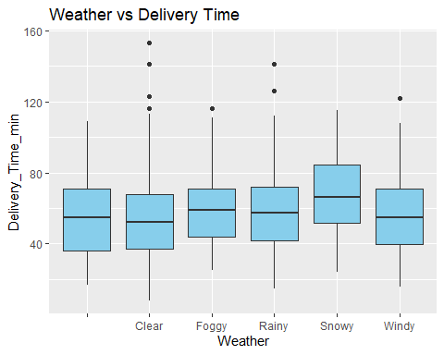
# Correlation Heatmap for Numerical Variables
library(ggcorrplot)
## Warning: package 'ggcorrplot' was built under R version 4.5.3
numerical_data <- data %>% select(Delivery_Time_min, Distance_km, Preparation_Time_min, Courier_Experience_yrs)
corr_matrix <- cor(numerical_data)
ggcorrplot(corr_matrix, lab = TRUE, title = "Correlation Heatmap")
## Warning: `aes_string()` was deprecated in ggplot2 3.0.0.
## ℹ Please use tidy evaluation idioms with `aes()`.
## ℹ See also `vignette("ggplot2-in-packages")` for more information.
## ℹ The deprecated feature was likely used in the ggcorrplot package.
## Please report the issue at <https://github.com/kassambara/ggcorrplot/issues>.
## This warning is displayed once per session.
## Call `lifecycle::last_lifecycle_warnings()` to see where this warning was
## generated.
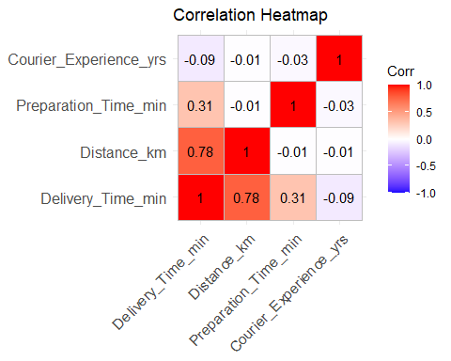
#Feature Selection
model_data <- data %>%
select(Delivery_Time_min,
Distance_km,
Traffic_Level,
Weather,
Courier_Experience_yrs,
Preparation_Time_min)
#Train-Test Split
set.seed(123)
train_index <- createDataPartition(model_data$Delivery_Time_min, p = 0.8, list = FALSE)
train_data <- model_data[train_index, ]
test_data <- model_data[-train_index, ]
#Model Building (Linear Regression)
model <- lm(Delivery_Time_min ~ ., data = train_data)
summary(model)
##
## Call:
## lm(formula = Delivery_Time_min ~ ., data = train_data)
##
## Residuals:
## Min 1Q Median 3Q Max
## -22.447 -5.101 -1.056 3.018 66.715
##
## Coefficients:
## Estimate Std. Error t value Pr(>|t|)
## (Intercept) 21.03138 3.31414 6.346 3.78e-10 ***
## Distance_km 3.02499 0.06743 44.864 < 2e-16 ***
## Traffic_LevelHigh 3.09272 2.24952 1.375 0.16958
## Traffic_LevelLow -8.76484 2.16720 -4.044 5.78e-05 ***
## Traffic_LevelMedium -3.28418 2.16824 -1.515 0.13027
## WeatherClear -7.02919 2.27411 -3.091 0.00207 **
## WeatherFoggy 1.36531 2.47069 0.553 0.58070
## WeatherRainy -1.44790 2.36036 -0.613 0.53978
## WeatherSnowy 3.95307 2.55628 1.546 0.12242
## WeatherWindy -4.07666 2.50844 -1.625 0.10454
## Courier_Experience_yrs -0.73702 0.13196 -5.585 3.24e-08 ***
## Preparation_Time_min 0.95517 0.05238 18.235 < 2e-16 ***
## ---
## Signif. codes: 0 '***' 0.001 '**' 0.01 '*' 0.05 '.' 0.1 ' ' 1
##
## Residual standard error: 10.55 on 766 degrees of freedom
## Multiple R-squared: 0.778, Adjusted R-squared: 0.7748
## F-statistic: 244.1 on 11 and 766 DF, p-value: < 2.2e-16
#Predictions
predictions <- predict(model, test_data)
#Model Evaluation
rmse <- sqrt(mean((test_data$Delivery_Time_min - predictions)^2))
print(paste("RMSE:", round(rmse, 2)))
## [1] "RMSE: 10.83"
rmse <- sqrt(mean((test_data$Delivery_Time_min - predictions)^2))
rmse
## [1] 10.82579
summary(model)$r.squared
## [1] 0.7780275
#Feature Importance
importance <- varImp(model)
plot(importance)
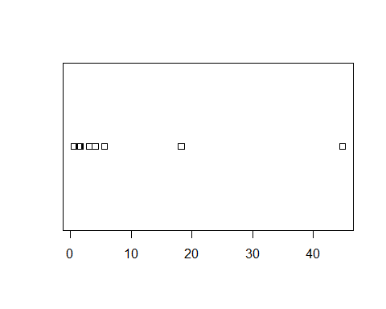
importance <- varImp(model)
print(importance)
## Overall
## Distance_km 44.8641745
## Traffic_LevelHigh 1.3748359
## Traffic_LevelLow 4.0443112
## Traffic_LevelMedium 1.5146792
## WeatherClear 3.0909632
## WeatherFoggy 0.5526026
## WeatherRainy 0.6134203
## WeatherSnowy 1.5464153
## WeatherWindy 1.6251739
## Courier_Experience_yrs 5.5852430
## Preparation_Time_min 18.2348652
plot(importance, main = "Variable Importance in Delivery Prediction")
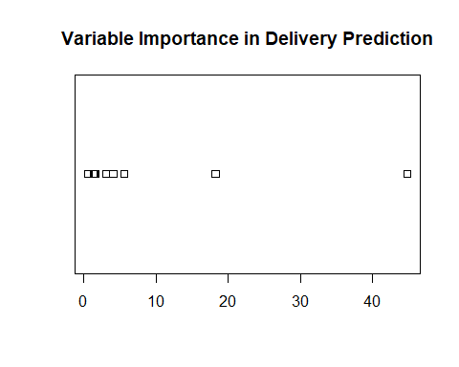
#Actual vs Predicted Plot
results <- data.frame(
Actual = test_data$Delivery_Time_min,
Predicted = predictions
)
ggplot(results, aes(x = Actual, y = Predicted)) +
geom_point(color = "blue") +
geom_abline(slope = 1, intercept = 0, color = "red") +
ggtitle("Actual vs Predicted Delivery Time")
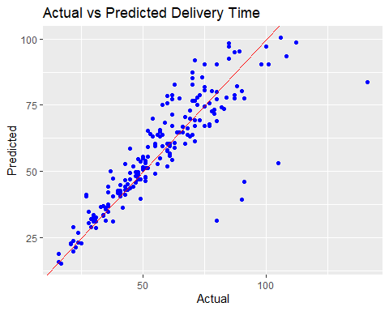
#Business Insight Summary
summary(data$Distance_km)
## Min. 1st Qu. Median Mean 3rd Qu. Max.
## 0.59 5.13 10.19 10.05 14.99 19.99
summary(data$Delivery_Time_min)
## Min. 1st Qu. Median Mean 3rd Qu. Max.
## 8.00 41.00 56.00 56.74 71.00 153.00

