Delta3D Simulation Core & Stealth Viewer build process
Version 0.6 -3/19/2009

Introduction
This document covers downloading, building, and running the Delta3D Simulation Core & Stealth Viewer suite of applications. These are the modules involved in the process: Delta3D, dtPhysX, and SimulationCore.

- Delta3D is an open source simulation gaming engine available from SourceForge.
- dtPhysX is an integration of PhysX, the commercial physics engine from Nvidia, with Delta3D. Using dtPhysX requires installing OS Drivers and an SDK. PhysX was formerly owned by Ageia until they were acquired by Nvidia, so the name Ageia will still be found in the library. dtPhysX refers to the sub-project itself, dtAgeiaPhysX refers to the repository directory name. dtPhysX is part of delta3d-extras on SourceForge.net.
- dtPhysics is a separate library that replaces dtPhysX, but is currently not supported as completely. It supports many physics engines via an abstraction layer. The HMMWV and Driver Demo do not yet run on dtPhysics. dtPhysics can be used to avoid installing PhysX if PhysX doesn't exist for the target configuration, isn't required, or is for some reason undesirable.
- SimulationCore contains both the SimulationCore libraries and the StealthViewer. Some art assets and data files that could be released to open source are also included with it; however, in general, you will need to provide your own 3D assets as well as your own HLA configuration files and RTI. SimulationCore is part of delta3d-extras on SourceForge.net.

*** NOTE - There is also a 5th repository of material called, DVTE-SimViewer, that is based on the Simulation Core and works with this system. This repository contains optional material that is not publically accessible unless you have access to US GOTS material. It contains the HMMWV driving simulator, night vision goggle support, a large set of art assets (such as 3D models) and configuration data, and road-based dead-reckoning support. If you believe your organization/company/project qualifies to have access to this material, you will need to contact Curtiss Murphy at Alion Science and Technology, cmmurphy@alionscience.com. As part of that request, you will need to have an official government sponsor involved.

The Simulation Core and Stealth Viewer suite is supported on both Linux x86 and Windows XP 32bit. It has also been known to work on Mac OS X and Linux x86-64.

Build Environment
All of the sub-projects that make up the Simulation Core and Stealth Viewer are built using CMake. This process typically supports both version 2.4.8 and 2.6.x. CMake is a powerful tool that allows you to define a single build process that can support builds on a wide variety of build environments. For this document, we will focus on Makefiles for Linux and Visual Studio 2005 (ver 8) for Windows. Visual Studio 2003 and 2008 should work, but all external dependencies will need to be rebuilt with the appropriate compiler. CMake is available at (http://www.cmake.org) – Downloads.

External Dependencies
The first process for building delta3d is getting the external dependencies.
  - Windows
Go to www.delta3d.org, then downloads, then Delta3D external dependencies. You want the 2.0 package for Visual Studio 2005 (8.0).
You will still have to download and build Qt 4.3.4 (ftp.trolltech.com/qt/source/qt-win-opensource-src-4.3.4.zip). Open a command window and "cd" to the directory where you extract the zip file. Run configure.exe and then run nmake and nmake install, which comes with visual studio. You may need to run vsvars.bat or vcvars.bat from visual studio to setup your paths prior to running configure.exe.
  - Linux
Depending on the distribution used, different methods exist for installing the dependencies. A full source package is available on SourceForge.net for Delta3d 2.2. It has a combined build and install script that will generate an ext directory like the one for Win32. For many distributions, such as Fedora and Ubuntu, most of the dependencies are available as prebuilt packages. The rest can be built from the source package. An easy way to do this is to edit the main script and comment out the scripts for the packages that are available on your distribution, then run it normally. The source package is also available from delta3d.org->Downloads->Delta3D External Dependencies. It is called dt_dep_src_2.2.tar.
Some Linux distributions have the environment variable QTDIR set by default. Make sure it is set to point to the 4.4.x version of QT. The value is /usr/lib/qt4 on Fedora 6 through 10.

Checking Out the Source Repositories
The Delta3D 2.2 release has been modified on the trunk with changes that the Simulation Core and Stealth Viewer require. Release branches also exist where the stable versions of the various sub-projects are matched up.
You will need a Subversion client to download the source. Tortoise works well on Windows. Typically the command line is used on Linux, but two plugins, Subclipse and Subversive, exist for the Eclipse IDE as well (http://www.eclipse.org) if you are planning on doing development. Both are good quality.
Do checkouts of the four repositories into the same directory. Make sure the names of the resulting directories match the names of the respective repositories, that is delta3d, dtAgeiaPhysX, and SimulationCore.

Trunk URLs
https://delta3d.svn.sourceforge.net/svnroot/delta3d/trunk/delta3d
https://delta3d-extras.svn.sourceforge.net/svnroot/delta3d-extras/dtAgeiaPhysX/trunk
https://delta3d-extras.svn.sourceforge.net/svnroot/delta3d-extras/dtPhysics/trunk
https://delta3d-extras.svn.sourceforge.net/svnroot/delta3d-extras/SimulationCore/trunk
Recent Release Branch
https://delta3d.svn.sourceforge.net/svnroot/delta3d/branches/2009_01_27_A
https://delta3d-extras.svn.sourceforge.net/svnroot/delta3d-extras/dtAgeiaPhysX/branches/2009_01_27_A
https://delta3d-extras.svn.sourceforge.net/svnroot/delta3d-extras/SimulationCore/branches/2009_01_27_A

Building Delta3D
Building Delta3D first requires running CMake. CMake may be run on the command line or as an interactive UI. A configure shell script exist to make this process simpler on Linux. If you edit that script to match your settings, you can run it once and be finished. In either the command line or UI case, CMake attempts to figure out the values for variables needed to generate the build system. The variables can be options, library paths, include paths, etc. These values may be set directly on the cmake command line using -Dname=value or in the UI. Here are the specifics for the UI with explanations for command line usage.
- Run CMake (most likely, this is C:\Program Files\CMake 2.6\bin\cmake-gui.exe or CMakeSetup.exe).
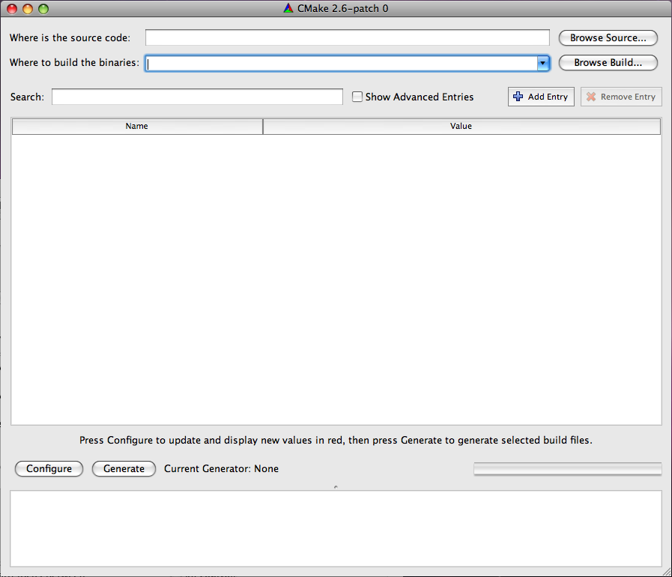
- Set the source path and the build binary path. Both should be the path to the root of your Delta3D project (ie, something like C:\Projects\Delta3D). CMake can support having the source and binary paths being different, but it is easiest to keep them the same.
- Once that is done, hit the configure button. It will then ask what generator to use.
    - Windows
On Windows, pick Visual Studio 2005.
    - Linux
On Linux, pick Unix Makefiles. While other generators should work, they are not covered in this document. On the command line, the generator is selected using the -G option, e.g. cmake . -G "Unix Makefiles". "Unix Makefiles" is the default on Linux.
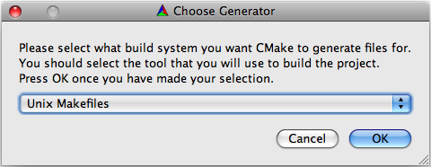
- After clicking okay, CMake will run a first round of configuration. It will show what paths it found, what it didn't find, and what options are available. Everything will be highlighted in red at this point because the values are not considered final. As part of the configure step, it makes some effort to resolve some of the settings. It will look for a DELTA_ROOT and other settings. Look at each of the settings and paths and verify that they are pointing to the correct directories.
- In addition to the overall settings, there are a few special settings that you need to consider. Look for the "BUILD_*" options in the UI. Note - if you are using the command line, you may set them with the "-D" option.
  - BUILD_BINDINGS: Enable this, or set it to ON, if you want to build the python bindings. You don't need these for the Simulation Core or the StealthViewer, and they take a considerable amount of time to compile. We recommend you disable this.
  - BUILD_EXAMPLES: Enable this, or set it to ON, if you want to build the delta3d example apps. These take time to build, and are unnecessary, but are helpful for development and also can be run to quickly verify if Delta3D is configured properly.
  - BUILD_HLA: Enable this, or set it to ON, if you want to build the HLA components. This is required for the Simulation Core and the Stealth Viewer, but you will need to supply your own RTI. You will have to set a few paths in a future step. Several RTI's are supported in the delta3d build. It should default to RTIS. Options exist to switch to other RTIS. Theses options are USE_RTIS, USE_CERTI, and USE_MAK. You should set only one to ON. On the command line do -DUSE_RTIS=ON, for example.
  - BUILD_ISENSE, BUILD_PLIB: These options deal with interfaces to joysticks and trackers. These are not used, so there is no need to enable them unless your custom application needs them.
- Run configure again.
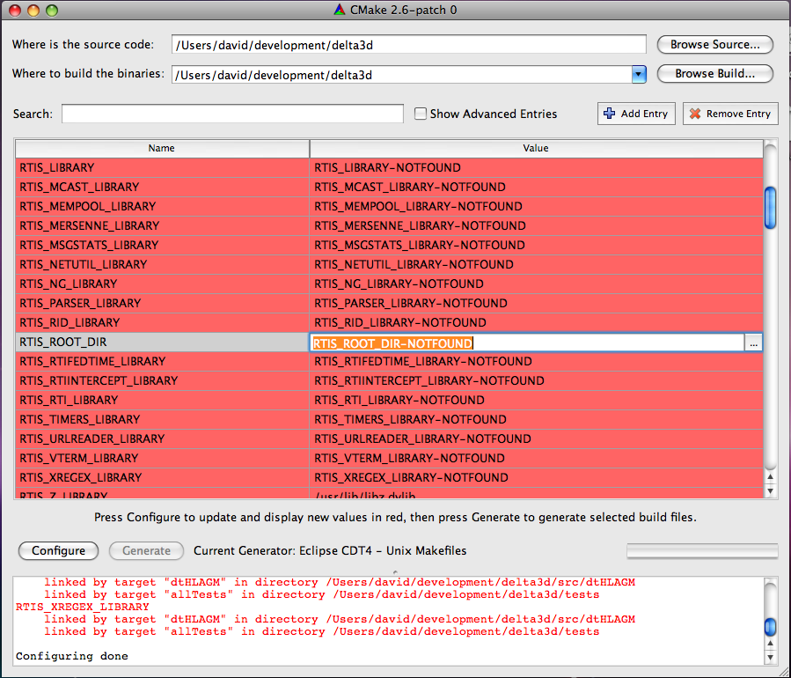
- Once configure finishes, you will see new variables for RTIS build options. If you have RTI and RTI_HOME set in your environment variables, it will probably find your RTI files. If these values are not correct, try setting the RTIS_ROOT_DIR option in the UI and press Configure again. Note – if you are using the command line, simply add -DRTIS_ROOT_DIR=YourPathToRTI. Run configure again.
- Hopefully, you now have no red values and no errors. Hit "Generate" or ‘OK’.
- Build Delta3D
    - Windows
On Windows, a “Delta3D.sln” file should exist in the root of the delta3d directory. Open your Visual Studio in the normal way and then open the solution file and build it.
    - Linux
On Linux, you should have a Makefile in the root. Running make (or make -j[x] where [x] is the number of concurrent threads), will build Delta3D. The default command line in the Linux configure script is:
cmake -debug-output . -DBUILD_HLA:BOOL=ON -DUSE_RTIS=ON -DBULID_PLIB:BOOL=ON -DBULID_BINDINGS:BOOL=ON -DBULID_ISENSE:BOOL=ON -DCMAKE_BUILD_TYPE=Release
You should change it to
cmake -debug-output . -DBUILD_HLA:BOOL=ON -DUSE_RTIS=ON -DBULID_PLIB:BOOL=OFF -DBULID_BINDINGS:BOOL=OFF -DBULID_ISENSE:BOOL=OFF -DCMAKE_BUILD_TYPE=Release -DRTIS_ROOT_DIR=[Your rti-s path]
If all the dependencies are setup correctly, this command line should run and build the Makefiles with no errors.

Note, If you need to support an RTI other than one that is supported, you can it by looking at the ones in the CMakeModules folder and make your own. If you add support for another RTI and would like to submit it, send the changed files and instructions to info@delta3d.org. The same is true for any Delta3D submissions. SimulationCore and the optional DVTE-SimViewer projects will have to updated to allow building the other RTI versions.

Building dtPhysX
This library is currently the more supported physics solution. You can build also build and run the StealthViewer using dtPhysics. Going forward, all the applications will support dtPhysics, and eventually it is planned to replace dtPhysX since it supports many physics engines including PhysX, ODE, and Bullet. dtPhysics is also planned to by migrated into delta3d proper as the delta3d physics solution. Today, however, if you plan on running the physics based applications such as the Driver Demo, or the HMMWV sim, you must build dtPhysX and compile support for it into SimulationCore. If you are writing a new application, dtPhysics is something to consider.
The process for dtPhysX is basically the same as delta3d above except that you point both CMake paths to your root dtPhysX directory. There are no build options to set, but you will need to install the PhysX System Software and SDK. Depending on which version or versions you have installed, CMake may not locate all of your directories. We recommend using PhysX version 2.7.3 at the moment, although 2.8.1 is being used on a number of applications done by other groups.

For Linux, there is just one tar.gz file that extracts into a set of RPMS. Once you extract them, you can install them as root by typing rpm -i *.rpm, assuming you have no other rpms in the directory where you extract it. If you are on a system that doesn't use RPMS, go to http://developer.nvidia.com/object/physx_downloads.html and get the .deb version. PhysX does not run on 64 bit Linux.

The CMake build will attempt to find the PhysX installation in the default locations. If CMake doesn't find it, you will need to set PHYSX_BASE_INCLUDE_DIR and possibly PHYSX_LIB_DIR_SEARCH. The base include directory is the parent directory for all the sub-library includes. It should contain the paths Cooking/include, Foundation/include, etc. Usually the directory is name SDKs. PHYSX_LIB_DIR_SEARCH should be found automatically on Windows since the libraries are under the SDKs folder. On Linux, it is /usr/lib/PhysX by the default. It should contain a version number directory such as "v2.8.0" which contains the libraries.

Also note that dtPhysX looks for delta3d in "../delta3d". If you don't have a DELTA_ROOT environment variable set and delta3d is not in the same parent directory as the dtAgeiaPhysX directory, you will have to set the DELTA_DIR CMake variable in the UI or on the command line with -DDELTA_DIR=[my path].

Assuming you have PhysX and Delta3D installed in the expected places, the configure script in the root should work for Linux without modification. You are now ready to build dtPhysX using Visual Studio (dtPhysX.sln) or make files.

Building SimulationCore
Use CMake on SimulationCore the same way you did for Delta3D and dtPhysX. In addition to resolving your paths, there are 2 important build options:
- BUILD_HLA: This option determines whether SimulationCore uses HLA or not. It defaults to ON or enabled. HLA is needed for the Stealth Viewer and some of the ther libraries, but you will have to provide your own RTI. See the section on building Delta3D for setting up the build with your own RTI. It works exactly the same way. If you do not enable this, the Stealth Viewer and HMMWV apps will not work. It is optional because some developers use various parts of the Simulation Core for non-HLA applications.
- USE_PHYSX, USE_dtPhysics: These both default to OFF. However, you must pick one. USE_PHYSX supports dtPhysX while USE_dtPhysics support building with dtPhysics. There are reasons for picking each one, so read the section about building dtPhysX for more information. USE_PHYSX is the more supported option currently, so we recommend using that in most cases. Using dtPhysics is not covered well in this document now, so if you are considering using it, contact David Guthrie directly at dguthrie@alionscience.com or on the delta3d forum at http://delta3d.org.
SimulationCore looks for Delta3D in "../delta3d". If you have not put it there, you will need to set the DELTA_DIR variable in the UI or with the "-DDELTA_DIR=[my path]" command line option. Likewise it looks for dtAgeiaPhysX in "../dtAgeiaPhysX" or "../dtPhysX". You can override that by setting DTPHYSX_DIR.
    - Windows
On Windows, a “SimulationCore.sln” file should exist in the root of the SimulationCore directory. Open your Visual Studio in the normal way and then open the solution file and build it.
    - Linux
Assuming you have Delta3D, PhysX, and dtPhysX installed in the expected places, the configure script in the root should work for Linux if you simply set -DRTIS_ROOT_DIR=[Your rti-s path]. That is, the full command line should like:

cmake -debug-output . -DBUILD_HLA:BOOL=ON -DUSE_AGEIA=ON -DCMAKE_BUILD_TYPE=Release -DRTIS_ROOT_DIR=[Your rti-s path]

or

cmake -debug-output . -DBUILD_HLA:BOOL=ON -DUSE_AGEIA=OFF -DCMAKE_BUILD_TYPE=Release -DRTIS_ROOT_DIR=[Your rti-s path]

Running Delta3D Applications
Once CMake is run on all the repositories, and built using CMake or Visual Studio, applications still will not run because all of the compiled libraries will need to be added to the library path. For these examples, remove the references to DVTE-SimViewer if you do not have access to that repository.

    - Windows
The accepted solution on Windows has been to run Visual Studio from a batch file so that the path will be setup, but you also set the environment variables system-wide. Either way, you need to set DELTA_ROOT, DELTA_DATA, and PATH. Here is an example DEV environment variable with all the projects installed there:
set PATH=%DEV%\dtAgeiaPhysX\bin;"C:\Program Files\Ageia Technologies\Ageia PhysX SDK\v2.7.3\Bin\Win32";%DEV%\SimulationCore\bin;%DEV%\DVTE-SimViewer\bin;%DEV%\delta3d\bin;%DEV%\delta3d\ext\bin;%DEV%\delta3d\ext\bin\osgPlugins;%DEV%\rtis-13\bin\win32_msvc-8.0;C:\Qt\4.4.3\bin
export DELTA_ROOT=%DEV%\delta3d
export DELTA_DATA=%DELTA_ROOT%\data
    - Linux
On Linux LD_LIBRARY_PATH needs to be set, as well as DELTA_ROOT and DELTA_DATA for the Delta3D examples to work. Assuming the DEV environment variable is set, here is an example
export LD_LIBRARY_PATH=${DEV}/dtAgeiaPhysX/lib:/usr/lib/PhysX/v2.7.3:${DEV}/SimulationCore/lib:${DEV}/DVTE-SimViewer/lib:${DEV}/delta3d/lib:${DEV}/delta3d/ext/lib:${DEV}/delta3d/ext/lib/osgPlugins:${DEV}/rtis-13/lib/linux_g++-4.1
export DELTA_ROOT=${DEV}/delta3d
export DELTA_DATA=${DELTA_ROOT}/data

