Summary of the Project

We first meet to discuss the structure of the project’s forms, we then created a first impressions E-R diagram. We then started to read the tutorials about how to implement the database.

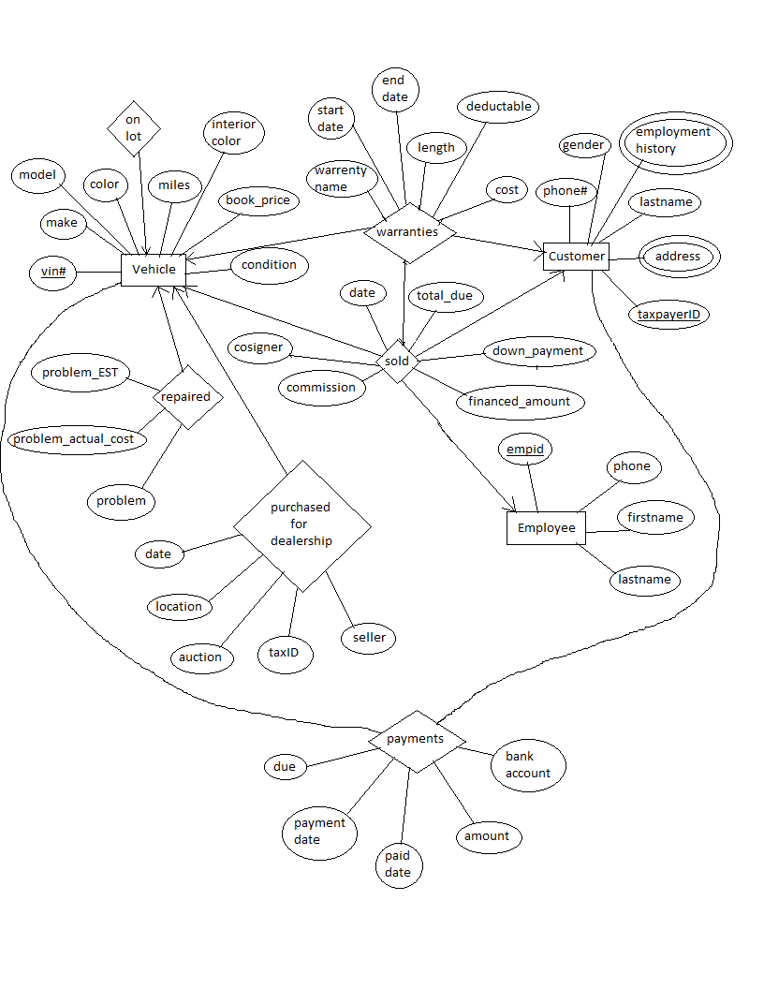

We thought it odd that the forms that the business used did not contain VIN in its reports, since the VIN of a vehicle is literally own unique identification number. We thought to add this as the primary key for vehicles. We tried to mimic the forms used by the company to create our input forms.