Testing plane to get pathfinder working

* Calculate ka and kv for different percent outputs of power
  + .6,.8, 1 precent output levels
  + Voltage from left and right side motor controller
  + Velocity from encoder data in meters
  + Calculate ka, kv from graph
    - = to 1/m form linear fit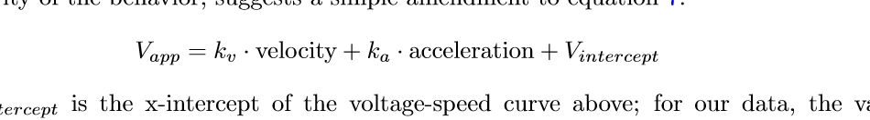
  + Drive delta for acceleration. I don’t know if accelorimiter from navx is useable
  + Calculate max jerk, find max velocity and max acceleration for different percent outputs of the robot
  + Eventually consider factoring in v intercept if needed to get more accurate profile
  + Collect and calculate for both sides of the robot… left and right side just to see if there is any wild difference which need to be taken into account when tuning
* Tune kp
  + Start it at about .8
  + Jacii says ki, kd , not really needed will se when we tune the robot for a wide verity of paths
* Add in nav x correction
  + Need do more digging on it.
* Add in csv load / write functionality for paths
  + Already sort of developed on old branch
* **GOAL: To get some sort of pathfinder functionality working for state.**

figure one. Linear relationship when determining kv.

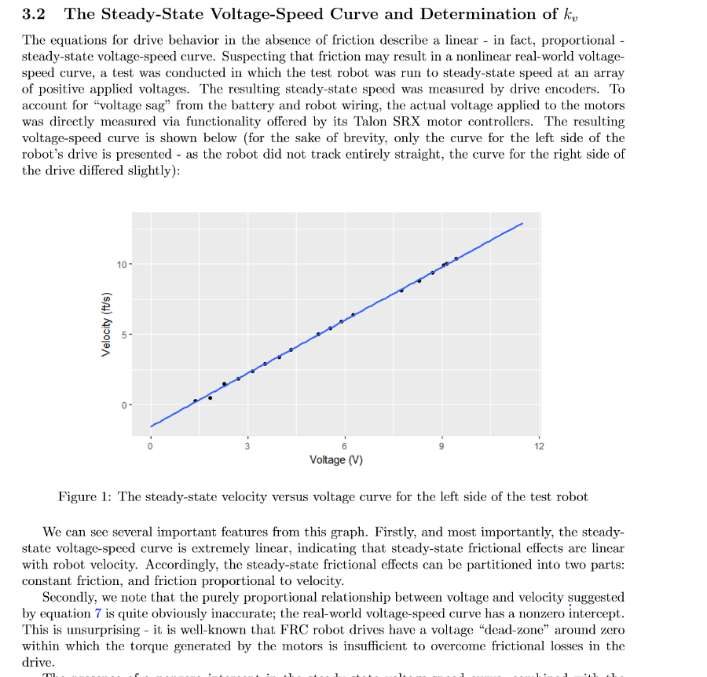

Figure two vapplied to motors with eqatuion what it really means. Would be a interesting thing to mess around in excel with for fun.