
GridPilot
User's Guide
Frederik Orellana
Niels Bohr Institute
University of Copenhagen
May 2009

Table of Contents
Introduction 2
Getting started 4
License 4
Requirements 4
Installing/upgrading 4
The user interface 5
The main window 5
The file browser 8
The monitoring window 9
The job monitor 9
The file transfer monitor 10
The log viewer 11
Running jobs 11
Building a transformation 11
Building a dataset 12
Generating job definitions 13
Submitting jobs 15
Monitoring jobs and retrieving output files 16
Examples 17
Running a simple job 18
Running 10 simple jobs 18
Deploying runtime environments 19
Finding and downloading a file from a GridFTP server 19
Registering files on a GridFTP server in a file catalog 20
Publishing files registered in one file catalog in another 22
Replicating ATLAS data from an SRM server to a GridFTP server 23
ATLAS Combined Test Beam photon simulation 25
ATLAS Combined Test Beam photon digitization 29
ATLAS Combined Test Beam electron (proton or muon) simulation 30
ATLAS mSugra simulation 33
Analyzing ATLAS AOD registered in DQ2 36
Appendix A: The configuration file 39
Configuration parameters 40
Appendix B: Bug reports and feature requests 50
Known issues 50
Reporting 51
Appendix C: Changing schemas 51
Acknowledgements 54

Introduction
This guide covers the functionality of GridPilot -0.2.0.
GridPilot is a tool to facilitate various tasks related to grid computing. More precisely, GridPilot has a plugin architecture for running computing jobs on various execution back-end. Currently supported execution back-ends are:
- local forking of processes
- remote forking of processes via SSH
- forking of processes in a locally running virtual machine (via SSH)
- GridFactory
- Amazon Elastic Compute Cloud
- NorduGrid/ARC
- EGEE/gLite
In order to manage many jobs, bookkeeping information is kept in a database table. This table can be hosted on various job database back-ends. Supported job database back-ends are:
- a local in-memory Java SQL engine, HSQLDB
- a remote MySQL database with plain password or X509 authentication (using a personal grid certificate)
In order to manage the input and output of jobs, various file transfer systems are supported:
- the local file system (on both UNIX/Linux and Windows)
- HTTPS with X509 authentication of both client and server
- GridFTP
- SRM
Moreover, in order to catalog these files, various file and dataset catalogs are supported:
- a local HSQLDB catalog
- a remote MySQL catalog
- ATLAS DQ2
- LFC
The various databases can be searched and the results are displayed as tables. When appropriate, rows can be copy-pasted between these tables. This makes e.g. copying information from one file catalog to another a trivial operation for the user.
For GridPilot, a job is a script running on a machine somewhere. Typically a "production" of data will then involve one Linux shell script (calling calling one or several applications) running with different input parameters on many machines. Such a production will result in a number of output files, which together make up a dataset. The jobs are prepared and run by GridPilot, following the instructions of the user. These instructions are given by filling two records in database tables. The records to be fill in are:
- a transformation record: a record with fields like "script", "arguments" and "outputFiles", specifying the location of the script (on the local disk, on a web server or on a GridFTP server), the arguments to run this script (like e.g. ./myscript.sh my_input_file.txt 3) and the names of the output files produced (and registered in a dataset/file catalog)
- a dataset record: a record with fields like "transformationName", "totalFiles" and "inputDataset", specifying the transformation used to produce this dataset, the number of files making up this dataset and the name of the dataset labeling the collection of input files
After this has been done, a number of job definition records are produced by GridPilot. These can be "submitted" to any of the execution back-ends, which will result in output files that can be registered as file records.

Getting started

License
GridPilot is provided under the terms of the GNU General Public License, available at http://www.gnu.org/licenses/gpl.html. This means that GridPilot is provided "as is" - the authors of GridPilot do not take any responsibility what so ever for any consequence of its use. The source code of GridPilot is available at http://www.gridpilot.dk/ or upon request.

Requirements
General
- SUN's Java Runtime Environment (JRE) 1.6.0_07 or higher. Get it here
- 500 MB of RAM or more
For using grid resources
- an X509 certificate with and accompanying secret RSA key
For using remote databases
- a fast and stable Internet connection: preferably 256 Mb/s or more, both ways

Installing/upgrading
To install:
- download the appropriate installer, zip file or tarball from http://www.gridpilot.dk/
- run the installer
- run GridPilot – this will trigger a series of configuration questions
If you're upgrading from a previous version, you should first delete or rename the configuration file “.gridpilot” (under UNIX/LInux) or “gridpilot.conf” (under MS Windows) and the directory “GridPilot”. After running the new version of GridPilot for the first time, you may then migrate your old configuration settings and/or files in the directory “GridPilot” by hand.

The user interface

The main window
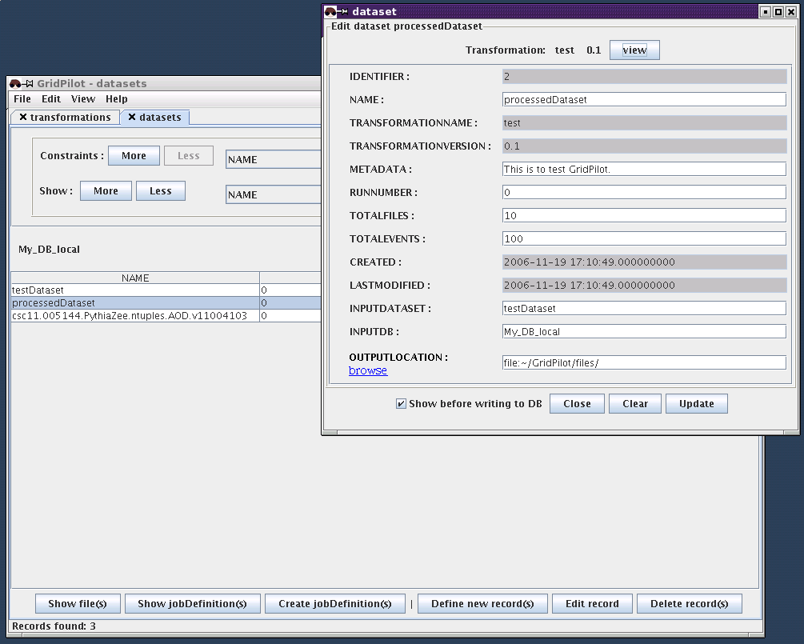
The main window and a dataset editing window.

The main window holds tabs that each contain a search interface for one of the database tables of "runtimeEnvironments", "transformations", "datasets", "jobDefinitions" or "files". When GridPilot starts, this window holds one or several tabs (specified in the configuration file). Tabs can be closed by clicking the small cross. New tabs can be opened by selecting "View" → [database] → [table]. Tabs can be rearranged by dragging and dropping.
The upper part of a tab holds the query interface. Queries can be narrowed by adding more constraints (internally, the constraints are combined with a logical and).
The lower part of a tab holds a table displaying the search results. Clicking on the column names causes the list to be sorted according to the values of that column. Selecting one or several row and right-clicking will bring up a menu of actions that can be performed on these record(s). One possibility is to edit or view an individual record. This is done by double-clicking on the corresponding row, using the right-click menu or the button at the bottom of the tab, which will bring up a small window with full record.
Of the 5 possible table types, only two should need manual editing: "transformations" and "datasets". The records of the "jobDefinitions" table are also generated by the user, but in an automatic fashion. These three tables will be discussed in turn in the section "Running jobs". The "runtimeEnvironments" table type and the "files" table type are not meant to, but can be edited by the user. Notice, however, that records from the "runtimeEnvironments" table that were generated automatically by GridPilot on startup, will be deleted when GridPilot exits.
A runtime environment table contains a list of runtime environments that can be selected when defining a transformation. This list is populated by the computing system plugins on startup. For example:
- the NorduGrid/ARC plugin queries the NorduGrid information system for installed runtime environments on the clusters where jobs can be executed with the active grid certificate
- the EGEE/gLite plugin queries the EGEE information system for installed runtime environments on the clusters where jobs can be executed with the active grid certificate
- the GridFactory, EC2 and *Fork* plugins query the defined runtime catalog URLs for installable runtime environments. You can add entries to a catalog with “Help” → ”Wizards: create software package”
Remark: The “runtime catalog URLs” is defined in the top-level of the configuration file. A runtime catalog is a text file in XML format containing information about runtime environments (software packages): where the software can be downloaded and on which other runtime environments it depends, etc. Currently, such catalogs are supported only by the GridFactory, EC2 and *Fork* plugins, but in the future also ARC sites will be able to subscribe to such catalogs .

A file table contains a list of files registered in the associated database back-end. Such a table is typically populated by GridPilot after determining that a job has finished successfully and its output files copied to a storage element. GridPilot can also register existing files that are not registered anywhere, replicate files and add the new locations to existing records or copy records from one database to another by simple copy-paste.

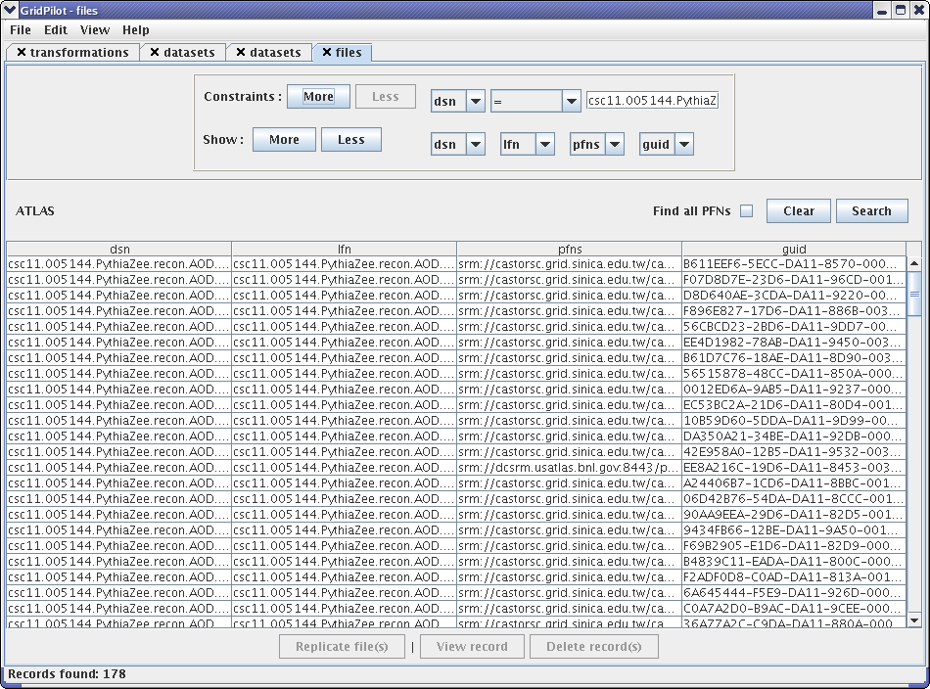
A file catalog tab in the main window.

Comment: technically, a "files" table is actually a "virtual table"; that is, it does not correspond to one table in a database. Instead, the file table can correspond to the physical tables "t_lfn", "t_pfn" and "t_meta"; or it is generated on the fly from the output files listed in the job definition table.

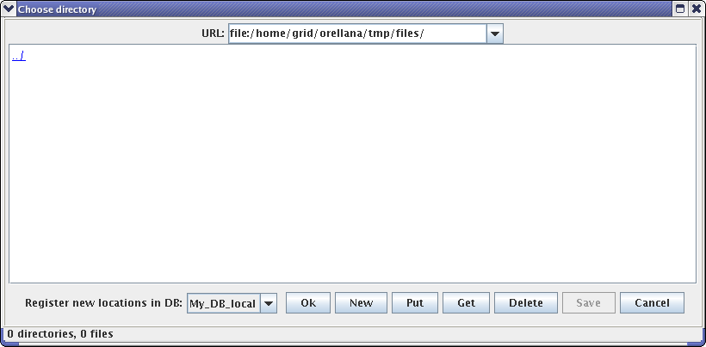

The directory chooser dialog presented when downloading/replicating files.
Files listed on a file table can be downloaded by clicking "Replicate file(s)" or from the right-click menu. The reason for using the word "replicate" instead of "download" is that the directory chooser that is popped up allows choosing a remote directory on a GridFTP server. If this is done, the file(s) will be copied using the third-party transfer capabilities of GridFTP. Another reason is that on the file chooser, one can also choose to have the new file locations registered in one of the available file catalogs.

The file browser

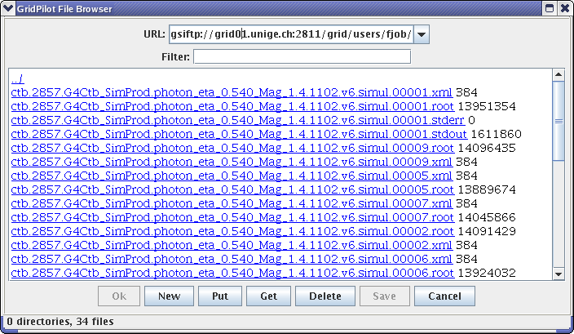
The file browser window.

The GridPilot file browser is opened by selecting "View" → "New browser" or typing ctrl+o. It works much like a standard file/web browser (e.g. the Explorer on MS Windows or Konqueror on Linux) with (very) limited functionality and some quirks. The main difference is that apart from the local file system and the web, also GridFTP servers can be browsed. Moreover, files can be downloaded and uploaded and files and directories can be created. The download/upload functionality is meant only for quickly accessing single, small files. Larger files should be transferred via the functionality provided on the file catalog tabs.
Hint: After typing in or selecting a URL from the history drop-down menu, you must hit return. Otherwise the location will not be opened, and, when the file browser is used a file/directory chooser, this means that what you actually choose is not the location you see in the address field of the browser, but a default location.

The monitoring window
The monitoring window contains at least three tabs. 3 of these tabs hold: a job monitor, a file transfer monitor and a log file viewer. The monitoring window is shown when a job is submitted or a file transfer is started. It can be manually shown or hidden by checking or unchecking "View" → "Show monitor", or by typing ctrl+m. Depending on which computing system plugins are enabled (in the preferences), other tabs may be present in the monitoring window – displaying information on virtual machines.

The job monitor

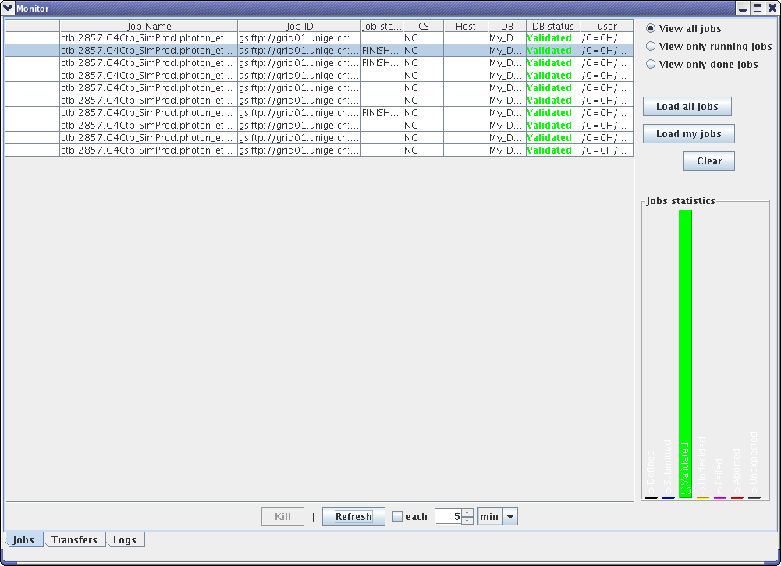
The job monitor tab in the monitor window.

If jobs were started with a previous launch of GridPilot, they can be retrieved by clicking "Load all jobs" or "Load my jobs". Alternatively, records can be selected in a "jobDefinitions" tab in the main window and chosen to be monitored with the button at the bottom or from the right-click menu.
Clicking "Clear" will simply clear the monitor, but not affect neither the running of the jobs nor the database records of the jobs. To update the status of all monitored jobs by querying their computing systems, the button "Refresh" should be clicked. Checking the "each" checkbox will cause such an update to be performed automatically with regular intervals.
The statistics panel shows current number of jobs that are validated, failed, running, etc. Different views are obtained by clicking on the graphics.
Clicking on the column names causes the list of jobs to be sorted according to the values of that column.
Selecting one or several jobs and right-clicking will bring up a menu of actions that can be performed on these jobs. These actions include killing the jobs, changing the job status and resubmitting the jobs.

The file transfer monitor

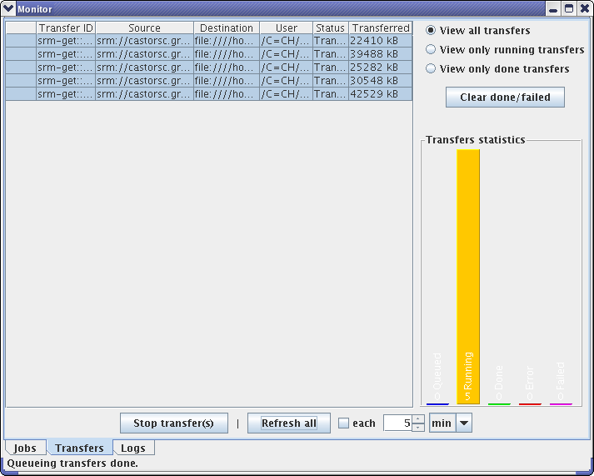
The transfer monitor tab in the monitor window.

Initiating a file transfer from the "files" tab in the main window will cause information about this transfer to be displayed on the file transfer monitor. The functionality of the file transfer monitor is very similar to that of the job monitor, with the important difference that information about file transfers is lost when GridPilot is closed. GridPilot is thus not meant to be used for large-scale file replication.
Hint: When downloading from an SRM server, GridPilot may time out before the server returns "Ready". This is usually solved by simply retrying the transfer manually, or changing the values of one or both of the following configuration parameters: “copy retries” and “copy retry timeout”.

The log viewer
Error information and some other information is logged in the file gridpilot.log. Information added since GridPilot was launched is displayed on the log viewer tab. Right-clicking in this tab will bring up a menu with some choices on how to display newly added information.

Running jobs
For GridPilot, every job and every file belong to a dataset. So, before running jobs and producing files, a dataset record must be defined.
Moreover, since a dataset is produced by a transformation, defining a dataset involves choosing a transformation. If a suitable transformation is not found in the transformation table, a new one should be defined.
The following should be considered when planning a production:
- where to store job information: this is determined by the database chosen for dataset record
- where to get input files: this is determined by the input dataset chosen when defining the dataset record
- where to store output files: this is chosen when defining the dataset record
- where to register output files: they will be registered in the database holding the dataset record
- on which computing resources to run: this is chosen on submission time

Building a transformation
A test transformation is automatically created on startup. It can be opened by double-clicking on the record on a "transformations" tab.
It is seen that the runtime environment chosen is "Linux". Clicking on the drop-down box reveals a list of names. These have been filled in by the enabled computing system plugins. If the right environment is not available, two things can be done: 1) a new one can be defined. This involves setting up the corresponding software on one or several computing back-ends. For example, when running locally, it involves writing a setup script and placing it in the folder defined in the configuration file by e.g. runtime directory = ~/GridPilot/runtimeEnvironments. 2) "Linux" can be chosen and a tarball containing the necessary software can be specified in the "inputFiles" field of the transformation record.
It is also seen that "name", "version" and "comment" have been specified. These are simply strings labeling the transformation.
The field "arguments" specifies which arguments the transformation script must be given. It must be given as a space separated list of strings. Each string can be anything, but typically is a mnemonic name, labeling the particular parameter given to the script. If the string is not one of the 'special arguments' listed in the section "Generating job definitions" it will appear as a field to be filled in when defining the jobs. The test transformation takes two arguments: "multiplier" and "inputFileURLs". "inputFileURLs" is one of the 'special arguments' and will be filled in automatically, leaving only "multiplier" to be filled in (any integer can be given).
The field "script" specifies the physical location of the transformation script. It can be on the local disk, on the web or on a GridFTP server.
The field "inputFiles" specifies input files that will be downloaded and placed next to the transformation script for all jobs. As mentioned above, this could for example be a tarball containing software used by the transformation.
Notice that in order to save typing work, one can simply use the menu items "Edit" → "Copy" and "Edit" → "Paste" to copy a transformation and then edit only the fields that need to be changed.

Building a dataset
The main consideration is whether or not the dataset to be defined has the files of another dataset as input files. If so, this other dataset should be found and selected on a "datasets" tab. Then, with this dataset record selected, the button "Define new record(s)" should be clicked. After clicking this button a window will pop up with fields to be filled in.
If an input dataset was selected, a drop-down box is presented, where the target database is chosen. In other words, it is allowed to define a dataset in one database with an input dataset from another. Once a choice has been made, most of the fields will be filled in automatically: fields that occur in both the source and target dataset records will be filled in with the values from the source. It is then up to one self to edit to one's liking. If several input datasets are selected, several new datasets will be defined. In this case, the fields are filled in with values from the first source dataset. Fields left empty will be filled with values from consecutive datasets.
The fields of the default schema that must be filled in are "name" and "outputLocation". If the data files to be produced are high energy physics data, they are likely to contain a number of so-called events. If the total number of events to be produced as output of the production is known, it can be specified in the field "totalEvents". The field "totalFiles" specifies the number of files to be produced. Optionally, one can fill in "metaData" with some information characterizing the data files in question.

Generating job definitions

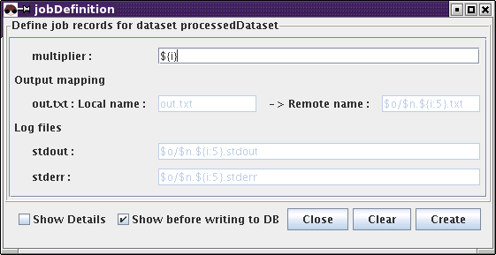
The job creation window.
Once a dataset record has been created, job definition records can be generated in an automatic way: on the "datasets" tab, select the created dataset record and click the button "Create job definitions". This will pop up a window that may or may not have fields to be filled in. If there are fields to be filled in, they will be unknown arguments of the transformation script. They may also be fields to be filled in if another schema than the default is used for the job definition table.
Usually it should not be necessary to fill in anything, or but a few static variables to be passed as arguments to the transformation script. For example, the output file(s) of the transformation are assigned a generated name to be used when uploaded to the final destination.
Clicking "Create" will pop up a confirmation window. Clicking "OK for all" will start the generation of the job definition records. This may take a few seconds, please leave the job definition window open to get the feedback that the generation of records has finished.

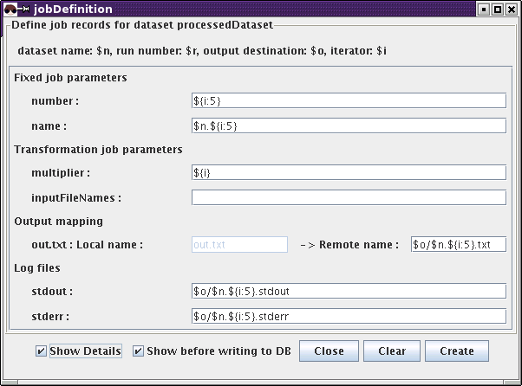
The job creation window with "Show details" checked.

There may be cases where even more control is needed. For such cases, a number of variables are available. Some of these are listed when the check-box "Show details" is checked. Here follows a list of all available variables:
$n | the value of the field "name" of the dataset record
$r | the value of the field "runNumber" of the dataset record
$o | the value of the field "outputLocation" of the dataset record
${i} | the number of the generated job definition (1,2,3,...)
${i:n} | the number of the generated job definition (1,2,3,...), padded with zeros to take up n digits
$1, $2, $3, ... | the value of the dataset field number 1, 2, 3, ...
Moreover, standard arithmetics can be used within curly braces. E.g. if ${i} is 4, then ${i:4} is 0004 and ${(i-1)%20 + 1} is equal to 5.
In general, when a transformation has some argument names specified in the field "arguments", GridPilot will prompt for the value of these when defining jobs. They will then be filled in the "jobDefinition" field "transPars". However, as mentioned, certain names are known and will be filled in automatically. These name are:
inputFileURLs | this argument will be assigned the value of the field of the same name in the job definition record, which in turn is filled in automatically if an input dataset has been chosen
nEvents | this argument will be assigned the value of the field of the same name in the job definition record, which in turn is filled in automatically if an input dataset has been chosen or the fields "totalFiles" and "totalEvents" have been filled in in the dataset record
eventMin | -''-
eventMax | -''-
inputFileNames | if left empty and an input dataset has been selected, this argument will be assigned the value of the field of the same name in the job definition record, which in turn is filled in automatically on job creation
Finally, if a transformation argument of name someName is matched by a line in the dataset field "metaData" of the form someName: some value, some value is filled in as value for the argument someName.

Submitting jobs
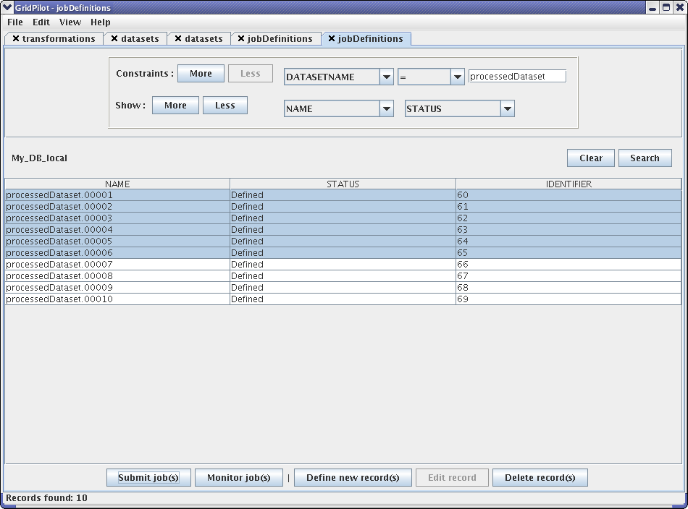
A job “definitions” tab in the main window.
Job submission is done by selecting jobs on a "jobDefintitions" tab clicking the button "Submit job(s) or using the right-click menu. The computing systems appearing are the ones defined in the configuration file.
Once submitted, the jobs will appear on the job monitoring tab in the "Monitor" window. Notice that this does not mean that they have actually been accepted on the computing system. Actual acceptance is signaled by a Job ID appearing in the first column.
After a job has been assigned a Job ID, one can click "Refresh" or use the right-click menu to get various information on selected job(s) as described in the section "The monitoring window".

Monitoring jobs and retrieving output files

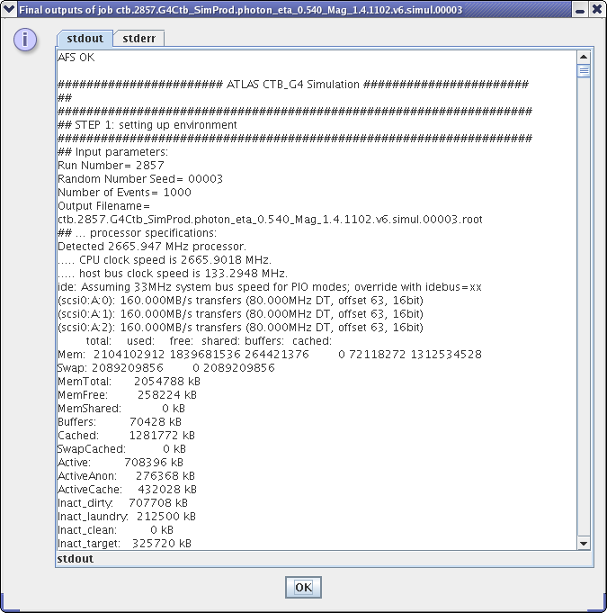
The stdout of a running job.

The status of jobs, can be tracked by regularly clicking the button "Refresh" and by using the items of the right-click menu to e.g. inspect the stdout. When GridPilot performs such a refresh and detects that a job has finished, certain actions will be performed:
- the stdout and stderr of the job will be downloaded to the local disk and checked for error messages. This is referred to as validation of the job
- if the job passes validation and if not already done by the computing system, output files (including stdout and stderr) will be copied to their final destination, as specified in the dataset record
- if the first two points have gone well, the job will be set as "Validated". If not, it will be set as "Failed" or "Undecided"
- if the first two points have gone well and if the database holding the job information is a file catalog, the output file of the job will be registered in the file catalog. If the database is not a file catalog, the output file will always figure on the "files" tab, irrespective of whether it actually exists or not
- if the stdout contains lines of the form GRIDPILOT METADATA: [someField] = [someValue] and the field [someField] is one of the fields of the "jobDefinitions" table, the value [someValue] will be filled in in the jobDefinition record
Hint: a job may write something on stderr without actually failing. However, a non-empty stderr will cause the job to be flagged as "Undecided". To avoid this, you can have your job script redirect stderr to stdout. E.g. for Bash, this is done with 2>&1.
If jobs have ended up in the state "Undecided", they can be set as "Validated" by hand from the right-click menu. This can also be done in an interactive way, by selecting "Decide" from the right-click menu.
In order to rerun jobs, they should first be set as "Failed", then as "Defined". This will trigger a cleaning up of possible output files. If such a clean-up is not desired (it may take some time, even if there were no output files produced), jobs can be set as "Aborted" and then "Defined". A shorter way to resubmit is to simply select "Resubmit" from the right-click menu. This will also trigger a clean-up of output files.
Failed jobs can be resubmitted from the right-click menu. This may make sense, if the failure was due to some temporary problem with the computing (grid) system.
Running jobs can be killed via the "Kill" button or from the right-click menu.

Examples

Notice: The jobs of these examples can run on any of the supported grid systems (currently, they are all Linux based), however, if you're on a Linux system you can also run these jobs locally with the “Fork” plugin. If you're on a different platform, e.g. MS Windows, you can run the jobs in a local virtual machine with the “VMFork” plugin.

Running a simple job
As a first simple example we will run a job that uses the uses the transformation “no_files_transformation”.
- open a “transformations” tab with “My_DB_local” ("View" → "My_DB_Local"→ "transformations") and click “Search”
- double-click on the row with name “no_files_transformation”. You'll see that the corresponding script, “ no_files_transformation .sh”, is an empty file
- write any Linux commands you like, e.g. ”echo hello world“ in this file. After doing this, click “Update” and “Close”
- open a “datasets” tab with “My_DB_local” and click “Search”
- select “no_files_dataset” and click “Create jobDefinition(s)”, “Create”, “OK” and “Close”
- click “Show jobDefinitions(s)” and “Submit job(s)” → [your favorite system]
- the job monitoring window will open and you can follow the progress of your job
- after the job has finished, the first time you click on “Refresh” on the job monitoring panel, the stdout and stderr of the job will be copied to the “outputLocation” of the dataset - by default your “grid home URL” (as set in your preferences)

Running 10 simple jobs
As a second simple example we will run a job that uses the uses the transformation “test”. To inspect this transformation, open a “transformations” tab with “My_DB_local” ("View" → "My_DB_Local"→ "transformations"). Click “Search” and double-click on the row with name “test”. You'll see that the corresponding script, “my_.sh”, is a shell script calling standard GNU/Linux tools. “test.sh” takes a number, “multiplier”, as argument and produces another number which it saves to a file, “out.txt”. After inspecting, you can just click “Close”.
We will run the script with numbers from 1 to 10 and save the 10 output files on a remote server as “test_dataset.01.txt”, “test_dataset .02.txt”, ..., “test_dataset .10.txt”.
- open a "datasets" tab with “My_DB_Local” ("View" → "My_DB_Local"→ "datasets")
- click on “Define new record(s)”
- fill in at lease the fields “NAME”, “TOTALFILES” and “OUTPUTLOCATION”. And example is given in the figure below
- click “Create” and “Close”
- on the “datasets” tab: select the created dataset and click “Create jobDefinition(s)”
- fill in the field “multiplier” with the value ${i:2}

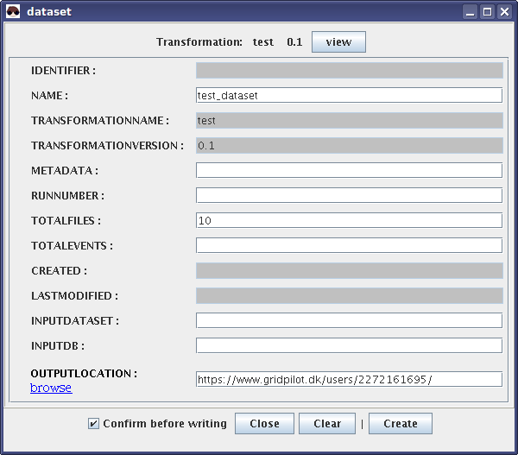

Deploying runtime environments

Finding and downloading a file from a GridFTP server
In this section is just described how to download a few files quickly, without going over any other file catalog than Google. Look for you favorite dataset name in google. If you're lucky and find some URL that start with "gsiftp://", type ctrl+o in GridPilot, copy-paste a directory (just chop off what's after the last "/") URL in the URL field and hit return. After waiting a few seconds for the SSL handshake, etc. you should see a list of the files in the directory.
Then, find the file you're interested in and click "Get". This will present you with a local directory chooser. After choosing a local directory, you will be prompted for a file name. Here you have to type in the name of the file (you could have copied the name from the browser window).

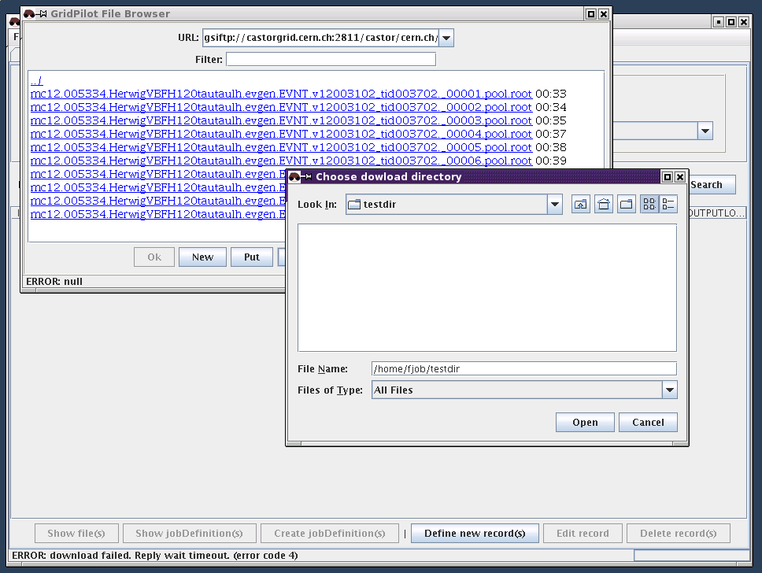
Browsing files on gsiftp://castorgrid.cern.ch/.

After this, the download should start. GridPilot will hang until the file has been downloaded. If it's a small file, you will not notice much. If it's a large file, it's a nuissance. Therefore, you should not use the file browser for downloading anything but a few small files.
Instead, you should locate files in a dataset/file catalog and initiate the transfer from the "files" tab on the main window.
However, some files on some GridFTP server may not be registered anywhere. Well, then you can register them!

Registering files on a GridFTP server in a file catalog
Let's take the example of a private production of ATLAS data that has been carried out and the files put on a GridFTP server.
These files are grouped in datasets that are registered in a dataset catalog on one of the database back-ends. The files are then registered in a file catalog on the same back-end.
If the target audience is limited, both registrations can be done on any MySQL server. The interested parties can then all have this server listed in their GridPilot configuration file.
If the target audience is the whole ATLAS collaboration, the dataset catalog should be a central DQ2 catalog and the file server one registered in the file "TiersOfATLAS".
Hint: Instead of immediately publishing datasets and files in a central catalog like the central ATLAS DQ2 dataset/file catalog, you can first publish them either in the default local database provided by GridPilot or in a regional MySQL database. Then you can always publish them in a higher-level database later, by simple copy-paste between GridPilot tabs.
Here, we will go through how an ATLAS dataset and 10 associated files were registered in a regional MySQL catalog.

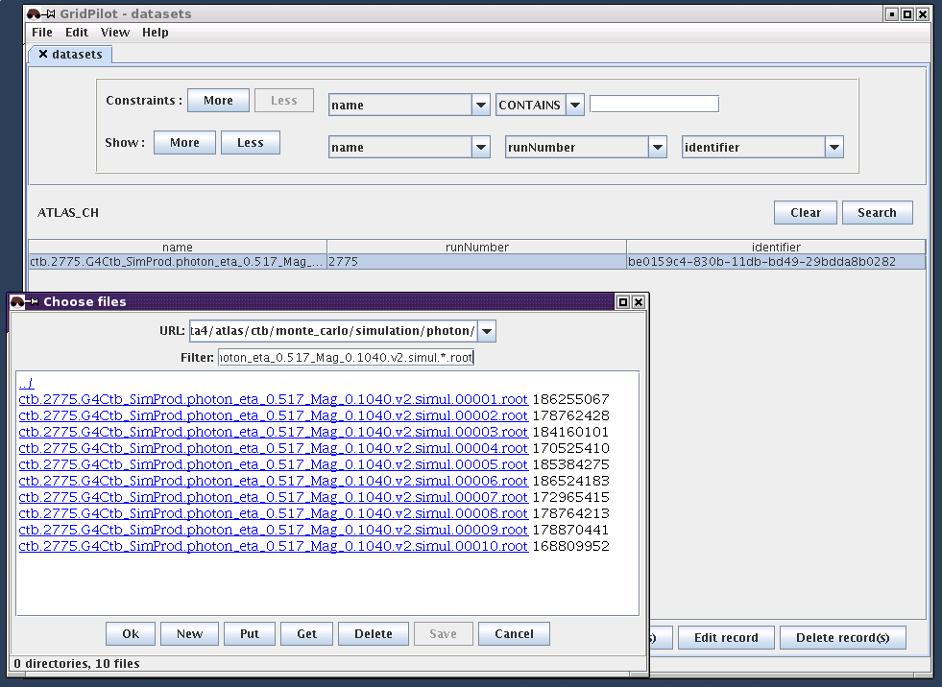
Registering files located on a GridFTP server in a MySQL dataset and file catalog.

- a "datasets" tab was opened with the database system to be used for registration. Then "Define new record(s)" was clicked and filled in as best possible. As a minimum, the "name" field must be filled in. The identifier field is filled in by GridPilot with a freshly generated UUID.
- the newly created dataset record was selected and from the right-click menu "Import file(s)" was chosen
- with the file selector that popped up the physical files were selected. GridPilot registers all files present in the selector window, so one should, if necessary, limit the selection by filling in the "Filter" text field and hitting return. In the case at hand the string ctb.2775.G4Ctb_SimProd.photon_eta_0.517_Mag_0.1040.v2.simul.*.root was used as filter. UUIDs were generated by GridPilot for all files
- Once the wanted files and none else were in the browser window, "OK" was clicked
- to verify that the files had been registered the dataset was selected and "Show files" was clicked

Publishing files registered in one file catalog in another
Let's see how the files just generated could be made available to the whole ATLAS collaboration.
In GridPilot logic, the files you want to register, must belong to a dataset, also in the new file catalog. So, first one has to create the dataset in the "ATLAS" database system and then register the files with this dataset:
- Open a "datasets" tab with the "ATLAS" database system: "View" → "ATLAS" → "datasets"
- Verify that the name is not already taken: type ctb.2775.G4Ctb_SimProd.photon_eta_0.517_Mag_0.1040.v2.simul in the search field
- Copy the dataset record to the "ATLAS" database system: the row on the "datasets" tab with the regional MySQL datase system can simply be copy-pasted into the "datasets" tab with the "ATLAS" database system
- Open a "files" tab with the ATLAS" database system: select the newly created dataset and click "Show file(s)"
- Register the files with the "ATLAS" database system: the rows on the "files" tab with the regional MySQL datase system can simply be copy-pasted into the "files" tab with the "ATLAS" database system

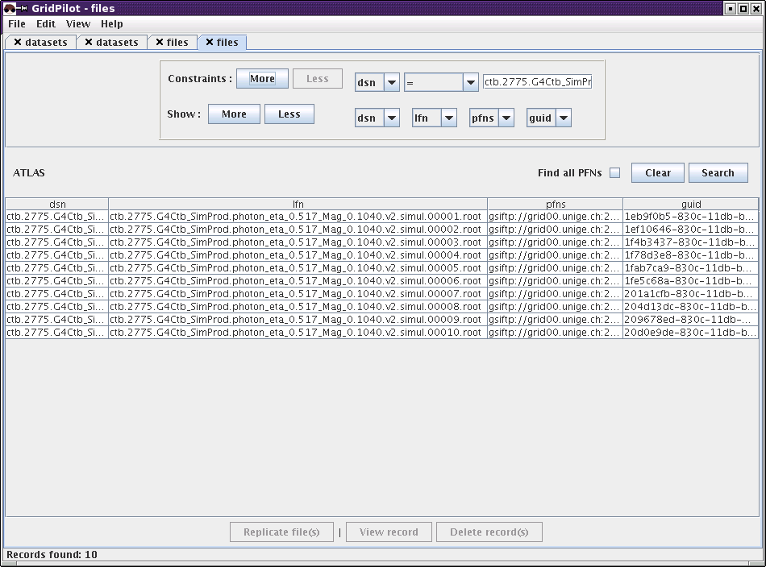
Re-publishing file information from a regional MySQL dataset/file catalog to the central ATLAS catalog.

Notice: the "ATLAS" database system has a few quirks as compared to the local and MySQL database systems:
- When copy-pasting a dataset into a "datasets" tab with the "ATLAS" database system, the dataset identifier is not kept. The ATLAS system operates with both a DUID and a VUID; GridPilot identifies the dataset identifier of the other database systems with the VUID of ATLAS. Unfortunately, when creating a new ATLAS dataset, it is not possible to force a VUID - a new one is always generated
- When files are added to an ATLAS dataset, the dataset keeps its VUID as you would expect. However, when deleting files from a dataset, a new dataset (or dataset version in ATLAS terminology) is generated, with a new VUID

Replicating ATLAS data from an SRM server to a GridFTP server
Task
- Locate the files of the dataset "csc11.005144.PythiaZee.recon.AOD.v11004103" in the central ATLAS dataset/file catalog
- Replicate them to a local GridFTP server - this includes registering the new file locations in a local MySQL dataset/file catalog
Notice
- GridPilot is not meant to be used for massive data movement. For this, the replication systems of the WLCG and/or ATLAS should be used. One reason is that GridPilot does not place the transfer requests with any external service and thus needs to run until the last transfer is completed.

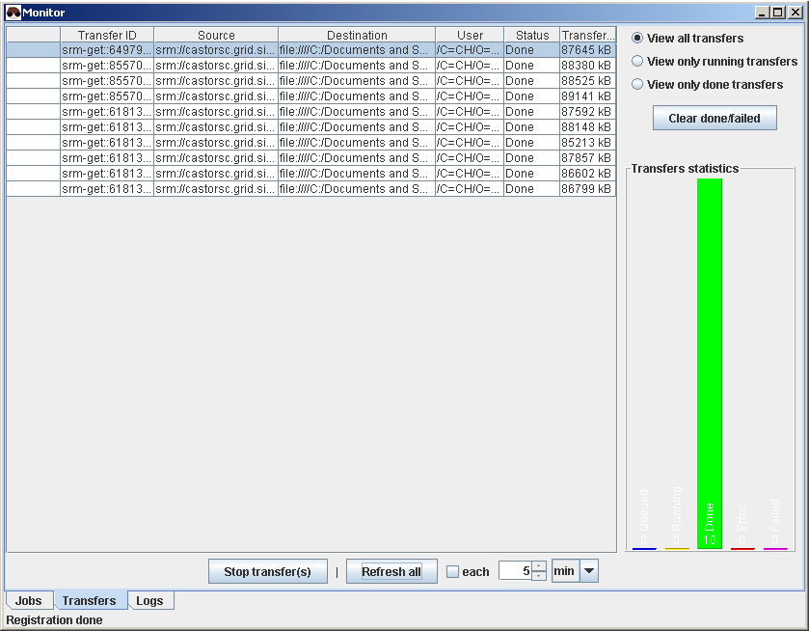Replicating ATLAS CSC files to a regional GridFTP server and MySQL dataset/file catalog.

Steps
- Open a "datasets" tab with the "ATLAS" database system: "View" → "ATLAS" → "datasets"
- Type in csc11.005144.PythiaZee.recon.AOD.v11004103 in the search field and hit return
- Select the dataset and click "Show files". GridPilot then first finds all the (unqualified) file names and then starts querying the DQ2 server and the grid file catalogs for the locations of the files
- After a while, all files will appear in the results table. GridPilot may report "No response from ATLAS for select. Do you want to interrupt it?". In this case, simply click "No" (timeouts are configurable)
- Select some files and click "Replicate file(s)"
- With the file chooser, choose a download destination on a GridFTP server where you have write access, and from the drop-down list "Register new location in DB", choose to register the new locations in a MySQL database where you have write access. If you don't have write access on any regional MySQL database, you can always choose to register in "My_DB_local"
- After the transfers have started, click "Refresh all" to follow the progress of the transfers
- Wait for the transfers to finish
Hint: When clicking "Show files" on the ATLAS "datasets" tab, the "files" tab can take a long time in loading, because GridPilot queries the file catalog(s) for each single file to get the physical file name (URL). To interrupt this and show the remaining records without physical file names, click on the small cross next to the progress bar in the lower right corner of the main window.
Hint
- If the transfers fail to start transferring on a first try, it is probably because GridPilot times out waiting for a "Ready" message from the SRM server files. You can simply select them in the file transfer monitor and choose "Retry transfer(s)" from the right-click menu. Notice that timeouts are configurable
- If the transfers still fail, you can try downloading from more sources by repeating the search in the "Files" tab with the checkbox "Find all PFNs" checked and then retrying the replication

ATLAS Combined Test Beam photon simulation
In this example we will re-simulate some ATLAS photon events from the Combined Test Beam exercise in 2004.
A suitable transformation script can be accessed at http://cern.ch/fjob/gridpilot/transformations/g4sim.CTB_G4Sim_photon.v6. To put this script to use, we have to create a record for it in GridPilot:
- open a "transformations" tab with any database system (where you have write access), e.g. "My_DB_local": "View" → "My_DB_local" → "transformations"
- click "Define new record(s)
- in the pop-up window, choose the runtime environment "ATLAS-11.0.2" from the drop-down list
- fill in the table in the pop-up window like in the figure below
Comment: If the runtime environment "ATLAS-11.0.2" is not available, try reconfiguring your NorduGrid/ARC computing system: e.g. to access Swiss resources you need to set GIISes = ldap://odin.switch.ch:2135/Mds-Vo-name=Switzerland,o=grid. To access only e.g. two computing resources you need to set clusters = first.host.org second.host.org

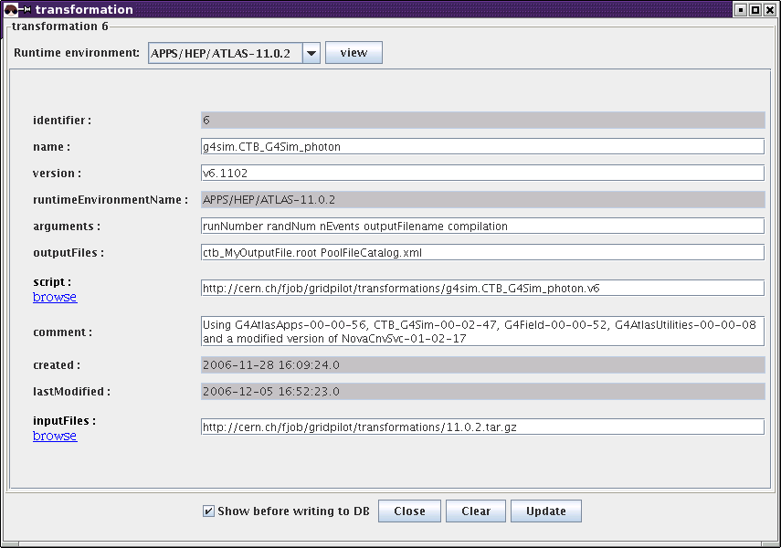
Creating an ATLAS transformation for photon simulation.

Next, we define a dataset:
- open a "datasets" tab with the same database system
- click "Define new record(s)
- in the drop-down in the pop-up window, choose the transformation you just created
- fill in the table in the pop-up window like in the figure below
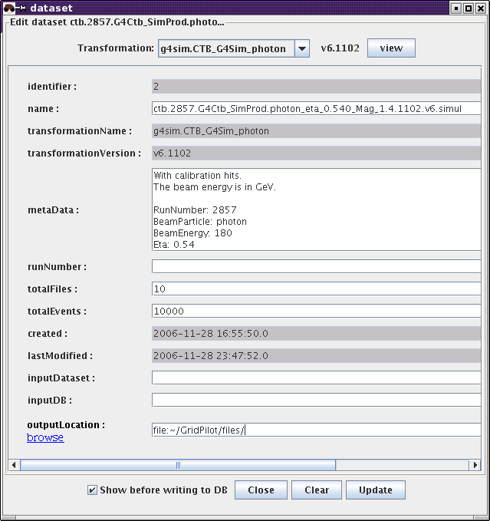
Creating an ATLAS photon simulation dataset.

Comments
- as "name" you can choose anything you like, but bear in mind that ATLAS has a naming convention that you may want to follow
- the "metaData" should contain some description of the data this dataset will contain. Lines of the form [field]: [value] are special: the values can be accessed when creating jobs (see below)
- the "outputLocation" can be either a directory on a GSIFTP server or a directory on your local hard disk. In the last case you can use the symbol "~" for you home directory (on any platform). It is recommended to click "browse" instead of typing in text by hand
Creating the job definitions is now straight forward:
- perform a search on the "datasets" tab
- select the row with the dataset you just created
- click "Create job definition(s)"
- in the pop-up window that appears there is only one field to fill out: "compilation". You can type either "0" (to not have the code recompiled) or "1" (to have the code recompiled). It is recommended to type 0 (or leave blank)
- in the pop-up window, click "Create". This will pop up a confirmation dialogue, displaying all the information GridPilot is going to store about this job
- click " OK for all"
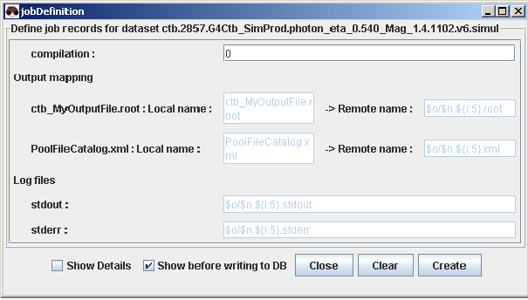
Creating job definitions.

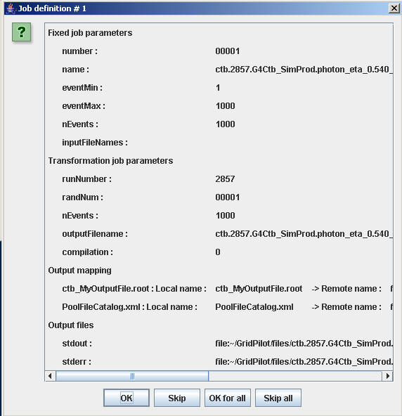
Confirmation dialog when creating job definitions.
Notice that the "Transformation job parameters" are filled out automatically by GridPilot: randNum, nEvents and outputFilename are recognized as standard parameters, runNumber is found using the "metaData" information of the dataset
You can now submit the jobs:
- on the "datasets" tab, select the row with the dataset you just created
- click "View job definition(s)"
- on the "jobDefinitions" tab that opens, select your job definitions and click "Submit", then choose one of the computing systems that appear
- on the job monitor you can now follow the progress of the jobs by clicking "Refresh" and/or using the right-click menu

ATLAS Combined Test Beam photon digitization
In this example we will run so-called "digitization" on the files we produced in the previous example. We will use the transformation script http://cern.ch/fjob/gridpilot/transformations/g4sim.CTB_G4Sim_photon.v6 in the simplest possible way: one input data file and one output data file. The GridPilot transformation record is produced like in the precedent example.
We define the dataset like above, but with a slight change:
- open a "datasets" tab with the same database system
- select the dataset you created above
- click "Define new record(s)
- in the pop-up window, choose the transformation you just created
- fill in the table in the pop-up window like in the figure below; notice that the fields are already filled with the values of the input dataset - change as appropriate
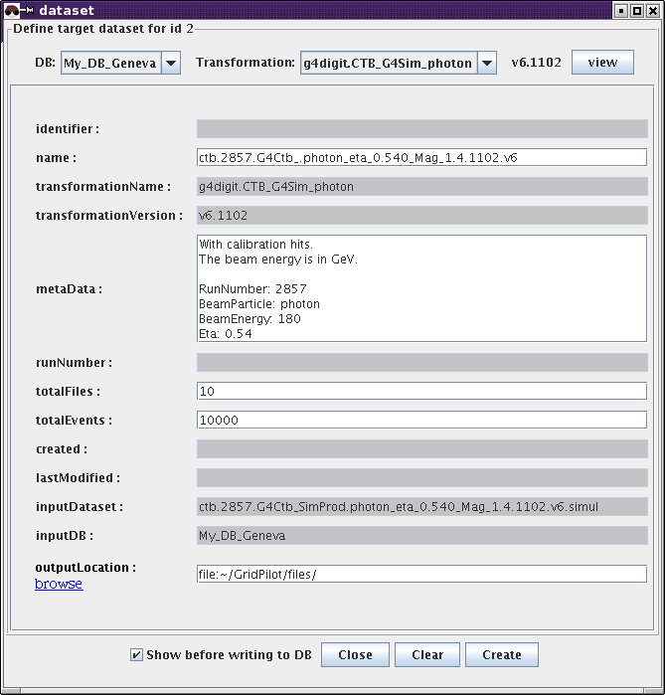
Creating an ATLAS digitization dataset.

Now you can create and submit jobs like in the previous example.

ATLAS Combined Test Beam electron (proton or muon) simulation
In this example we will simulate some ATLAS electron events from the Combined Test Beam exercise in 2004.
We will follow the same procedure as in the previous two examples.
A suitable transformation script can be accessed at http://cern.ch/fjob/gridpilot/transformations/g4sim.CTB_G4Sim.v4. To put this script to use, we have to create a record for it in GridPilot:
- open a "transformations" tab with any database system (where you have write access), e.g. "My_DB_local": "View" → "My_DB_local" → "transformations"
- click "Define new record(s)
- in the pop-up window, choose the runtime environment "ATLAS-11.0.2" from the drop-down list
- fill in the table in the pop-up window like in the figure below
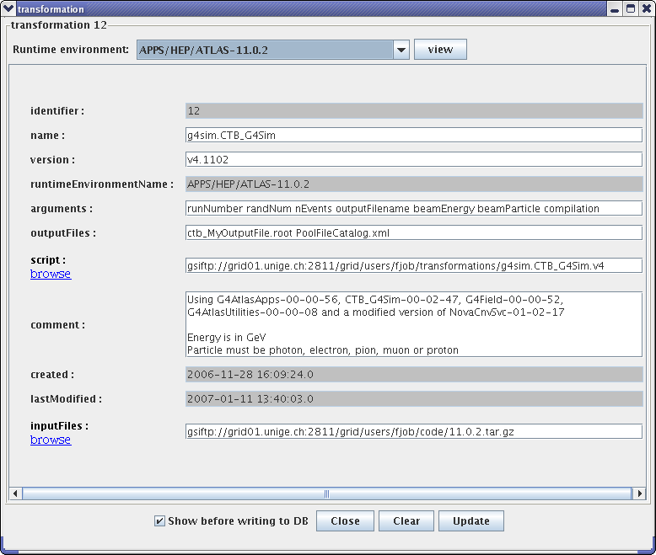
Creating an ATLAS transformation for CTB simulation.

Next, we define a dataset:
- open a "datasets" tab with the same database system
- click "Define new record(s)
- in the drop-down in the pop-up window, choose the transformation you just created
- fill in the table in the pop-up window like in the figure below
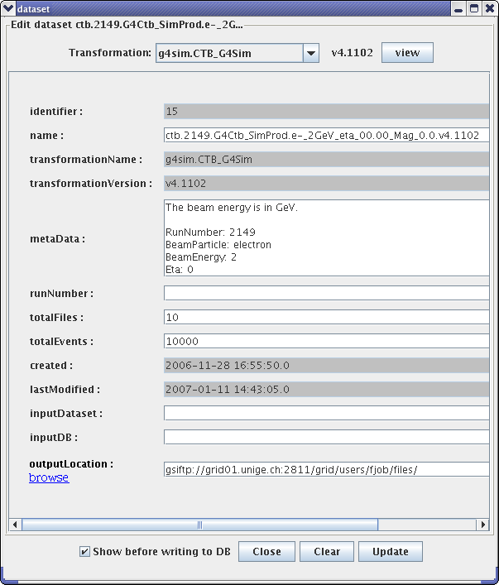
Creating an ATLAS electron simulation dataset.
Comments
- as "name" you can choose anything you like, but bear in mind that ATLAS has a naming convention that you may want to follow
- the "metaData" should contain some description of the data this dataset will contain. Lines of the form [field]: [value] are special: the values can be accessed when creating jobs (see below)
- the "outputLocation" can be either a directory on a GSIFTP server or a directory on your local hard disk. In the last case you can use the symbol "~" for you home directory (on any platform). It is recommended to click "browse" instead of typing in text by hand
Creating the job definitions is now straight forward:
- perform a search on the "datasets" tab
- select the row with the dataset you just created
- click "Create job definition(s)"
- in the pop-up window that appears there is only one field to fill out: "compilation". You can type either "0" (to not have the code recompiled) or "1" (to have the code recompiled). It is recommended to type 0 (or leave blank)
- in the pop-up window, click "Create". This will pop up a confirmation dialogue, displaying all the information GridPilot is going to store about this job
- click " OK for all"
Notice that the "Transformation job parameters" are filled out automatically by GridPilot: randNum, nEvents and outputFilename are recognized as standard parameters, runNumber, beamEnergy, beamParticle are found using the "metaData" information of the dataset
You can now submit the jobs:
- on the "datasets" tab, select the row with the dataset you just created
- click "View job definition(s)"
- on the "jobDefinitions" tab that opens, select your job definitions and click "Submit", then choose one of the computing systems that appear
- on the job monitor you can now follow the progress of the jobs by clicking "Refresh" and/or using the right-click menu
The output files can be digitized by the same procedure as for the photons (see above), using the transformation script http://cern.ch/fjob/gridpilot/transformations/g4digit.CTB_G4Sim.v4.

ATLAS mSugra simulation
Task: Simulate 1'681 x 10'000 ATLAS mSugra events with 41x41 different values of the mSugra parameters m0 and m12: 0,100,200,...,4000 x 0,25,50,...,1000.
Details
- the ATLAS software release to be used is 11.0.5
- the transformation script at http://cern.ch/fjob/gridpilot/transformations/mSugraSim.pl
- input file for the transformation script: http://cern.ch/fjob/gridpilot/mSugraInputs.tar.gz
- the script takes three parameters: A0, tan(β), sign(μ) m_Top, m0, m1, [number of events]
- of these, the first 4 are static for this dataset, i.e. do not change for the whole production
- output should be copied to a GridFTP server
Steps
- Create a transformation:
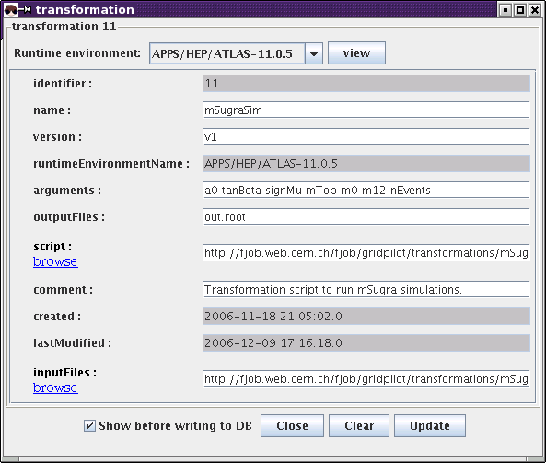
Transformation for simulation of ATLAS mSugra events.

- Create a dataset: Notice that the static parameters have been given as metadata
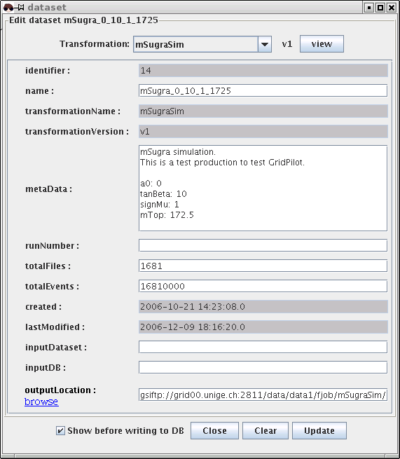
ATLAS mSugra dataset.

- Create the job definitions:
Comments
- we have to find an algorithm to map i = 1,2,3,...,1681 to the dublets (m0,m12) = (0,0), (0,25),..., (4000,1000). The answer is: ((i - mod(i, 41))/41*100, (mod(i, 41))*25), with i=0,1,...,1680
- in order to use this algorithm in the job definition fields, we check "Show details"
- then we fill in the fields, using ${((i-1)-(i-1)%41)/41*100} for "m0" and ${(i-1)%41*25} for "m12". Here we use the fact that basic arithmetics expressions enclosed by ${...} in the job definition fields, are interpreted by GridPilot
- notice that the fields that only appeard after clicking "Show details" can safely be left blank, as they are filled in automatically by GridPilot

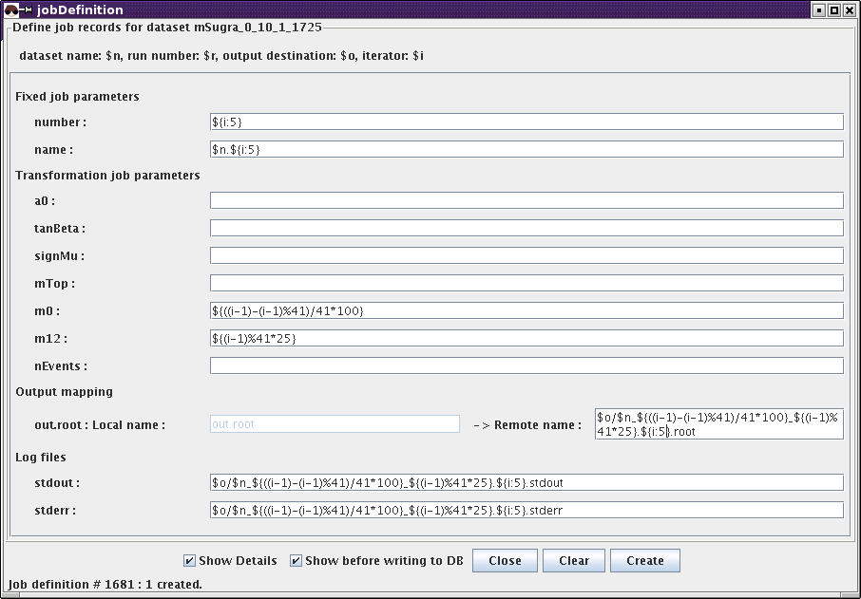
Creating ATLAS mSugra job definitions.

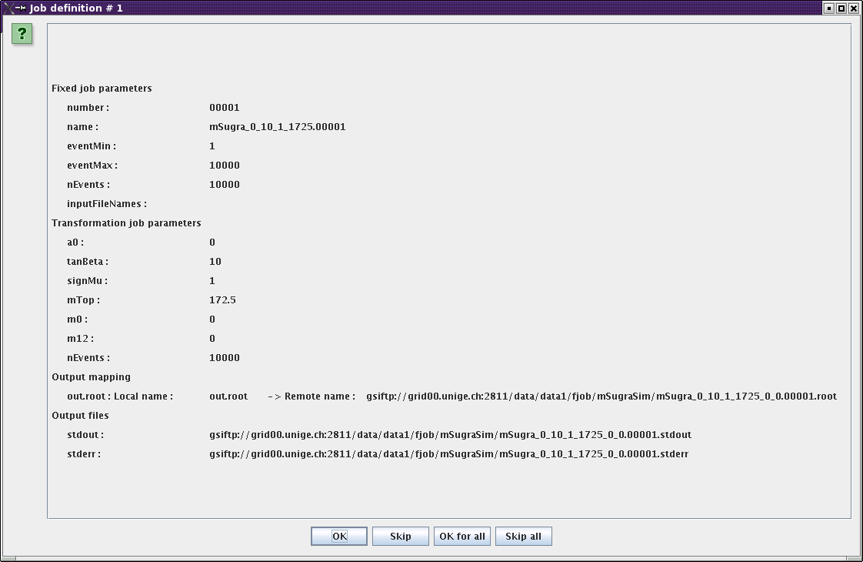
Confirmation dialog when creating ATLAS mSugra job definitions.

- Submit and monitor the jobs as in the previous examples. With 1681 jobs involved, this is a larger production. It is recommended to submit batches of a few hundred jobs at a time. The figure below shows the situation a day after 100 jobs were submitted. A good deal of them have failed because the (m0, m12) parameter dublet was outside of the allowed range. The rest are either running or have finished correctly and been validated.
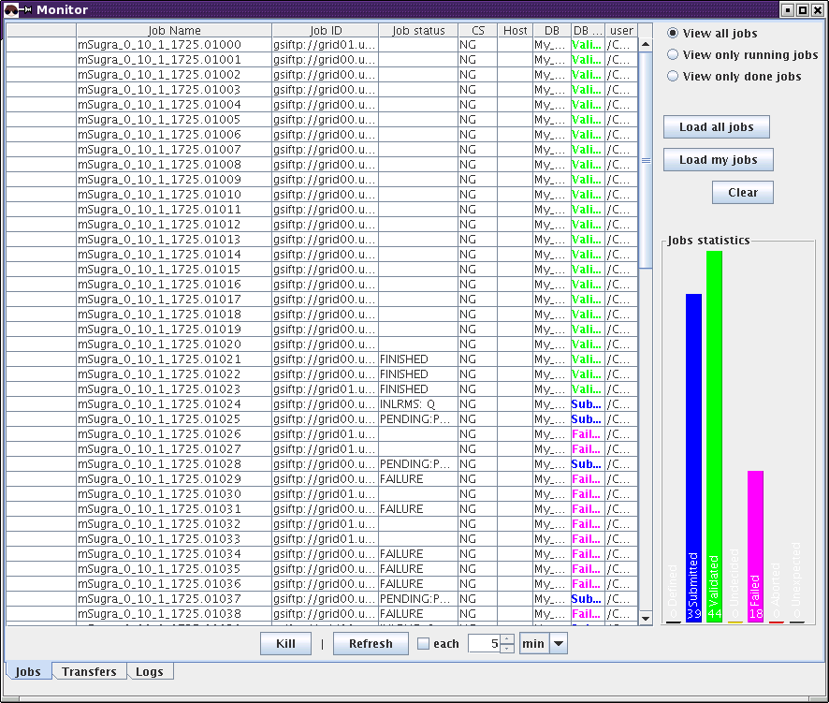
Monitoring running mSugra jobs.

Analyzing ATLAS AOD registered in DQ2
For simplicity we will use the test transformation, "test" that is shipped with GridPilot. The transformation script "test.sh" takes two arguments: multiplier and inputFileNames (a comma separated list of file names) and calculates a hash number from that, which it writes out to a files "out.txt". We will see how we can use this transformation on input files registered in DQ2. This example is for illustration only; once you've understood how this works, you should define your own transformation that does something sensible with the input files.
- open a "datasets" tab with the ATLAS database system; let's again search for the dataset csc11.005144.PythiaZee.recon.AOD.v11004103
- select the dataset record and click "Define new record(s)"
- select "My_DB_Local" from the drop-down list on the window that is popped up
- if more than one transformation is present in your local database, another drop-down list will appear from which you can choose the transformation "test"; otherwise you will simply see "Transformation: test 0.1"
- fill out the "NAME" field with a name of your choice, e.g. csc11.005144.PythiaZee.recon.hash.v11004103
- fill out the field "OUTPUTLOCATION" with a location of your choice, e.g. file:~/GridPilot/files/
- fill out the field "TOTALFILES" with e.g. 3. If this field were left blank all 178 job definitions would be generated. Like this, only the first 3 will be generated, which is fine, since this is only a test
- click "Create" and "OK" in the confirmation dialog
- click on the "datasets" tab with "My_DB_local"
- click "Create job definition(s)"
- fill in some number in the field "multiplier", e.g. ${i}
- click the checkbox "Show details"
- clear the field "Remote name". This causes the name to be generated automatically, by simply appending ".out" to the input file name
- click "Create"

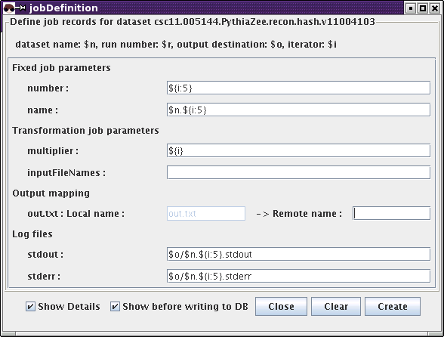
Creating jobs with input files from the ATLAS data management system DQ2.

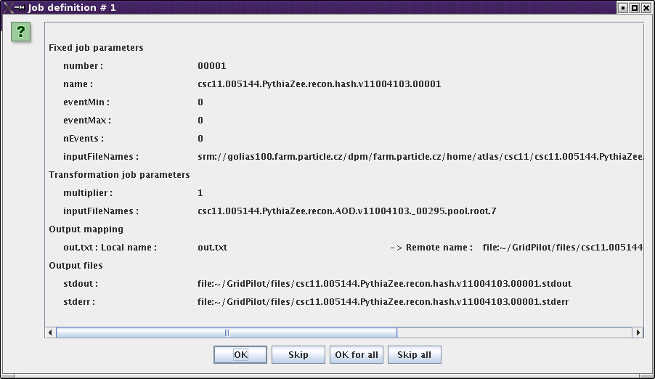
Confirmation dialog when creating jobs with input files from the ATLAS datamanagement system DQ2. Notice that the destination file has been named after the input file.

- after the jobs have been created, you can submit them to "NG"
Remark
If you want to run the jobs on your local computer, you need to add the following two lines to your configuration file, in the section [FORK]:
remote copy command = ngcp
required runtime environment = ARC
and create a file "ARC" in your local runtime directory (configured by runtime directory)
The contents of this file could for example be:
currentDir=$PWD
cd ~/nordugrid-arc-standalone-0.5.57
source setup.sh
echo "[my password]" | grid-proxy-init -pwstdin
cd $currentDir

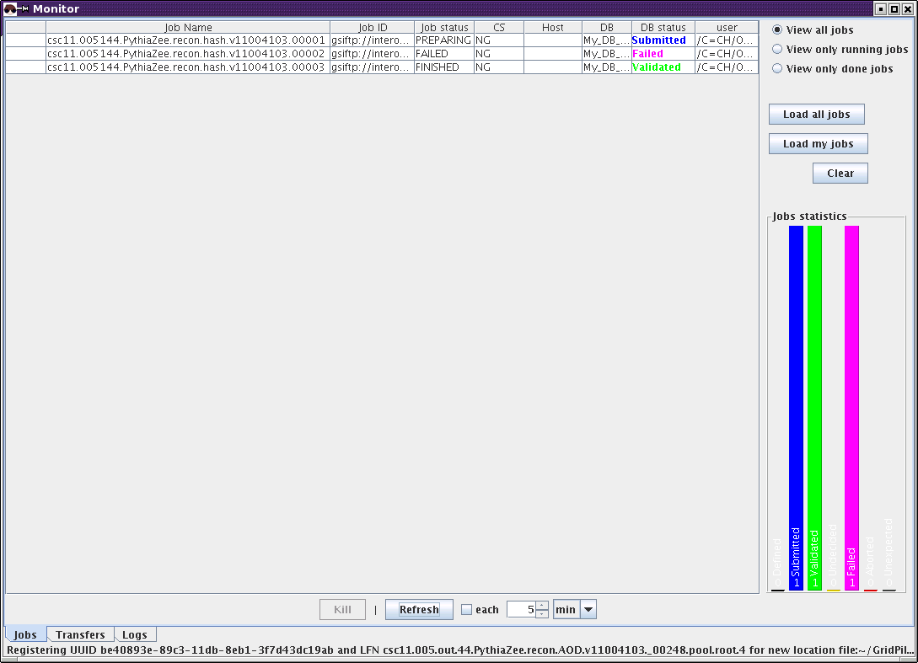
Running ATLAS jobs. One has failed because getting the input file timed out. It should be resubmitted.

Appendix A: The configuration file
The configuration file must be present and must be in one of the following locations:
for UNIX/Linux:
- [home directory]/.gridpilot
- [gridpilot installation directory]/gridpilot.conf
Here [home directory] will typically be something like "/home/myusername".
for MS Windows:
- [home directory]\gridpilot.conf
- [gridpilot installation directory]\gridpilot.conf
Here [home directory] will typically be something like "C:\Documents and Settings\My Name"
When running GridPilot>0.3.0 for the first time, a configuration file will be created automatically. This file can then be edited later by choosing “Edit” → “Preferences”. In particular, you may want to change which computing, file transfer and database systems are enabled, which defaults are set for download locations (where finished jobs store their output), etc.
If changes are made to the configuration file while GridPilot is running, they will not be effective until after GridPilot has been restarted.
Below follows a list of all configuration parameters, together with a short description and suggestions for settings. Notice that each [name] [value] must be on one line.

Configuration parameters
NOTICE: this list is not up to date; it is the list as of version 0.1.1 of GridPilot. Some parameters have changed name and some have been added since then. The shipped configuration file now contains in-line description of all parameters.
GridPilot section
name | default value | description
user |  | User name used to fill in the field "userInfo" of job definition records. This name is only used for field in jobDefinition tables ONLY if no name can be obtained from a grid certificate. If not specified (and no name can be obtained from a grid certificate), the local user name under which GridPilot is running is used
resources | /resources/ | path to images, certificates, etc.
debug | 0 | Debug level ; 0 : all debugs are disabled, 3 : maximum. Notice that having a high debug level can have a big impact on performance
job attributes | number name | attributes always used when creating job definitions
initial panels | transformation dataset | panels (tabs) displayed on startup. The database used for these panels is the first one in the list "Systems" in the section "Databases"
browser history file | ~/gridpilot_history.txt | location of the file holding the history of the file browser
proxy server |  | name or IP address of web proxy server
proxy port |  | web proxy port
preferred file servers |  | ordered, space separated list of closest file servers for downloading data files. Each entry must either be a fulle URL or a host name. Wildcards are allowed in host names (e.g. *.ch)
proxy time left limit | 43200 | number of seconds before timeout of grid proxy when it will be renewed. The default corresonds to 12 hours
proxy time valid | 129600 | number of seconds a proxy is valid. The default corresponds to 36 hours
certificate file | ~/.globus/usercert.pem | location of the grid certificate
grid proxy directory | ~/.globus | where the grid proxy is kept
key password |  | password to decrypt the secret key of the grid certificate. It is NOT recommended to set this
ca certificates |  | A comma separated list of fully qualified file or directory paths specifying where to look for CA certificates. If it is left blank, the default certificates shipped with GridPilot will be used
maximum simultaneous submissions | 3 | number of submission threads. Notice that specifying more than a few, may stress the computing system and have a counterproductive effect
time between  submissions | 5000 | milliseconds between each submission (in each thread)
randomized submission | no | whether or not to choose a random host to submit to - for computing systems that can choose between multiple hosts. NOT tested
maximum simultaneous transfers | 10 | number of file transfer threads. Queued transfers will be picked by the first free thread
time between transfers | 500 | milliseconds between each transfer (in each tread)
randomized transfers | no | this tag is not yet used
gridftp home url | ~ | default URL when replicating (downloading)
maximum simultaneous checking | 3 | number of job checking threads
time between checks | 500 | milliseconds between each check (in each thread)
delay before validation | 3000 | milliseconds between each validation (in each thread)
maximum simultaneous validating | 3 | number of job validating threads
default timeout | 60 | default timeout for threads spawned by the computing system plugin manager
[some method] timeout | 60 | individual timeouts can be specified for some of the methods of the computing system manager
db timeout | 60 | default timeout for threads spawned by the database system plugin manager
File transfer systems section
Systems | gsiftp srm | the enabled file transfer subsystems. Each specified subsystem must be defined in a subsection
globus tcp port range | 9001,9010 | comma separated list of ports used for accessing GridFTP servers
copy retries | 0 | number of times a file transfer will be retried if it fails on a first attempt
copy retry timeout | 120 | seconds until a file transfer retry times out
File transfer system : gsiftp
class | gridpilot.ftplugins.gsiftp.GSIFTPFileTransfer | the class to be loaded. Do not change this
max transfers by update | 1 | number of file transfers whose status is checked by each thread (see maximum simultaneous transfers)
File transfer system : srm
class | gridpilot.ftplugins.srm.SRMFileTransfer | the class to be loaded. Do not change this
submit check retries | 2 | retries, before timing out, to get "Ready" from the SRM server for a submitted transfer
submit check sleep | 10000 | miliseconds between retries
max transfers by update | 1 | number of file transfers whose status is checked by each thread (see maximum simultaneous transfers)
Databases section
systems | My_DB_local | the enabled database subsystems. Each specified subsystem must be defined in a subsection. Notice that the same class can be used for several subsystem definitions. The only system that is defined by default is My_DB_local, since GridPilot cannot know to which remote MySQL databases the user has access
Database system : My_DB_local : This is the default local system, holding both job information and an explicit file catalog
class | gridpilot.dbplugins.hsqldb.HSQLDBDatabase | the class to be loaded. Do not change this
driver | org.hsqldb.jdbcDriver | the class providing the interface to the database back-end. Do not change this
database | hsql://localhost/~/GridPilot/My_DB | this may start with either hsql://[host name]/ or file://. What comes after specifies the path to the physical files holding the database information. Starting with = hsql://localhost/= causes a database server to be started - which, in principle, can be accessed from other hosts. For the case at hand, the actual file holding the database information is "/GridPilot/My_DB.script"
user | sa | the user name for accessing the database. Do not change this
password | "" | the password for accessing the database. Do not change this
parameters | driver database user password | the parameters to be given to the constructor of the class. Do not change this
default dataset fields | name runNumber identifier | fields to be displayed in the list of search results
hidden dataset fields | metaData | fields not to be displayed in the list of search results
default jobDefinition fields | name status | fields to be displayed in the list of search results
default file fields | dsname lfname pfname guid | fields to be displayed in the list of search results
file identifier | guid | the identifier field of the file table
file name | lfname | the name field of the file table
file dataset reference | name dsname | the back reference mapping from the dataset to the file table (the order is a bit misleading)
[table name] field names | [too long to be displayed] | comma separated list of the fields of this table. If the table is not present, it will be created with these fields. This system has definitions for table names: "dataset", "jobDefinition", "transformation" and "runtimeEnvironment"
[table name]vfield types | [too long to be displayed] | the data types of the fields. Must be specified for all tables
file field names | lfname, pfname, filetype, md5sum, fsize, lastmodified, archival, dsname, guid | field names of the virtual file table. Should not be changed, as this is in compliance with standard grid file catalogs
t_lfn field names | llfname, guid | definition of one of the physical tables making up the file table
t_lfn field types | lLONGVARCHAR, VARCHAR NULL | definition of one of the physical tables making up the file table
t_pfn field names | pfname, guid, filetype | definition of one of the physical tables making up the file table
t_pfn field types | LONGVARCHAR, VARCHAR NULL, LONGVARCHAR NULL | definition of one of the physical tables making up the file table
t_meta field names | guid, md5sum, fsize, lastmodified, archival, dsname | definition of one of the physical tables making up the file table
t_meta field types | VARCHAR, LONGVARCHAR NULL, LONGVARCHAR NULL, LONGVARCHAR NULL, LONGVARCHAR NULL, LONGVARCHAR, VARCHAR | definition of one of the physical tables making up the file table
Database system : [some_remote_database] : this is a template remote MySQL system, holding job information and a file catalog generated from this
class | gridpilot.dbplugins.mysql.MySQLDatabase | the class to be loaded. Do not change this
driver | org.gjt.mm.mysql.Driver | the class providing the interface to the database back-end. Do not change this
database | jdbc:mysql://[some.server.org]:3306/[database name] | the location of the database. If no database name is specified, it is inferred from the subject of the grid certificate (a hash number) - if present
user | sa | the user name for accessing the database. If this is not specified, X509 authentication with the grid certificate will be attempted. If this fails, GridPilot will prompt for a user name and a password
password | "" | the password for accessing the database. Not used if X509 authentication is used
parameters | driver database user password | the parameters to be given to the constructor of the class. Do not change this
connect timeout | 0 | timeout for connecting to the database. 0 means no timeout
socket timeout | 0 | timeout on network sockets. 0 means no timeout
default dataset fields | name runNumber identifier | fields to be displayed in the list of search results
hidden dataset fields | metaData | fields not to be displayed in the list of search results
default jobDefinition fields | name status | fields to be displayed in the list of search results
default file fields | name datasetName url | fields to be displayed in the list of search results
file name | fileName | the name field of the file table
[table name] field names | [too long to be displayed] | comma separated list of the fields of this table. If the table is not present, it will be created with these fields. This system has definitions for table names: "dataset", "jobDefinition", "transformation" and "runtimeEnvironment"
[table name] field types | [too long to be displayed] | the data types of the fields. Must be specified for all tables
Database system : ATLAS : this defines a system for accessing ATLAS data information stored in various catalogs: the DQ2 dataset catalog (accessed via a web service), the file "TiersOfATLAS" (a plain text file on the web), MySQL file catalogs, LFC file catalogs on the WLCG. Writing file information is done by writing to the MySQL database registered as alias for the "home catalog server". Authentication and authorization on this MySQL database is done via the grid certificate. The MySQL database should then be synchronized with the LFC database by a cron job running on the MySQL server machine
class | gridpilot.dbplugins.atlas.ATLASDatabase | the class to be loaded. Do not change this
parameters |  | the parameters to be given to the constructor of the class. Do not change this
DQ2 server | atlddmpro.cern.ch | host name of the DQ2 server
DQ2 port | 8000 | http port on the DQ2 server
DQ2 secure port | 8443 | https port on the DQ2 server
DQ2 path | /dq2 | root path on the DQ2 web server
home site | [a server acronym from the TOA file] mysql://dq2user:dqpwd@  [some.host.org]:3306/localreplicas | the "home" LFC or MySQL server (its alias from TOA) and, for an LFC server, its optional MySQL URL alias; if the "home" server is an LFC server and no MySQL alias is given, there is only read access. If a MySQL alias is given, write access is obtained by not specifying any user:password in the URL. In this case the grid certificate is used for authentication
preferred sites |  | a space separated list of preferred download sites from the "Tiers of ATLAS" file. E.g. CSCS PICDISK CERNCAF ...
file catalog  timeout | 5000 | timeout in milliseconds when accessing file catalogs. If a file is registered on several locations, GridPilot will move on to the next after this timeout
default dataset  fields | dsn incomplete complete vuid | fields not to be displayed in the list of search results
dataset identifier | vuid | the identifier field of the dataset table
dataset name | dsn | the name field of the dataset table
default file fields | dsn lfn pfns guid | fields to be displayed in the list of search results. Do not change this
file identifier | guid | the name field of the file table
file name | lfn | the name field of the file table
file dataset reference | dsn dsn | the back reference mapping from the dataset to the file table (the order is a bit misleading)
tiers of atlas | http://atlas.web.cern.ch/Atlas/GROUPS/DATABASE/  project/ddm/releases/TiersOfATLASCache.py | file to resolve site names to file catalog servers
Computing systems section
Systems | FORK NG | the enabled computing subsystems. Each specified subsystem must be defined in a subsection
Computing system : FORK : This is the default local system, simply producing and running a script. It works on both MS Windows and UNIX/Linux. Notice that jobs are run in Java threads; so, they only run as long as GridPilot is running
host | localhost | choose to run jobs on the local host
user |  | not needed on the local host
password |  | not needed on the local host
class | gridpilot.csplugins.fork.ForkComputingSystem | the class to be loaded. Do not change this
working directory | ~/GridPilot/jobs | directory to cd to before running the job
max jobs by update | 10 | number of jobs whose status is checked by each thread (see maximum simultaneous checking)
shell | /bin/bash | shell used for running the job. Only relevant for UNIX/Linux
runtime directory | ~/GridPilot/runtimeEnvironments | directory with runtime setup scripts
Transformation  directory | ~/GridPilot/transformations | where to create a sample test transformation. If not defined, none is created
runtime databases | My_DB_local [ some_other_database another_one] | at startup, the directory specified the "runtime directory" is scanned recursively and the file names are written in the table "runtimeEnvironments" in the databases specified here
Computing system : NG : This is the computing system running jobs on NorduGrid/ARC
class | gridpilot.csplugins.ng.NGComputingSystem | the class to be loaded. Do not change this
max jobs by update | 1 | number of jobs whose status is checked by each thread (see maximum simultaneous checking)
working directory | ~/GridPilot/jobs | directory to cd to before running the job
runtime databases | My_DB_local [ some_other_database] | at startup, the grid information system is queried for available runtime environments and the found names are written in the table "runtimeEnvironments" in the databases specified here
use information system | yes | whether or not to use the grid information system to find resources and get the status of jobs. Not much can be done if this is set to no
GIISes | ldap://index4.nordugrid.org:2135/  Mds-Vo-name=nordugrid,o=grid | space separated list of GIIS servers
clusters | [some.host.org] | space separated list of clusters onto which to submit jobs. Overrides the list of clusters returned by the information system
cpu time | 1800 | the maximum CPU time (in seconds) required by submitted jobs
shell | /bin/sh | shell used for running the job

Appendix B: Bug reports and feature requests
Before reporting a bug, please check if it has not already been reported and if it is not a know issue (see below).

Known issues
- On some platforms, in rare cases, the GUI may freeze in a non-reproducible manner. This seems to be a Swing issue. Any suggestions on what the exact cause may be are welcome. The 'old' (refactored several times without much change) class "Table" is under suspicion. The solution is to kill (under MS Windows, use the Task Manager) and restart GridPilot
- Tables with more than a few hundred rows may take a long time in sorting, when clicking on one of the column names. This is because the sorting algorithm of the "Table" class is the simplest possible. It would not be difficult to implement e.g. "bubble sort" and that would presumably improve the situation considerably
- When the MySQL connection is lost, e.g. due to a temporary network failure, it is not communicated to the user. In such a situation, the solution is to select "File" → "Databases" → "Reconnect"
- Transformations can depend on only one runtime environment
- Pasting using ctrl+v works only in tabs where a search has already been carried out. In "fresh" panels one has to use the menu: "Edit" -> "Paste"
- When the database "ATLAS" is enabled in the configuration file, GridPilot may hang on startup if the URL specified by tiers of atlas = http://atlas.web.cern.ch/Atlas/GROUPS/DATABASE/project/ddm/releases/TiersOfATLASCache.py is not available. This happens from time to time. The solution is to download the file at a time when it is available and replace the setting with e.g. tiers of atlas = file:~/GridPilot/TiersOfATLASCache.txt
- When pasting a dataset into the "ATLAS" "datasets" tab, it will no keep it's identifier (VUID); instead a new one will be generated. This is due to a limitation in the (DQ2) back-end
- The implementation of the ATLAS database system does not use caching. This means that performance is probably far below what it could potentially be
- The implementation of the MySQL database system does not use caching. This means that performance is probably far below what it could potentially be. This, in turn, means that without a very fast internet connection, keeping job information in a MySQL database is currently not a good idea
- The NorduGrid/ARC computing system has a very simplistic brokering algorithm: the first suitable cluster with free CPUs is chosen. If no suitable cluster with free CPUs is found, the cluster with the largest total number of CPUs is taken. The state of the clusters (free CPUs) is refreshed for each 10th submitted job. This simple approach has some limitations:
  - data proximity is not taken into account
- in the (common) situation where all queues are full, one cluster will get all the jobs

Reporting
Bugs can be reported here:
https://savannah.cern.ch/bugs/?func=additem&group=atcom
Please give as full a description as possible. This includes choosing the GridPilot release and specifying the operating system, Java version, etc.
To get full debug information from GridPilot, set debug = 3 in the configuration file.
Feature requests are very welcome. In particular it would be interesting to know which features, if any, would be needed for GridPilot to be useful outside of high energy physics. Feature requests can be submitted the same place, by choosing "Severity" → "Wish".

Appendix C: Changing schemas
The schemas of the tables of the main panel are defined in the configuration file. Those of the table "file" and the associated "t_lfn", "t_pfn" and "t_meta" should not be changed. The rest can be changed, but some fields are mandatory. If a table speficied in the configuration file for a certain database is not found, it is created. Thus, if a table has not yet been used, it suffices to change the schema in the configuration file. If it has already been used, that is, if GridPilot has already been launched with this table specified in the configuration file, it has to be modified by hand, outside of GridPilot. For HSQLDB, one can edit the text file "[DB name].script" by hand. For MySQL, one can use e.g. PHPMyAdmin.
Here follows the list of mandatory fields:
NOTICE: this list is not up to date; it is the list as of version 0.1.1 of GridPilot. To see the current schemas, please consult the shipped configuration.
For the table "jobDefinition":
[identifier] | this need not actually be called "identifier", but there needs to be an identifier. If the name "identifier" is not chosen, but e.g. "id", one must set jobDefinition identifier = id in the configuration file
[name] | again, this need not actually be called "name"
datasetName | this need not actually be called "datasetName", but if not, the variables jobDefinition dataset reference needs to be set in the configuration file
number | mandatory
status | mandatory
userInfo | mandatory
inputFileNames | mandatory
transPars | mandatory
outFileMapping | mandatory
stdoutDest | mandatory
stderrDest | mandatory
jobID | mandatory
outTmp | mandatory
errTmp | mandatory
validationResult | mandatory
computingSystem | mandatory
For the table "dataset":
[identifier] | this need not actually be called "identifier"
[name] | this need not actually be called "name"
[transformationName] | this need not actually be called "transformationName", but if not, the variables transformation name and dataset transformation reference need to be set in the configuration file
[transformationVersion] | this need not actually be called "transformationVersion", but if not, the variables dataset transformation version reference needs to be set in the configuration file
inputDataset | mandatory to be able to process datasets
inputDB | mandatory to be able to process datasets
outputLocation | mandatory
For the table "transformation":
[identifier] | this need not actually be called "identifier"
[name] | this need not actually be called "name"
version | mandatory
[runtimeEnvironmentName] | this need not actually be called "transformationVersion", but if not, the variables transformation runtimeEnvironment reference needs to be set in the configuration file
arguments | mandatory
outputFiles | mandatory
script | mandatory
inputFiles | mandatory
For the table "runtimeEnvironment":
[identifier] | this need not actually be called "identifier"
[name] | this need not actually be called "name"
computingSystem | mandatory
certificate | mandatory
url | mandatory
initLines | mandatory

Acknowledgements
The work on GridPilot was motivated by a desire to simplify small data productions with the ATLAS off-line software, thus enabling single individuals to carry out data analysis, using a large number of processors and accessing grid storage elements. To some extent, the code draws on previous work of the ATLAS production group at CERN and also has contributions from developers outside of CERN. In particular, I would like to thank: Cyril Topfel who contributed the authenticated DQ2 functionality, Marco Niinimaki who demonstrated how to build the code as an applet, and finally Luc Goossens and Vandy Berten who wrote the first GUI for ATLAS data production.

The second argument, “inputFileNames”, is optional (it defaults to “data1.txt,data2.txt”) and we will not use it in this example.

