ATLAS data processing with GridPilot
on NorduGrid and WLCG
Frederik Orellana, Morten Badensø, Jørgen Beck Hansen, Jacob Debel,
Simon Heisterkamp, Ask Emil Jensen, Peter Kadlecik
Niels Bohr Institute, University of Copenhagen

Abstract— We present a novel tool for managing data processing on grid resources. The tool provides a graphical user interface that offers new ATLAS users a quick and gentle start with computing, using a library of applications built up by previous users.
Data analysis, Data management, Computer interfaces, Computer data analysis, Computer simulation, Grid computing, Computer usability

Introduction
A challenge facing all new ATLAS members, like master and PhD students, is getting access to and using grid computing facilities to access data or carry out data processing or simulation. Often, a new student spends weeks or months building up a collection of script to facilitate his data processing activities and when the student leaves again, this knowledge leaves with him and the next student starts all over.
ATLAS is not unique in this regard; other e-science communities face similar issues, but ATLAS is probably unique in the scale and complexity of its distributed computing infrastructure: The grid facilities used by ATLAS are large in scale: the aggregated number of CPU cores used by the ATLAS production system is in the order of 42'000, the total storage available is in the order of 46 PB. These resources are distributed worldwide and used by hundreds of ATLAS users. Each of these grid facilities belongs to one or several of the grids used by ATLAS: the Worldwide LHC Computing Grid (WLCG), NorduGrid and Open Science Grid (OSG) and access proceeds via 3 different flavors of grid protocols: gLite [1], ARC [2] and Globus [3] respectively. On top of the grid facilities and protocols, ATLAS has built more layers of abstraction: the ATLAS production system, PanDA [4] and the DQ2 [5] dataset catalog and management system.
In order to allow users to use these resources for data processing and analysis, over the years, several client tool projects have emerged within ATLAS, notably Ganga [6] and PanDA/Pathena [7]. Both of these present the user with a Linux command-line interface and handle data and job management via the application programming interfaces (APIs) and command-line interfaces of DQ2 and the various grid software stacks. Currently, both support OSG and WLCG, PanDA/Pathena supports NorduGrid via a third-party service and Ganga supports NorduGrid via a plugin.
The e-science group at the Niels Bohr Institute (NBI) has for some time worked with the local ATLAS group on:
- Contributing CPU and storage resources to ATLAS production through the Nordic Data Grid Facility (NDGF).
- Putting tools in place for local users to access ATLAS data from all over the world.
- Putting tools in place for local users to use NDGF resources to carry out data processing and analysis.
- Creating a user-friendly local tier-3 analysis facility.
As the amount of data is increasing and getting more interesting, in the coming years, more and more users are expected to need 2 – 4. This makes it crucial to have automatized tools and procedures in place, such that a physicist can spend his time doing physics, not computing, and such that the computing staff is not overloaded by manual support work. Notice that although the scientific content of the data analyses is expected to vary tremendously, the purely computational tasks are expected to follow a few well-known patterns: Athena simulation, Athena dataset processing and Root ntuple analysis.
Therefore we have put in place a library of applications, wherein a new student can simply find an application that matches his needs and only modify e.g. the name of the input dataset and/or a text file of code (e.g. Athena jobOptions or a Root macro). Currently, our library contains the following ATLAS applications:
- Simulation with a standard event generation transformation and a custom jobOptions file
- ESD to D3PD conversion with standard ATLAS reconstruction transformation
- ESD to ntuple conversion with standard ATLAS reconstruction transformation
- RDO to ESD conversion with a custom jobOptions file and extra Athena tags
- “Boildown” of ntuple files using a Root macro
Since importing and exporting applications is next to trivial, the library is expected to grow if and when students need different templates than those available.

Implementation
To manage user datasets and computing jobs, we use a GUI application called GridPilot. GridPilot was originally conceived for ATLAS test-beam data production [10] and developed into a general-purpose grid GUI in the context of the NBI e-science group. It has a plugin architecture and supports various computing, file transfer and database back-ends – notably the NorduGrid and WLCG grids, the GridFTP [11] and SRM [12] file transfer protocols and the ATLAS DQ2 dataset/file catalog.

GridPilot is implemented in Java and is available on all popular operating systems (Windows *, Mac OS X, Linux). It has no external dependencies, meaning that direct communication with a number of web services were implemented using available libraries from Globus, gLite and ARC – or, in the case of the ATLAS services, from scratch. In other words, contrary to the Linux-only command-line clients Ganga and PanDA/Pathena, GridPilot is strictly a GUI application and strictly cross-platform.
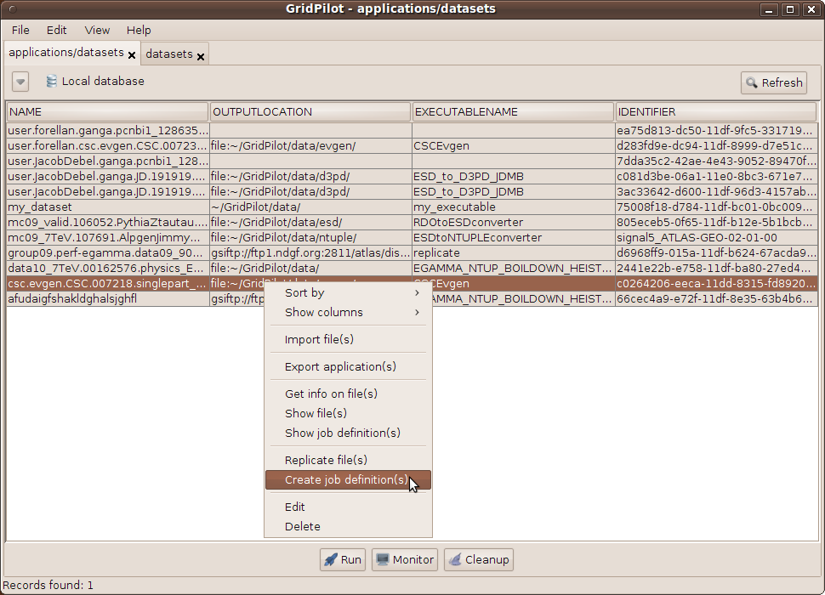
Illustration 1: Main GridPilot window with user applications/datasets.

Work flow
The idea is that the user keeps his data and data productions organized in so-called datasets. To GridPilot, a dataset is simply a database record with a number of fields, notably name, input dataset, number of files, output location and executable.

An executable is another database record with a number of fields, notably name, version, executable file and runtime environment. The executable file is the script or binary that will actually be executed a number of times in order to produce this dataset. Typically it will be run with each of the files of the input dataset as input. A runtime environment is yet another database record with a number of fields, notably name and computing system.
Returning to the datasets, each dataset is the parent of a number of file records, and if the dataset was produced with GridPilot, it also is the parent of a number of job definition records. Each of these job definition records contain enough information to create a job that can run on any of the supported computing back-ends.
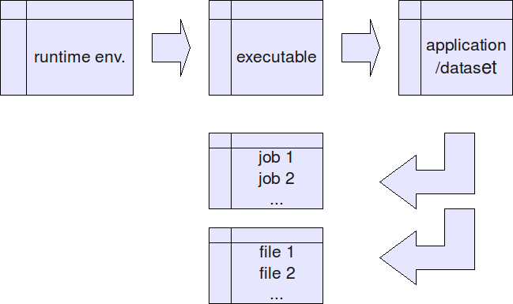
Illustration 2: Relationships of the GridPilot database records.
All the user has to worry about are the dataset and executable records. Once he has created a dataset record, job definitions can be created and run automatically. If the jobs finish successfully, output files are registered as file records in the local database. If he deems that his dataset is of interest to other ATLAS users, he can publish it to the DQ2 catalog by simply copy-pasting the record to the ATLAS datasets tab. If he deems that his work is a good example for others to use as starting point or template for their data processing, he can choose “Export selected application(s)” from the “File” menu. By default this will export the application to the central GridPilot “app store”, but the user can export to any directory - local or remote.

Data management
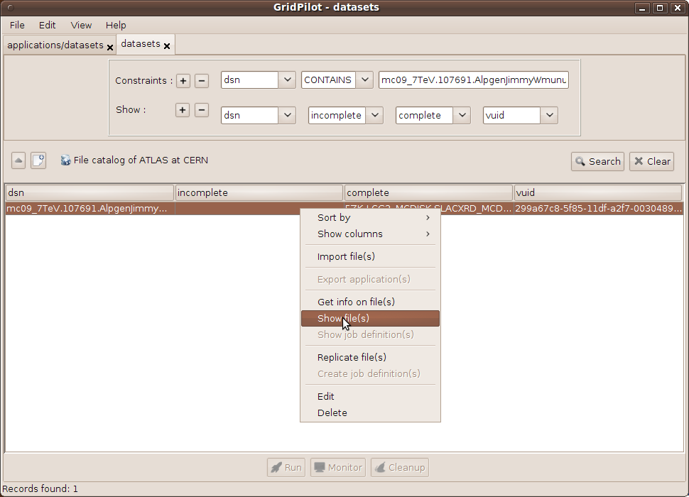
Illustration 3: Main GridPilot window with ATLAS datasets.
GridPilot has some support for data management: Files can be downloaded from, uploaded to and replicated between grid file servers and the ATLAS DQ2 dataset catalog and LFC file catalog are specifically supported. Notice that all this is meant to allow a user to easily find and download a few files to study before submitting a large-scale production to a grid back-end. For large-scale transfers, the PanDA web interface for replication requests or the DQ2 suite of command-line tools should be used.
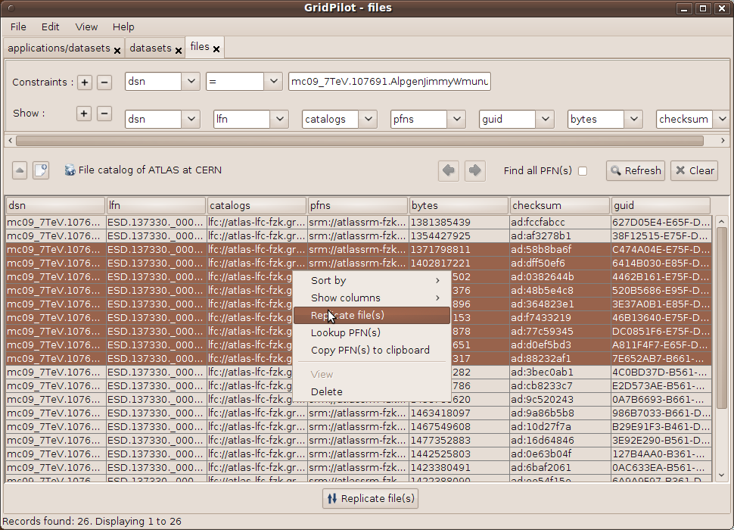
Illustration 4: Main GridPilot window with ATLAS file records.

An example: ESD to ntuple
To illustrate the use of GridPilot, let's look at running a specific application, imported from the GridPilot “app store”. This application converts ESD data files to Root ntuple format, using a standard transformation from the ATLAS Athena software package.

 | NorduGrid tier-3 cluster | WLCG
Average submission time per job (s) | 1.34 | 3.69
Average CPU time per job (s) | 125.3 | 295.8
Summed CPU time (s) | 3259 | 7691
Summed download time (s) | - | 72041
Total submission, waiting, processing and data transfer time (s) | 6356 | 37528
Table 1: Summary of ESD to ntuple runs.
We ran the application over 26 input files totaling 36 GB, generating 26 output files, first on a single cluster via NorduGrid, then on WLCG at large. The cluster, nominally had 160 cores, but 10 - 20 were busy with other jobs. On WLCG, the number of simultaneously running jobs varied, but did not exceed 10. The running times are summarized in the table above. Clearly, the speedup offered by running on grid resources is very modest, but this is presumably to a large extent due to the short running time of each job: The overhead of the grid system dominates the actual execution time. All this, however is not really important in the context of this paper. What is important is that the application is very easy to import run, alter to one's needs and possibly export - for the benefit of others.

Conclusion
The main motivation for the current work was a desire to get new ATLAS students faster on track with their real work, which is data analysis, and avoid having them spend too much time on computing setup and infrastructure – in particular on the intricacies of the grid technology used by ATLAS. The idea was to provide a working model that is easy and compelling and at the same time forces users to work in a reproducible manner - allowing others to reuse their work. To achieve this, we have created a new general GUI wherein ATLAS-specific features are implemented as plugins. As the example of the last section demonstrates, our goal was met: GridPilot can be used to easily run standard ATLAS data processing on two major production grids. A related benefit of using GridPilot is long-term traceability or data provenance: Data, produced by simulation or processing on grid resources can be reproduced with a few mouse-clicks. GridPilot is available at [13].

References
- E. Laure et al., “Programming the Grid with gLite”, In Computational Methods in Science and Technology, pages 33–46, Scientific Publishers OWN, 2006
- M. Ellert et al., “Advanced Resource Connector middleware for lightweight computational Grids”, Future Generation Computer Systems (2007) 23, http://www.nordugrid.org/
- I. Foster and C. Kesselman, “Globus: A metacomputing infrastructure toolkit”, The International Journal of Supercomputer Applications and High Performance Computing, 11(2):115–128, 1997
- T.Maeno (ATLAS Collaboration), “PanDA: Distributed Production and Distributed Analysis System for ATLAS”, J.Phys.Conf.Ser. 119 (2008) 062036, http://iopscience.iop.org/1742-6596/119/6/062036
- M Branco et al (2008), “Managing ATLAS data on a petabyte-scale with DQ2”, J. Phys.: Conf. Ser. 119 062017, doi: 10.1088/1742-6596/119/6/062017, http://iopscience.iop.org/1742-6596/119/6/062017
- J. T. Mościcki, F. Brochu, J. Ebke, U. Egede, J. Elmsheuser, K. Harrison, R. W. L. Jones, H. C. Lee, D. Liko, A. Maier, A. Muraru, G. N. Patrick, K. Pajchel, W. Reece, B. H. Samset, M. W. Slater, A. Soroko, C. L. Tan, D. C. Vanderster, M. Williams, “GANGA: A tool for computational-task management and easy access to Grid resources ”, Computer Physics Communications, Volume 180, Issue 11, http://arxiv.org/abs/arxiv:0902.2685
- G. Negri, D. Barberis, K. Bos, A. Klimentov and M. Lamanna, "Distributed Computing in ATLAS ", Proceedings of Science, PoS (ACAT08) 035, http://pos.sissa.it/cgi-bin/reader/conf.cgi?confid=70
- ATLAS glossary, https://twiki.cern.ch/twiki/bin/viewauth/Atlas/AtlasGlossary
- The grid acronym soup, http://www.gridpp.ac.uk/gas/
- M. Dosil, A. Farilla, M. Gallas, V. Giangiobbe and F. Orellana., “Massive data processing for the atlas combined test beam”. February 2006. 4pp. Paper presented (talk) at CHEP ‘06 and published in IEEE Transactions on Nuclear Science, Volume 53, Issue 5, Oct. 2006
- W. Allcock, J. Bester, J. Bresnahan, A. Chervenak, L. Liming, S. Tuecke, “GridFTP: Protocol extensions to FTP for the Grid (2001)”, Internet draft, https://grid.desy.de/docs/GridFTPprotocol.pdf
- A. Shishani, A. Sim and J. Gu, “Storage Resource Managers: Middleware Components for Grid Storage”, in Nineteenth IEEE Symposium on Mass Storage Systems, 2002, https://sdm.lbl.gov/srm-wg/
- GridPilot web page, http://www.gridpilot.dk/

Ganga has a graphical user interface, but it is far less used than the command-line interface.
The acronyms used are names of ATLAS data formats: Event Summary Data, flat ntuples (D3PD) and Raw Data Objects. For more on ATLAS and grid acronyms, see [8, 9].

