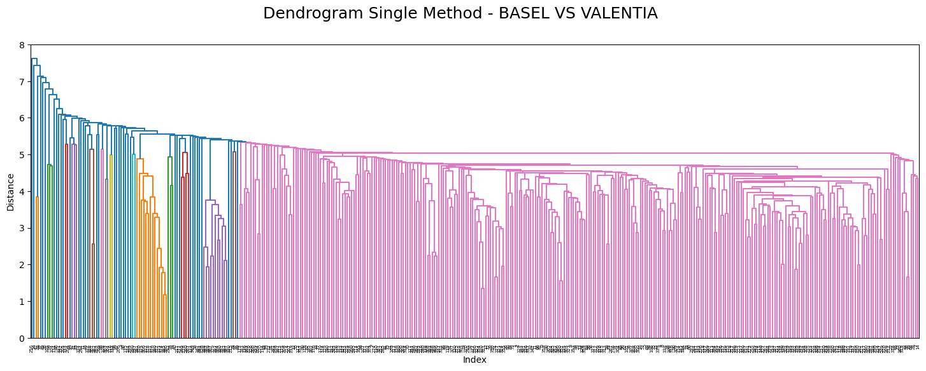
No insights, just a very jumbled mess with 1 super category

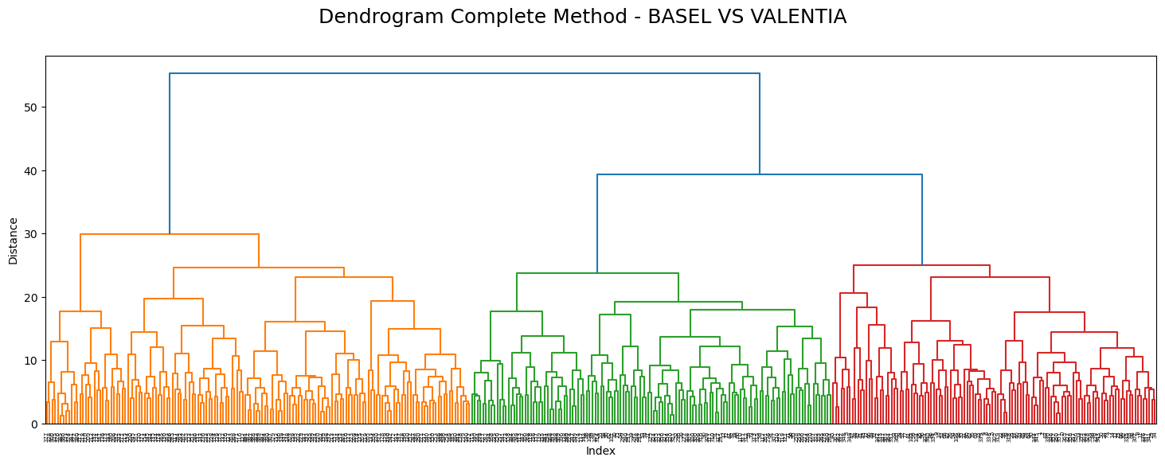
Stronger separations with likely seasonal clusters

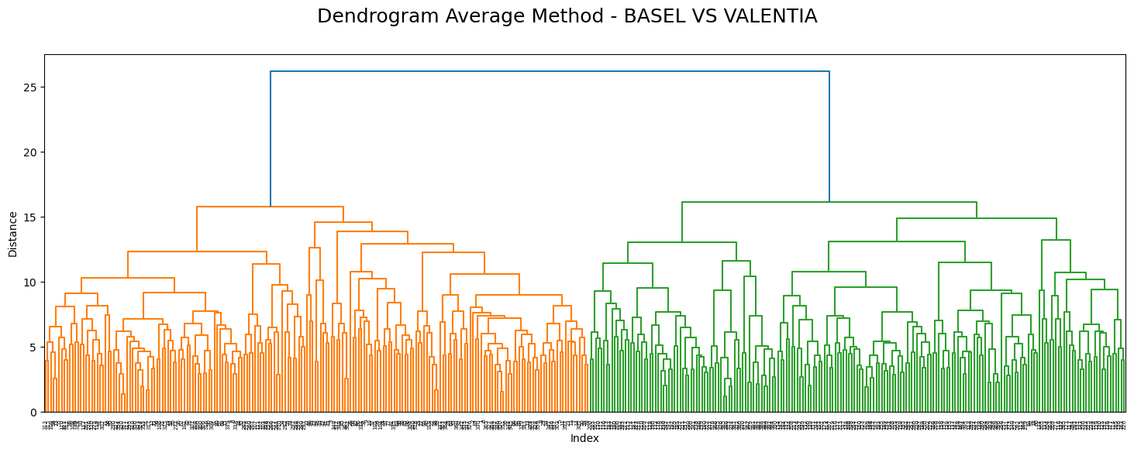
Only created 2 categories with approximately equal distributions
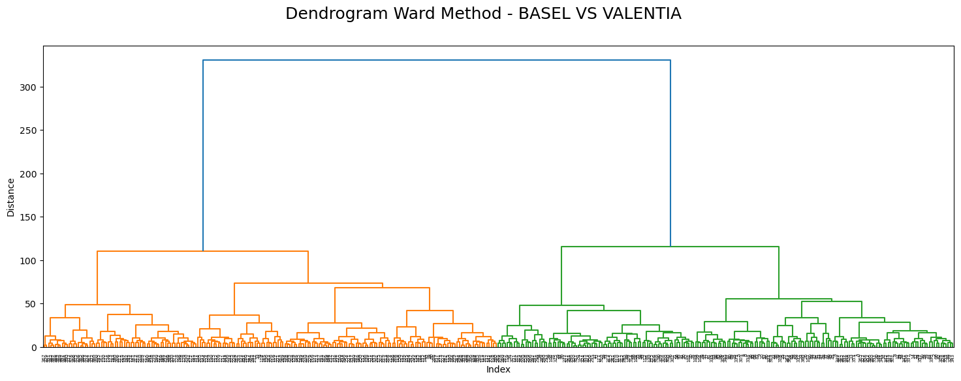
2 large categories with much more splitting at the bottom of each category

For the scaled data, my dendrograms failed due to scaled data not fitting properly. Changing stations and years would likely fix the problem as seen through other submissions.

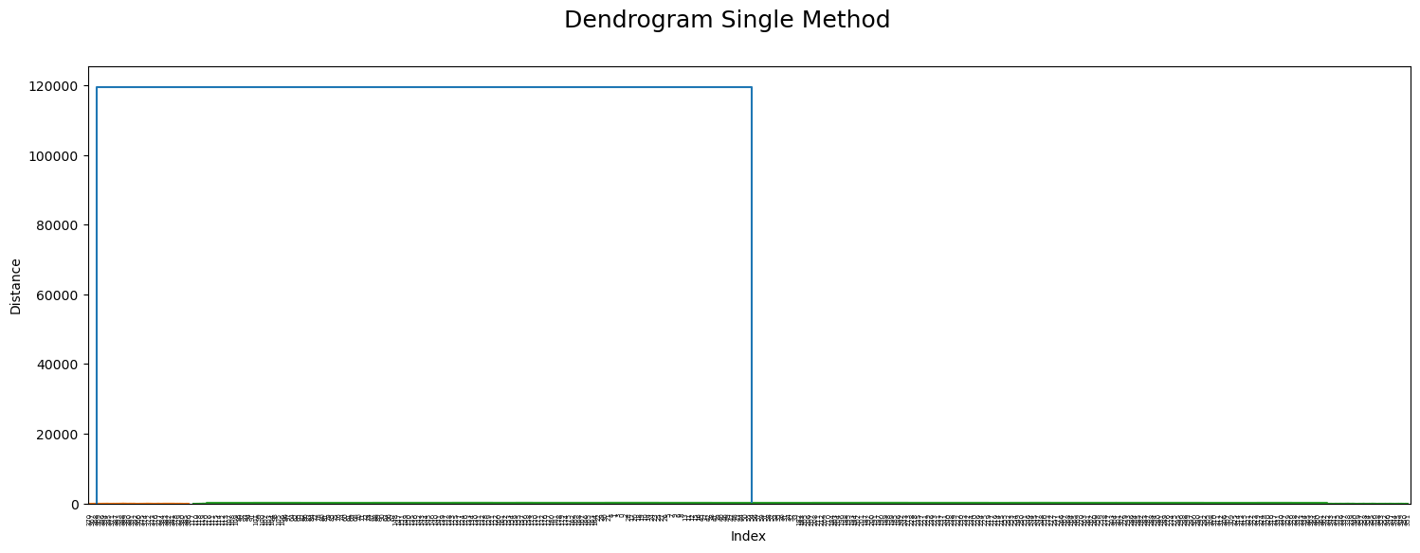

Finally, we did a PCA and all methods ended up looking like this with 3 clusters having 1 major split. Perhaps PCA is not the best method to use with dendrograms as dimensionality reduction can harm them more than helping them.

