Random Forest Model

I chose the 2010s for my model for all stations since it has the most updated data and chose around 100 estimators for a balance of accuracy and training time.

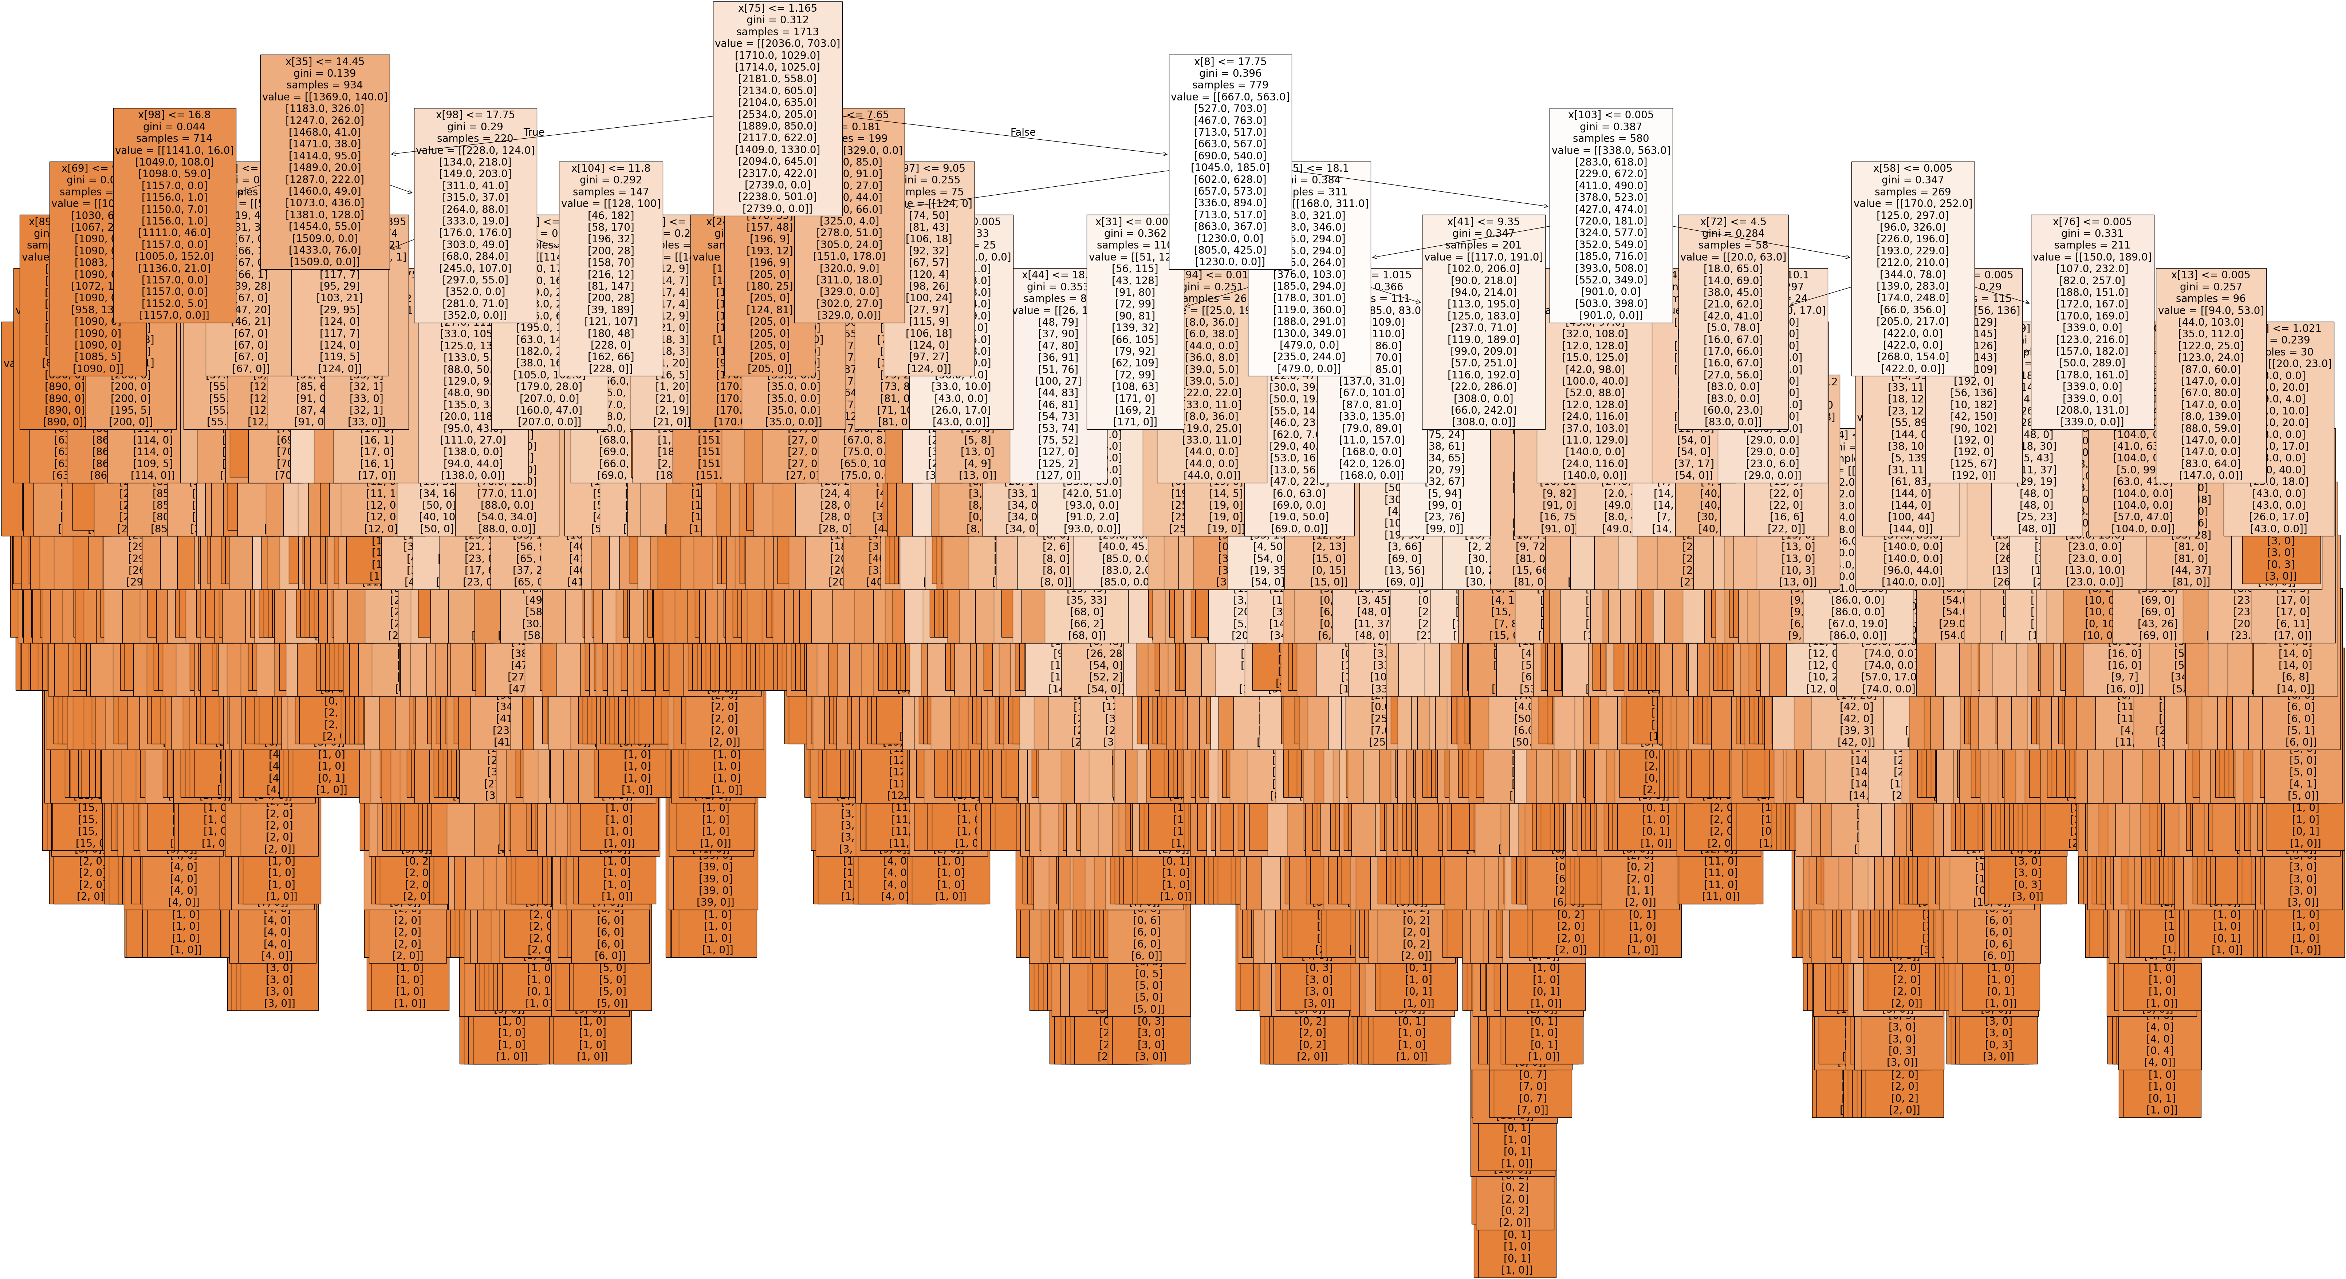

Model Accuracy: 0.5848849945235487
Precision Score: 0.9043927648578811
Recall Score: 0.8866371120962635
F1 Score: 0.8954269267668692

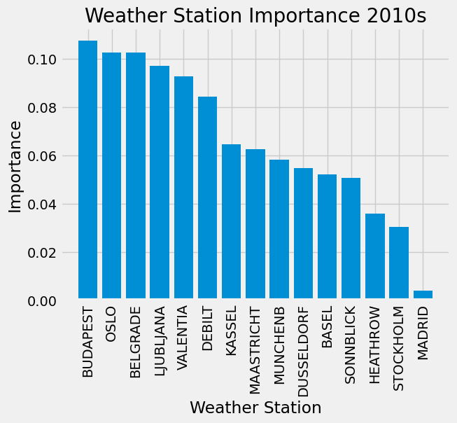

Based on the importance chart, I chose Budapest, Oslo, Belgrade to look at for further study.

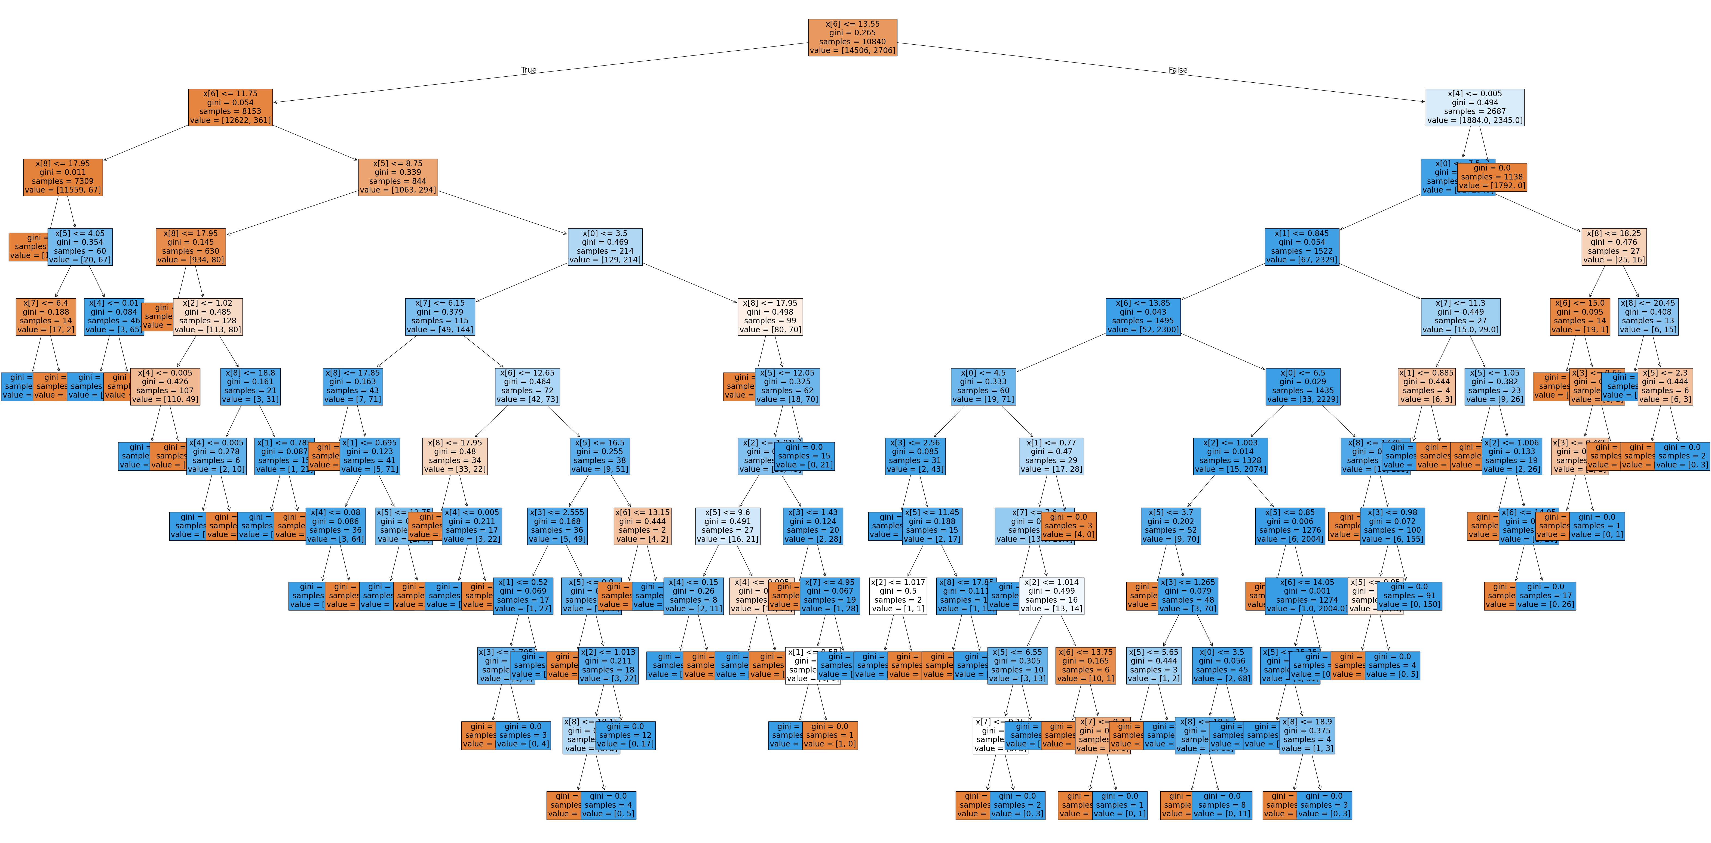
Model Accuracy: 1.0
Precision Score: 1.0
Recall Score: 1.0
F1 Score: 1.0
Model is likely overfitted.

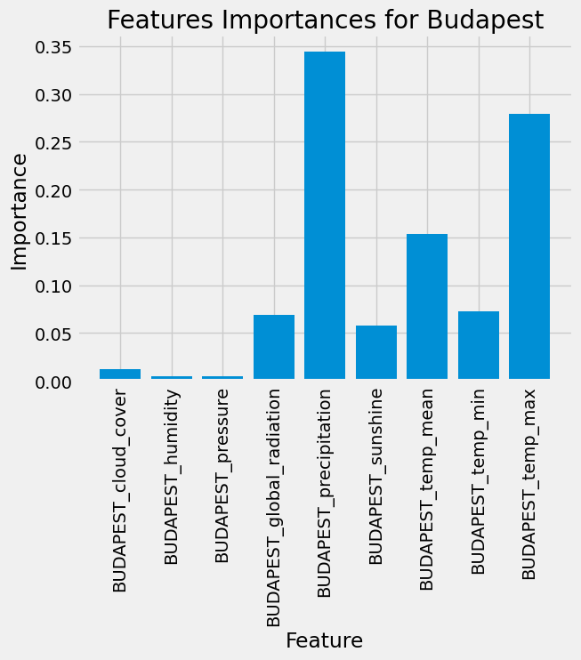

Model Accuracy: 1.0
Precision Score: 1.0
Recall Score: 1.0
F1 Score: 1.0
Model is likely overfit.

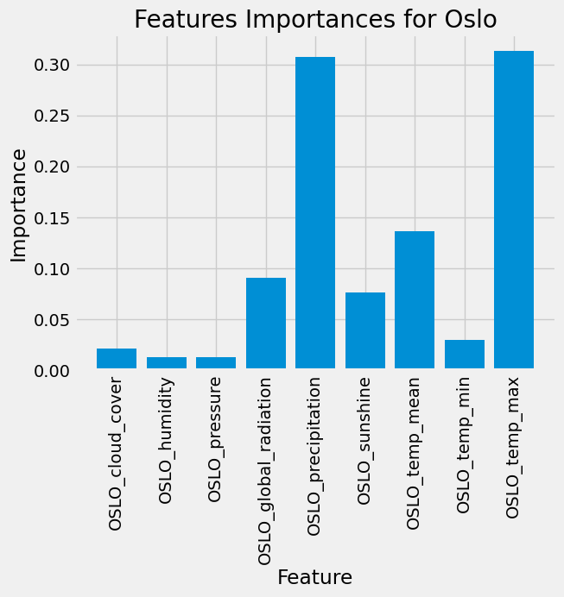

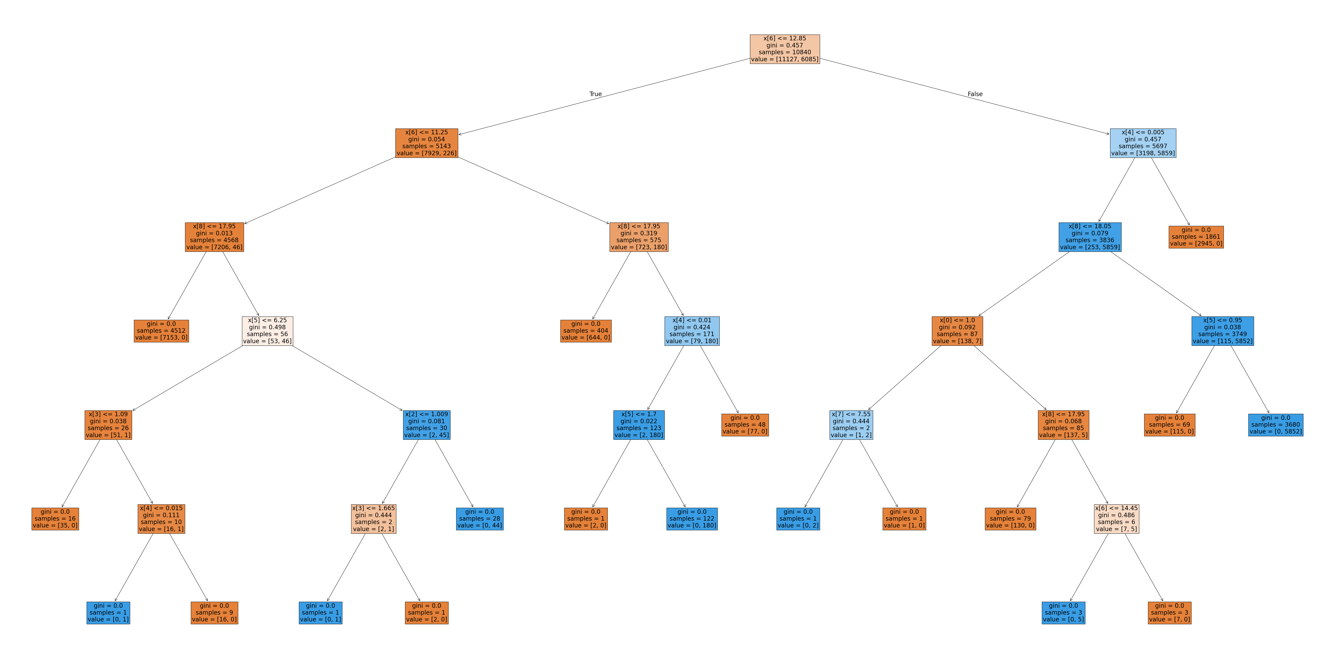

Model Accuracy: 1.0
Precision Score: 1.0
Recall Score: 1.0
F1 Score: 1.0
Model is likely overfit



