Random Forest

Dataset | 2-3 Accuracy | 2-4 Accuracy
All Stations (2010-2019) | 58.4% | 63.4%
Oslo (All Years) | 100% | 100%

All Stations (Before Optimization)
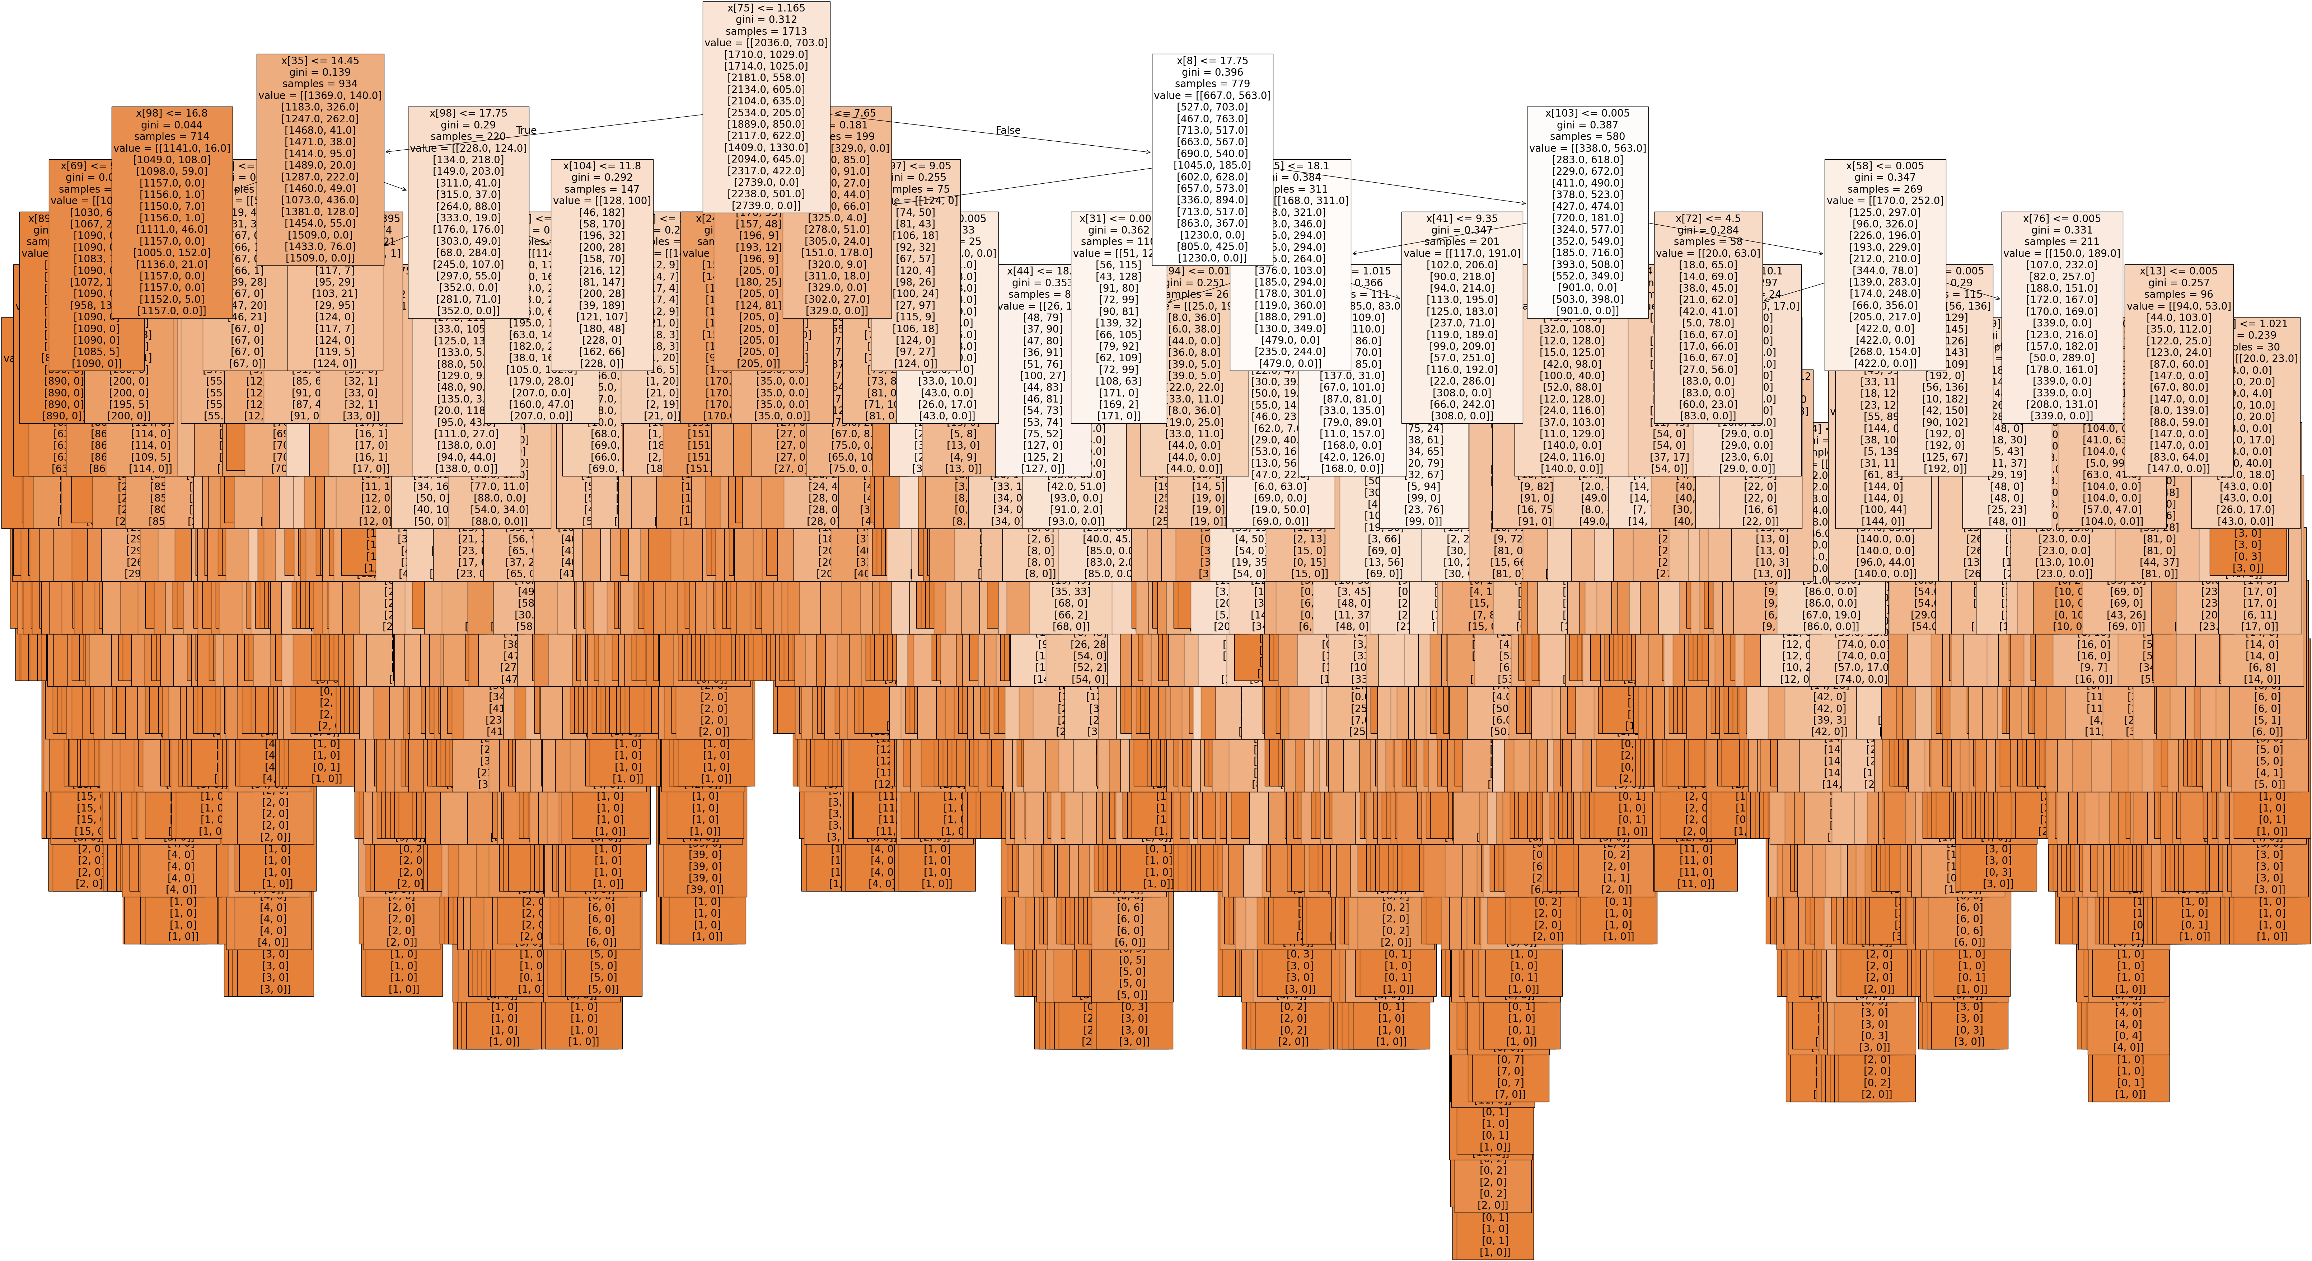

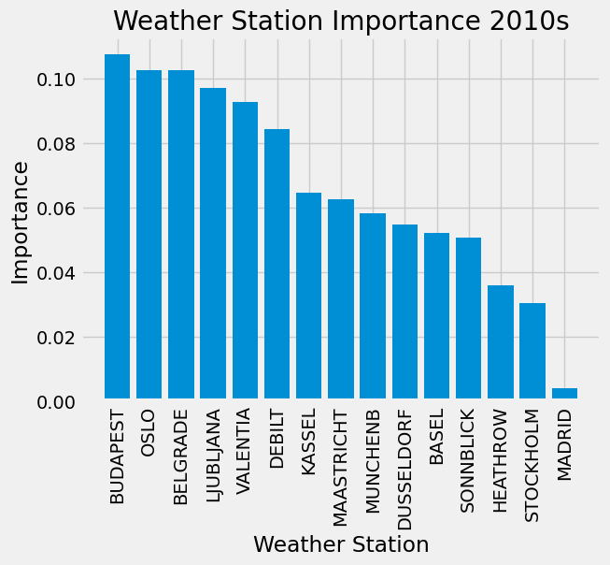
All Weather Stations (After Optimization)

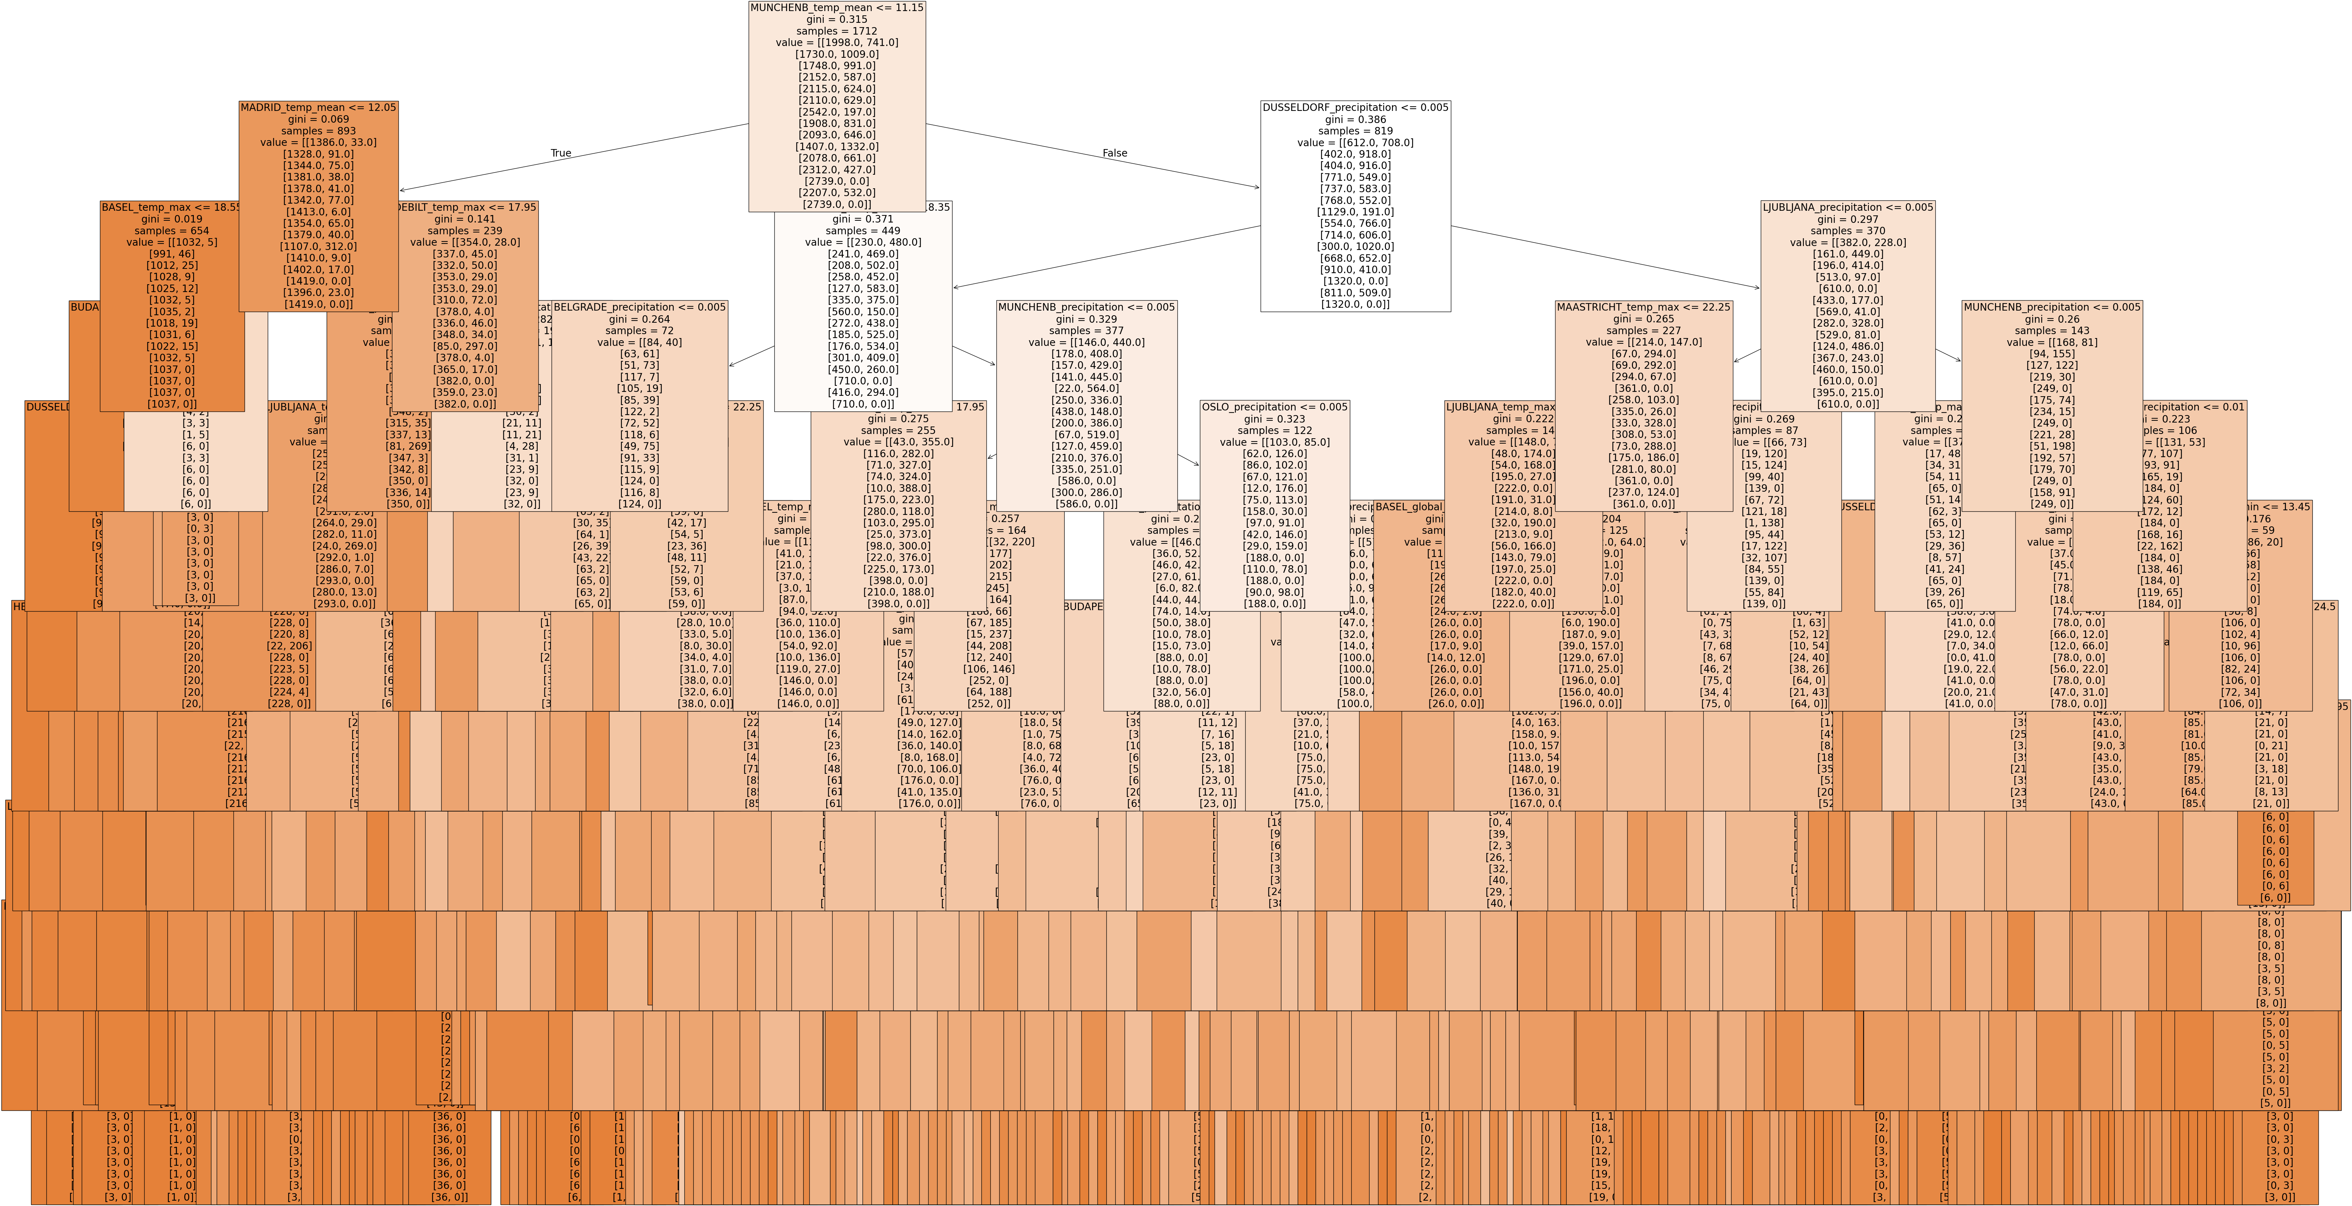

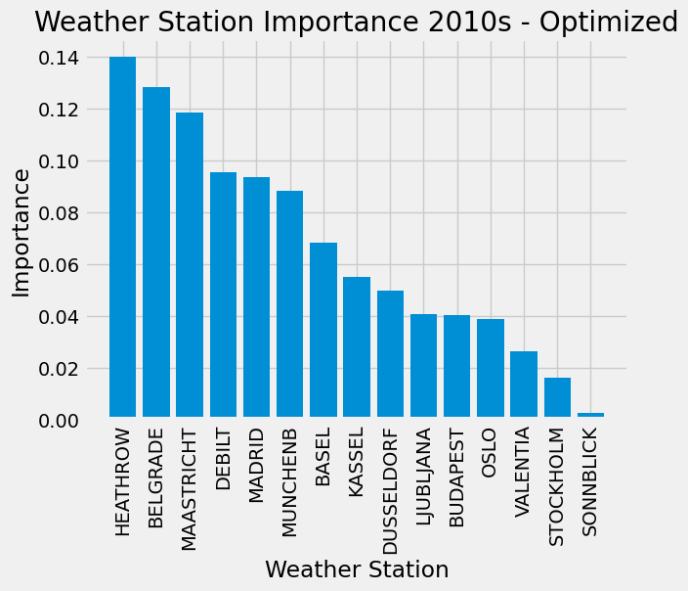

The model accuracy has gone up approximately 5% after updating the model. Both decision trees are very difficult to interpret at large, but the optimized one is much more simplified in depth and node count when compared to the previous model with its stacked nodes seemingly going on forever. In the optimized model, the highest features (Oslo, Budapest) rank much more lower near the bottom of all weather stations. Meanwhile, Heathrow surges to first place while Belgrade moves up to second place.

Oslo (Before Optimization)
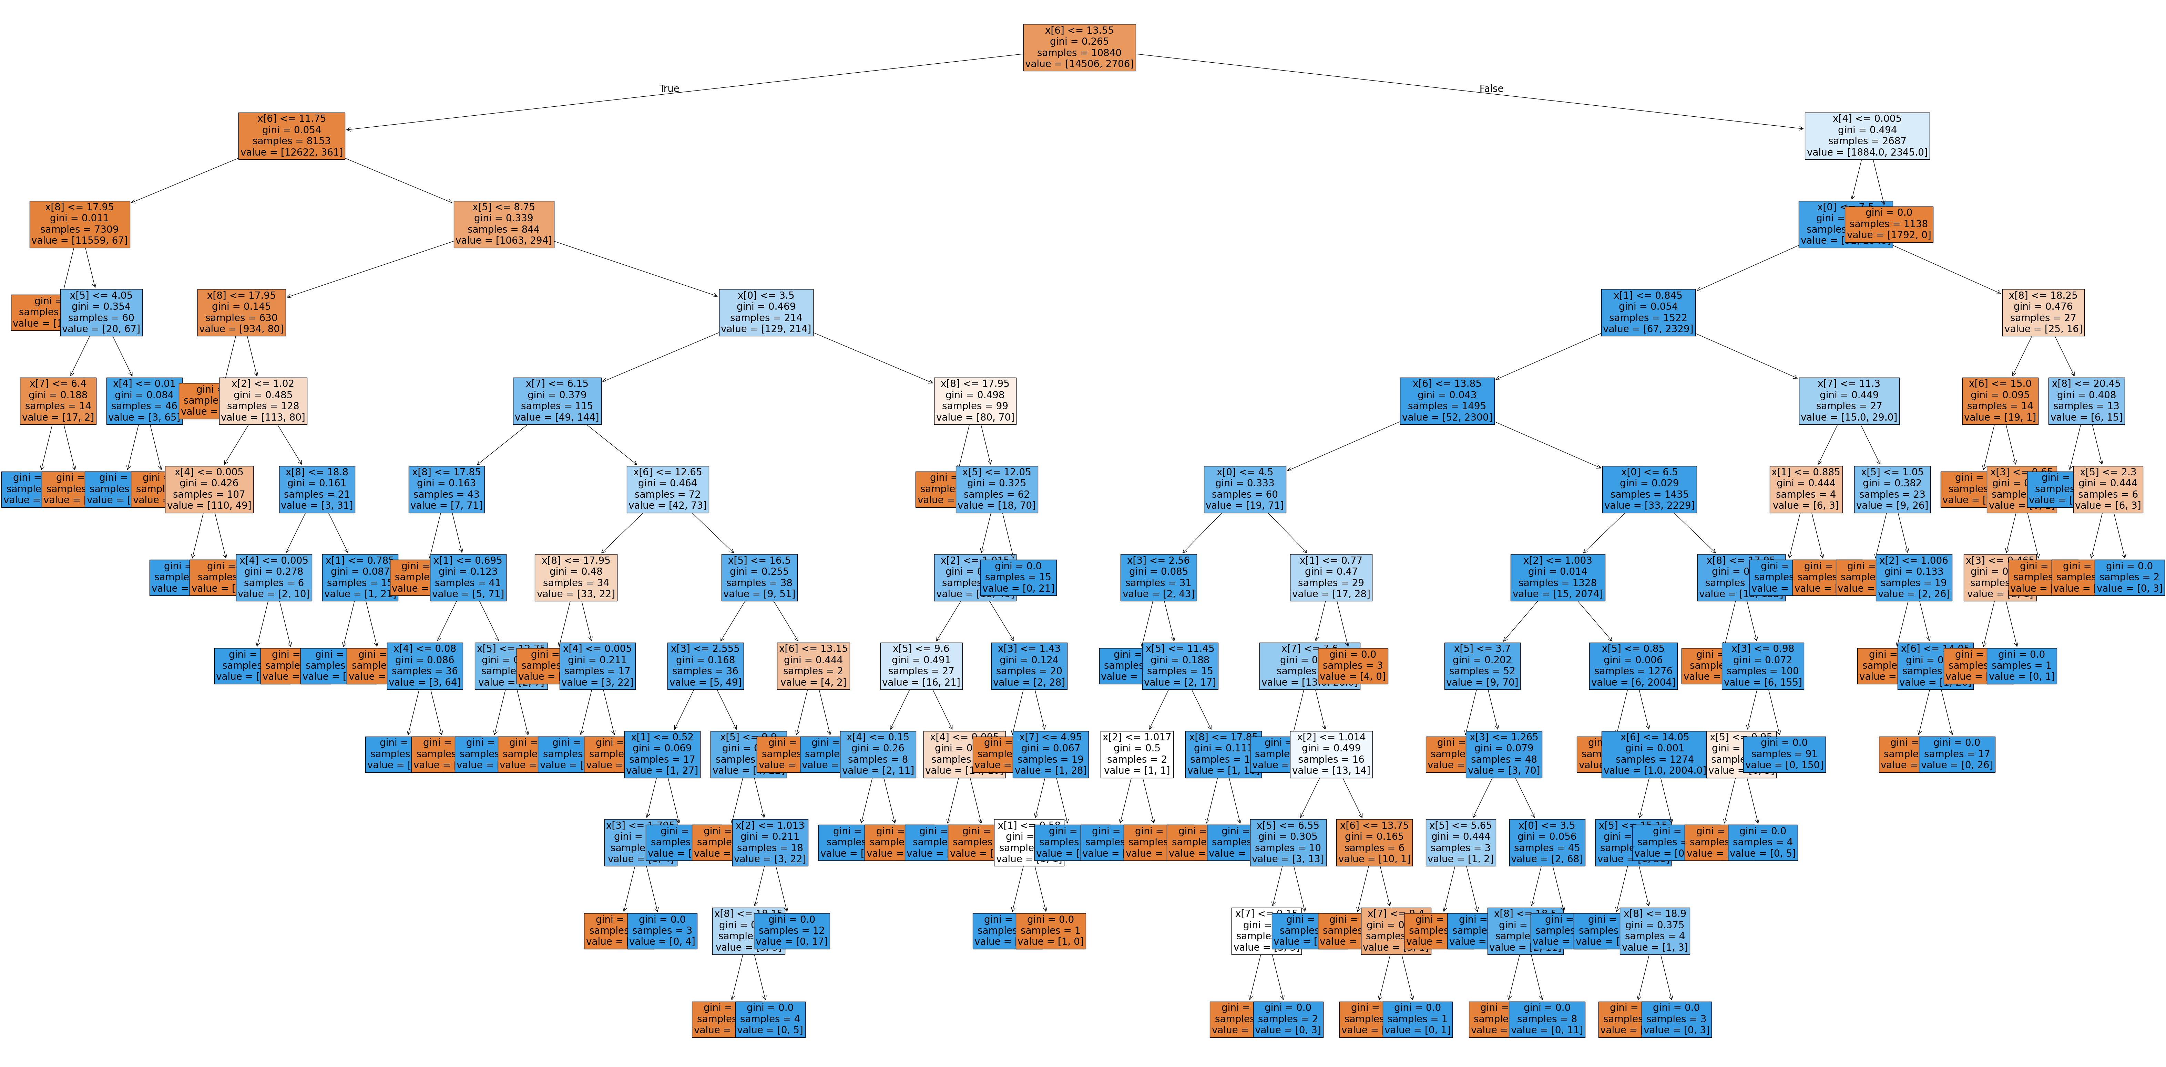

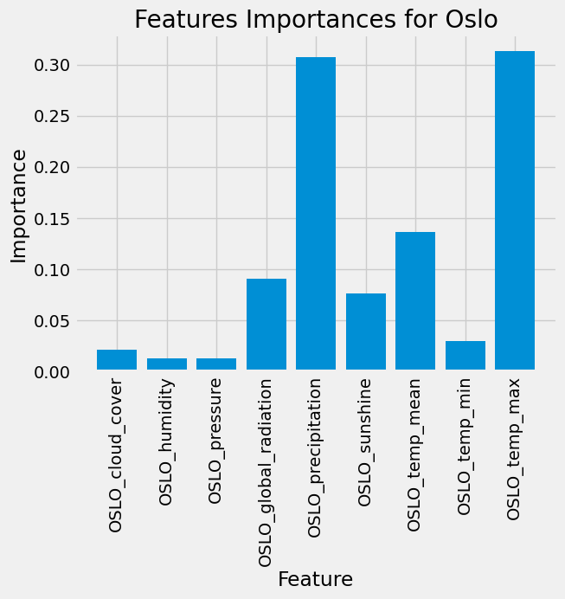

Oslo (After Optimization)

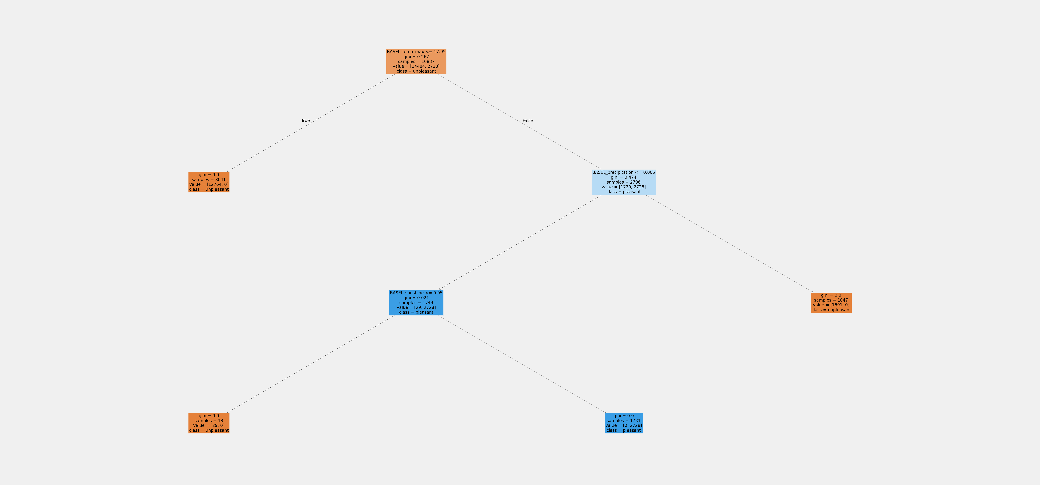

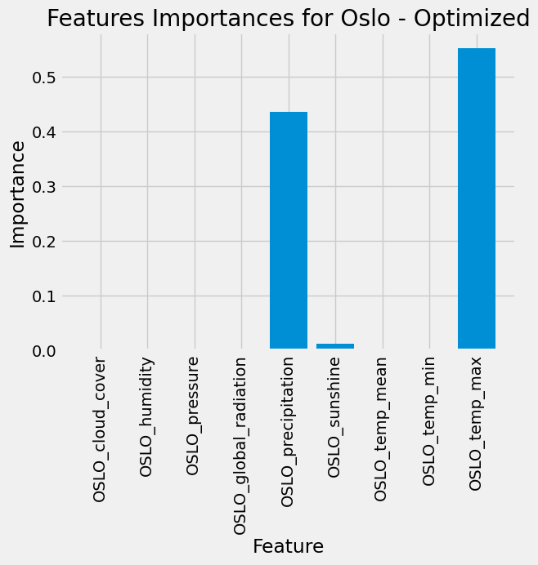

It is very likely that the Oslo (as well as many other trees not shown here) weather station trees are overfitted. Further research may be needed to determine if this is correct or not. As with most other stations after optimization, the model puts heavy emphasis on precipitation and maximum temperature to make its predictions with a very small emphasis on the sunshine feature. The unoptimized model, however spread its secondary features (eg: not temp_max and precipitation) among radiation, sunshine, temp_mean, and temp_min alongside small amounts of the remaining features.

CNN Model
Accuracy before optimization: 12.1%
Accuracy after optimization: 76.3%

Parameter | 2-2 | 2-4
neurons | 256 | 25
epochs | 30 | 21
batch_size | 32 | 247
learning_rate | - | .164
kernel | 2 | 3
activation | relu | softplus
optimizer | Adam | Adadelta
layers 1 | - | 3
layers 2 | - | 2
normalization | - | .708
dropout | - | .020
dropout_rate | - | .290

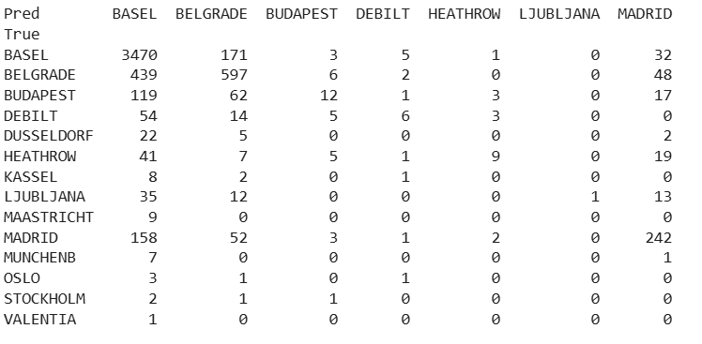

After optimization our accuracy jumps up from low 12% to around 76.3%. I could probably increase said accuracy further further but I do not have the computing power to do so by trying out more hyperparameter combations. This improvement is driven primarily by changing our optimizer and learning rate to newer and generally better ones, going from Adam to Adadelta was a huge accuracy boost.

Iteration

To optimize weather predictions for the Air Ambulance company, swe should egment the dataset by location, time intervals, or weather features and begin to break data down by individual or clustered weather stations (e.g., continental vs. coastal) to capture localized patterns. Time-based segmentation (seasons, months, years) helps reveal seasonal trends, while grouping by metrics like temperature, precipitation, and sunshine enables targeted analysis of flight safety factors.
For modeling, an optimized random forest is ideal to start. It's easy to interpret, less complex to tune, and resists overfitting, especially when used with station-specific data. However, it struggles with non-linear relationships and scalability. A CNN, though computationally heavier and less transparent, excels at extracting intricate spatial and temporal patterns from large datasets with minimal feature engineering. Begin with the random forest for its clarity and accuracy, then transition to CNNs to uncover deeper, complex trends. Key weather variables for flight safety identified include maximum temperature and precipitation.

