Handwriting

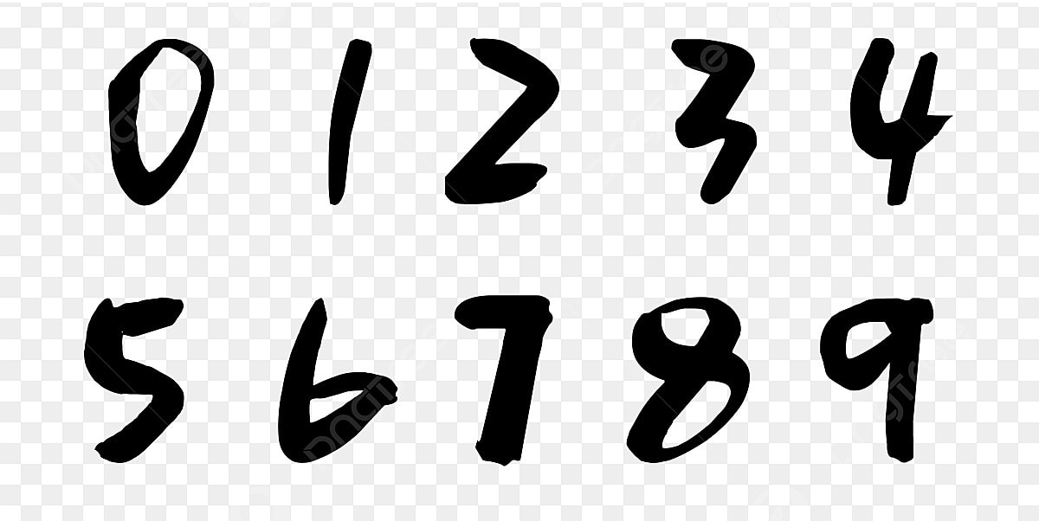

Here are the images I drew with a marker and uploaded into the MNIST training data. All of my predictions resulted in the number 4 for some reason. Not sure why that number in particular, but I don’t think the thick marker lines fit the dataset well enough. Low accuracy considering all predictions were 4 with only 10%.

Part 2

Epochs | Accuracy | Loss
5 | 0.58 | 0.13
10 | 0.91 | 0.02
15 | 0.9 | 0.04
20 | 1 | .005

The 20 epoch model is likely overfit and should not be used.

Confusion Matrix Insights
- Misclassifications are most frequent between "cloudy" and "shine" (37 errors), followed by confusion with "rain".
- "Shine" and "sunrise" classes show high accuracy with minimal errors.
- The model struggles primarily with distinguishing "cloudy" from both "shine" and "rain".

Applying GANs to Weather Prediction
1. Storm Tracking and Forecasting
Generative Adversarial Networks (GANs) can be trained on satellite imagery and radar data to simulate the evolution of storm systems. By learning spatiotemporal patterns, GANs can generate realistic future frames of storm movement, aiding in short-term forecasting and early warning systems. For an example, the AST-GAN model uses attention-based spatiotemporal GANs to forecast tropical cyclone wind speeds and structure with high accuracy.

2. Climate Simulation and Scenario Modeling
GANs can emulate high-resolution climate simulations by learning from historical datasets. This allows for rapid generation of ensemble climate scenarios, which are essential for uncertainty quantification and long-term planning. One model shown in the links below did this quite successfully.

3. Extreme Weather Phenomena Detection
GANs can be used to detect and classify meteorological phenomena such as hurricanes, heavy precipitation, and convective systems. By segmenting radar and satellite images, GANs help identify patterns that traditional models may miss, improving early warning capabilities.One study applied GANs to simulate extreme precipitation events and improve hydroclimatic understanding.
Links:
A Generative Adversarial Network with an Attention Spatiotemporal Mechanism for Tropical Cyclone Forecasts | Advances in Atmospheric Sciences
Latent Diffusion Model for Generating Ensembles of Climate Simulations
Simulating Extreme Precipitation Phenomena Through Generative Adversarial Networks: Advancing Hydroclimatic Understanding | SpringerLink

