Volumetric Rendering
Brandon Booth, Evan Hatch, Jorge Garrido Resendiz, Brian Valdillez

Project Introduction
Our aim for this project was to study volumetric rendering, a 3D rendering technique which forgoes a traditional polygonal model in favor of a 3D sampled data set, and then apply the acquired knowledge in building a working volumetric renderer. We ended up creating a hybrid volumetric renderer, which takes advantage of the GPU’s triangle rendering and shading power to do most of the calculations for ray casting.

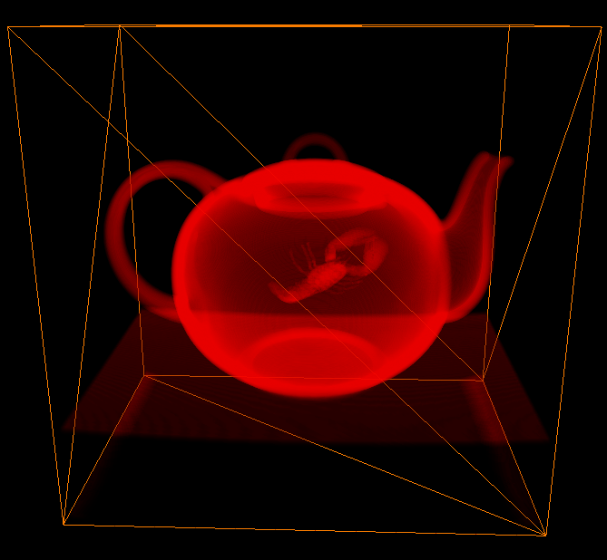

Left: Image capture of final renderer output.
( Boston Teapot )

Implementation
We drew from two key sources in creating our volumetric renderer. In our implementation, we transitioned from C++, the language used in our assignment-based renderer, to C# for our project-based renderer, to take advantage of our first source, Microsoft's XNA Game Studio. XNA Game Studio provided us with a framework for easily displaying to the screen and also supported 3D texture storage and sampling natively. Another key advantage was the ability to easily hook up a shader to our volume to offload much of the ray casting work to the GPU. Our second source was the blog "Graphics Runner", which featured a basic tutorial on a volumetric renderer pipeline we decided to use as the base for our project.
Volume data is usually stored as an isovalue ranging from 0 to 255 in slices within a three-dimensional [x,y,z] array. The z value represents the depth, or which slice is being referenced. The x and y values represent width and height values within the specified slice. The isovalue represents a voxel, which in this case stores the opacity of the volumetric model at that location.
Our renderer uses an existing volumetric data file format, the RAW format, to store models. There are several benefits to using an existing file format in regards to our project. An existing file format means there are models already created. To compound this potential issue, none of our group's members had any experience with 3D modeling, meaning we would have needed some method of transforming an existing polygonal model to a volumetric format, diverting our attention from other aspects of the project. Additionally, the volume data we used were generated by CT scans, resulting in highly detailed models based on actual physical objects. The voxel data is loaded into a Texture3D object, which is designed to represent a three-dimensional array of data.
Once we have the density data, we need a transfer function to apply RGB and alpha values to the density levels. These are normally implemented in a manner similar to a color lookup table, where key isovalues known as control points are given specific RGB and alpha values and then interpolated across to generate the non-key RGB and alpha values.
For the transfer function, a TransferControlPoints struct was created. This struct stores the control points used to generate the color lookup and alpha lookup tables. The struct is instantiated with our handpicked control points, which is then used to generate a Color array of size 256. Cubic splines are fit to the list of control points in order to smoothly interpolate between them. This Color array only needs to be instantiated once, frontloading this aspect of the processing. Our transfer function is one-dimensional, as it is only based on the single scalar value stored within each voxel. More complicated volumetric models can store multiple values within each voxel to generate a more complicated color scheme.
With the transfer function ready to be applied to the volume data, the final step is to fill the screen's pixel buffer. In true volumetric rendering, for each pixel a ray is cast from the camera through the volume data. At regular intervals, the RGBA values are additively sampled and blended front to back to determine the final pixel color. The ray ends when the cumulative alpha value reaches opaqueness or the ray finishes passing through the volume, whichever comes first.
However, our renderer, being built upon a traditional 3D pipeline, has to take a different approach to be able to display volumetric models in real time. First, a polygonal bounding box is created and fit to the volume. The positions of the front and back-facing triangles of the bounding box are then rendered to textures. A pixel shader then samples the textures to easily determine the world-based start and end coordinates for ray casting, and then steps from the front-facing pixel towards the back-facing pixel, sampling the 3D texture in the manner used for true volumetric rendering.
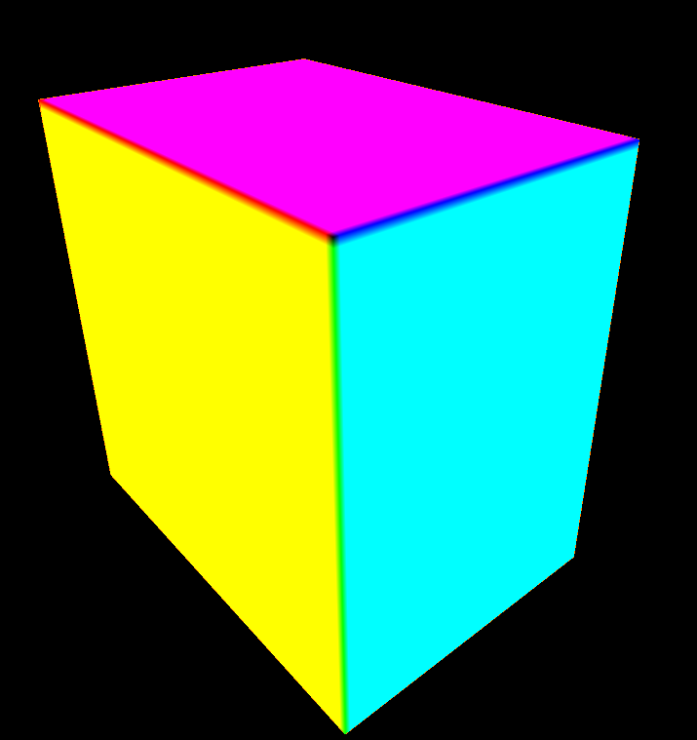
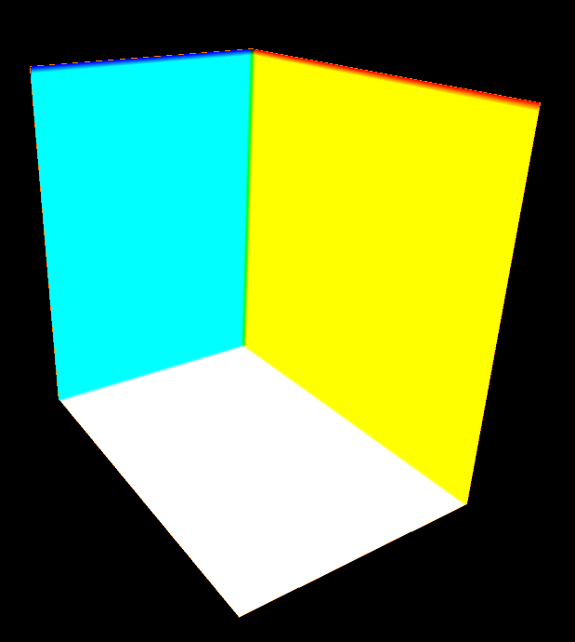

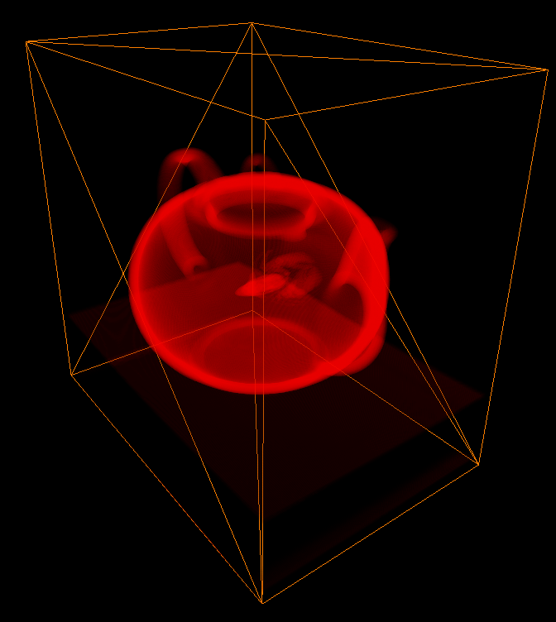

Above: Front-facing pixel texture
Top: Bottom-facing pixel texture
Right: Rendered teapot

Challenges
∙Transfer Function—Splines: In creating the transfer function generator, we created our own spline algorithm calculator. Initially, we tried to code our own linear equation modeler, but it proved complicated. In looking for an easier solution, we discovered that the structure of the linear system happened to be tridiagonal. Once this fact was realized, we could use the Thomas algorithm, matrix-based Gaussian elimination method of solving tridiagonal systems of equations.

∙Transfer Function—Control Points: The transfer function allows us to generate a smooth translation between control points. However, the control points themselves need to come from somewhere. To produce visually appealing coloration, we had to manually experiment with the control point values.

∙Ray Casting—Distortion: One of the last issues we faced before we reached the final version of the renderer was a bizarre distortion effect being applied to the model when the bounding box was turned towards certain angles. The path for the ray cast was being calculated based on the camera position and the front-facing triangle texture. In transforming the camera position to model space, the inverse world matrix was being incorrectly calculated. We changed the path calculations to use the front-facing triangle texture and back-facing triangle texture as the algorithm normally used, and the problem was resolved.

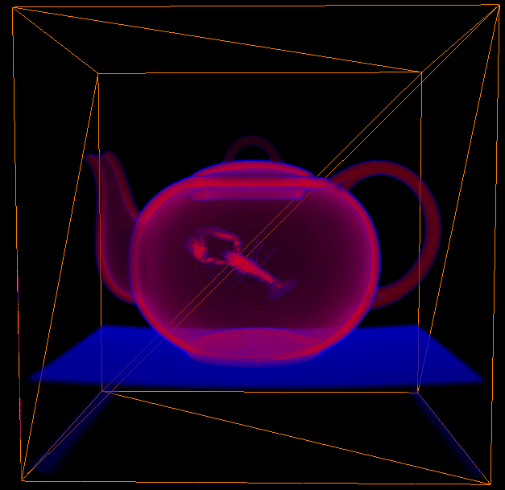
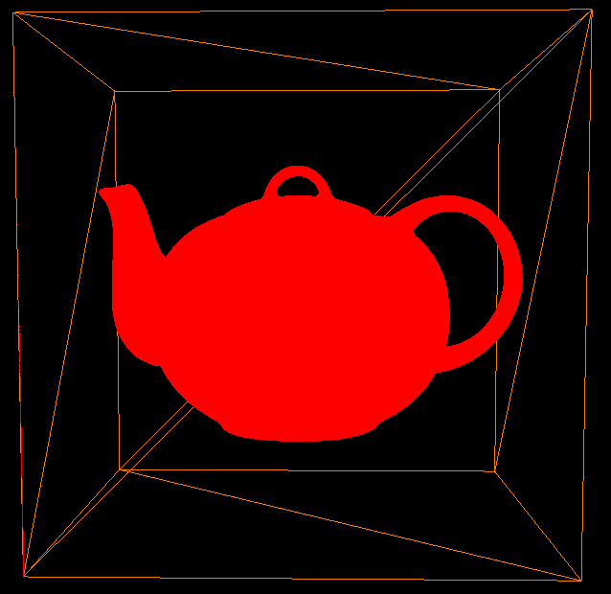

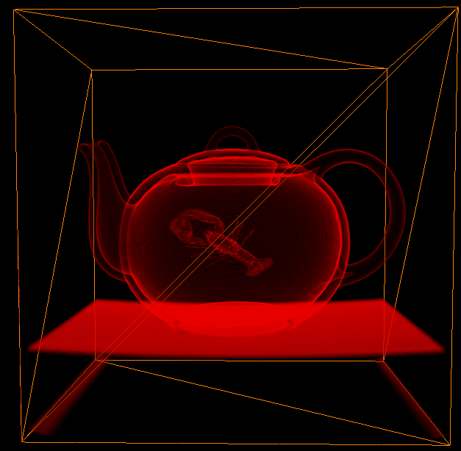
Above:
Opaque teapot. Alpha: 0.02; Range: 130
Top:
Translucent teapot (Blue Tinge). Alpha: 0; Range: 0
Right:
Detailed teapot. Alpha: 0.03; Range: 30
Conclusion
Volumetric rendering has seen applications in medical and entertainment fields, but the traditional polygonal-based method is still predominant. It is currently used for specialized purposes that can take advantage of the inherent properties of volumetric rendering. CT scans, for example, can be volumetrically rendered so that the control points can be adjusted to view different layers and sections of the object. If volumetric rendering is ever going to replace polygonal rendering, commercial hardware would need to experience a complete paradigm shift before it has any chance of being used exclusively in real-time applications.

References
Hayward, Kyle. “Graphics Runner”. Available: http://graphicsrunner.blogspot.com/2009/01/volume-rendering-101.html
Volumetric Datasets. Available: http://www.gris.uni-tuebingen.de/edu/areas/scivis/volren/datasets/datasets.html

