
COMMISSIONING AND OPERATIONS MANUAL
Installation, Calibration,
and Operation Guide
Delta X Software - Multi-Robot Sorting on a Shared Conveyor

Applies to Delta X Software 1.3.0 and the multi-robot tracking platform
Audience: system integrators, commissioning engineers, and lead operators

Document Control
Field | Value
Document | Delta X Multi-Robot Installation, Calibration, and Operation Guide
Revision | 0.2 - Release candidate
Date | 2026-08-24
Scope | One camera, one encoder, one conveyor, and multiple delta robots using shared tracking
Example assets | script-example/multi-robot-sorting/

SAFETY: G-Script, vision, and tracking are not safety functions. E-stop, guards, axis limits, end-effector energy isolation, and collision prevention must be implemented by an appropriate safety circuit, PLC, or controller.

How to Use This Guide
- System integrators should follow Sections 1 through 9 during initial commissioning.
- Operators should use Sections 10 through 12 and the acceptance checklist in Section 13.
- Every calibration section has an acceptance gate. Do not proceed until the previous gate passes.
- Numeric values in sample programs are starting points and must be replaced with measurements from the actual cell.

Contents
- System architecture and coordinate conventions
- Hardware installation
- Software installation
- Project and device setup
- Encoder calibration
- Camera and image-region calibration
- Camera P to conveyor C mapping
- Conveyor C to robot Ri mapping
- Detector and tracking configuration
- Multi-robot G-Script configuration
- Operation, stopping, and fault recovery
- Acceptance and maintenance

1. System Architecture and Coordinate Conventions
The system uses one shared moving-object map. The camera produces detections; encoder-aware tracking converts detections into stable UIDs; each robot is an independent worker that obtains ownership through an atomic claim.
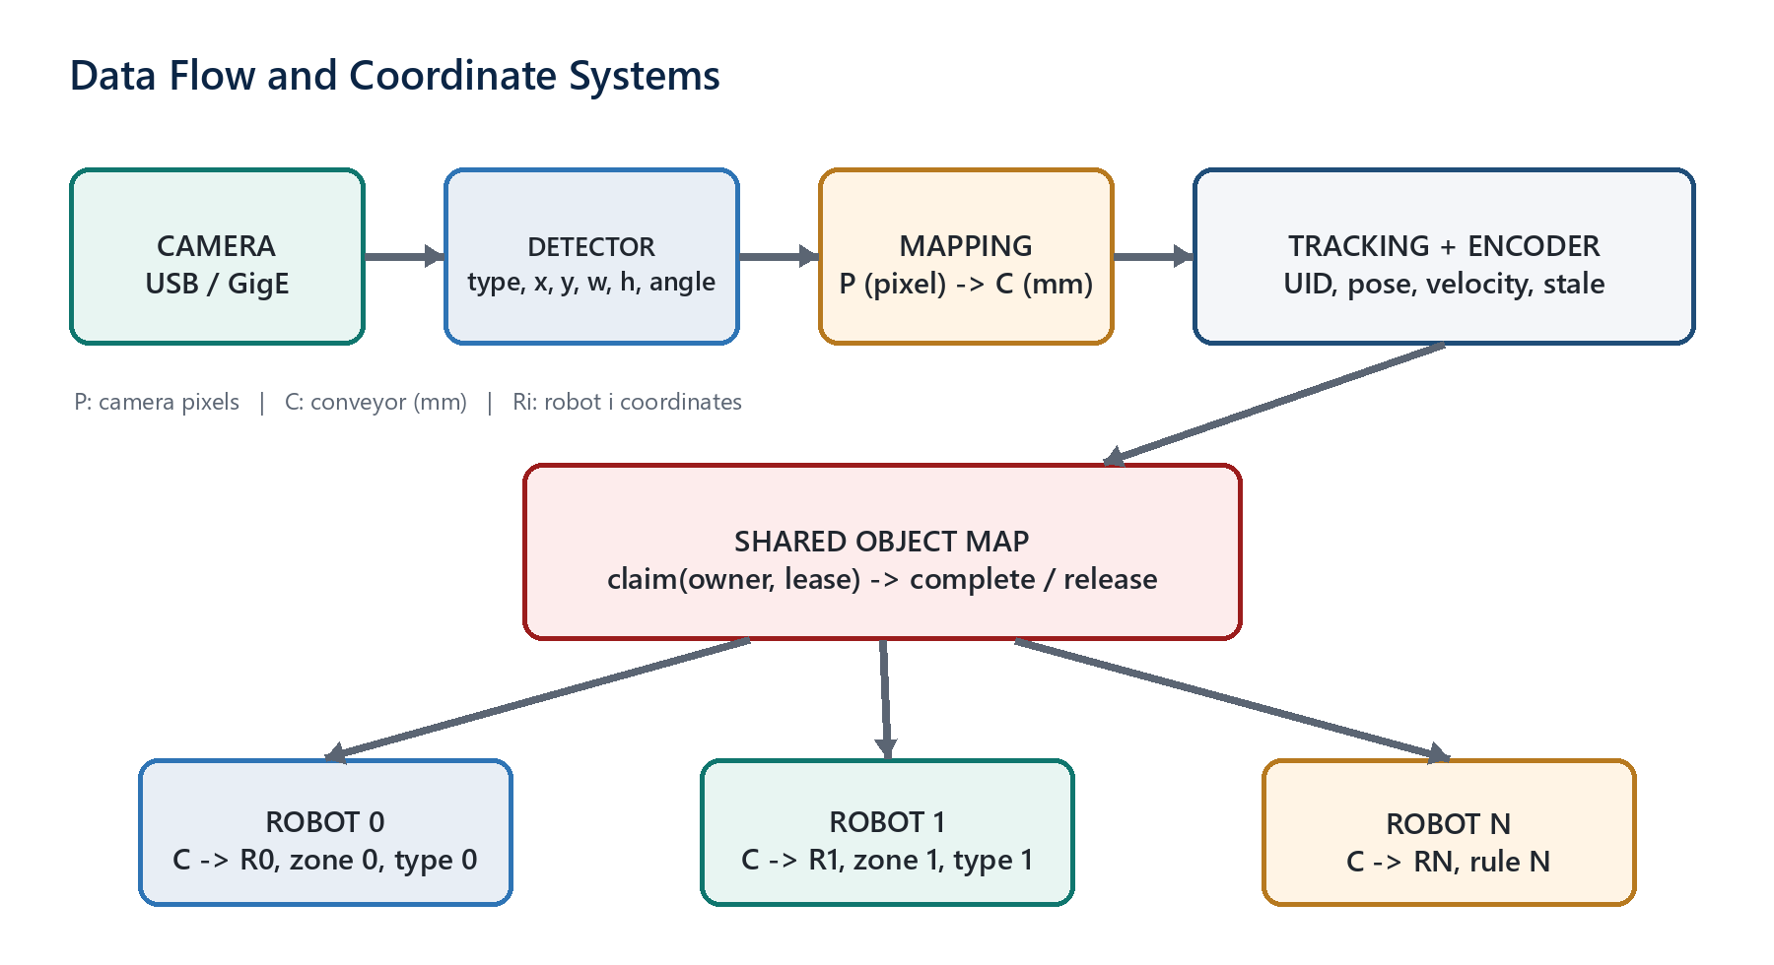
Figure 1 - Camera to detector to tracking to shared object map to robot workers

Keep three coordinate systems separate
System | Unit | Convention and use
P | pixel | Camera coordinates after resize, crop, and warp; used only before mapping.
C | mm | Shared conveyor system; use +Y along belt travel and +X across the belt.
Ri | mm/deg | Robot i local coordinates; every robot G01 move executes in this system.

RULE: Define claim zones in C. Only after a successful claim may a worker map the pick point from C to Ri with ConveyorToRobotN.Map(x,y).
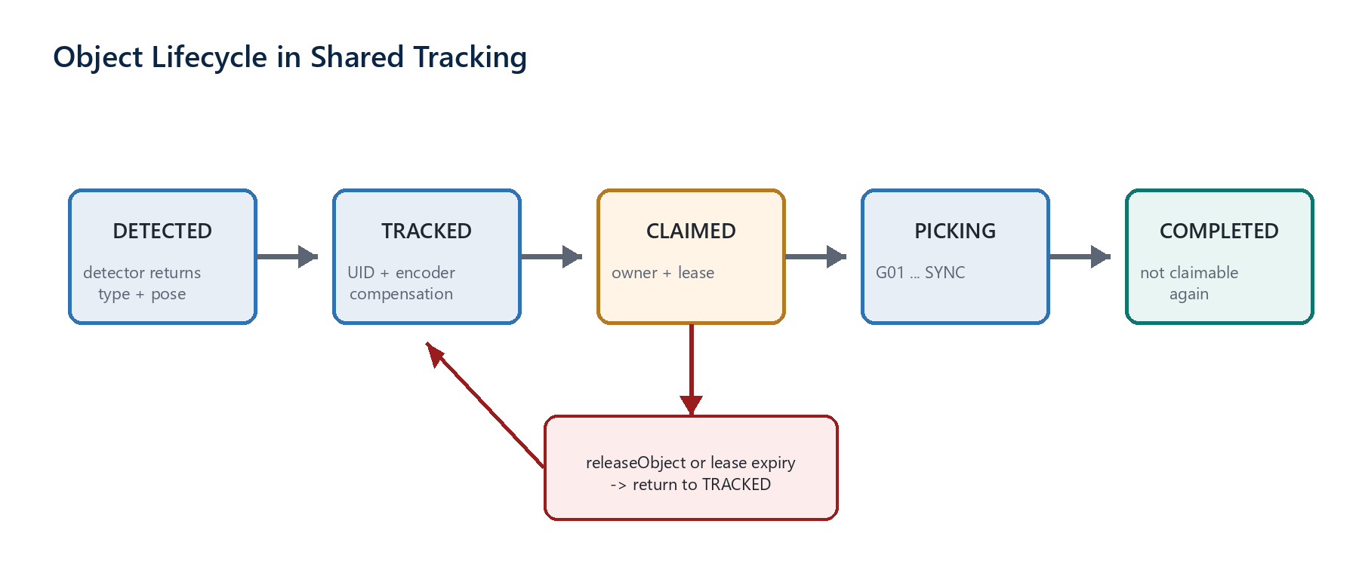
Figure 2 - UID lifecycle and owner/lease protection against duplicate picks

2. Hardware Installation

2.1 Recommended mechanical layout
- Mount the encoder on a non-slip shaft or a measuring wheel with stable pressure. Do not use motor pulses when the transmission may slip relative to the belt.
- Place the camera far enough upstream for inference, communication, and robot approach. Rigidly mount camera, lens, and lighting as one assembly.
- Install robots in conveyor order. Keep robot workspaces non-overlapping until a collision coordinator is available.
- Separate encoder and camera cables from power cables; terminate shielding according to the manufacturer requirements.
- Verify that E-stop, guards, mechanical limits, safe torque off, and vacuum release operate independently of the PC.

2.2 Naming convention
Device | Software name | Related variable or matrix
Camera/detect | detect0 | tracking0, #Objects
Encoder | encoder0 | tracking0.VelocityVector
Conveyor | conveyor0 | +Y of C
First robot | robot0 | #0.ConveyorToRobot0, #R0...
Second robot | robot1 | #0.ConveyorToRobot1, #R1...

ACCEPTANCE: Moving the belt by hand in the production direction increases C.Y. If it does not, reverse the sign in exactly one place.

3. Installing Delta X Software

3.1 Windows operator station
- Windows 10/11 64-bit and Microsoft Visual C++ Redistributable 2015-2022 x64.
- A portable package includes the Qt runtime, OpenCV DLL, GScript_Documentation.html, script-example/, and plugin/. Models and proprietary camera runtimes are installed separately.
- Install Basler pylon Runtime or Hikrobot MVS Runtime before using the corresponding GigE/USB3 Vision camera.
- Install 64-bit Python when using an external detector or YOLO; use a dedicated virtual environment for the cell.
py -3.10 -m venv %LOCALAPPDATA%\DeltaX\py
%LOCALAPPDATA%\DeltaX\py\Scripts\pip install ^
ultralytics==8.0.200 opencv-python==4.9.0.80 numpy==1.26.4

3.2 Build from source (development station)
- Visual Studio 2022 MSVC v143, workload Desktop development with C++.
- Qt 6 for MSVC 2022 x64 with Serial Port, Multimedia, Svg, and Svg Widgets.
- Rerun qmake after changing a Qt kit to avoid stale generated ui_*.h files.
- Build Release, run windeployqt, and then use the repository packaging script to include verified runtime assets.
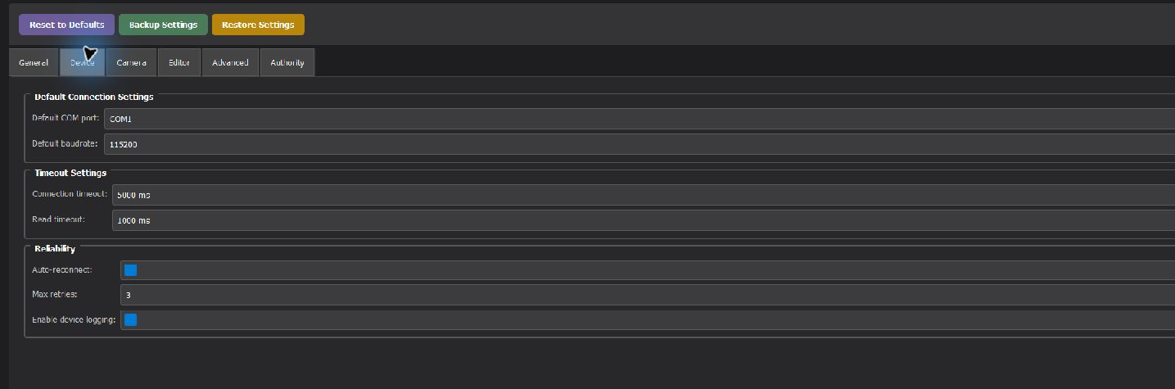
Figure 3 - Settings > Device: default COM port, baud rate, timeout, and reconnect
DO NOT SAVE YET: Do not click Save Settings until COM ports, baud rates, timeout, and the default camera have been verified. Back up settings before a major change.

4. Project and Device Setup
- Open Delta X Software, click + to create a project, and save it with an unambiguous cell or line name.
- On Robot, add robot0, robot1, and so on; select the controller COM port, baud rate, model, and degrees of freedom.
- On Conveyor, add conveyor0 and select direct G-code control or robot output according to the wiring design.
- On Encoder, add encoder0, select the X/Y axis, link conveyor0 when required, and enable Active.
- In Object Detector, create detect0, select Webcam / Industrial Camera / Images / Socket, and attach tracking0.
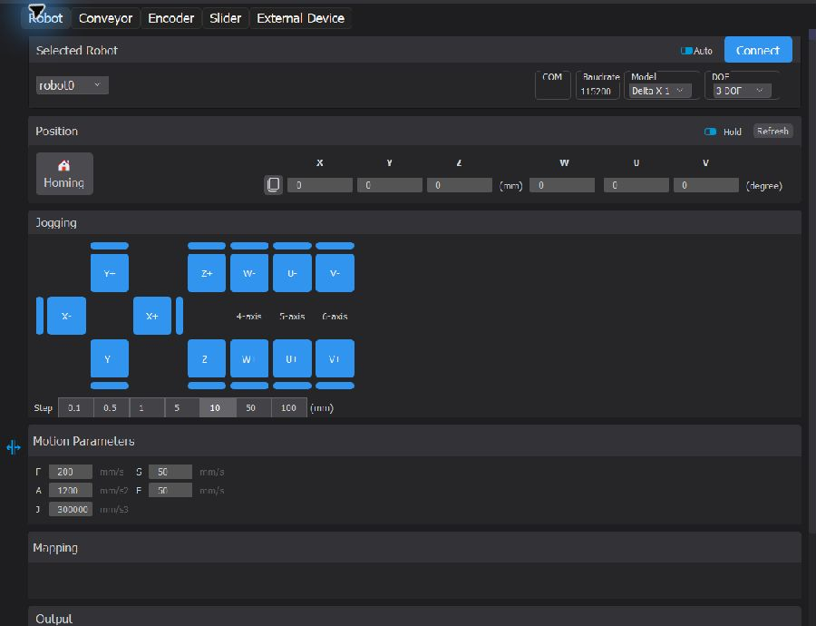
Figure 4 - Robot: connection, homing, pose, jogging, and motion parameters
JOGGING: For first motion, use a safe Z, 0.1-1 mm steps, and low speed. Verify X/Y/Z/W signs before homing or running a program.
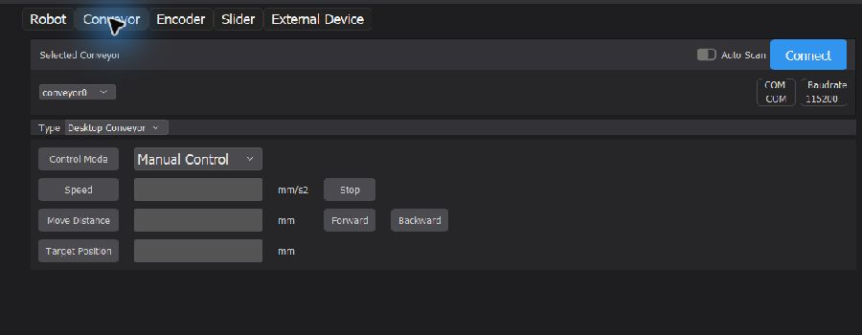
Figure 5 - Conveyor: Manual Control mode, speed, distance, and target position
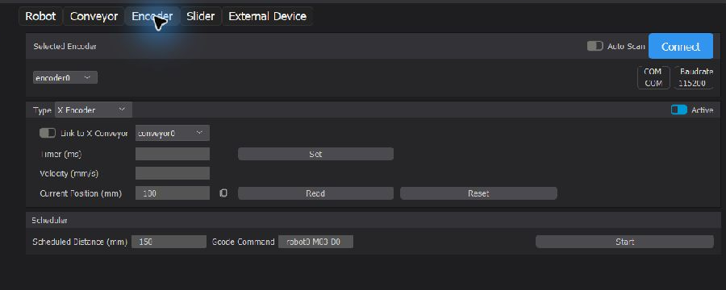
Figure 6 - Encoder: conveyor link, timer, velocity, position, reset, and scheduled G-code

5. Encoder Calibration
The encoder is the authoritative source for conveyor travel. Do not replace it with PC-time interpolation: the conveyor accelerates, decelerates, and may slip.

5.1 Determine mm/count and sign
- Mark two belt positions 500-1000 mm apart; stop at the first position and reset the encoder.
- Move in the production direction to the second position and record the count or reported-position difference.
- Calculate mm_per_count = measured distance / count difference. Example: 1000 mm / 20000 counts = 0.05 mm/count.
- Repeat forward and reverse travel at least five times. If error changes with load, correct mechanical slip before software tuning.
- Verify sign: travel along +Y must increase C.Y. Reverse the sign in the encoder configuration or Reverse Value, never in several locations.
Test | Measured value | Requirement
1000 mm travel | ________ mm | Error below half of the pick tolerance
Five repetitions | Max-Min: ________ | No cumulative error growth
Direction reversal | Difference: ________ | Backlash is within budget
Encoder loss | Detection time: ________ | No new claims are issued

ACCEPTANCE: Cumulative camera-to-pick error is below the end-effector error budget, and workers receive no new object when encoder data is stale.

6. Camera and Image-Region Calibration
Fix resolution, focus, exposure, ROI, and camera position before collecting points. Any resize, crop, or warp change after calibration invalidates the matrix.
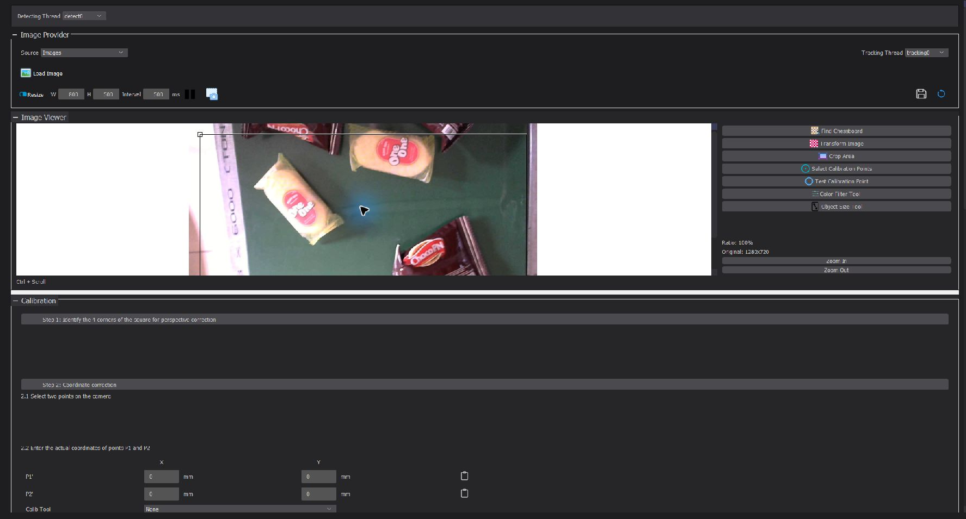
Figure 7 - Object Detector image view, camera tools, and Calibration panel

6.1 Correct perspective with a chessboard
- Place a flat, undamaged chessboard on the belt plane and cover the camera work area.
- Click Find Chessboard. Select Edit chessboard for an existing setup or Find new chessboard for a new one.
- Enter the correct row/column count and square size; verify every detected corner.
- Correct misplaced corners with the adjustment tool, then enable Transform Image.
- Enable Crop Area and retain only the object path ROI; lock width, height, and exposure.
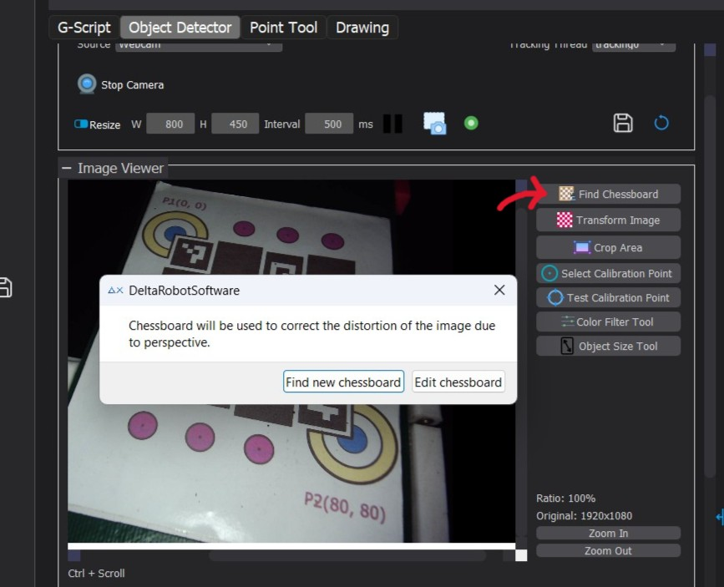
Figure 8 - Find Chessboard: create or edit configuration
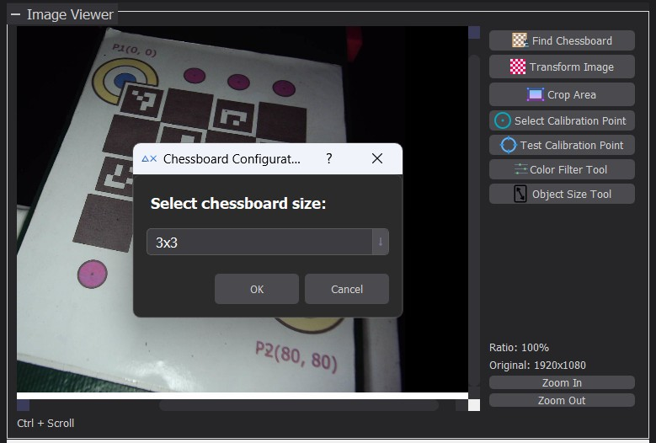
Figure 9 - Select the measured chessboard dimensions
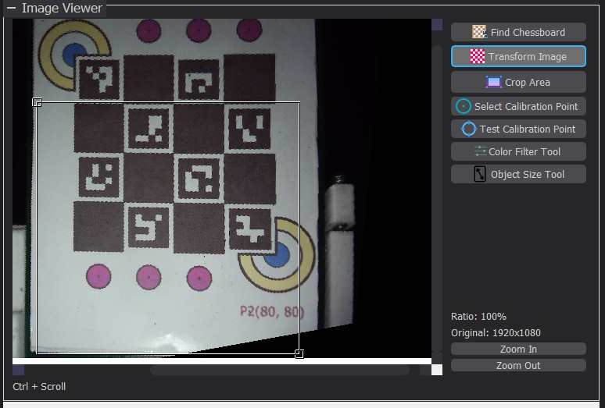
Figure 10 - Enable Transform Image after all corners are correct
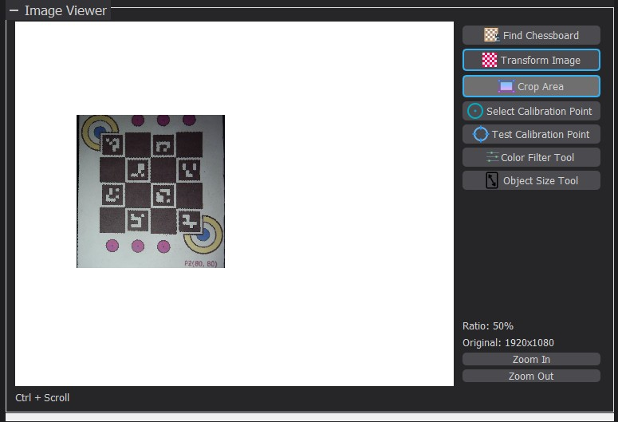
Figure 11 - Cropped ROI containing only the usable conveyor region
ACCEPTANCE: Straight belt references remain straight throughout the ROI, perspective is negligible, and parts are not blurred at production speed.

7. Map Camera P to Conveyor C
P-to-C mapping converts a detection centre from pixels to millimetres. The two-point model is appropriate after perspective correction leaves only rotation, scale, and translation.
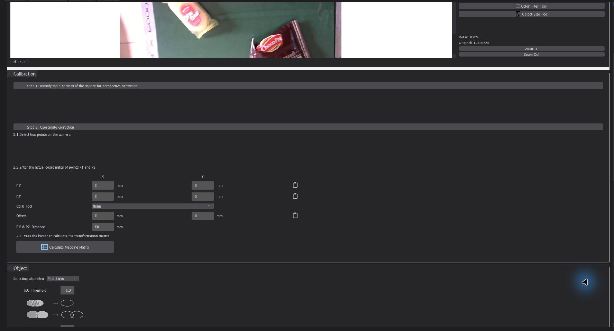
Figure 12 - Calibration: P1/P2, real coordinates, offset, distance, and matrix calculation

7.1 Two-point procedure
- Enable Select Calibration Points, choose a clear belt reference T, and copy its image coordinates into P1.
- Enter the measured P1' coordinates in C. If the encoder was reset at T, use X=0 and Y=0.
- Move the conveyor exactly 80-100 mm using a measured reference or encoder travel.
- Select the same reference T again and copy its image coordinates into P2; enter P2' with unchanged X and encoder travel as Y.
- Click Calculate Mapping Matrix, assign a stable name, and use Test Calibration Point on points excluded from the fit.
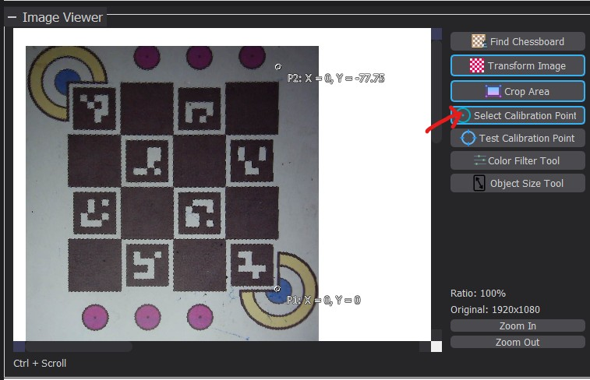
Figure 13 - Select the Calibration Point tool
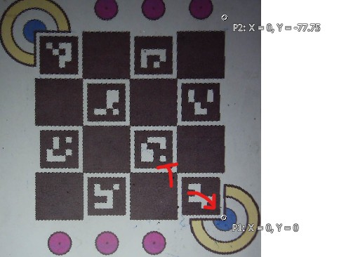
Figure 14 - Select reference T for P1
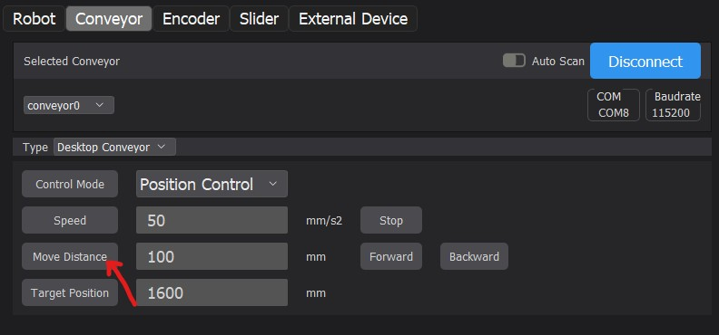
Figure 15 - Move the belt through a measured 100 mm travel
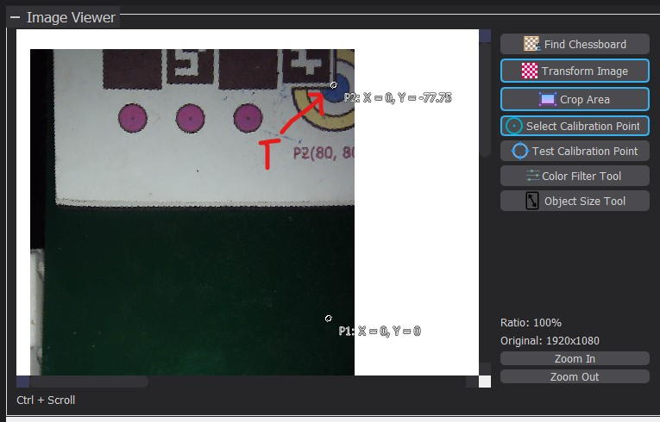
Figure 16 - Select the same reference T for P2
UPGRADE PATH: If ROI-edge error is worse than centre error, use Cloud Point Mapping across the full ROI. Do not hide calibration error by increasing Distance Threshold.

8. Map Conveyor C to Each Robot Ri
Every robot requires a separate matrix because position, mounting angle, and origin differ. Store matrices in the tracking group, for example #0.ConveyorToRobot0 and #0.ConveyorToRobot1.
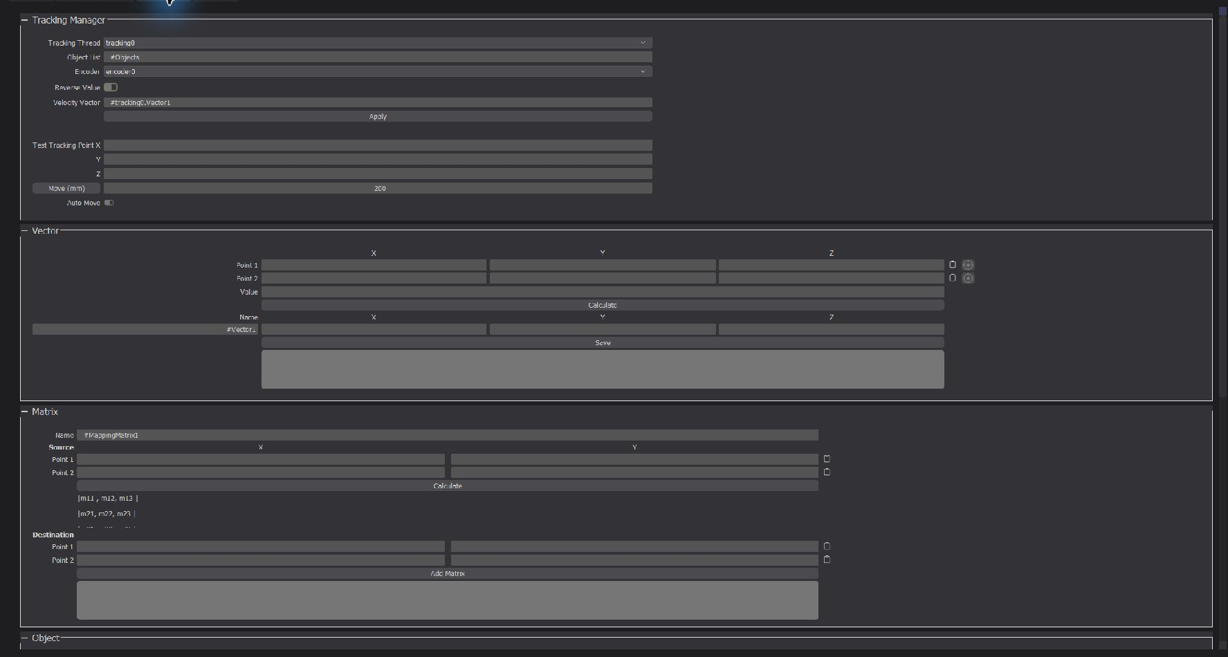
Figure 17 - Point Tool: Tracking Manager, velocity vector, and source/destination matrix
- Choose two widely separated belt references away from the edge of the robot workspace.
- At each reference, record C coordinates as Source; jog the robot to the same reference and record Ri as Destination.
- Click Calculate/Add Matrix and save it as the matching #0.ConveyorToRobotN.
- Validate at least three points excluded from fitting, including two pick-zone corners and one centre point.
- Teach SafeZ, PickZ, PlaceX/Y/Z, AngleOffset, and angle sign independently for each robot.
- Transform belt velocity from C to Ri. The SYNC vector is mm/s in robot axes, never counts/s or pixels/s.
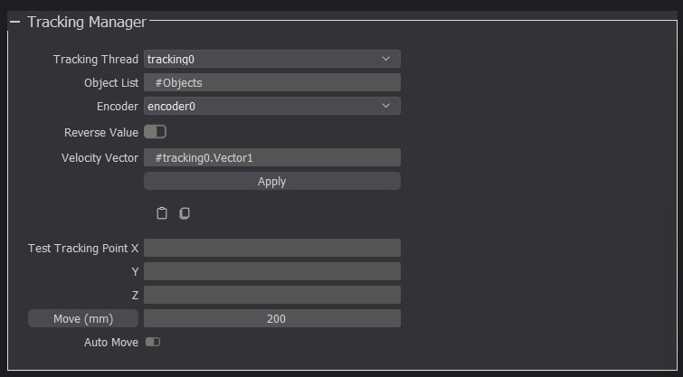
Figure 18 - Encoder and velocity vector in Tracking Manager
Robot i parameter | Taught value | Verification
ConveyorToRobotN | ________________ | Maximum error ______ mm
SafeZ / PickZ | ______ / ______ mm | No collision / reliable pickup
Place XYZ | ________________ | Correct bin and recipe
AngleOffset | ______ deg | Correct at 0/45/90 deg
BeltVector | (____, ____, ____) mm/s | Robot follows the correct direction

9. Detector and Tracking Configuration
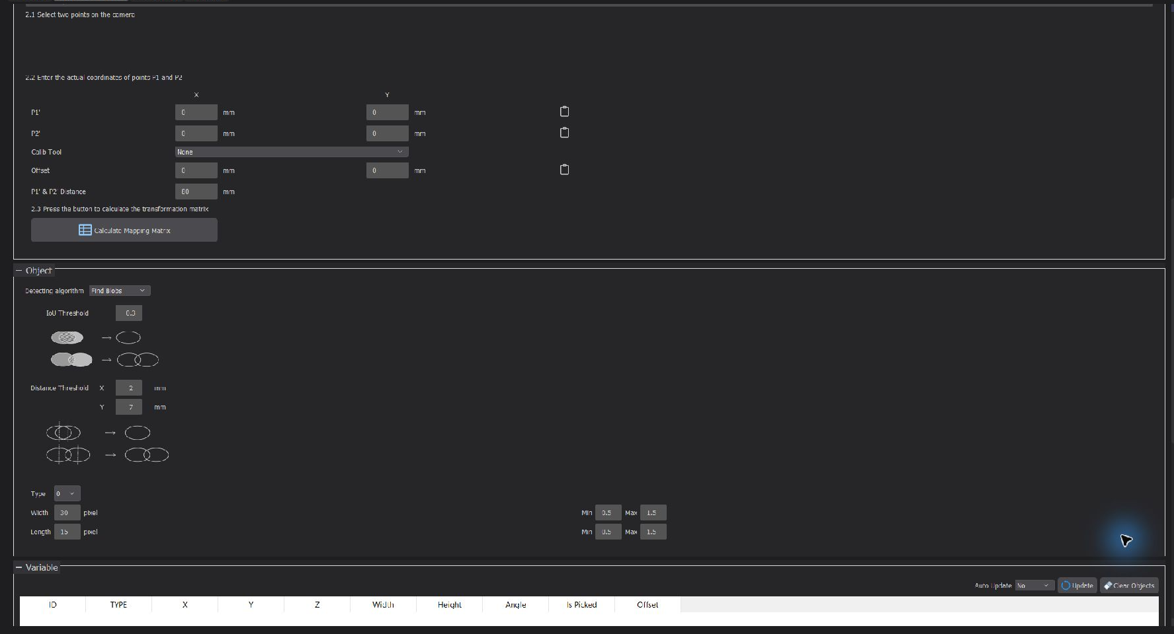
Figure 19 - IoU, distance, type, dimensions, and detector limits

9.1 Select a detector
Detector | Use when | Parameters to fix
Find Blobs | Background and objects have stable colour contrast | Colour filter, min/max width/length
Find Circles | Parts are circular with clear edges | Radius and centre distance
External Script | Several classes or complex shapes require AI/YOLO | Model, class-to-type map, coordinateSpace

9.2 Tune association
- DistanceThreshold must exceed v_belt x frame_period + 2 x detection_error but remain below minimum part separation.
- IoUThreshold must tolerate inter-frame movement without allowing nearby parts to exchange UIDs.
- One detection associates with at most one track per cycle. Monitor ID, Type, X, Y, Angle, and Is Picked.
- Tracking rejects new claims when detections or encoder data exceed the stale limit (2 seconds by default).
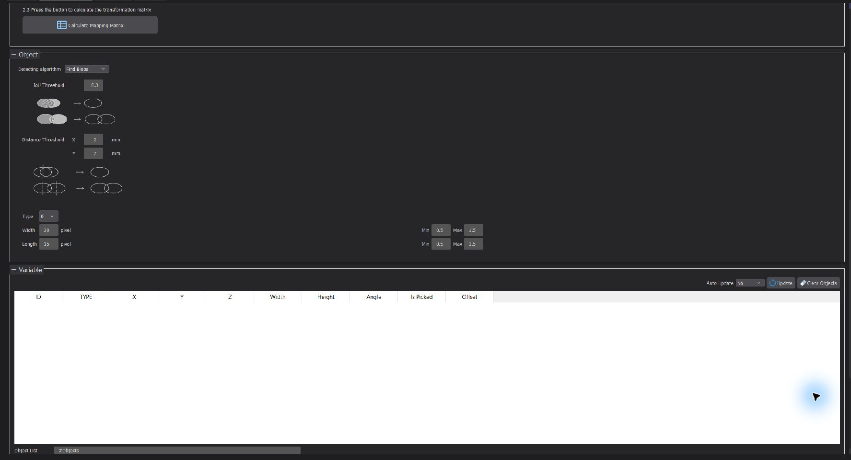
Figure 20 - #Objects table for UID, type, pose, angle, and picked state

9.3 External detector
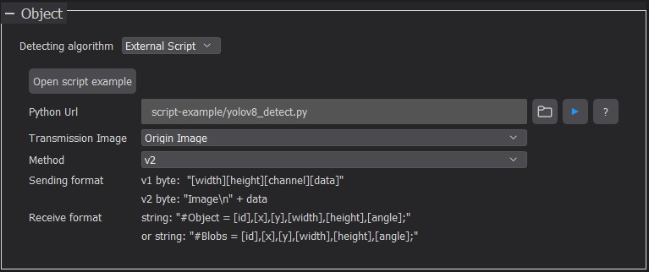
Figure 21 - Select External Script as the detecting algorithm
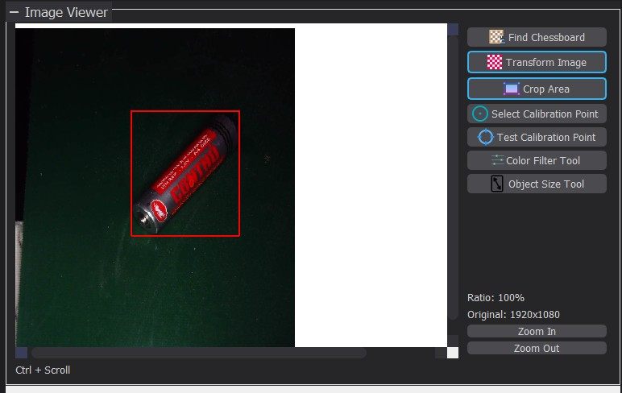
Figure 22 - YOLO detection with bounding box and angle
{
"type": "objects",
"coordinateSpace": "image",
"listName": "#Objects",
"list": [
{"type": 0, "x": 412.5, "y": 238.0, "z": 0,
"w": 35, "h": 62, "angle": 17, "isPicked": false}
]
}
DATA CONTRACT: The detector never assigns UIDs. Use coordinateSpace=image for pixel x/y; use conveyor only when the detector returns calibrated C coordinates in millimetres.

10. Multi-Robot G-Script Configuration
Use exactly one vision loop for tracking0 and one worker loop per robot. Never run multiple vision threads that publish into the same tracking ID.
Thread | Script | Responsibility
Vision | 00-vision-tracking.gcode | Continuously capture, detect, and commit correlated frames
Robot 0 | 10-robot0-type0.gcode | Claim type 0 in robot0 zone, pick, and place
Robot 1 | 11-robot1-type1.gcode | Claim type 1 in robot1 zone, pick, and place

10.1 Vision loop
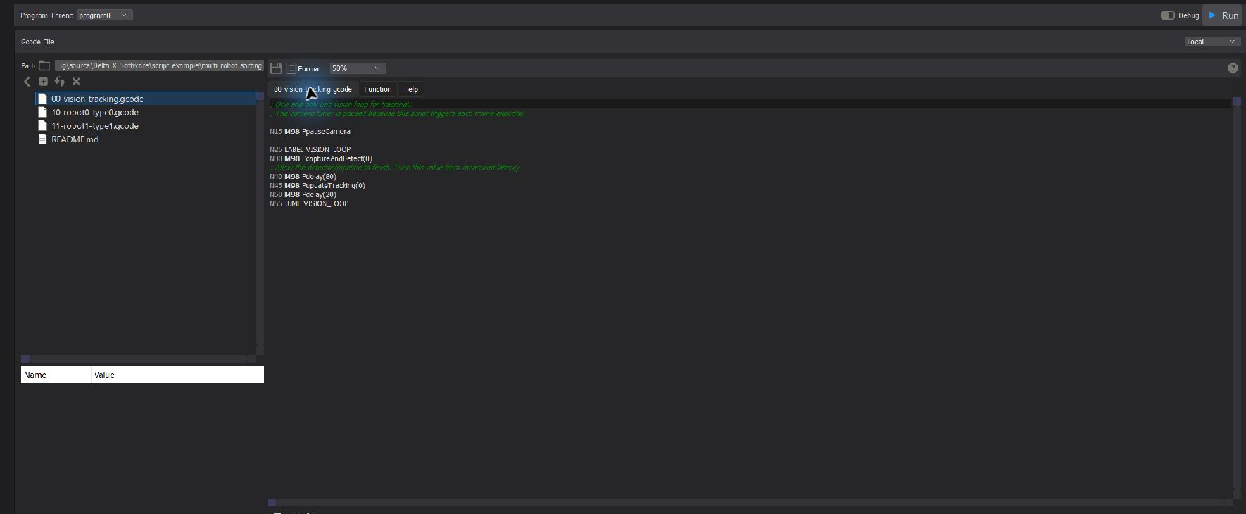
Figure 23 - Load multi-robot-sorting and open the vision loop in the G-Script editor
; One and only one vision loop for tracking0.
N25 LABEL VISION_LOOP
N30 M98 PcaptureAndDetect(0)
N50 M98 Pdelay(20)
N55 JUMP VISION_LOOP
CURRENT EXAMPLE: The current vision example uses PcaptureAndDetect, which waits for FrameReady. Do not add a fixed detector delay; use the primitive timeout and measured telemetry.

10.2 Worker loop and atomic claim
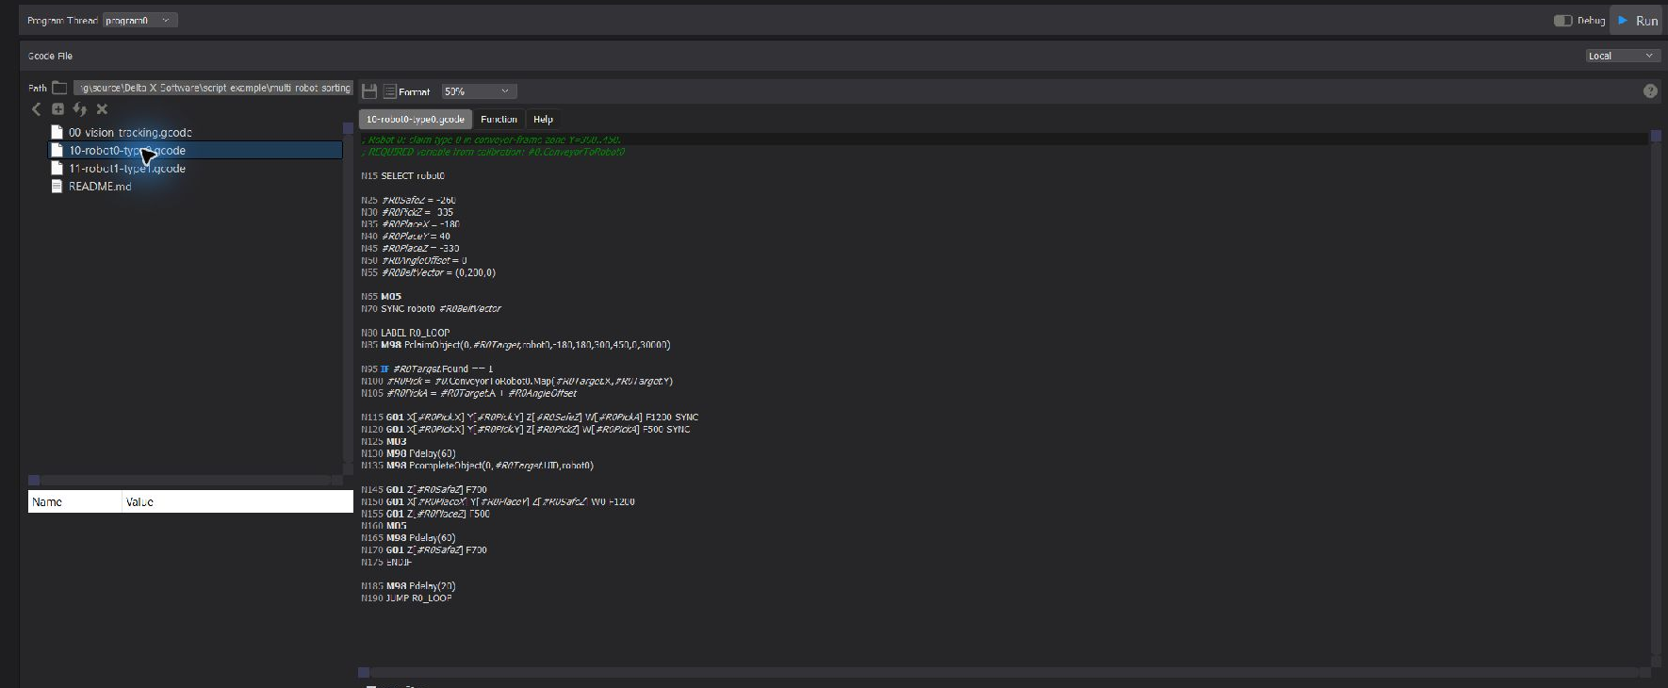
Figure 24 - robot0 worker: claim, Map, G01 SYNC, complete, and place
M98 PclaimObject(0,#R0Target,robot0,-180,180,300,450,0,30000)
IF #R0Target.Found == 1
#R0Pick = #0.ConveyorToRobot0.Map(#R0Target.X,#R0Target.Y)
G01 X[#R0Pick.X] Y[#R0Pick.Y] Z[#R0SafeZ] F1200 SYNC
G01 X[#R0Pick.X] Y[#R0Pick.Y] Z[#R0PickZ] F500 SYNC
M03
M98 Pdelay(60)
M98 PcompleteObject(0,#R0Target.UID,robot0)
ENDIF
Primitive | When to use | Rule
claimObject | Before a robot approaches a part | Continue only when Found=1
releaseObject | Abandoning a part before pickup | Use the matching UID and owner
completeObject | After the end effector secures the part | Never complete before pickup confirmation

OWNERSHIP: On ReleaseRejected or CompleteRejected, stop the worker in a controlled manner. Never continue with an old pose when ownership is uncertain.

11. Operating Sequence

11.1 Start of shift
- Inspect robot workspaces, E-stop, guards, air/vacuum, and obstructions while the conveyor is stopped.
- Open the software, load the approved project/recipe, and confirm G-Script paths.
- Connect robots, conveyor, encoder, and camera. Confirm that every COM port and IP address maps to the intended device.
- Home each robot at low speed; verify SafeZ and a safe end-effector state.
- Reset the encoder at the reference and verify sign and stable velocity at low belt speed.
- Run the vision thread only; confirm stable UIDs through the ROI and live updates in #Objects.
- Dry-run robot0 with the end effector disabled or PickZ raised. Perform a real pick with one robot only after the dry run passes.
- Enable additional robots one at a time while monitoring claim owners and non-overlapping workspaces.
RUN CONDITIONS: Camera/detector and encoder are fresh; mapping has passed validation; robots are homed; the vision loop is active; and no stale track or claim remains from a previous run.

11.2 Production monitoring
Observation | Normal | Stop condition
UID | Stable throughout the ROI | UID exchange or ghost track
Encoder | Continuous position and velocity | Frozen, sign jumps, or stale
Claim | One owner per UID | Two workers on one part or repeated lease expiry
Pick | Stable error | Error grows with position or speed
Cycle time | Within the approved baseline | Increase caused by inference, wait, or robot timeout

11.3 Normal stop
- Stop feeding new parts and let claimed parts complete or release.
- Stop robot workers, then stop the vision loop.
- Stop the conveyor, move robots to approved safe poses, and disable end effectors.
- Save only approved project/configuration changes; never persist unreviewed test values.

12. Fault Recovery and Troubleshooting
Symptom | Likely cause | Action
No part can be claimed | Stale detector/encoder or wrong zone/type | Check freshness, C.X/C.Y, and typeFilter
UID changes between frames | Distance/IoU too strict or latency too high | Measure motion per frame and retune thresholds
Pick error grows with Y | Incorrect mm/count or BeltVector | Recalibrate encoder and SYNC vector
Pick error at ROI edges | Insufficient warp or P-to-C mapping | Correct perspective or use Cloud Point Mapping
Position correct, angle wrong | AngleOffset, sign, or mirror | Test 0/45/90 deg; correct sign before offset
CompleteRejected | Expired lease, wrong owner, or changed UID | Stop the worker and discard the old target
GigE camera not listed | Missing vendor runtime, NIC, or subnet | Install pylon/MVS and verify IP/firewall policy
G-Script help missing | GScript_Documentation.html absent | Restore the file in the portable application directory

CAMERA OR ENCODER LOSS: Stop part feeding and robots through the cell state machine. Shared tracking blocks new claims when stale but does not replace cell-level controlled-stop logic.

Recover a worker terminated after claiming
- Stop the conveyor and robot safely, then determine whether the part was physically picked.
- If not picked, wait for lease expiry or release with the matching owner/UID. Never delete a track while its worker still runs.
- If picked but not completed, handle the part through the approved recovery procedure and clear state under supervisor authority.
- Run vision only and verify a stable shared map before restarting any worker.

13. Cell Acceptance
Area | Test | Acceptance criterion | Result
Encoder | Five 1000 mm cycles | Error within pick budget | ___
P-to-C mapping | Nine points across ROI | Maximum/RMS error accepted | ___
C-to-Ri mapping | Three points per robot | Within suction/grip radius | ___
Tracking | 100 consecutive parts | No out-of-policy UID exchange/ghost | ___
Ownership | Two workers compete for one part | Exactly one Found=1 | ___
Lease | Terminate worker after claim | Part unlocks only after lease | ___
Stale input | Disconnect encoder/camera | No new claim; cell stops | ___
Throughput | Run target speed | Cycle time and reject rate accepted | ___
Safety | Test E-stop and guard | Stops independently of PC/G-Script | ___

PRODUCTION GATE: Enter production only after every item passes and the acceptance record is approved. Collision avoidance, pickup sensors, recipe/bin logic, and the cell fault state machine require separate assessment.

Calibration record
Parameter | Value | Date / performed by
Camera resolution / exposure / ROI | ____________________________ | ________________
mm_per_count / encoder sign | ____________________________ | ________________
Mapping P->C max/RMS | ____________________________ | ________________
ConveyorToRobot0 max error | ____________________________ | ________________
ConveyorToRobot1 max error | ____________________________ | ________________
DistanceThreshold / IoU | ____________________________ | ________________
Detector latency / frame period | ____________________________ | ________________
LeaseMs / stale timeout | ____________________________ | ________________

14. Parameter and Path Reference
Asset | Repository path
Design guide | docs/multi-robot-conveyor-sorting.md
Vision loop | script-example/multi-robot-sorting/00-vision-tracking.gcode
Robot0 worker | script-example/multi-robot-sorting/10-robot0-type0.gcode
Robot1 worker | script-example/multi-robot-sorting/11-robot1-type1.gcode
Test ownership | tests/tracking_claim/

Claim result variables
#result.Found
#result.UID
#result.Type
#result.X #result.Y #result.Z
#result.W #result.L #result.A
#result.ClaimOwner
#result.ClaimExpiresAt
CURRENT BOUNDARY: The platform provides shared tracking, atomic claims, leases, type/pose, and sample workers. A production cell must additionally validate multi-robot collision prevention, pickup quality confirmation, recipe/bin logic, OEE, and the cell-level fault/recovery state machine.

