Homework 4
Programming Languages Principles and Implementations
Brandon DeLuca
Ivan Tang

Grammars

All Parse Trees created using: http://mshang.ca/syntree/
Exercise 1:
We consider the BNF grammar below:
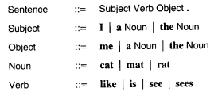
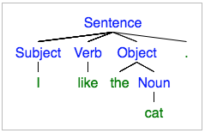
- Show that I like the cat. is recognized by this BNF grammar using a rightmost derivation and, then, a parse tree.
Sentence => Subject Verb Object.
=> Subject Verb the Noun.
=> Subject Verb the cat.
=> Subject like the cat.
=> I like the cat.

- Provide an expression that is NOT recognized by the grammar.
I like dogs.
Object needs either “a” or “the” if not using “me”. Also, “dogs” is not a known noun. This sentence is grammatically correct in English, but not correct/recognizable according to the BNF grammar.

Exercise 2:

We consider the following grammar:

EXPRESSION ::= NUMERAL | ( EXPRESSION OPERATOR EXPRESSION )
NUMERAL ::= 0 | 1 | 2 | 3 | 4 | 5 | 6 | 7 | 8 | 9
OPERATORS ::= + | -

Show that (4 - (3 + 2)) is a legal EXPRESSION using a leftmost derivation, and,then, a parse tree.

EXPRESSION => (EXPRESSION OPERATOR EXPRESSION)
=> (NUMERAL OPERATOR EXPRESSION)
=> (4 OPERATOR EXPRESSION)
=> (4 - EXPRESSION)
=> (4 - (EXPRESSION OPERATOR EXPRESSION))
=> (4 - (NUMERAL OPERATOR EXPRESSION))
=> (4 - (3 OPERATOR EXPRESSION))
=> (4 - (3 + EXPRESSION))
=> (4 - (3 + NUMERAL))
=> (4 - (3 + 2))

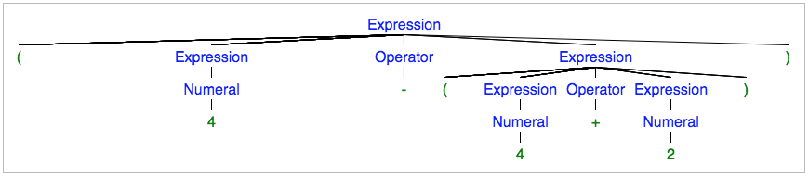

Exercise 3:

Show that the following grammar is ambiguous:

X -> a | bX | bXcX
where a,b,c are terminals.

Determining if grammar is ambiguous is done by checking if there are two ways to arrive at the same result. I used “bbaca”, since one of the cases is bXcX and one is bX. This easily allows you to create two instances of the creation of this string.

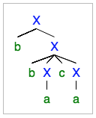
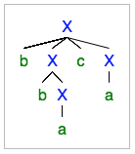

Exercise 4:

- Design a BNF grammar that recognizes expressions of the form Ai where A is in {a,b,c} and i is a digit.

EXPRESSION ::= LETTER DIGIT
LETTER ::= |a| b| c
DIGIT ::= 0|1|2|3|4|5|6|7|8|9

- Design a BNF grammar that recognizes lists of the form A1, A2, A3, …, An. Use question a).

EXPRESSION ::= SET | EXPRESSION , SET
SET ::= LETTER DIGIT
LETTER ::= |a| b| c
DIGIT ::= 0|1|2|3|4|5|6|7|8|9

- Write a BNF grammar and a regular expression that describes the structure of US telephone numbers, which can either be (xxx)xxx-xxxx or xxx-xxxx, where x is a digit from 0 to 9.
BNF Grammar:
<telephonenumber>::= (<digit><digit><digit>)<digit><digit><digit> <digit><digit><digit><digit> |
<digit><digit><digit>-<digit><digit><digit><digit>
<digit> ::= 0|1|2|3|4|5|6|7|8|9

Regular Expression:
\(?\d+\)?[-]?\d+[-]?\d+
Tested using: https://regex101.com/r/dErw7V/2

Exercise 5:
Do the online exercises here: https://regex.sketchengine.co.uk/ and report your answers.

- .*p.t.*
- .*ap.?t*
- (r|b)|(f|a)+fg+.*(f|k|h).*
- .*s\. .*|.*g\. .*|.*\? .*|.*\." .*|.*! .*|.*!' .*|.*\) .*

Exercise 6:

- Write a JAY program that computes the sum of the n first numbers with a loop.

void main () {
int n, counter, total;
n = 10; // “n” numbers, 10 chosen as an example
counter = 1; // counter to stop when it hits the max
total = 0; // sum

while (counter <= n) {
total = total + counter;
counter = counter + 1;
}
}

- Write a JAY program that assigns the minimum of two numbers in a variable called min.

void main () {
int min, firstNum, secondNum;
min = 0;
firstNum = 5;
secondNum = 10;

if (firstNum <= secondNum)
min = firstNum;
else
min = secondNum;
}

- Provide 2 examples of lexical errors in JAY.
- ~

“~” is not recognized as anything in Jay.

- &

“&&” is recognized, but a single “&” is not.

- Provide 2 examples of JAY programs with 2 different syntax errors.
- count += 4;

“+=” is not recognized as an assignment expression because the “+” would not be considered as part of the Identifier. In Java for example, the += syntax would be interpreted as “count = count + 4;”, but in Jay, this would be a syntax error.

- if () count = count + 2;

The if statement cannot have a blank Expression in the IfStatement part of the Statement. The “(“ and “)” would not be lexical errors since they are recognized, but the missing Expression would have an error.

- Provide 2 examples of JAY programs with errors that are neither detected during the lexical analysis nor during the syntactic analysis.

1)
void main () {
// Divide by Zero
int min, first, second;
min = 5;
first = 0;
second = min / first;
}

2)
void main () {
// Adding Boolean Values
boolean min, first, second;
min = false;
first = true;
second = first + min;
}

Explanation:
- Dividing by zero is syntactically correct in Jay, but we know that the end result will not be usable since dividing by zero is not possible. The program will execute, but gives us an erroneous output.
- The concrete syntax of Jay allows the user to add two identifiers, but adding two Boolean values is not possible.

