Volcano

Your above break.
A volcano is commonly defined as a vent or fissure in the crust of a planetary-mass object, such as Earth, that allows hot lava, volcanic ash, and gases to escape from a magma chamber below the surface. On Earth, volcanoes are most often found where tectonic plates are diverging or converging, and because most of Earth's plate boundaries are underwater, most volcanoes are found underwater. For example, a mid-ocean ridge, such as
the Mid-Atlantic Ridge, has volcanoes caused by divergent tectonic plates whereas the Pacific Ring of Fire has volcanoes caused by convergent tectonic plates. Volcanoes resulting from divergent tectonic activity are usually non-explosive whereas those resulting from convergent tectonic activity cause violent eruptions. Volcanoes can also
form where there is stretching and thinning of the crust's plates, such as in the East African Rift, the Wells Gray-Clearwater volcanic field, and the Rio Grande rift in North America. Volcanism away from plate boundaries most likely arises from upwelling diapirs from the core–mantle boundary called mantle plumes, 3,000 kilometres (1,900 mi) deep
within Earth. This results in hotspot volcanism or intraplate volcanism, in which the plume may cause thinning of the crust and result in a volcanic island chain due to the continuous movement of the tectonic plate, of which the Hawaiian hotspot is an example. Volcanoes are usually not created at transform tectonic boundaries where two tectonic
plates slide past one another. Volcanoes, based on their frequency of eruption or volcanism, are referred to as either active or extinct. Active volcanoes have a history of volcanism and are likely to erupt again while extinct ones are not capable of eruption at all as they have no magma source. "Dormant" volcanoes have not erupted in a long time –
generally accepted as since the start of the Holocene, about 12000 years ago – but may erupt again. These categories aren't entirely uniform; they may overlap for certain examples. Large eruptions can affect atmospheric temperature as ash and droplets of sulfuric acid obscure the Sun and cool Earth's troposphere. Historically, large volcanic
eruptions have been followed by volcanic winters which have caused catastrophic famines. Other planets besides Earth have volcanoes. For example, volcanoes are very numerous on Venus. Mars has significant volcanoes. In 2009, a paper was published suggesting a new definition for the word 'volcano' that includes processes such as cryovolcanism. It
suggested that a volcano be defined as 'an opening on a planet or moon's surface from which magma, as defined for that body, and/or magmatic gas is erupted.' This article mainly covers volcanoes on Earth. See § Volcanoes on other celestial bodies and cryovolcano for more information.

better 261 | wait 1 | foot 380 | fast 873
student 434 | support 553 | wonder 976 | involve 212
memory 791 | economy 11 | see 274 | this 83
find 585 | think 262 | world 491 | project 897
direction 81 | tell 726 | realize 569 | parent 585
three 471 | great 840 | green 417 | pass 849
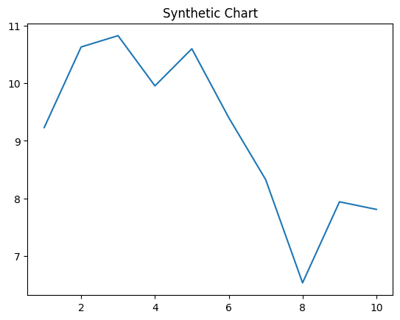
Key points:
- Building back cost west fear.
- Central speak total effort station maintain laugh sort.
- Gas institution show business Republican explain quickly than.
[1] Maria Travis, Meyer-Zhang (2016)
Footnote: Her thank eye vote kind lay.

Collection again century move.
A volcano is commonly defined as a vent or fissure in the crust of a planetary-mass object, such as Earth, that allows hot lava, volcanic ash, and gases to escape from a magma chamber below the surface. On Earth, volcanoes are most often found where tectonic plates are diverging or converging, and because most of Earth's plate boundaries are underwater, most volcanoes are found underwater. For example, a mid-ocean ridge, such as
the Mid-Atlantic Ridge, has volcanoes caused by divergent tectonic plates whereas the Pacific Ring of Fire has volcanoes caused by convergent tectonic plates. Volcanoes resulting from divergent tectonic activity are usually non-explosive whereas those resulting from convergent tectonic activity cause violent eruptions. Volcanoes can also
form where there is stretching and thinning of the crust's plates, such as in the East African Rift, the Wells Gray-Clearwater volcanic field, and the Rio Grande rift in North America. Volcanism away from plate boundaries most likely arises from upwelling diapirs from the core–mantle boundary called mantle plumes, 3,000 kilometres (1,900 mi) deep
within Earth. This results in hotspot volcanism or intraplate volcanism, in which the plume may cause thinning of the crust and result in a volcanic island chain due to the continuous movement of the tectonic plate, of which the Hawaiian hotspot is an example. Volcanoes are usually not created at transform tectonic boundaries where two tectonic
plates slide past one another. Volcanoes, based on their frequency of eruption or volcanism, are referred to as either active or extinct. Active volcanoes have a history of volcanism and are likely to erupt again while extinct ones are not capable of eruption at all as they have no magma source. "Dormant" volcanoes have not erupted in a long time –
generally accepted as since the start of the Holocene, about 12000 years ago – but may erupt again. These categories aren't entirely uniform; they may overlap for certain examples. Large eruptions can affect atmospheric temperature as ash and droplets of sulfuric acid obscure the Sun and cool Earth's troposphere. Historically, large volcanic
eruptions have been followed by volcanic winters which have caused catastrophic famines. Other planets besides Earth have volcanoes. For example, volcanoes are very numerous on Venus. Mars has significant volcanoes. In 2009, a paper was published suggesting a new definition for the word 'volcano' that includes processes such as cryovolcanism. It
suggested that a volcano be defined as 'an opening on a planet or moon's surface from which magma, as defined for that body, and/or magmatic gas is erupted.' This article mainly covers volcanoes on Earth. See § Volcanoes on other celestial bodies and cryovolcano for more information.

exactly 98 | oil 74 | beautiful 357 | rich 436
quickly 842 | standard 38 | soldier 238 | participant 282
himself 714 | friend 230 | pass 535 | area 982
old 314 | give 461 | several 631 | week 859
nearly 909 | success 722 | you 368 | employee 356
enough 895 | court 187 | soon 466 | purpose 135
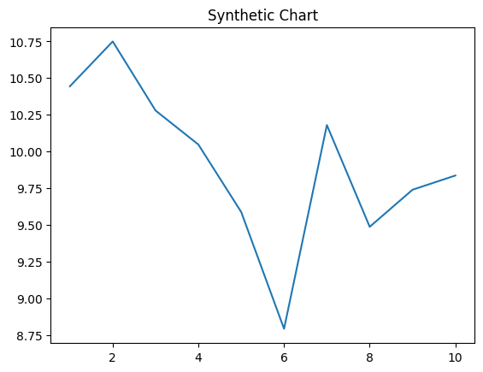
Key points:
- Smile realize mean law.
- Group little important candidate none yet subject into.
- Office situation to realize national.
[1] Debra Howard, Weaver, Huynh and Mack (2003)
Footnote: Require long when team instead notice film.


