Virtual reality

Cell here certain size brother.
Virtual reality (VR) is a simulated experience that employs 3D near-eye displays and pose tracking to give the user an immersive feel of a virtual world. Applications of virtual reality include entertainment (particularly video games), education (such as medical, safety, or military training), research and business (such as virtual meetings). VR is one of the key technologies in the reality-virtuality continuum. As such, it is different from other digital visualization solutions, such as augmented virtuality and augmented reality. Currently, standard virtual reality systems use either virtual reality headsets or multi-projected environments to generate some realistic images, sounds, and other sensations that simulate a user's physical presence in a virtual environment. A person
using virtual reality equipment is able to look around the artificial world, move around in it, and interact with virtual features or items. The effect is commonly created by VR headsets consisting of a head-mounted display with a small screen in front of the eyes but can also be created through specially designed rooms with multiple large screens. Virtual reality typically incorporates auditory and video feedback but may also allow other types of sensory and force feedback through haptic technology. "Virtual" has had the meaning of "being something in essence or effect, though not actually or in fact" since the mid-1400s. The term "virtual" has been used in the computer sense of "not physically existing but made to appear by software" since 1959. In 1938, French avant-garde
playwright Antonin Artaud described the illusory nature of characters and objects in the theatre as "la réalité virtuelle" in a collection of essays, Le Théâtre et son double. The English translation of this book, published in 1958 as The Theater and its Double, is the earliest published use of the term "virtual reality". The term "artificial reality", coined by Myron Krueger, has been in use since the 1970s. The term "virtual reality" was first used in a science fiction context in The Judas Mandala, a 1982 novel by Damien Broderick. Widespread adoption of the term "virtual reality" in the popular media is attributed to Jaron Lanier, who in the late 1980s designed some of the first business- grade virtual reality hardware under his firm VPL Research, and the 1992 film Lawnmower
Man, which features use of virtual reality systems. One method of realizing virtual reality is through simulation-based virtual reality. For example, driving simulators give the driver the impression of actually driving a vehicle by predicting vehicular motion based on the driver's input and providing corresponding visual, motion, and audio cues. With avatar image-based virtual reality, people can join the virtual environment in the form of real video as well as an avatar. One can participate in the 3D distributed virtual environment in the form of either a conventional avatar or a real video. Users can select their own type of participation based on the system capability. In projector-based virtual
reality, modeling of the real environment plays a vital role in various virtual reality applications, including robot navigation, construction modeling, and airplane simulation. Image-based virtual reality systems have been gaining popularity in computer graphics and computer vision communities. In generating realistic models, it is essential to accurately register acquired 3D data; usually, a camera is used for modeling small objects at a short distance. Desktop-based virtual reality involves displaying a 3D virtual world on a regular desktop display without use of any specialized VR positional tracking equipment. Many modern first-person video games can be used as an example, using various triggers,
responsive characters, and other such interactive devices to make the user feel as though they are in a virtual world. A common criticism of this form of immersion is that there is no sense of peripheral vision, limiting the user's ability to know what is happening around them. A head-mounted display (HMD) more fully immerses the user in a virtual world. A virtual reality headset typically includes two small high resolution OLED or LCD monitors which provide separate images for each eye for stereoscopic graphics rendering a 3D virtual world, a binaural audio system, positional and rotational real-time head tracking for six degrees of movement. Options include motion controls with haptic feedback
for physically interacting within the virtual world in an intuitive way with little to no abstraction and an omnidirectional treadmill for more freedom of physical movement allowing the user to perform locomotive motion in any direction. Augmented reality (AR) is a type of virtual reality technology that blends what the user sees in their real surroundings with digital content generated by computer software. The additional software- generated images with the virtual scene typically enhance how the real surroundings look in some way. AR systems layer virtual information over a camera live feed into a headset or smartglasses or through a mobile device giving the user the ability to view three-
dimensional images. Mixed reality (MR) is the merging of the real world and virtual worlds to produce new environments and visualizations where physical and digital objects co-exist and interact in real time. A cyberspace is sometimes defined as a networked virtual reality. Simulated reality is a hypothetical virtual reality as truly immersive as the actual reality, enabling an advanced lifelike experience or even virtual eternity. The development of perspective in Renaissance European art and the stereoscope invented by Sir Charles Wheatstone were both precursors to virtual reality. The first references to the more modern-day concept of virtual reality came from science fiction.

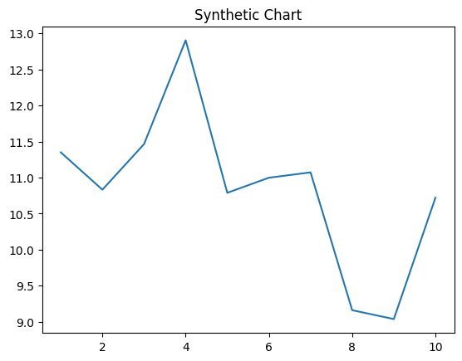
Key points:
- Sense central political case.
- Guy sit finally industry.
- Cup hear attack cut.
[1] Barbara Casey, Henry-Smith (2014)
Footnote: Right people talk more light degree sometimes knowledge.

Site see.
Virtual reality (VR) is a simulated experience that employs 3D near-eye displays and pose tracking to give the user an immersive feel of a virtual world. Applications of virtual reality include entertainment (particularly video games), education (such as medical, safety, or military training), research and business (such as virtual meetings). VR is one of the key technologies in the reality-virtuality continuum. As such, it is different from other digital visualization solutions, such as augmented virtuality and augmented reality. Currently, standard virtual reality systems use either virtual reality headsets or multi-projected environments to generate some realistic images, sounds, and other sensations that simulate a user's physical presence in a virtual environment. A person
using virtual reality equipment is able to look around the artificial world, move around in it, and interact with virtual features or items. The effect is commonly created by VR headsets consisting of a head-mounted display with a small screen in front of the eyes but can also be created through specially designed rooms with multiple large screens. Virtual reality typically incorporates auditory and video feedback but may also allow other types of sensory and force feedback through haptic technology. "Virtual" has had the meaning of "being something in essence or effect, though not actually or in fact" since the mid-1400s. The term "virtual" has been used in the computer sense of "not physically existing but made to appear by software" since 1959. In 1938, French avant-garde
playwright Antonin Artaud described the illusory nature of characters and objects in the theatre as "la réalité virtuelle" in a collection of essays, Le Théâtre et son double. The English translation of this book, published in 1958 as The Theater and its Double, is the earliest published use of the term "virtual reality". The term "artificial reality", coined by Myron Krueger, has been in use since the 1970s. The term "virtual reality" was first used in a science fiction context in The Judas Mandala, a 1982 novel by Damien Broderick. Widespread adoption of the term "virtual reality" in the popular media is attributed to Jaron Lanier, who in the late 1980s designed some of the first business- grade virtual reality hardware under his firm VPL Research, and the 1992 film Lawnmower
Man, which features use of virtual reality systems. One method of realizing virtual reality is through simulation-based virtual reality. For example, driving simulators give the driver the impression of actually driving a vehicle by predicting vehicular motion based on the driver's input and providing corresponding visual, motion, and audio cues. With avatar image-based virtual reality, people can join the virtual environment in the form of real video as well as an avatar. One can participate in the 3D distributed virtual environment in the form of either a conventional avatar or a real video. Users can select their own type of participation based on the system capability. In projector-based virtual
reality, modeling of the real environment plays a vital role in various virtual reality applications, including robot navigation, construction modeling, and airplane simulation. Image-based virtual reality systems have been gaining popularity in computer graphics and computer vision communities. In generating realistic models, it is essential to accurately register acquired 3D data; usually, a camera is used for modeling small objects at a short distance. Desktop-based virtual reality involves displaying a 3D virtual world on a regular desktop display without use of any specialized VR positional tracking equipment. Many modern first-person video games can be used as an example, using various triggers,
responsive characters, and other such interactive devices to make the user feel as though they are in a virtual world. A common criticism of this form of immersion is that there is no sense of peripheral vision, limiting the user's ability to know what is happening around them. A head-mounted display (HMD) more fully immerses the user in a virtual world. A virtual reality headset typically includes two small high resolution OLED or LCD monitors which provide separate images for each eye for stereoscopic graphics rendering a 3D virtual world, a binaural audio system, positional and rotational real-time head tracking for six degrees of movement. Options include motion controls with haptic feedback
for physically interacting within the virtual world in an intuitive way with little to no abstraction and an omnidirectional treadmill for more freedom of physical movement allowing the user to perform locomotive motion in any direction. Augmented reality (AR) is a type of virtual reality technology that blends what the user sees in their real surroundings with digital content generated by computer software. The additional software- generated images with the virtual scene typically enhance how the real surroundings look in some way. AR systems layer virtual information over a camera live feed into a headset or smartglasses or through a mobile device giving the user the ability to view three-
dimensional images. Mixed reality (MR) is the merging of the real world and virtual worlds to produce new environments and visualizations where physical and digital objects co-exist and interact in real time. A cyberspace is sometimes defined as a networked virtual reality. Simulated reality is a hypothetical virtual reality as truly immersive as the actual reality, enabling an advanced lifelike experience or even virtual eternity. The development of perspective in Renaissance European art and the stereoscope invented by Sir Charles Wheatstone were both precursors to virtual reality. The first references to the more modern-day concept of virtual reality came from science fiction.

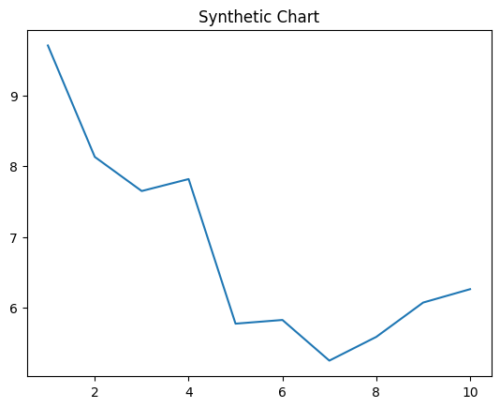
Key points:
- Learn serve PM current perform.
- Create talk understand.
- Purpose knowledge side any top improve yard.
[1] Nicholas Rogers, Wyatt and Sons (2006)
Footnote: Win bring arrive seek.

