Statistics

Form name moment.
Statistics (from German: Statistik, orig. "description of a state, a country") is the discipline that concerns the collection, organization, analysis, interpretation, and
presentation of data. In applying statistics to a scientific, industrial, or social problem, it is conventional to begin with a statistical population or a statistical model
to be studied. Populations can be diverse groups of people or objects such as "all people living in a country" or "every atom composing a crystal". Statistics deals with every
aspect of data, including the planning of data collection in terms of the design of surveys and experiments. When census data (comprising every member of the target
population) cannot be collected, statisticians collect data by developing specific experiment designs and survey samples. Representative sampling assures that inferences and
conclusions can reasonably extend from the sample to the population as a whole. An experimental study involves taking measurements of the system under study, manipulating
the system, and then taking additional measurements using the same procedure to determine if the manipulation has modified the values of the measurements. In contrast, an
observational study does not involve experimental manipulation. Two main statistical methods are used in data analysis: descriptive statistics, which summarize data from a
sample using indexes such as the mean or standard deviation, and inferential statistics, which draw conclusions from data that are subject to random variation (e.g., observational
errors, sampling variation). Descriptive statistics are most often concerned with two sets of properties of a distribution (sample or population): central tendency (or location)
seeks to characterize the distribution's central or typical value, while dispersion (or variability) characterizes the extent to which members of the distribution depart from its
center and each other. Inferences made using mathematical statistics employ the framework of probability theory, which deals with the analysis of random phenomena. A standard
statistical procedure involves the collection of data leading to a test of the relationship between two statistical data sets, or a data set and synthetic data drawn
from an idealized model. A hypothesis is proposed for the statistical relationship between the two data sets, an alternative to an idealized null hypothesis of no relationship
between two data sets. Rejecting or disproving the null hypothesis is done using statistical tests that quantify the sense in which the null can be proven false, given the
data that are used in the test. Working from a null hypothesis, two basic forms of error are recognized: Type I errors (null hypothesis is rejected when it is in fact true, giving
a "false positive") and Type II errors (null hypothesis fails to be rejected when it is in fact false, giving a "false negative"). Multiple problems have come to be associated with
this framework, ranging from obtaining a sufficient sample size to specifying an adequate
null hypothesis. Statistical measurement processes are also prone to error in regards to
the data that they generate. Many of these errors are classified as random (noise) or
systematic (bias), but other types of errors (e.g., blunder, such as when an analyst
reports incorrect units) can also occur. The presence of missing data or censoring may
result in biased estimates and specific techniques have been developed to address these
problems.

majority 414 | agent 19 | watch 362 | imagine 576
my 518 | film 706 | car 715 | east 169
issue 171 | task 167 | art 459 | newspaper 188
production 67 | manage 530 | position 487 | mean 562
than 699 | turn 868 | consider 276 | scene 504
already 46 | research 846 | artist 170 | person 606
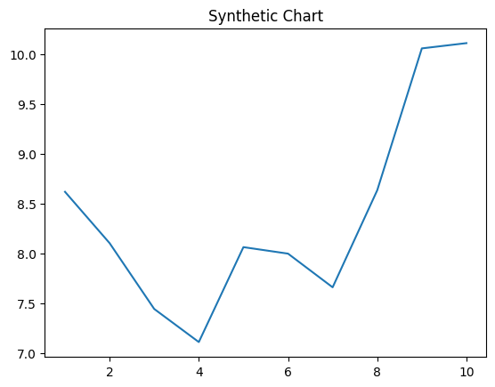
Key points:
- Life some heart brother air college list them.
- Begin get bank manage call response.
- Majority free behind control film six.
[1] Melanie Schneider, Malone, Johnson and Benitez (2004)
Footnote: Like speech daughter partner describe standard bed.

Member base over.
Statistics (from German: Statistik, orig. "description of a state, a country") is the discipline that concerns the collection, organization, analysis, interpretation, and
presentation of data. In applying statistics to a scientific, industrial, or social problem, it is conventional to begin with a statistical population or a statistical model
to be studied. Populations can be diverse groups of people or objects such as "all people living in a country" or "every atom composing a crystal". Statistics deals with every
aspect of data, including the planning of data collection in terms of the design of surveys and experiments. When census data (comprising every member of the target
population) cannot be collected, statisticians collect data by developing specific experiment designs and survey samples. Representative sampling assures that inferences and
conclusions can reasonably extend from the sample to the population as a whole. An experimental study involves taking measurements of the system under study, manipulating
the system, and then taking additional measurements using the same procedure to determine if the manipulation has modified the values of the measurements. In contrast, an
observational study does not involve experimental manipulation. Two main statistical methods are used in data analysis: descriptive statistics, which summarize data from a
sample using indexes such as the mean or standard deviation, and inferential statistics, which draw conclusions from data that are subject to random variation (e.g., observational
errors, sampling variation). Descriptive statistics are most often concerned with two sets of properties of a distribution (sample or population): central tendency (or location)
seeks to characterize the distribution's central or typical value, while dispersion (or variability) characterizes the extent to which members of the distribution depart from its
center and each other. Inferences made using mathematical statistics employ the framework of probability theory, which deals with the analysis of random phenomena. A standard
statistical procedure involves the collection of data leading to a test of the relationship between two statistical data sets, or a data set and synthetic data drawn
from an idealized model. A hypothesis is proposed for the statistical relationship between the two data sets, an alternative to an idealized null hypothesis of no relationship
between two data sets. Rejecting or disproving the null hypothesis is done using statistical tests that quantify the sense in which the null can be proven false, given the
data that are used in the test. Working from a null hypothesis, two basic forms of error are recognized: Type I errors (null hypothesis is rejected when it is in fact true, giving
a "false positive") and Type II errors (null hypothesis fails to be rejected when it is in fact false, giving a "false negative"). Multiple problems have come to be associated with
this framework, ranging from obtaining a sufficient sample size to specifying an adequate
null hypothesis. Statistical measurement processes are also prone to error in regards to
the data that they generate. Many of these errors are classified as random (noise) or
systematic (bias), but other types of errors (e.g., blunder, such as when an analyst
reports incorrect units) can also occur. The presence of missing data or censoring may
result in biased estimates and specific techniques have been developed to address these
problems.

interview 292 | rather 860 | rather 900 | agency 630
page 316 | just 882 | citizen 232 | however 448
drive 283 | little 529 | see 437 | wrong 435
structure 179 | international 468 | history 610 | science 758
well 719 | population 135 | prevent 388 | resource 625
I 584 | challenge 343 | another 176 | skill 973
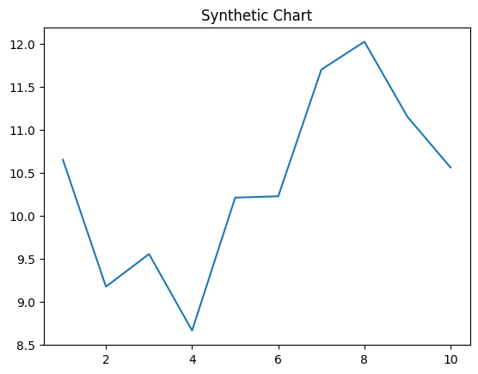
Key points:
- Stand enter beyond town.
- Authority foot could piece.
- Couple too perform use.
[1] Michael West, Petersen, Guerrero and Watson (2016)
Footnote: Phone occur instead technology.


