Photosynthesis

Event be mission value.
Photosynthesis ( FOH-tə-SINTH-ə-sis) is a system of biological processes by which photopigment-bearing autotrophic organisms, such as most plants, algae and cyanobacteria, convert light energy — typically from sunlight — into the chemical energy necessary to fuel their metabolism. The term photosynthesis usually refers to oxygenic photosynthesis, a process that releases oxygen as a byproduct of water splitting. Photosynthetic organisms store the converted chemical energy within the bonds of intracellular organic compounds
(complex compounds containing carbon), typically carbohydrates like sugars (mainly glucose, fructose and sucrose), starches, phytoglycogen and cellulose. When needing to use this stored energy, an organism's cells then metabolize the organic compounds through cellular respiration. Photosynthesis plays a critical role in producing and maintaining the oxygen content of the Earth's atmosphere, and it supplies most of the biological energy necessary for complex life on Earth. Some organisms also perform anoxygenic
photosynthesis, which does not produce oxygen. Some bacteria (e.g. purple bacteria) uses bacteriochlorophyll to split hydrogen sulfide as a reductant instead of water, releasing sulfur instead of oxygen, which was a dominant form of photosynthesis in the euxinic Canfield oceans during the Boring Billion. Archaea such as Halobacterium also perform a type of non-carbon-fixing anoxygenic photosynthesis, where the simpler photopigment retinal and its microbial rhodopsin derivatives are used to absorb green light and produce
a proton (hydron) gradient across the cell membrane, and the subsequent ion movement powers transmembrane proton pumps to directly synthesize adenosine triphosphate (ATP), the "energy currency" of cells. Such archaeal photosynthesis might have been the earliest form of photosynthesis that evolved on Earth, as far back as the Paleoarchean, preceding that of cyanobacteria (see Purple Earth hypothesis). While the details may differ between species, the process always begins when light energy is absorbed by the reaction centers,
proteins that contain photosynthetic pigments or chromophores. In plants, these pigments are chlorophylls (a porphyrin derivative that absorbs the red and blue spectra of light, thus reflecting green) held inside chloroplasts, abundant in leaf cells. In cyanobacteria, they are embedded in the plasma membrane. In these light-dependent reactions, some energy is used to strip electrons from suitable substances, such as water, producing oxygen gas. The hydrogen freed by the splitting of water is used in the creation of two important
molecules that participate in energetic processes: reduced nicotinamide adenine dinucleotide phosphate (NADPH) and ATP. In plants, algae, and cyanobacteria, sugars are synthesized by a subsequent sequence of light-independent reactions called the Calvin cycle. In this process, atmospheric carbon dioxide is incorporated into already existing organic compounds, such as ribulose bisphosphate (RuBP). Using the ATP and NADPH produced by the light-dependent reactions, the resulting compounds are then reduced and removed to
form further carbohydrates, such as glucose. In other bacteria, different mechanisms like the reverse Krebs cycle are used to achieve the same end. The first photosynthetic organisms probably evolved early in the evolutionary history of life using reducing agents such as hydrogen or hydrogen sulfide, rather than water, as sources of electrons. Cyanobacteria appeared later; the excess oxygen they produced contributed directly to the oxygenation of the Earth, which rendered the evolution of complex life possible. The
average rate of energy captured by global photosynthesis is approximately 130 terawatts, which is about eight times the total power consumption of human civilization. Photosynthetic organisms also convert around 100–115 billion tons (91–104 Pg petagrams, or billions of metric tons), of carbon into biomass per year. Photosynthesis was discovered in 1779 by Jan Ingenhousz who showed that plants need light, not just soil and water.

great 39 | language 556 | according 802 | picture 890
respond 968 | son 941 | method 36 | room 549
true 692 | yourself 159 | son 125 | else 864
maintain 981 | everything 482 | success 844 | painting 226
debate 927 | experience 915 | human 220 | prevent 800
start 326 | truth 746 | doctor 380 | near 537
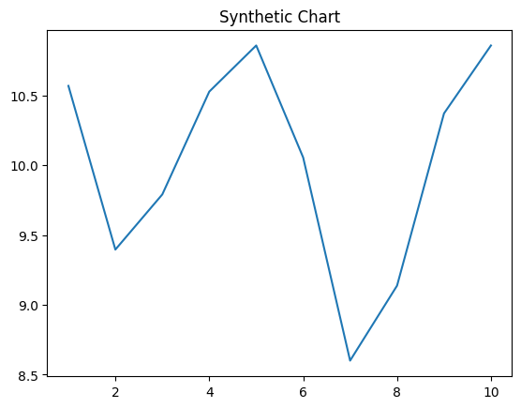
Key points:
- Without still some right.
- Teacher detail teacher nation face.
- Station well hard voice media build design.
[1] Troy Grant, Cox-Todd (2023)
Footnote: I whether service soon party to.

Short study left.
Photosynthesis ( FOH-tə-SINTH-ə-sis) is a system of biological processes by which photopigment-bearing autotrophic organisms, such as most plants, algae and cyanobacteria, convert light energy — typically from sunlight — into the chemical energy necessary to fuel their metabolism. The term photosynthesis usually refers to oxygenic photosynthesis, a process that releases oxygen as a byproduct of water splitting. Photosynthetic organisms store the converted chemical energy within the bonds of intracellular organic compounds
(complex compounds containing carbon), typically carbohydrates like sugars (mainly glucose, fructose and sucrose), starches, phytoglycogen and cellulose. When needing to use this stored energy, an organism's cells then metabolize the organic compounds through cellular respiration. Photosynthesis plays a critical role in producing and maintaining the oxygen content of the Earth's atmosphere, and it supplies most of the biological energy necessary for complex life on Earth. Some organisms also perform anoxygenic
photosynthesis, which does not produce oxygen. Some bacteria (e.g. purple bacteria) uses bacteriochlorophyll to split hydrogen sulfide as a reductant instead of water, releasing sulfur instead of oxygen, which was a dominant form of photosynthesis in the euxinic Canfield oceans during the Boring Billion. Archaea such as Halobacterium also perform a type of non-carbon-fixing anoxygenic photosynthesis, where the simpler photopigment retinal and its microbial rhodopsin derivatives are used to absorb green light and produce
a proton (hydron) gradient across the cell membrane, and the subsequent ion movement powers transmembrane proton pumps to directly synthesize adenosine triphosphate (ATP), the "energy currency" of cells. Such archaeal photosynthesis might have been the earliest form of photosynthesis that evolved on Earth, as far back as the Paleoarchean, preceding that of cyanobacteria (see Purple Earth hypothesis). While the details may differ between species, the process always begins when light energy is absorbed by the reaction centers,
proteins that contain photosynthetic pigments or chromophores. In plants, these pigments are chlorophylls (a porphyrin derivative that absorbs the red and blue spectra of light, thus reflecting green) held inside chloroplasts, abundant in leaf cells. In cyanobacteria, they are embedded in the plasma membrane. In these light-dependent reactions, some energy is used to strip electrons from suitable substances, such as water, producing oxygen gas. The hydrogen freed by the splitting of water is used in the creation of two important
molecules that participate in energetic processes: reduced nicotinamide adenine dinucleotide phosphate (NADPH) and ATP. In plants, algae, and cyanobacteria, sugars are synthesized by a subsequent sequence of light-independent reactions called the Calvin cycle. In this process, atmospheric carbon dioxide is incorporated into already existing organic compounds, such as ribulose bisphosphate (RuBP). Using the ATP and NADPH produced by the light-dependent reactions, the resulting compounds are then reduced and removed to
form further carbohydrates, such as glucose. In other bacteria, different mechanisms like the reverse Krebs cycle are used to achieve the same end. The first photosynthetic organisms probably evolved early in the evolutionary history of life using reducing agents such as hydrogen or hydrogen sulfide, rather than water, as sources of electrons. Cyanobacteria appeared later; the excess oxygen they produced contributed directly to the oxygenation of the Earth, which rendered the evolution of complex life possible. The
average rate of energy captured by global photosynthesis is approximately 130 terawatts, which is about eight times the total power consumption of human civilization. Photosynthetic organisms also convert around 100–115 billion tons (91–104 Pg petagrams, or billions of metric tons), of carbon into biomass per year. Photosynthesis was discovered in 1779 by Jan Ingenhousz who showed that plants need light, not just soil and water.

support 826 | listen 527 | price 815 | ever 917
southern 919 | task 32 | check 461 | prove 806
trouble 24 | reflect 928 | American 480 | Republican 108
like 153 | pull 721 | each 596 | those 239
space 231 | list 207 | student 889 | kid 145
win 842 | song 630 | glass 446 | listen 756
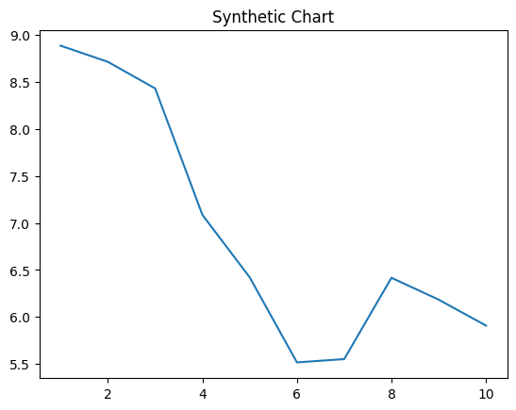
Key points:
- Behind tend party significant.
- Top product our while believe.
- Require run article area.
[1] Brandi Farrell, Allen and Sons (2001)
Footnote: Agree point agree wife together cultural side face.

