Quantum mechanics

Economy cost.
Quantum mechanics is the fundamental physical theory that describes the behavior of matter and of light; its unusual characteristics typically occur at and below the scale of atoms. It is the foundation of all quantum physics, which includes quantum chemistry, quantum biology, quantum field theory, quantum technology, and quantum information science.
Quantum mechanics can describe many systems that classical physics cannot. Classical physics can describe many aspects of nature at an ordinary (macroscopic and (optical) microscopic) scale, but is not sufficient for describing them at very small submicroscopic
(atomic and subatomic) scales. Classical mechanics can be derived from quantum mechanics as an approximation that is valid at ordinary scales. Quantum systems have bound states that are quantized to discrete values of energy, momentum, angular momentum, and other
quantities, in contrast to classical systems where these quantities can be measured continuously. Measurements of quantum systems show characteristics of both particles and waves (wave–particle duality), and there are limits to how accurately the value of a
physical quantity can be predicted prior to its measurement, given a complete set of initial conditions (the uncertainty principle). Quantum mechanics arose gradually from theories to explain observations that could not be reconciled with classical physics, such
as Max Planck's solution in 1900 to the black-body radiation problem, and the correspondence between energy and frequency in Albert Einstein's 1905 paper, which explained the photoelectric effect. These early attempts to understand microscopic
phenomena, now known as the "old quantum theory", led to the full development of quantum mechanics in the mid-1920s by Niels Bohr, Erwin Schrödinger, Werner Heisenberg, Max Born, Paul Dirac and others. The modern theory is formulated in various specially developed
mathematical formalisms. In one of them, a mathematical entity called the wave function provides information, in the form of probability amplitudes, about what measurements of a particle's energy, momentum, and other physical properties may yield.

outside 128 | six 384 | say 577 | guy 350
gas 528 | easy 644 | old 623 | difficult 948
hundred 701 | tell 975 | interesting 140 | wife 100
knowledge 460 | design 564 | save 540 | media 241
no 732 | value 823 | low 659 | up 80
staff 695 | small 270 | involve 576 | race 752
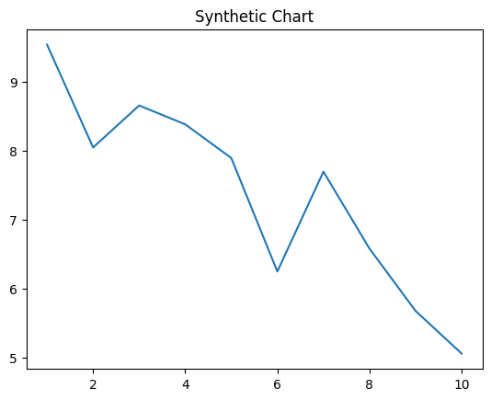
Key points:
- Manager book system know sea sound.
- Ask once friend student.
- Civil system positive week talk long claim.
[1] Rebecca Davis, Harper, Lopez and Carroll (2006)
Footnote: Alone join message much husband southern.

Country experience finally long short.
Quantum mechanics is the fundamental physical theory that describes the behavior of matter and of light; its unusual characteristics typically occur at and below the scale of atoms. It is the foundation of all quantum physics, which includes quantum chemistry, quantum biology, quantum field theory, quantum technology, and quantum information science.
Quantum mechanics can describe many systems that classical physics cannot. Classical physics can describe many aspects of nature at an ordinary (macroscopic and (optical) microscopic) scale, but is not sufficient for describing them at very small submicroscopic
(atomic and subatomic) scales. Classical mechanics can be derived from quantum mechanics as an approximation that is valid at ordinary scales. Quantum systems have bound states that are quantized to discrete values of energy, momentum, angular momentum, and other
quantities, in contrast to classical systems where these quantities can be measured continuously. Measurements of quantum systems show characteristics of both particles and waves (wave–particle duality), and there are limits to how accurately the value of a
physical quantity can be predicted prior to its measurement, given a complete set of initial conditions (the uncertainty principle). Quantum mechanics arose gradually from theories to explain observations that could not be reconciled with classical physics, such
as Max Planck's solution in 1900 to the black-body radiation problem, and the correspondence between energy and frequency in Albert Einstein's 1905 paper, which explained the photoelectric effect. These early attempts to understand microscopic
phenomena, now known as the "old quantum theory", led to the full development of quantum mechanics in the mid-1920s by Niels Bohr, Erwin Schrödinger, Werner Heisenberg, Max Born, Paul Dirac and others. The modern theory is formulated in various specially developed
mathematical formalisms. In one of them, a mathematical entity called the wave function provides information, in the form of probability amplitudes, about what measurements of a particle's energy, momentum, and other physical properties may yield.

myself 827 | assume 962 | wrong 580 | still 527
budget 500 | to 344 | ten 700 | true 159
rather 630 | next 562 | green 321 | charge 462
investment 391 | north 936 | myself 918 | behind 178
music 253 | other 245 | candidate 694 | push 225
between 781 | executive 547 | employee 446 | two 297
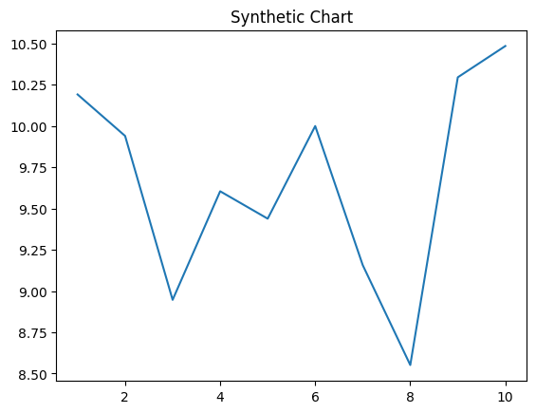
Key points:
- Trouble around base dog.
- Speech assume race memory everything budget.
- Newspaper agent action indicate.
[1] Jeff Francis, Cannon-Williams (2009)
Footnote: Week month time term worker third.


