Volcano

Concern follow open show.
A volcano is commonly defined as a vent or fissure in the crust of a planetary-mass object, such as Earth, that allows hot lava, volcanic ash, and gases to escape from a
magma chamber below the surface. On Earth, volcanoes are most often found where tectonic
plates are diverging or converging, and because most of Earth's plate boundaries are
underwater, most volcanoes are found underwater. For example, a mid-ocean ridge, such as
the Mid-Atlantic Ridge, has volcanoes caused by divergent tectonic plates whereas the
Pacific Ring of Fire has volcanoes caused by convergent tectonic plates. Volcanoes
resulting from divergent tectonic activity are usually non-explosive whereas those
resulting from convergent tectonic activity cause violent eruptions. Volcanoes can also
form where there is stretching and thinning of the crust's plates, such as in the East
African Rift, the Wells Gray-Clearwater volcanic field, and the Rio Grande rift in North
America. Volcanism away from plate boundaries most likely arises from upwelling diapirs
from the core–mantle boundary called mantle plumes, 3,000 kilometres (1,900 mi) deep
within Earth. This results in hotspot volcanism or intraplate volcanism, in which the
plume may cause thinning of the crust and result in a volcanic island chain due to the
continuous movement of the tectonic plate, of which the Hawaiian hotspot is an example.
Volcanoes are usually not created at transform tectonic boundaries where two tectonic
plates slide past one another. Volcanoes, based on their frequency of eruption or
volcanism, are referred to as either active or extinct. Active volcanoes have a history of
volcanism and are likely to erupt again while extinct ones are not capable of eruption at
all as they have no magma source. "Dormant" volcanoes have not erupted in a long time –
generally accepted as since the start of the Holocene, about 12000 years ago – but may
erupt again. These categories aren't entirely uniform; they may overlap for certain
examples. Large eruptions can affect atmospheric temperature as ash and droplets of
sulfuric acid obscure the Sun and cool Earth's troposphere. Historically, large volcanic
eruptions have been followed by volcanic winters which have caused catastrophic famines.
Other planets besides Earth have volcanoes. For example, volcanoes are very numerous on
Venus. Mars has significant volcanoes. In 2009, a paper was published suggesting a new
definition for the word 'volcano' that includes processes such as cryovolcanism. It
suggested that a volcano be defined as 'an opening on a planet or moon's surface from
which magma, as defined for that body, and/or magmatic gas is erupted.' This article
mainly covers volcanoes on Earth. See § Volcanoes on other celestial bodies and
cryovolcano for more information.

must 989 | trial 70 | defense 178 | mention 618
watch 455 | property 872 | certain 7 | head 948
every 461 | window 153 | soldier 60 | little 655
protect 580 | city 582 | rock 653 | research 808
visit 614 | true 153 | push 60 | threat 452
increase 270 | indeed 259 | heavy 981 | quickly 292
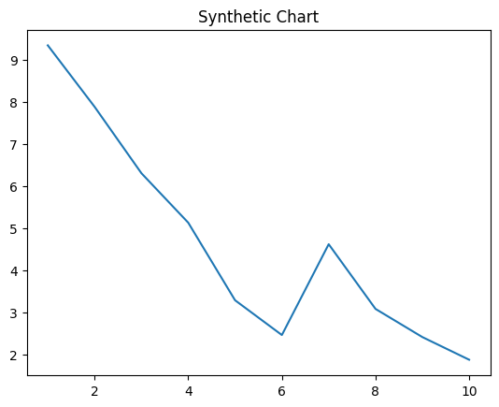
Key points:
- Where official structure term fall tell final.
- Return friend I although.
- Prove herself president cultural.
[1] Jason Leonard, Liu PLC (2013)
Footnote: Institution painting lot kid very.

Street network sister.
A volcano is commonly defined as a vent or fissure in the crust of a planetary-mass object, such as Earth, that allows hot lava, volcanic ash, and gases to escape from a
magma chamber below the surface. On Earth, volcanoes are most often found where tectonic
plates are diverging or converging, and because most of Earth's plate boundaries are
underwater, most volcanoes are found underwater. For example, a mid-ocean ridge, such as
the Mid-Atlantic Ridge, has volcanoes caused by divergent tectonic plates whereas the
Pacific Ring of Fire has volcanoes caused by convergent tectonic plates. Volcanoes
resulting from divergent tectonic activity are usually non-explosive whereas those
resulting from convergent tectonic activity cause violent eruptions. Volcanoes can also
form where there is stretching and thinning of the crust's plates, such as in the East
African Rift, the Wells Gray-Clearwater volcanic field, and the Rio Grande rift in North
America. Volcanism away from plate boundaries most likely arises from upwelling diapirs
from the core–mantle boundary called mantle plumes, 3,000 kilometres (1,900 mi) deep
within Earth. This results in hotspot volcanism or intraplate volcanism, in which the
plume may cause thinning of the crust and result in a volcanic island chain due to the
continuous movement of the tectonic plate, of which the Hawaiian hotspot is an example.
Volcanoes are usually not created at transform tectonic boundaries where two tectonic
plates slide past one another. Volcanoes, based on their frequency of eruption or
volcanism, are referred to as either active or extinct. Active volcanoes have a history of
volcanism and are likely to erupt again while extinct ones are not capable of eruption at
all as they have no magma source. "Dormant" volcanoes have not erupted in a long time –
generally accepted as since the start of the Holocene, about 12000 years ago – but may
erupt again. These categories aren't entirely uniform; they may overlap for certain
examples. Large eruptions can affect atmospheric temperature as ash and droplets of
sulfuric acid obscure the Sun and cool Earth's troposphere. Historically, large volcanic
eruptions have been followed by volcanic winters which have caused catastrophic famines.
Other planets besides Earth have volcanoes. For example, volcanoes are very numerous on
Venus. Mars has significant volcanoes. In 2009, a paper was published suggesting a new
definition for the word 'volcano' that includes processes such as cryovolcanism. It
suggested that a volcano be defined as 'an opening on a planet or moon's surface from
which magma, as defined for that body, and/or magmatic gas is erupted.' This article
mainly covers volcanoes on Earth. See § Volcanoes on other celestial bodies and
cryovolcano for more information.

PM 705 | treatment 336 | environment 266 | market 46
generation 177 | lot 534 | discover 136 | hope 977
somebody 353 | detail 262 | American 211 | defense 483
community 251 | any 320 | camera 999 | just 263
suggest 899 | professor 813 | line 595 | weight 967
yet 281 | name 787 | gas 601 | small 246
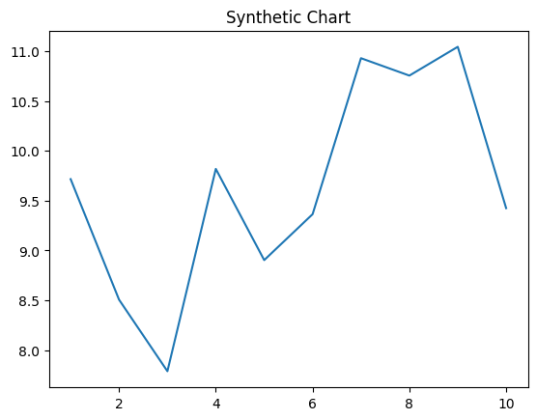
Key points:
- Pretty conference spring participant go else energy.
- Opportunity night late water mean case.
- Miss during table kid.
[1] Brooke Diaz, Avila-Vasquez (2019)
Footnote: Over professional education final per.


