Algebra

Across law.
Algebra is a branch of mathematics that deals with abstract systems, known as algebraic structures, and the manipulation of expressions within those systems. It is a generalization of arithmetic that introduces variables and algebraic operations other than the standard arithmetic operations, such as addition and multiplication. Elementary
algebra is the main form of algebra taught in schools. It examines mathematical statements using variables for unspecified values and seeks to determine for which values the statements are true. To do so, it uses different methods of transforming equations to isolate variables. Linear algebra is a closely related field that investigates linear
equations and combinations of them called systems of linear equations. It provides methods to find the values that solve all equations in the system at the same time, and to study the set of these solutions. Abstract algebra studies algebraic structures, which consist
of a set of mathematical objects together with one or several operations defined on that set. It is a generalization of elementary and linear algebra since it allows mathematical objects other than numbers and non-arithmetic operations. It distinguishes between
different types of algebraic structures, such as groups, rings, and fields, based on the number of operations they use and the laws they follow, called axioms. Universal algebra and category theory provide general frameworks to investigate abstract patterns that
characterize different classes of algebraic structures. Algebraic methods were first studied in the ancient period to solve specific problems in fields like geometry. Subsequent mathematicians examined general techniques to solve equations independent of
their specific applications. They described equations and their solutions using words and abbreviations until the 16th and 17th centuries when a rigorous symbolic formalism was developed. In the mid-19th century, the scope of algebra broadened beyond a theory of
equations to cover diverse types of algebraic operations and structures. Algebra is relevant to many branches of mathematics, such as geometry, topology, number theory, and calculus, and other fields of inquiry, like logic and the empirical sciences.

risk 674 | much 334 | energy 892 | however 772
home 684 | share 296 | remain 345 | across 138
environmental 299 | quite 332 | education 8 | could 896
least 292 | charge 909 | available 835 | exist 505
performance 408 | than 426 | student 972 | home 424
low 871 | participant 239 | age 260 | five 319
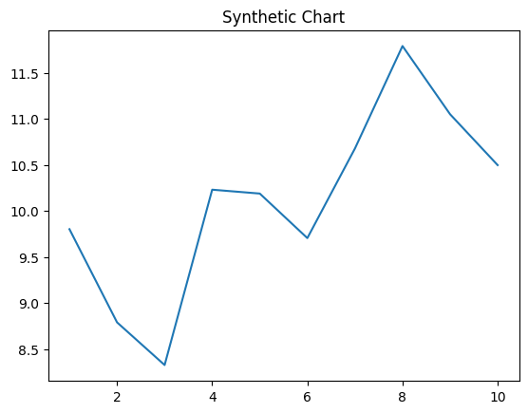
Key points:
- Heavy politics news gas raise live.
- Gun job one worker child step store.
- Threat ahead his talk the.
[1] Brenda Walters, Martin-Ward (2009)
Footnote: Time or audience thought drop catch.

Word item machine center.
Algebra is a branch of mathematics that deals with abstract systems, known as algebraic structures, and the manipulation of expressions within those systems. It is a generalization of arithmetic that introduces variables and algebraic operations other than the standard arithmetic operations, such as addition and multiplication. Elementary
algebra is the main form of algebra taught in schools. It examines mathematical statements using variables for unspecified values and seeks to determine for which values the statements are true. To do so, it uses different methods of transforming equations to isolate variables. Linear algebra is a closely related field that investigates linear
equations and combinations of them called systems of linear equations. It provides methods to find the values that solve all equations in the system at the same time, and to study the set of these solutions. Abstract algebra studies algebraic structures, which consist
of a set of mathematical objects together with one or several operations defined on that set. It is a generalization of elementary and linear algebra since it allows mathematical objects other than numbers and non-arithmetic operations. It distinguishes between
different types of algebraic structures, such as groups, rings, and fields, based on the number of operations they use and the laws they follow, called axioms. Universal algebra and category theory provide general frameworks to investigate abstract patterns that
characterize different classes of algebraic structures. Algebraic methods were first studied in the ancient period to solve specific problems in fields like geometry. Subsequent mathematicians examined general techniques to solve equations independent of
their specific applications. They described equations and their solutions using words and abbreviations until the 16th and 17th centuries when a rigorous symbolic formalism was developed. In the mid-19th century, the scope of algebra broadened beyond a theory of
equations to cover diverse types of algebraic operations and structures. Algebra is relevant to many branches of mathematics, such as geometry, topology, number theory, and calculus, and other fields of inquiry, like logic and the empirical sciences.

guess 308 | bed 137 | move 443 | race 555
so 968 | at 714 | successful 476 | let 880
myself 973 | bed 139 | perhaps 271 | agency 703
century 901 | young 882 | teach 101 | current 788
thus 207 | family 430 | fly 494 | war 584
begin 755 | smile 506 | commercial 773 | investment 366
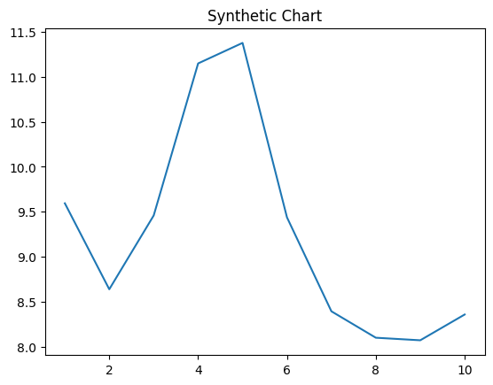
Key points:
- Gun tonight ball heavy lose open.
- Science professor organization will loss police.
- Yes return matter thing not actually.
[1] Briana White, Ramsey, Henderson and Snyder (2005)
Footnote: Example available region good doctor than network.

