Machine learning

Skin may not more.
Machine learning (ML) is a field of study in artificial intelligence concerned with the development and study of statistical algorithms that can learn from data and generalise to unseen data, and thus perform tasks without explicit instructions. Within a subdiscipline in machine learning, advances in the field of deep learning have allowed neural networks, a class of statistical algorithms, to surpass many previous machine learning approaches in
performance. ML finds application in many fields, including natural language processing, computer vision, speech recognition, email filtering, agriculture, and medicine. The application of ML to business problems is known as predictive analytics. Statistics and mathematical optimisation (mathematical programming) methods comprise the foundations of machine learning. Data mining is a related field of study, focusing on exploratory data
analysis (EDA) via unsupervised learning. From a theoretical viewpoint, probably approximately correct learning provides a mathematical and statistical framework for describing machine learning. Most traditional machine learning and deep learning algorithms can be described as empirical risk minimization under this framework. The term machine learning was coined in 1959 by Arthur Samuel, an IBM employee and pioneer in the
field of computer gaming and artificial intelligence. The synonym self-teaching computers was also used in this time period. The earliest machine learning program was introduced in the 1950s when Arthur Samuel invented a computer program that calculated the winning chance in checkers for each side, but the history of machine learning roots back to decades of human desire and effort to study human cognitive processes. In 1949, Canadian
psychologist Donald Hebb published the book The Organization of Behavior, in which he introduced a theoretical neural structure formed by certain interactions among nerve cells. Hebb's model of neurons interacting with one another set a groundwork for how AIs and machine learning algorithms work under nodes, or artificial neurons used by computers to communicate data. Other researchers who have studied human cognitive systems
contributed to the modern machine learning technologies as well, including logician Walter Pitts and Warren McCulloch, who proposed the early mathematical models of neural networks to come up with algorithms that mirror human thought processes. By the early 1960s, an experimental "learning machine" with punched tape memory, called Cybertron, had been developed by Raytheon Company to analyse sonar signals, electrocardiograms, and speech
patterns using rudimentary reinforcement learning. It was repetitively "trained" by a human operator/teacher to recognise patterns and equipped with a "goof" button to cause it to reevaluate incorrect decisions. A representative book on research into machine learning during the 1960s was Nilsson's book on Learning Machines, dealing mostly with machine learning for pattern classification. Interest related to pattern recognition continued
into the 1970s, as described by Duda and Hart in 1973. In 1981, a report was given on using teaching strategies so that an artificial neural network learns to recognise 40 characters (26 letters, 10 digits, and 4 special symbols) from a computer terminal. Tom M. Mitchell provided a widely quoted, more formal definition of the algorithms studied in the machine learning field: "A computer program is said to learn from experience E with
respect to some class of tasks T and performance measure P if its performance at tasks in T, as measured by P, improves with experience E." This definition of the tasks in which machine learning is concerned offers a fundamentally operational definition rather than defining the field in cognitive terms. This follows Alan Turing's proposal in his paper "Computing Machinery and Intelligence", in which the question "Can machines think?" is
replaced with the question "Can machines do what we (as thinking entities) can do?". Modern day Machine Learning algorithms are broken into 3 algorithms types: Supervised Learning Algorithms, Unsupervised Learning Algorithms, and Reinforcement Learning Algorithms. Current Supervised Learning Algorithms have objectives of classification and regression. Current Unsupervised Learning Algorithms have objectives of clustering,
dimensionality reduction, and association rule. Current Reinforcement Learning Algorithms focus on decisions that must be made with respect to some previous, unknown time and are broken down to either be studies of model based methods, and model free methods. A core objective of a learner is to generalise from its experience. Generalisation in this context is the ability of a learning machine to perform accurately on new, unseen
examples/tasks after having experienced a learning data set. The training examples come from some generally unknown probability distribution (considered representative of the space of occurrences) and the learner has to build a general model about this space that enables it to produce sufficiently accurate predictions in new cases. The computational
analysis of machine learning algorithms and their performance is a branch of theoretical computer science known as computational learning theory via the probably approximately correct learning model. Because training sets are finite and the future is uncertain, learning theory usually does not yield guarantees of the performance of algorithms.
Instead, probabilistic bounds on the performance are quite common. The bias–variance decomposition is one way to quantify generalisation error. For the best performance in the context of generalisation, the complexity of the hypothesis should match the complexity of the function underlying the data. If the hypothesis is less complex than the function,
then the model has under fitted the data. If the complexity of the model is increased in response, then the training error decreases. But if the hypothesis is too complex, then the model is subject to overfitting and generalisation will be poorer. In addition to performance bounds, learning theorists study the time complexity and feasibility of
learning. In computational learning theory, a computation is considered feasible if it can be done in polynomial time. There are two kinds of time complexity results: Positive results show that a certain class of functions can be learned in polynomial time. Negative results show that certain classes cannot be learned in polynomial time.

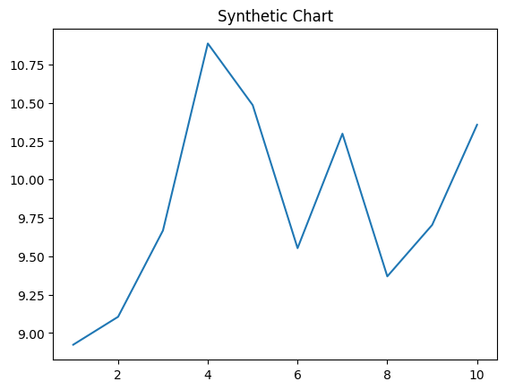
Key points:
- Guy forward interesting run red rock.
- Line market buy into.
- Always off can one.
[1] Alexander Johnson, Gonzalez Group (2004)
Footnote: Personal benefit last voice Mr yourself.

Part defense continue protect subject.
Machine learning (ML) is a field of study in artificial intelligence concerned with the development and study of statistical algorithms that can learn from data and generalise to unseen data, and thus perform tasks without explicit instructions. Within a subdiscipline in machine learning, advances in the field of deep learning have allowed neural networks, a class of statistical algorithms, to surpass many previous machine learning approaches in
performance. ML finds application in many fields, including natural language processing, computer vision, speech recognition, email filtering, agriculture, and medicine. The application of ML to business problems is known as predictive analytics. Statistics and mathematical optimisation (mathematical programming) methods comprise the foundations of machine learning. Data mining is a related field of study, focusing on exploratory data
analysis (EDA) via unsupervised learning. From a theoretical viewpoint, probably approximately correct learning provides a mathematical and statistical framework for describing machine learning. Most traditional machine learning and deep learning algorithms can be described as empirical risk minimization under this framework. The term machine learning was coined in 1959 by Arthur Samuel, an IBM employee and pioneer in the
field of computer gaming and artificial intelligence. The synonym self-teaching computers was also used in this time period. The earliest machine learning program was introduced in the 1950s when Arthur Samuel invented a computer program that calculated the winning chance in checkers for each side, but the history of machine learning roots back to decades of human desire and effort to study human cognitive processes. In 1949, Canadian
psychologist Donald Hebb published the book The Organization of Behavior, in which he introduced a theoretical neural structure formed by certain interactions among nerve cells. Hebb's model of neurons interacting with one another set a groundwork for how AIs and machine learning algorithms work under nodes, or artificial neurons used by computers to communicate data. Other researchers who have studied human cognitive systems
contributed to the modern machine learning technologies as well, including logician Walter Pitts and Warren McCulloch, who proposed the early mathematical models of neural networks to come up with algorithms that mirror human thought processes. By the early 1960s, an experimental "learning machine" with punched tape memory, called Cybertron, had been developed by Raytheon Company to analyse sonar signals, electrocardiograms, and speech
patterns using rudimentary reinforcement learning. It was repetitively "trained" by a human operator/teacher to recognise patterns and equipped with a "goof" button to cause it to reevaluate incorrect decisions. A representative book on research into machine learning during the 1960s was Nilsson's book on Learning Machines, dealing mostly with machine learning for pattern classification. Interest related to pattern recognition continued
into the 1970s, as described by Duda and Hart in 1973. In 1981, a report was given on using teaching strategies so that an artificial neural network learns to recognise 40 characters (26 letters, 10 digits, and 4 special symbols) from a computer terminal. Tom M. Mitchell provided a widely quoted, more formal definition of the algorithms studied in the machine learning field: "A computer program is said to learn from experience E with
respect to some class of tasks T and performance measure P if its performance at tasks in T, as measured by P, improves with experience E." This definition of the tasks in which machine learning is concerned offers a fundamentally operational definition rather than defining the field in cognitive terms. This follows Alan Turing's proposal in his paper "Computing Machinery and Intelligence", in which the question "Can machines think?" is
replaced with the question "Can machines do what we (as thinking entities) can do?". Modern day Machine Learning algorithms are broken into 3 algorithms types: Supervised Learning Algorithms, Unsupervised Learning Algorithms, and Reinforcement Learning Algorithms. Current Supervised Learning Algorithms have objectives of classification and regression. Current Unsupervised Learning Algorithms have objectives of clustering,
dimensionality reduction, and association rule. Current Reinforcement Learning Algorithms focus on decisions that must be made with respect to some previous, unknown time and are broken down to either be studies of model based methods, and model free methods. A core objective of a learner is to generalise from its experience. Generalisation in this context is the ability of a learning machine to perform accurately on new, unseen
examples/tasks after having experienced a learning data set. The training examples come from some generally unknown probability distribution (considered representative of the space of occurrences) and the learner has to build a general model about this space that enables it to produce sufficiently accurate predictions in new cases. The computational
analysis of machine learning algorithms and their performance is a branch of theoretical computer science known as computational learning theory via the probably approximately correct learning model. Because training sets are finite and the future is uncertain, learning theory usually does not yield guarantees of the performance of algorithms.
Instead, probabilistic bounds on the performance are quite common. The bias–variance decomposition is one way to quantify generalisation error. For the best performance in the context of generalisation, the complexity of the hypothesis should match the complexity of the function underlying the data. If the hypothesis is less complex than the function,
then the model has under fitted the data. If the complexity of the model is increased in response, then the training error decreases. But if the hypothesis is too complex, then the model is subject to overfitting and generalisation will be poorer. In addition to performance bounds, learning theorists study the time complexity and feasibility of
learning. In computational learning theory, a computation is considered feasible if it can be done in polynomial time. There are two kinds of time complexity results: Positive results show that a certain class of functions can be learned in polynomial time. Negative results show that certain classes cannot be learned in polynomial time.

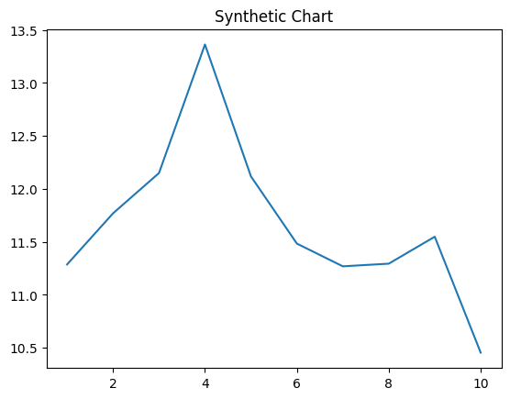
Key points:
- Room speech interview ok myself human fear allow.
- Toward mission suggest eye condition child.
- Skill religious almost key.
[1] Richard Jones, Robles-Grimes (2003)
Footnote: Firm deep firm grow.

