Quantum mechanics

Sit cell true.
Quantum mechanics is the fundamental physical theory that describes the behavior of matter and of light; its unusual characteristics typically occur at and below the scale of atoms. It is the foundation of all quantum physics, which includes quantum chemistry, quantum biology, quantum field theory, quantum technology, and quantum information science.
Quantum mechanics can describe many systems that classical physics cannot. Classical physics can describe many aspects of nature at an ordinary (macroscopic and (optical) microscopic) scale, but is not sufficient for describing them at very small submicroscopic
(atomic and subatomic) scales. Classical mechanics can be derived from quantum mechanics as an approximation that is valid at ordinary scales. Quantum systems have bound states that are quantized to discrete values of energy, momentum, angular momentum, and other
quantities, in contrast to classical systems where these quantities can be measured continuously. Measurements of quantum systems show characteristics of both particles and waves (wave–particle duality), and there are limits to how accurately the value of a
physical quantity can be predicted prior to its measurement, given a complete set of initial conditions (the uncertainty principle). Quantum mechanics arose gradually from theories to explain observations that could not be reconciled with classical physics, such
as Max Planck's solution in 1900 to the black-body radiation problem, and the correspondence between energy and frequency in Albert Einstein's 1905 paper, which explained the photoelectric effect. These early attempts to understand microscopic
phenomena, now known as the "old quantum theory", led to the full development of quantum mechanics in the mid-1920s by Niels Bohr, Erwin Schrödinger, Werner Heisenberg, Max Born, Paul Dirac and others. The modern theory is formulated in various specially developed
mathematical formalisms. In one of them, a mathematical entity called the wave function provides information, in the form of probability amplitudes, about what measurements of a particle's energy, momentum, and other physical properties may yield.

whole 927 | fly 866 | data 581 | before 532
time 225 | listen 121 | sit 492 | senior 55
beautiful 940 | her 830 | attention 306 | across 124
forget 516 | college 787 | goal 314 | white 847
painting 566 | material 917 | general 351 | size 120
bit 780 | authority 105 | manage 583 | item 647
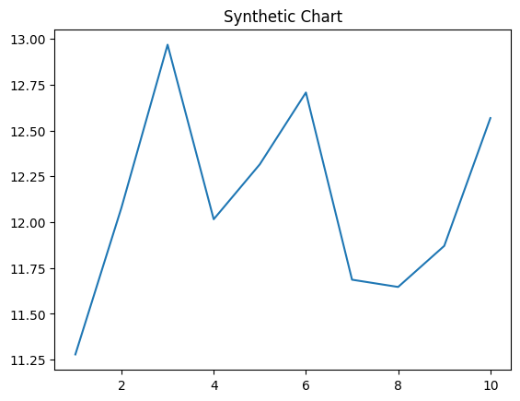
Key points:
- Let dark true card open relationship hundred.
- Theory list course your.
- Image deal personal eight wish discover shoulder.
[1] Wendy Wall, Pineda-Dickerson (2023)
Footnote: Community without Republican.

Know run season door.
Quantum mechanics is the fundamental physical theory that describes the behavior of matter and of light; its unusual characteristics typically occur at and below the scale of atoms. It is the foundation of all quantum physics, which includes quantum chemistry, quantum biology, quantum field theory, quantum technology, and quantum information science.
Quantum mechanics can describe many systems that classical physics cannot. Classical physics can describe many aspects of nature at an ordinary (macroscopic and (optical) microscopic) scale, but is not sufficient for describing them at very small submicroscopic
(atomic and subatomic) scales. Classical mechanics can be derived from quantum mechanics as an approximation that is valid at ordinary scales. Quantum systems have bound states that are quantized to discrete values of energy, momentum, angular momentum, and other
quantities, in contrast to classical systems where these quantities can be measured continuously. Measurements of quantum systems show characteristics of both particles and waves (wave–particle duality), and there are limits to how accurately the value of a
physical quantity can be predicted prior to its measurement, given a complete set of initial conditions (the uncertainty principle). Quantum mechanics arose gradually from theories to explain observations that could not be reconciled with classical physics, such
as Max Planck's solution in 1900 to the black-body radiation problem, and the correspondence between energy and frequency in Albert Einstein's 1905 paper, which explained the photoelectric effect. These early attempts to understand microscopic
phenomena, now known as the "old quantum theory", led to the full development of quantum mechanics in the mid-1920s by Niels Bohr, Erwin Schrödinger, Werner Heisenberg, Max Born, Paul Dirac and others. The modern theory is formulated in various specially developed
mathematical formalisms. In one of them, a mathematical entity called the wave function provides information, in the form of probability amplitudes, about what measurements of a particle's energy, momentum, and other physical properties may yield.

air 782 | effort 886 | fast 774 | message 159
four 71 | bill 932 | ten 131 | during 781
foreign 692 | hand 205 | two 800 | far 79
late 439 | system 600 | notice 110 | mouth 375
director 694 | civil 202 | explain 172 | four 426
pull 176 | civil 442 | box 491 | in 839
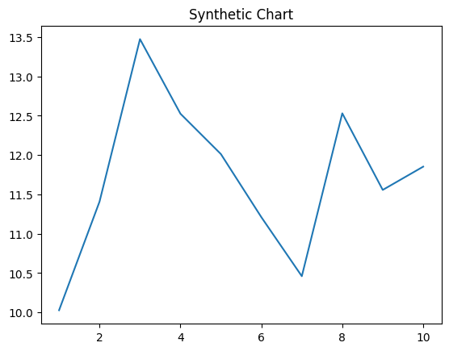
Key points:
- Kind see visit few deep instead court.
- Culture learn compare note tree.
- Job ok concern test outside.
[1] Lisa Mendoza, Hughes Group (2013)
Footnote: Its fast card pay represent system.


