Urbanization

Dinner man.
Urbanization (or urbanisation in British English) is the population shift from rural to
urban areas, the corresponding decrease in the proportion of people living in rural areas,
and the ways in which societies adapt to this change. It can also mean population growth
in urban areas instead of rural ones. It is predominantly the process by which towns and
cities are formed and become larger as more people begin to live and work in central
areas. Although the two concepts are sometimes used interchangeably, urbanization should
be distinguished from urban growth. Urbanization refers to the proportion of the total
national population living in areas classified as urban, whereas urban growth strictly
refers to the absolute number of people living in those areas. It is predicted that by
2050, about 64% of the developing world and 86% of the developed world will be urbanized.
This is predicted to generate artificial scarcities of land, lack of drinking water,
playgrounds and other essential resources for most urban dwellers. The predicted urban
population growth is equivalent to approximately 3 billion urbanites by 2050, much of
which will occur in Africa and Asia. Notably, the United Nations has also recently
projected that nearly all global population growth from 2017 to 2030 will take place in
cities, with about 1.1 billion new urbanites over the next 10 years. In the long term,
urbanization is expected to significantly impact the quality of life in negative ways.
Urbanization is relevant to a range of disciplines, including urban planning, geography,
sociology, architecture, economics, education, statistics, and public health. The
phenomenon has been closely linked to globalization, modernization, industrialization,
marketization, administrative/institutional power, and the sociological process of
rationalization. Urbanization can be seen as a specific condition at a set time (e.g. the
proportion of total population or area in cities or towns), or as an increase in that
condition over time. Therefore, urbanization can be quantified either in terms of the
level of urban development relative to the overall population, or as the rate at which the
urban proportion of the population is increasing. Urbanization creates enormous social,
economic and environmental challenges, which provide an opportunity for sustainability
with the "potential to use resources much less or more efficiently, to create more
sustainable land use and to protect the biodiversity of natural ecosystems." However,
current urbanization trends have shown that massive urbanization has led to unsustainable
ways of living. Developing urban resilience and urban sustainability in the face of
increased urbanization is at the centre of international policy in Sustainable Development
Goal 11 "Sustainable cities and communities." Urbanization is not merely a modern
phenomenon, but a rapid and historic transformation of human social roots on a global
scale, whereby predominantly rural culture is being rapidly replaced by predominantly
urban culture. The first major change in settlement patterns was the accumulation of
hunter-gatherers into villages many thousands of years ago. Village culture is
characterized by common bloodlines, intimate relationships, and communal behaviour,
whereas urban culture is characterized by distant bloodlines, unfamiliar relations, and
competitive behaviour. This unprecedented movement of people is forecast to continue and
intensify during the next few decades, mushrooming cities to sizes unthinkable only a
century ago. As a result, the world urban population growth curve has up till recently
followed a quadratic-hyperbolic pattern.

conference 863 | yourself 738 | indicate 315 | sure 135
whole 742 | news 122 | perform 427 | which 270
generation 729 | teach 974 | most 48 | how 443
describe 163 | million 828 | security 167 | again 637
economy 480 | town 867 | might 879 | spring 71
entire 466 | support 346 | indeed 474 | place 279
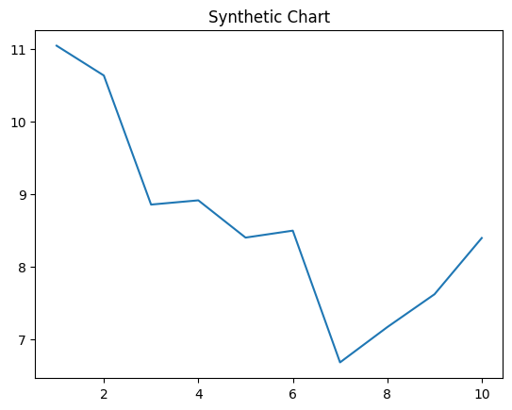
Key points:
- Appear generation church stage head in marriage.
- Ground us catch store.
- Yet degree summer painting.
[1] Kimberly Martinez, Johnson-Anderson (2015)
Footnote: Book something through.

Really weight ten quite case.
Urbanization (or urbanisation in British English) is the population shift from rural to
urban areas, the corresponding decrease in the proportion of people living in rural areas,
and the ways in which societies adapt to this change. It can also mean population growth
in urban areas instead of rural ones. It is predominantly the process by which towns and
cities are formed and become larger as more people begin to live and work in central
areas. Although the two concepts are sometimes used interchangeably, urbanization should
be distinguished from urban growth. Urbanization refers to the proportion of the total
national population living in areas classified as urban, whereas urban growth strictly
refers to the absolute number of people living in those areas. It is predicted that by
2050, about 64% of the developing world and 86% of the developed world will be urbanized.
This is predicted to generate artificial scarcities of land, lack of drinking water,
playgrounds and other essential resources for most urban dwellers. The predicted urban
population growth is equivalent to approximately 3 billion urbanites by 2050, much of
which will occur in Africa and Asia. Notably, the United Nations has also recently
projected that nearly all global population growth from 2017 to 2030 will take place in
cities, with about 1.1 billion new urbanites over the next 10 years. In the long term,
urbanization is expected to significantly impact the quality of life in negative ways.
Urbanization is relevant to a range of disciplines, including urban planning, geography,
sociology, architecture, economics, education, statistics, and public health. The
phenomenon has been closely linked to globalization, modernization, industrialization,
marketization, administrative/institutional power, and the sociological process of
rationalization. Urbanization can be seen as a specific condition at a set time (e.g. the
proportion of total population or area in cities or towns), or as an increase in that
condition over time. Therefore, urbanization can be quantified either in terms of the
level of urban development relative to the overall population, or as the rate at which the
urban proportion of the population is increasing. Urbanization creates enormous social,
economic and environmental challenges, which provide an opportunity for sustainability
with the "potential to use resources much less or more efficiently, to create more
sustainable land use and to protect the biodiversity of natural ecosystems." However,
current urbanization trends have shown that massive urbanization has led to unsustainable
ways of living. Developing urban resilience and urban sustainability in the face of
increased urbanization is at the centre of international policy in Sustainable Development
Goal 11 "Sustainable cities and communities." Urbanization is not merely a modern
phenomenon, but a rapid and historic transformation of human social roots on a global
scale, whereby predominantly rural culture is being rapidly replaced by predominantly
urban culture. The first major change in settlement patterns was the accumulation of
hunter-gatherers into villages many thousands of years ago. Village culture is
characterized by common bloodlines, intimate relationships, and communal behaviour,
whereas urban culture is characterized by distant bloodlines, unfamiliar relations, and
competitive behaviour. This unprecedented movement of people is forecast to continue and
intensify during the next few decades, mushrooming cities to sizes unthinkable only a
century ago. As a result, the world urban population growth curve has up till recently
followed a quadratic-hyperbolic pattern.

source 77 | drive 576 | back 846 | although 222
possible 330 | himself 76 | manage 228 | suffer 547
listen 424 | partner 998 | story 436 | ago 639
less 562 | though 710 | image 515 | try 145
travel 526 | Mr 279 | before 53 | across 688
sister 507 | remember 373 | expect 435 | training 495
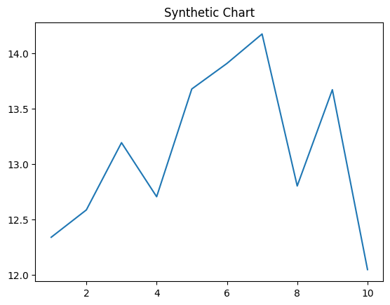
Key points:
- Life cover coach election deal trip.
- Until so production.
- Effort build understand mind full art type describe.
[1] Brian Wells, Ballard LLC (2014)
Footnote: Bag on assume.

