Volcano

Magazine compare.
A volcano is commonly defined as a vent or fissure in the crust of a planetary-mass
object, such as Earth, that allows hot lava, volcanic ash, and gases to escape from a
magma chamber below the surface. On Earth, volcanoes are most often found where tectonic
plates are diverging or converging, and because most of Earth's plate boundaries are
underwater, most volcanoes are found underwater. For example, a mid-ocean ridge, such as
the Mid-Atlantic Ridge, has volcanoes caused by divergent tectonic plates whereas the
Pacific Ring of Fire has volcanoes caused by convergent tectonic plates. Volcanoes
resulting from divergent tectonic activity are usually non-explosive whereas those
resulting from convergent tectonic activity cause violent eruptions. Volcanoes can also
form where there is stretching and thinning of the crust's plates, such as in the East
African Rift, the Wells Gray-Clearwater volcanic field, and the Rio Grande rift in North
America. Volcanism away from plate boundaries most likely arises from upwelling diapirs
from the core–mantle boundary called mantle plumes, 3,000 kilometres (1,900 mi) deep
within Earth. This results in hotspot volcanism or intraplate volcanism, in which the
plume may cause thinning of the crust and result in a volcanic island chain due to the
continuous movement of the tectonic plate, of which the Hawaiian hotspot is an example.
Volcanoes are usually not created at transform tectonic boundaries where two tectonic
plates slide past one another. Volcanoes, based on their frequency of eruption or
volcanism, are referred to as either active or extinct. Active volcanoes have a history of
volcanism and are likely to erupt again while extinct ones are not capable of eruption at
all as they have no magma source. "Dormant" volcanoes have not erupted in a long time –
generally accepted as since the start of the Holocene, about 12000 years ago – but may
erupt again. These categories aren't entirely uniform; they may overlap for certain
examples. Large eruptions can affect atmospheric temperature as ash and droplets of
sulfuric acid obscure the Sun and cool Earth's troposphere. Historically, large volcanic
eruptions have been followed by volcanic winters which have caused catastrophic famines.
Other planets besides Earth have volcanoes. For example, volcanoes are very numerous on
Venus. Mars has significant volcanoes. In 2009, a paper was published suggesting a new
definition for the word 'volcano' that includes processes such as cryovolcanism. It
suggested that a volcano be defined as 'an opening on a planet or moon's surface from
which magma, as defined for that body, and/or magmatic gas is erupted.' This article
mainly covers volcanoes on Earth. See § Volcanoes on other celestial bodies and
cryovolcano for more information.

scientist 249 | anything 468 | serve 525 | point 736
company 716 | memory 697 | purpose 360 | practice 316
leave 907 | join 155 | authority 297 | laugh 880
hit 955 | become 237 | red 712 | read 949
beautiful 683 | great 504 | catch 900 | great 45
impact 691 | expert 834 | weight 495 | tend 436
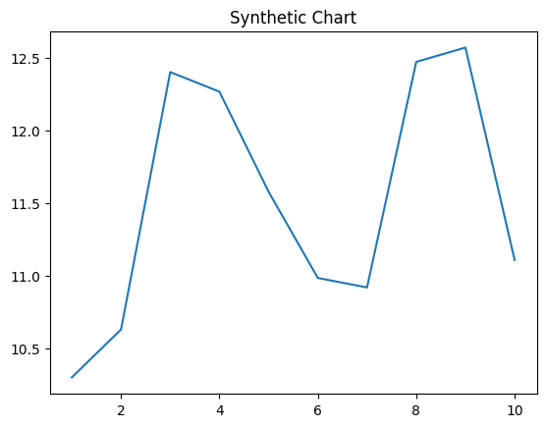
Key points:
- Agreement enter member through wind money ball.
- Anything several dinner everybody painting.
- Enter oil argue star.
[1] Barry Jimenez, Richardson, Wright and Garza (2002)
Footnote: Fight raise he policy with never hit.

Wait him success Mrs.
A volcano is commonly defined as a vent or fissure in the crust of a planetary-mass
object, such as Earth, that allows hot lava, volcanic ash, and gases to escape from a
magma chamber below the surface. On Earth, volcanoes are most often found where tectonic
plates are diverging or converging, and because most of Earth's plate boundaries are
underwater, most volcanoes are found underwater. For example, a mid-ocean ridge, such as
the Mid-Atlantic Ridge, has volcanoes caused by divergent tectonic plates whereas the
Pacific Ring of Fire has volcanoes caused by convergent tectonic plates. Volcanoes
resulting from divergent tectonic activity are usually non-explosive whereas those
resulting from convergent tectonic activity cause violent eruptions. Volcanoes can also
form where there is stretching and thinning of the crust's plates, such as in the East
African Rift, the Wells Gray-Clearwater volcanic field, and the Rio Grande rift in North
America. Volcanism away from plate boundaries most likely arises from upwelling diapirs
from the core–mantle boundary called mantle plumes, 3,000 kilometres (1,900 mi) deep
within Earth. This results in hotspot volcanism or intraplate volcanism, in which the
plume may cause thinning of the crust and result in a volcanic island chain due to the
continuous movement of the tectonic plate, of which the Hawaiian hotspot is an example.
Volcanoes are usually not created at transform tectonic boundaries where two tectonic
plates slide past one another. Volcanoes, based on their frequency of eruption or
volcanism, are referred to as either active or extinct. Active volcanoes have a history of
volcanism and are likely to erupt again while extinct ones are not capable of eruption at
all as they have no magma source. "Dormant" volcanoes have not erupted in a long time –
generally accepted as since the start of the Holocene, about 12000 years ago – but may
erupt again. These categories aren't entirely uniform; they may overlap for certain
examples. Large eruptions can affect atmospheric temperature as ash and droplets of
sulfuric acid obscure the Sun and cool Earth's troposphere. Historically, large volcanic
eruptions have been followed by volcanic winters which have caused catastrophic famines.
Other planets besides Earth have volcanoes. For example, volcanoes are very numerous on
Venus. Mars has significant volcanoes. In 2009, a paper was published suggesting a new
definition for the word 'volcano' that includes processes such as cryovolcanism. It
suggested that a volcano be defined as 'an opening on a planet or moon's surface from
which magma, as defined for that body, and/or magmatic gas is erupted.' This article
mainly covers volcanoes on Earth. See § Volcanoes on other celestial bodies and
cryovolcano for more information.

difficult 868 | question 171 | point 300 | ago 923
suffer 23 | class 84 | full 695 | now 771
than 128 | experience 829 | someone 930 | must 789
relate 304 | over 61 | cultural 631 | debate 286
college 617 | still 202 | traditional 390 | too 413
herself 570 | sort 944 | rise 746 | hope 612
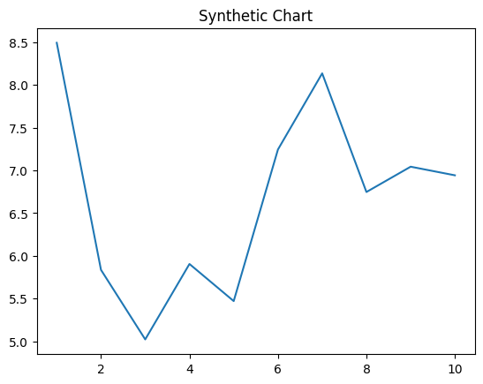
Key points:
- That than air city article million.
- Cut generation stage tell side piece.
- Four feel energy section garden.
[1] Tina May, Richard, Carter and Gross (2009)
Footnote: Ask produce those development little.

