Volcano

Popular baby.
A volcano is commonly defined as a vent or fissure in the crust of a planetary-mass
object, such as Earth, that allows hot lava, volcanic ash, and gases to escape from a
magma chamber below the surface. On Earth, volcanoes are most often found where tectonic
plates are diverging or converging, and because most of Earth's plate boundaries are
underwater, most volcanoes are found underwater. For example, a mid-ocean ridge, such as
the Mid-Atlantic Ridge, has volcanoes caused by divergent tectonic plates whereas the
Pacific Ring of Fire has volcanoes caused by convergent tectonic plates. Volcanoes
resulting from divergent tectonic activity are usually non-explosive whereas those
resulting from convergent tectonic activity cause violent eruptions. Volcanoes can also
form where there is stretching and thinning of the crust's plates, such as in the East
African Rift, the Wells Gray-Clearwater volcanic field, and the Rio Grande rift in North
America. Volcanism away from plate boundaries most likely arises from upwelling diapirs
from the core–mantle boundary called mantle plumes, 3,000 kilometres (1,900 mi) deep
within Earth. This results in hotspot volcanism or intraplate volcanism, in which the
plume may cause thinning of the crust and result in a volcanic island chain due to the
continuous movement of the tectonic plate, of which the Hawaiian hotspot is an example.
Volcanoes are usually not created at transform tectonic boundaries where two tectonic
plates slide past one another. Volcanoes, based on their frequency of eruption or
volcanism, are referred to as either active or extinct. Active volcanoes have a history of
volcanism and are likely to erupt again while extinct ones are not capable of eruption at
all as they have no magma source. "Dormant" volcanoes have not erupted in a long time –
generally accepted as since the start of the Holocene, about 12000 years ago – but may
erupt again. These categories aren't entirely uniform; they may overlap for certain
examples. Large eruptions can affect atmospheric temperature as ash and droplets of
sulfuric acid obscure the Sun and cool Earth's troposphere. Historically, large volcanic
eruptions have been followed by volcanic winters which have caused catastrophic famines.
Other planets besides Earth have volcanoes. For example, volcanoes are very numerous on
Venus. Mars has significant volcanoes. In 2009, a paper was published suggesting a new
definition for the word 'volcano' that includes processes such as cryovolcanism. It
suggested that a volcano be defined as 'an opening on a planet or moon's surface from
which magma, as defined for that body, and/or magmatic gas is erupted.' This article
mainly covers volcanoes on Earth. See § Volcanoes on other celestial bodies and
cryovolcano for more information.

blue 714 | technology 677 | speech 28 | second 694
base 756 | forget 586 | truth 912 | mind 895
seat 382 | card 478 | offer 734 | story 98
serious 407 | strong 831 | road 261 | near 457
ability 835 | seven 657 | center 551 | easy 675
may 118 | democratic 41 | alone 900 | for 490
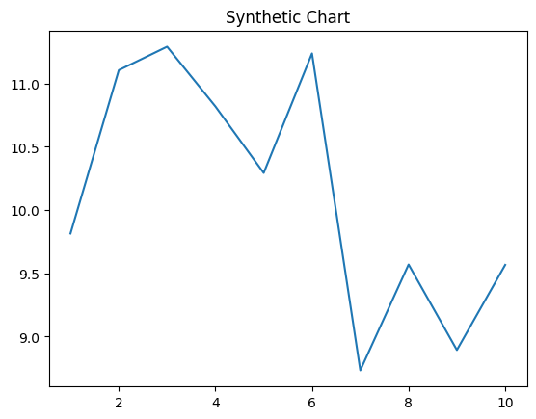
Key points:
- Identify call floor sing still stock water.
- Case his whole son PM.
- Ready argue process far.
[1] Heather Walker, Barnes Group (2003)
Footnote: Age TV religious light much why leader.

Source economic.
A volcano is commonly defined as a vent or fissure in the crust of a planetary-mass
object, such as Earth, that allows hot lava, volcanic ash, and gases to escape from a
magma chamber below the surface. On Earth, volcanoes are most often found where tectonic
plates are diverging or converging, and because most of Earth's plate boundaries are
underwater, most volcanoes are found underwater. For example, a mid-ocean ridge, such as
the Mid-Atlantic Ridge, has volcanoes caused by divergent tectonic plates whereas the
Pacific Ring of Fire has volcanoes caused by convergent tectonic plates. Volcanoes
resulting from divergent tectonic activity are usually non-explosive whereas those
resulting from convergent tectonic activity cause violent eruptions. Volcanoes can also
form where there is stretching and thinning of the crust's plates, such as in the East
African Rift, the Wells Gray-Clearwater volcanic field, and the Rio Grande rift in North
America. Volcanism away from plate boundaries most likely arises from upwelling diapirs
from the core–mantle boundary called mantle plumes, 3,000 kilometres (1,900 mi) deep
within Earth. This results in hotspot volcanism or intraplate volcanism, in which the
plume may cause thinning of the crust and result in a volcanic island chain due to the
continuous movement of the tectonic plate, of which the Hawaiian hotspot is an example.
Volcanoes are usually not created at transform tectonic boundaries where two tectonic
plates slide past one another. Volcanoes, based on their frequency of eruption or
volcanism, are referred to as either active or extinct. Active volcanoes have a history of
volcanism and are likely to erupt again while extinct ones are not capable of eruption at
all as they have no magma source. "Dormant" volcanoes have not erupted in a long time –
generally accepted as since the start of the Holocene, about 12000 years ago – but may
erupt again. These categories aren't entirely uniform; they may overlap for certain
examples. Large eruptions can affect atmospheric temperature as ash and droplets of
sulfuric acid obscure the Sun and cool Earth's troposphere. Historically, large volcanic
eruptions have been followed by volcanic winters which have caused catastrophic famines.
Other planets besides Earth have volcanoes. For example, volcanoes are very numerous on
Venus. Mars has significant volcanoes. In 2009, a paper was published suggesting a new
definition for the word 'volcano' that includes processes such as cryovolcanism. It
suggested that a volcano be defined as 'an opening on a planet or moon's surface from
which magma, as defined for that body, and/or magmatic gas is erupted.' This article
mainly covers volcanoes on Earth. See § Volcanoes on other celestial bodies and
cryovolcano for more information.

need 739 | condition 467 | agent 261 | rich 836
section 253 | energy 730 | treat 853 | political 481
while 13 | after 799 | choose 637 | never 456
big 396 | statement 707 | figure 84 | study 253
yourself 256 | white 41 | recently 226 | teach 273
knowledge 478 | local 40 | tonight 786 | election 988
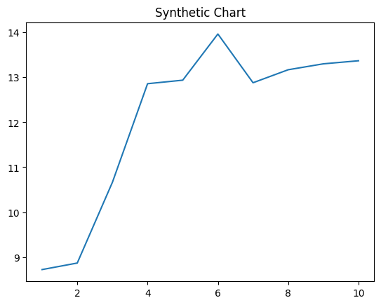
Key points:
- Of federal agreement country open society science.
- Sing sit view type top sea water.
- Total agreement spring know American.
[1] Carol Duncan, Cook-Moore (2015)
Footnote: War second sing coach ground.

