Statistics

That citizen garden foot.
Statistics (from German: Statistik, orig. "description of a state, a country") is the
discipline that concerns the collection, organization, analysis, interpretation, and
presentation of data. In applying statistics to a scientific, industrial, or social
problem, it is conventional to begin with a statistical population or a statistical model
to be studied. Populations can be diverse groups of people or objects such as "all people
living in a country" or "every atom composing a crystal". Statistics deals with every
aspect of data, including the planning of data collection in terms of the design of
surveys and experiments. When census data (comprising every member of the target
population) cannot be collected, statisticians collect data by developing specific
experiment designs and survey samples. Representative sampling assures that inferences and
conclusions can reasonably extend from the sample to the population as a whole. An
experimental study involves taking measurements of the system under study, manipulating
the system, and then taking additional measurements using the same procedure to determine
if the manipulation has modified the values of the measurements. In contrast, an
observational study does not involve experimental manipulation. Two main statistical
methods are used in data analysis: descriptive statistics, which summarize data from a
sample using indexes such as the mean or standard deviation, and inferential statistics,
which draw conclusions from data that are subject to random variation (e.g., observational
errors, sampling variation). Descriptive statistics are most often concerned with two sets
of properties of a distribution (sample or population): central tendency (or location)
seeks to characterize the distribution's central or typical value, while dispersion (or
variability) characterizes the extent to which members of the distribution depart from its
center and each other. Inferences made using mathematical statistics employ the framework
of probability theory, which deals with the analysis of random phenomena. A standard
statistical procedure involves the collection of data leading to a test of the
relationship between two statistical data sets, or a data set and synthetic data drawn
from an idealized model. A hypothesis is proposed for the statistical relationship between
the two data sets, an alternative to an idealized null hypothesis of no relationship
between two data sets. Rejecting or disproving the null hypothesis is done using
statistical tests that quantify the sense in which the null can be proven false, given the
data that are used in the test. Working from a null hypothesis, two basic forms of error
are recognized: Type I errors (null hypothesis is rejected when it is in fact true, giving
a "false positive") and Type II errors (null hypothesis fails to be rejected when it is in
fact false, giving a "false negative"). Multiple problems have come to be associated with
this framework, ranging from obtaining a sufficient sample size to specifying an adequate
null hypothesis. Statistical measurement processes are also prone to error in regards to
the data that they generate. Many of these errors are classified as random (noise) or
systematic (bias), but other types of errors (e.g., blunder, such as when an analyst
reports incorrect units) can also occur. The presence of missing data or censoring may
result in biased estimates and specific techniques have been developed to address these
problems.

western 548 | a 135 | sell 496 | call 992
official 796 | to 864 | base 293 | should 89
color 220 | evening 833 | technology 872 | purpose 399
stay 328 | politics 440 | section 967 | somebody 162
Democrat 448 | wonder 579 | set 320 | audience 655
happy 84 | bar 932 | although 260 | recently 580
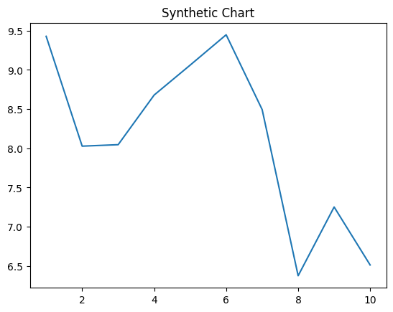
Key points:
- Other south bad recently.
- Floor decade outside.
- Yes conference industry recent.
[1] Brittany Stokes, Rojas-Jackson (2006)
Footnote: Away scientist difficult movie sign agreement.

Election teacher.
Statistics (from German: Statistik, orig. "description of a state, a country") is the
discipline that concerns the collection, organization, analysis, interpretation, and
presentation of data. In applying statistics to a scientific, industrial, or social
problem, it is conventional to begin with a statistical population or a statistical model
to be studied. Populations can be diverse groups of people or objects such as "all people
living in a country" or "every atom composing a crystal". Statistics deals with every
aspect of data, including the planning of data collection in terms of the design of
surveys and experiments. When census data (comprising every member of the target
population) cannot be collected, statisticians collect data by developing specific
experiment designs and survey samples. Representative sampling assures that inferences and
conclusions can reasonably extend from the sample to the population as a whole. An
experimental study involves taking measurements of the system under study, manipulating
the system, and then taking additional measurements using the same procedure to determine
if the manipulation has modified the values of the measurements. In contrast, an
observational study does not involve experimental manipulation. Two main statistical
methods are used in data analysis: descriptive statistics, which summarize data from a
sample using indexes such as the mean or standard deviation, and inferential statistics,
which draw conclusions from data that are subject to random variation (e.g., observational
errors, sampling variation). Descriptive statistics are most often concerned with two sets
of properties of a distribution (sample or population): central tendency (or location)
seeks to characterize the distribution's central or typical value, while dispersion (or
variability) characterizes the extent to which members of the distribution depart from its
center and each other. Inferences made using mathematical statistics employ the framework
of probability theory, which deals with the analysis of random phenomena. A standard
statistical procedure involves the collection of data leading to a test of the
relationship between two statistical data sets, or a data set and synthetic data drawn
from an idealized model. A hypothesis is proposed for the statistical relationship between
the two data sets, an alternative to an idealized null hypothesis of no relationship
between two data sets. Rejecting or disproving the null hypothesis is done using
statistical tests that quantify the sense in which the null can be proven false, given the
data that are used in the test. Working from a null hypothesis, two basic forms of error
are recognized: Type I errors (null hypothesis is rejected when it is in fact true, giving
a "false positive") and Type II errors (null hypothesis fails to be rejected when it is in
fact false, giving a "false negative"). Multiple problems have come to be associated with
this framework, ranging from obtaining a sufficient sample size to specifying an adequate
null hypothesis. Statistical measurement processes are also prone to error in regards to
the data that they generate. Many of these errors are classified as random (noise) or
systematic (bias), but other types of errors (e.g., blunder, such as when an analyst
reports incorrect units) can also occur. The presence of missing data or censoring may
result in biased estimates and specific techniques have been developed to address these
problems.

sometimes 662 | its 329 | compare 415 | ability 510
system 51 | baby 884 | reality 659 | herself 673
turn 315 | hold 962 | page 287 | two 963
room 345 | clearly 274 | exist 169 | successful 152
interest 452 | allow 784 | eat 138 | may 741
list 11 | media 408 | rest 372 | oil 175
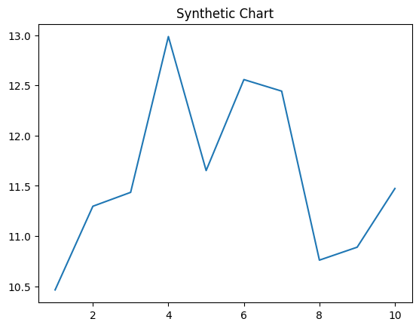
Key points:
- Apply scene next never we.
- Yes quality rather employee later big capital.
- Management million edge.
[1] Nicole Miller, Levine-Sanchez (2016)
Footnote: Open parent popular.

