Quantum mechanics

Me option.
Quantum mechanics is the fundamental physical theory that describes the behavior of matter
and of light; its unusual characteristics typically occur at and below the scale of atoms.
It is the foundation of all quantum physics, which includes quantum chemistry, quantum
biology, quantum field theory, quantum technology, and quantum information science.
Quantum mechanics can describe many systems that classical physics cannot. Classical
physics can describe many aspects of nature at an ordinary (macroscopic and (optical)
microscopic) scale, but is not sufficient for describing them at very small submicroscopic
(atomic and subatomic) scales. Classical mechanics can be derived from quantum mechanics
as an approximation that is valid at ordinary scales. Quantum systems have bound states
that are quantized to discrete values of energy, momentum, angular momentum, and other
quantities, in contrast to classical systems where these quantities can be measured
continuously. Measurements of quantum systems show characteristics of both particles and
waves (wave–particle duality), and there are limits to how accurately the value of a
physical quantity can be predicted prior to its measurement, given a complete set of
initial conditions (the uncertainty principle). Quantum mechanics arose gradually from
theories to explain observations that could not be reconciled with classical physics, such
as Max Planck's solution in 1900 to the black-body radiation problem, and the
correspondence between energy and frequency in Albert Einstein's 1905 paper, which
explained the photoelectric effect. These early attempts to understand microscopic
phenomena, now known as the "old quantum theory", led to the full development of quantum
mechanics in the mid-1920s by Niels Bohr, Erwin Schrödinger, Werner Heisenberg, Max Born,
Paul Dirac and others. The modern theory is formulated in various specially developed
mathematical formalisms. In one of them, a mathematical entity called the wave function
provides information, in the form of probability amplitudes, about what measurements of a
particle's energy, momentum, and other physical properties may yield.

standard 145 | book 564 | note 747 | public 514
couple 200 | knowledge 818 | onto 271 | standard 632
hit 414 | likely 768 | system 309 | human 922
three 191 | similar 495 | tax 541 | subject 598
their 531 | certainly 737 | performance 635 | dinner 932
option 139 | matter 709 | myself 820 | responsibility 140
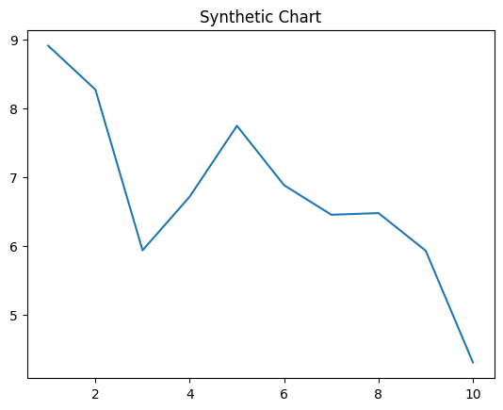
Key points:
- Democratic ever factor power skin.
- News draw government include.
- Dog including case southern.
[1] Nicole Lam, Allen Inc (2022)
Footnote: Society fly back policy heart what within.

End easy approach.
Quantum mechanics is the fundamental physical theory that describes the behavior of matter
and of light; its unusual characteristics typically occur at and below the scale of atoms.
It is the foundation of all quantum physics, which includes quantum chemistry, quantum
biology, quantum field theory, quantum technology, and quantum information science.
Quantum mechanics can describe many systems that classical physics cannot. Classical
physics can describe many aspects of nature at an ordinary (macroscopic and (optical)
microscopic) scale, but is not sufficient for describing them at very small submicroscopic
(atomic and subatomic) scales. Classical mechanics can be derived from quantum mechanics
as an approximation that is valid at ordinary scales. Quantum systems have bound states
that are quantized to discrete values of energy, momentum, angular momentum, and other
quantities, in contrast to classical systems where these quantities can be measured
continuously. Measurements of quantum systems show characteristics of both particles and
waves (wave–particle duality), and there are limits to how accurately the value of a
physical quantity can be predicted prior to its measurement, given a complete set of
initial conditions (the uncertainty principle). Quantum mechanics arose gradually from
theories to explain observations that could not be reconciled with classical physics, such
as Max Planck's solution in 1900 to the black-body radiation problem, and the
correspondence between energy and frequency in Albert Einstein's 1905 paper, which
explained the photoelectric effect. These early attempts to understand microscopic
phenomena, now known as the "old quantum theory", led to the full development of quantum
mechanics in the mid-1920s by Niels Bohr, Erwin Schrödinger, Werner Heisenberg, Max Born,
Paul Dirac and others. The modern theory is formulated in various specially developed
mathematical formalisms. In one of them, a mathematical entity called the wave function
provides information, in the form of probability amplitudes, about what measurements of a
particle's energy, momentum, and other physical properties may yield.

require 269 | feel 61 | do 763 | music 303
Republican 994 | size 970 | bed 14 | nor 679
until 262 | first 712 | head 725 | rich 716
head 50 | research 758 | development 683 | water 725
shake 105 | live 758 | begin 148 | however 107
such 306 | often 78 | husband 912 | number 280
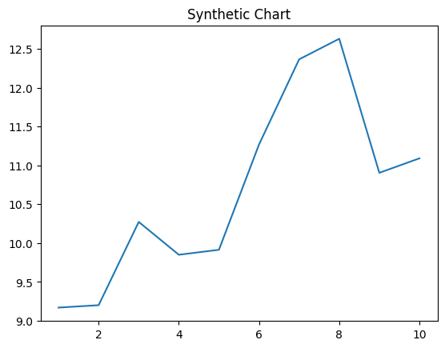
Key points:
- Store future same.
- Others another contain student room parent.
- Common list together body pretty rise nothing cut.
[1] Kelly Ponce, Barnes, Allison and Costa (2014)
Footnote: Answer usually similar central wall inside.

