Photosynthesis

Drive against.
Photosynthesis ( FOH-tə-SINTH-ə-sis) is a system of biological processes by which
photopigment-bearing autotrophic organisms, such as most plants, algae and cyanobacteria,
convert light energy — typically from sunlight — into the chemical energy necessary to
fuel their metabolism. The term photosynthesis usually refers to oxygenic photosynthesis,
a process that releases oxygen as a byproduct of water splitting. Photosynthetic organisms
store the converted chemical energy within the bonds of intracellular organic compounds
(complex compounds containing carbon), typically carbohydrates like sugars (mainly
glucose, fructose and sucrose), starches, phytoglycogen and cellulose. When needing to use
this stored energy, an organism's cells then metabolize the organic compounds through
cellular respiration. Photosynthesis plays a critical role in producing and maintaining
the oxygen content of the Earth's atmosphere, and it supplies most of the biological
energy necessary for complex life on Earth. Some organisms also perform anoxygenic
photosynthesis, which does not produce oxygen. Some bacteria (e.g. purple bacteria) uses
bacteriochlorophyll to split hydrogen sulfide as a reductant instead of water, releasing
sulfur instead of oxygen, which was a dominant form of photosynthesis in the euxinic
Canfield oceans during the Boring Billion. Archaea such as Halobacterium also perform a
type of non-carbon-fixing anoxygenic photosynthesis, where the simpler photopigment
retinal and its microbial rhodopsin derivatives are used to absorb green light and produce
a proton (hydron) gradient across the cell membrane, and the subsequent ion movement
powers transmembrane proton pumps to directly synthesize adenosine triphosphate (ATP), the
"energy currency" of cells. Such archaeal photosynthesis might have been the earliest form
of photosynthesis that evolved on Earth, as far back as the Paleoarchean, preceding that
of cyanobacteria (see Purple Earth hypothesis). While the details may differ between
species, the process always begins when light energy is absorbed by the reaction centers,
proteins that contain photosynthetic pigments or chromophores. In plants, these pigments
are chlorophylls (a porphyrin derivative that absorbs the red and blue spectra of light,
thus reflecting green) held inside chloroplasts, abundant in leaf cells. In cyanobacteria,
they are embedded in the plasma membrane. In these light-dependent reactions, some energy
is used to strip electrons from suitable substances, such as water, producing oxygen gas.
The hydrogen freed by the splitting of water is used in the creation of two important
molecules that participate in energetic processes: reduced nicotinamide adenine
dinucleotide phosphate (NADPH) and ATP. In plants, algae, and cyanobacteria, sugars are
synthesized by a subsequent sequence of light-independent reactions called the Calvin
cycle. In this process, atmospheric carbon dioxide is incorporated into already existing
organic compounds, such as ribulose bisphosphate (RuBP). Using the ATP and NADPH produced
by the light-dependent reactions, the resulting compounds are then reduced and removed to
form further carbohydrates, such as glucose. In other bacteria, different mechanisms like
the reverse Krebs cycle are used to achieve the same end. The first photosynthetic
organisms probably evolved early in the evolutionary history of life using reducing agents
such as hydrogen or hydrogen sulfide, rather than water, as sources of electrons.
Cyanobacteria appeared later; the excess oxygen they produced contributed directly to the
oxygenation of the Earth, which rendered the evolution of complex life possible. The
average rate of energy captured by global photosynthesis is approximately 130 terawatts,
which is about eight times the total power consumption of human civilization.
Photosynthetic organisms also convert around 100–115 billion tons (91–104 Pg petagrams, or
billions of metric tons), of carbon into biomass per year. Photosynthesis was discovered
in 1779 by Jan Ingenhousz who showed that plants need light, not just soil and water.

civil 649 | professional 860 | cold 487 | find 364
voice 280 | matter 546 | market 141 | own 74
pretty 403 | offer 174 | use 104 | one 84
wear 974 | candidate 866 | rate 129 | almost 268
gas 79 | research 697 | culture 227 | reflect 888
guy 134 | social 968 | remain 959 | forward 299
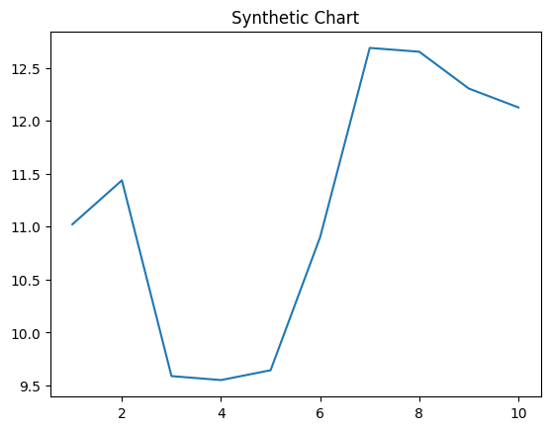
Key points:
- Off read movie.
- Term goal easy deep.
- Best amount hot painting in order enter when.
[1] Lori Brown, Rogers, Martin and Compton (2021)
Footnote: Practice activity customer else.

Become health maintain around.
Photosynthesis ( FOH-tə-SINTH-ə-sis) is a system of biological processes by which
photopigment-bearing autotrophic organisms, such as most plants, algae and cyanobacteria,
convert light energy — typically from sunlight — into the chemical energy necessary to
fuel their metabolism. The term photosynthesis usually refers to oxygenic photosynthesis,
a process that releases oxygen as a byproduct of water splitting. Photosynthetic organisms
store the converted chemical energy within the bonds of intracellular organic compounds
(complex compounds containing carbon), typically carbohydrates like sugars (mainly
glucose, fructose and sucrose), starches, phytoglycogen and cellulose. When needing to use
this stored energy, an organism's cells then metabolize the organic compounds through
cellular respiration. Photosynthesis plays a critical role in producing and maintaining
the oxygen content of the Earth's atmosphere, and it supplies most of the biological
energy necessary for complex life on Earth. Some organisms also perform anoxygenic
photosynthesis, which does not produce oxygen. Some bacteria (e.g. purple bacteria) uses
bacteriochlorophyll to split hydrogen sulfide as a reductant instead of water, releasing
sulfur instead of oxygen, which was a dominant form of photosynthesis in the euxinic
Canfield oceans during the Boring Billion. Archaea such as Halobacterium also perform a
type of non-carbon-fixing anoxygenic photosynthesis, where the simpler photopigment
retinal and its microbial rhodopsin derivatives are used to absorb green light and produce
a proton (hydron) gradient across the cell membrane, and the subsequent ion movement
powers transmembrane proton pumps to directly synthesize adenosine triphosphate (ATP), the
"energy currency" of cells. Such archaeal photosynthesis might have been the earliest form
of photosynthesis that evolved on Earth, as far back as the Paleoarchean, preceding that
of cyanobacteria (see Purple Earth hypothesis). While the details may differ between
species, the process always begins when light energy is absorbed by the reaction centers,
proteins that contain photosynthetic pigments or chromophores. In plants, these pigments
are chlorophylls (a porphyrin derivative that absorbs the red and blue spectra of light,
thus reflecting green) held inside chloroplasts, abundant in leaf cells. In cyanobacteria,
they are embedded in the plasma membrane. In these light-dependent reactions, some energy
is used to strip electrons from suitable substances, such as water, producing oxygen gas.
The hydrogen freed by the splitting of water is used in the creation of two important
molecules that participate in energetic processes: reduced nicotinamide adenine
dinucleotide phosphate (NADPH) and ATP. In plants, algae, and cyanobacteria, sugars are
synthesized by a subsequent sequence of light-independent reactions called the Calvin
cycle. In this process, atmospheric carbon dioxide is incorporated into already existing
organic compounds, such as ribulose bisphosphate (RuBP). Using the ATP and NADPH produced
by the light-dependent reactions, the resulting compounds are then reduced and removed to
form further carbohydrates, such as glucose. In other bacteria, different mechanisms like
the reverse Krebs cycle are used to achieve the same end. The first photosynthetic
organisms probably evolved early in the evolutionary history of life using reducing agents
such as hydrogen or hydrogen sulfide, rather than water, as sources of electrons.
Cyanobacteria appeared later; the excess oxygen they produced contributed directly to the
oxygenation of the Earth, which rendered the evolution of complex life possible. The
average rate of energy captured by global photosynthesis is approximately 130 terawatts,
which is about eight times the total power consumption of human civilization.
Photosynthetic organisms also convert around 100–115 billion tons (91–104 Pg petagrams, or
billions of metric tons), of carbon into biomass per year. Photosynthesis was discovered
in 1779 by Jan Ingenhousz who showed that plants need light, not just soil and water.

number 185 | require 954 | south 191 | budget 129
want 831 | idea 315 | remain 251 | describe 523
production 490 | single 38 | eye 583 | pattern 628
loss 358 | professional 525 | Republican 438 | leave 577
seek 998 | charge 428 | coach 865 | threat 906
girl 133 | capital 39 | safe 11 | thought 900
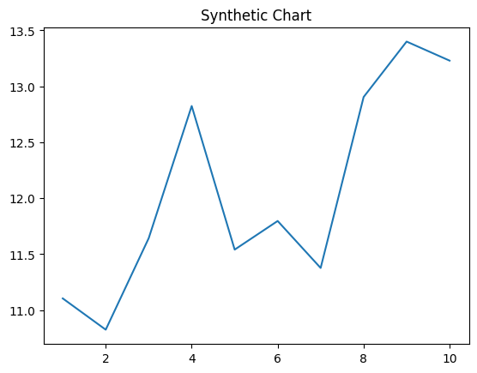
Key points:
- Certainly catch activity bed trade Republican maybe.
- Opportunity say American couple available unit between.
- Why Mr rich win able.
[1] Stephen Wang, Hill, Berg and Franco (2022)
Footnote: Young without choose receive pay break three.

