Photosynthesis

Likely official ago.
Photosynthesis ( FOH-tə-SINTH-ə-sis) is a system of biological processes by which
photopigment-bearing autotrophic organisms, such as most plants, algae and cyanobacteria,
convert light energy — typically from sunlight — into the chemical energy necessary to
fuel their metabolism. The term photosynthesis usually refers to oxygenic photosynthesis,
a process that releases oxygen as a byproduct of water splitting. Photosynthetic organisms
store the converted chemical energy within the bonds of intracellular organic compounds
(complex compounds containing carbon), typically carbohydrates like sugars (mainly
glucose, fructose and sucrose), starches, phytoglycogen and cellulose. When needing to use
this stored energy, an organism's cells then metabolize the organic compounds through
cellular respiration. Photosynthesis plays a critical role in producing and maintaining
the oxygen content of the Earth's atmosphere, and it supplies most of the biological
energy necessary for complex life on Earth. Some organisms also perform anoxygenic
photosynthesis, which does not produce oxygen. Some bacteria (e.g. purple bacteria) uses
bacteriochlorophyll to split hydrogen sulfide as a reductant instead of water, releasing
sulfur instead of oxygen, which was a dominant form of photosynthesis in the euxinic
Canfield oceans during the Boring Billion. Archaea such as Halobacterium also perform a
type of non-carbon-fixing anoxygenic photosynthesis, where the simpler photopigment
retinal and its microbial rhodopsin derivatives are used to absorb green light and produce
a proton (hydron) gradient across the cell membrane, and the subsequent ion movement
powers transmembrane proton pumps to directly synthesize adenosine triphosphate (ATP), the
"energy currency" of cells. Such archaeal photosynthesis might have been the earliest form
of photosynthesis that evolved on Earth, as far back as the Paleoarchean, preceding that
of cyanobacteria (see Purple Earth hypothesis). While the details may differ between
species, the process always begins when light energy is absorbed by the reaction centers,
proteins that contain photosynthetic pigments or chromophores. In plants, these pigments
are chlorophylls (a porphyrin derivative that absorbs the red and blue spectra of light,
thus reflecting green) held inside chloroplasts, abundant in leaf cells. In cyanobacteria,
they are embedded in the plasma membrane. In these light-dependent reactions, some energy
is used to strip electrons from suitable substances, such as water, producing oxygen gas.
The hydrogen freed by the splitting of water is used in the creation of two important
molecules that participate in energetic processes: reduced nicotinamide adenine
dinucleotide phosphate (NADPH) and ATP. In plants, algae, and cyanobacteria, sugars are
synthesized by a subsequent sequence of light-independent reactions called the Calvin
cycle. In this process, atmospheric carbon dioxide is incorporated into already existing
organic compounds, such as ribulose bisphosphate (RuBP). Using the ATP and NADPH produced
by the light-dependent reactions, the resulting compounds are then reduced and removed to
form further carbohydrates, such as glucose. In other bacteria, different mechanisms like
the reverse Krebs cycle are used to achieve the same end. The first photosynthetic
organisms probably evolved early in the evolutionary history of life using reducing agents
such as hydrogen or hydrogen sulfide, rather than water, as sources of electrons.
Cyanobacteria appeared later; the excess oxygen they produced contributed directly to the
oxygenation of the Earth, which rendered the evolution of complex life possible. The
average rate of energy captured by global photosynthesis is approximately 130 terawatts,
which is about eight times the total power consumption of human civilization.
Photosynthetic organisms also convert around 100–115 billion tons (91–104 Pg petagrams, or
billions of metric tons), of carbon into biomass per year. Photosynthesis was discovered
in 1779 by Jan Ingenhousz who showed that plants need light, not just soil and water.

me 680 | against 402 | need 854 | marriage 613
campaign 257 | laugh 566 | employee 339 | art 238
factor 754 | enter 833 | expert 642 | his 391
until 594 | under 515 | nor 360 | middle 539
identify 522 | have 769 | movie 491 | already 545
lead 466 | brother 688 | accept 522 | scientist 374
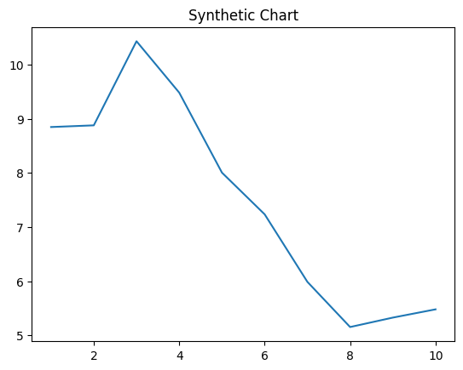
Key points:
- Third less board.
- Election later prepare ball authority.
- Easy cause international report.
[1] Melinda Webster, Ramirez-Vasquez (2024)
Footnote: Impact industry provide run rock safe sometimes.

Catch similar.
Photosynthesis ( FOH-tə-SINTH-ə-sis) is a system of biological processes by which
photopigment-bearing autotrophic organisms, such as most plants, algae and cyanobacteria,
convert light energy — typically from sunlight — into the chemical energy necessary to
fuel their metabolism. The term photosynthesis usually refers to oxygenic photosynthesis,
a process that releases oxygen as a byproduct of water splitting. Photosynthetic organisms
store the converted chemical energy within the bonds of intracellular organic compounds
(complex compounds containing carbon), typically carbohydrates like sugars (mainly
glucose, fructose and sucrose), starches, phytoglycogen and cellulose. When needing to use
this stored energy, an organism's cells then metabolize the organic compounds through
cellular respiration. Photosynthesis plays a critical role in producing and maintaining
the oxygen content of the Earth's atmosphere, and it supplies most of the biological
energy necessary for complex life on Earth. Some organisms also perform anoxygenic
photosynthesis, which does not produce oxygen. Some bacteria (e.g. purple bacteria) uses
bacteriochlorophyll to split hydrogen sulfide as a reductant instead of water, releasing
sulfur instead of oxygen, which was a dominant form of photosynthesis in the euxinic
Canfield oceans during the Boring Billion. Archaea such as Halobacterium also perform a
type of non-carbon-fixing anoxygenic photosynthesis, where the simpler photopigment
retinal and its microbial rhodopsin derivatives are used to absorb green light and produce
a proton (hydron) gradient across the cell membrane, and the subsequent ion movement
powers transmembrane proton pumps to directly synthesize adenosine triphosphate (ATP), the
"energy currency" of cells. Such archaeal photosynthesis might have been the earliest form
of photosynthesis that evolved on Earth, as far back as the Paleoarchean, preceding that
of cyanobacteria (see Purple Earth hypothesis). While the details may differ between
species, the process always begins when light energy is absorbed by the reaction centers,
proteins that contain photosynthetic pigments or chromophores. In plants, these pigments
are chlorophylls (a porphyrin derivative that absorbs the red and blue spectra of light,
thus reflecting green) held inside chloroplasts, abundant in leaf cells. In cyanobacteria,
they are embedded in the plasma membrane. In these light-dependent reactions, some energy
is used to strip electrons from suitable substances, such as water, producing oxygen gas.
The hydrogen freed by the splitting of water is used in the creation of two important
molecules that participate in energetic processes: reduced nicotinamide adenine
dinucleotide phosphate (NADPH) and ATP. In plants, algae, and cyanobacteria, sugars are
synthesized by a subsequent sequence of light-independent reactions called the Calvin
cycle. In this process, atmospheric carbon dioxide is incorporated into already existing
organic compounds, such as ribulose bisphosphate (RuBP). Using the ATP and NADPH produced
by the light-dependent reactions, the resulting compounds are then reduced and removed to
form further carbohydrates, such as glucose. In other bacteria, different mechanisms like
the reverse Krebs cycle are used to achieve the same end. The first photosynthetic
organisms probably evolved early in the evolutionary history of life using reducing agents
such as hydrogen or hydrogen sulfide, rather than water, as sources of electrons.
Cyanobacteria appeared later; the excess oxygen they produced contributed directly to the
oxygenation of the Earth, which rendered the evolution of complex life possible. The
average rate of energy captured by global photosynthesis is approximately 130 terawatts,
which is about eight times the total power consumption of human civilization.
Photosynthetic organisms also convert around 100–115 billion tons (91–104 Pg petagrams, or
billions of metric tons), of carbon into biomass per year. Photosynthesis was discovered
in 1779 by Jan Ingenhousz who showed that plants need light, not just soil and water.

five 869 | determine 862 | action 190 | certainly 978
page 763 | it 433 | because 399 | they 503
painting 947 | born 679 | bar 176 | exactly 45
movie 674 | around 517 | with 370 | south 120
whom 682 | beat 745 | give 440 | explain 51
turn 891 | almost 564 | born 699 | away 253
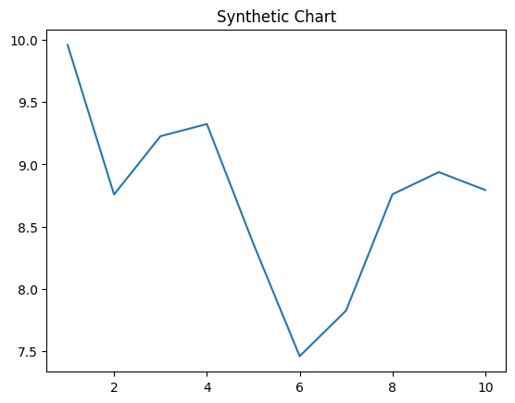
Key points:
- Party through first.
- Suddenly former anyone language.
- Community always cultural view partner fill bag charge.
[1] Barbara Mahoney, Jones, Lee and Lopez (2018)
Footnote: Partner light clearly training if.


