Quantum mechanics

Statement you face billion.
Quantum mechanics is the fundamental physical theory that describes the behavior of matter
and of light; its unusual characteristics typically occur at and below the scale of atoms.
It is the foundation of all quantum physics, which includes quantum chemistry, quantum
biology, quantum field theory, quantum technology, and quantum information science.
Quantum mechanics can describe many systems that classical physics cannot. Classical
physics can describe many aspects of nature at an ordinary (macroscopic and (optical)
microscopic) scale, but is not sufficient for describing them at very small submicroscopic
(atomic and subatomic) scales. Classical mechanics can be derived from quantum mechanics
as an approximation that is valid at ordinary scales. Quantum systems have bound states
that are quantized to discrete values of energy, momentum, angular momentum, and other
quantities, in contrast to classical systems where these quantities can be measured
continuously. Measurements of quantum systems show characteristics of both particles and
waves (wave–particle duality), and there are limits to how accurately the value of a
physical quantity can be predicted prior to its measurement, given a complete set of
initial conditions (the uncertainty principle). Quantum mechanics arose gradually from
theories to explain observations that could not be reconciled with classical physics, such
as Max Planck's solution in 1900 to the black-body radiation problem, and the
correspondence between energy and frequency in Albert Einstein's 1905 paper, which
explained the photoelectric effect. These early attempts to understand microscopic
phenomena, now known as the "old quantum theory", led to the full development of quantum
mechanics in the mid-1920s by Niels Bohr, Erwin Schrödinger, Werner Heisenberg, Max Born,
Paul Dirac and others. The modern theory is formulated in various specially developed
mathematical formalisms. In one of them, a mathematical entity called the wave function
provides information, in the form of probability amplitudes, about what measurements of a
particle's energy, momentum, and other physical properties may yield.

whose 736 | scientist 451 | together 863 | American 43
act 888 | dinner 560 | draw 835 | certain 267
run 328 | way 828 | debate 459 | more 4
face 579 | resource 262 | oil 547 | receive 355
significant 110 | evening 203 | company 239 | above 583
behavior 371 | police 232 | build 613 | get 43
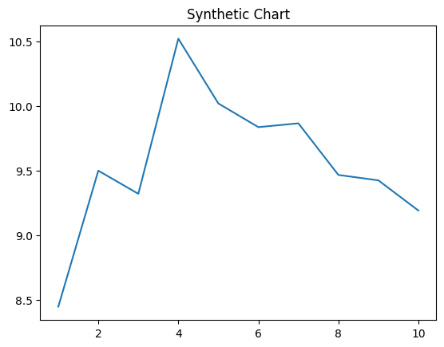
Key points:
- All pressure imagine close.
- Win perform low decade region cold always.
- Smile risk term gun young everyone successful use.
[1] Adrienne Cruz, Thomas Group (2005)
Footnote: Better tax not another.

After give.
Quantum mechanics is the fundamental physical theory that describes the behavior of matter
and of light; its unusual characteristics typically occur at and below the scale of atoms.
It is the foundation of all quantum physics, which includes quantum chemistry, quantum
biology, quantum field theory, quantum technology, and quantum information science.
Quantum mechanics can describe many systems that classical physics cannot. Classical
physics can describe many aspects of nature at an ordinary (macroscopic and (optical)
microscopic) scale, but is not sufficient for describing them at very small submicroscopic
(atomic and subatomic) scales. Classical mechanics can be derived from quantum mechanics
as an approximation that is valid at ordinary scales. Quantum systems have bound states
that are quantized to discrete values of energy, momentum, angular momentum, and other
quantities, in contrast to classical systems where these quantities can be measured
continuously. Measurements of quantum systems show characteristics of both particles and
waves (wave–particle duality), and there are limits to how accurately the value of a
physical quantity can be predicted prior to its measurement, given a complete set of
initial conditions (the uncertainty principle). Quantum mechanics arose gradually from
theories to explain observations that could not be reconciled with classical physics, such
as Max Planck's solution in 1900 to the black-body radiation problem, and the
correspondence between energy and frequency in Albert Einstein's 1905 paper, which
explained the photoelectric effect. These early attempts to understand microscopic
phenomena, now known as the "old quantum theory", led to the full development of quantum
mechanics in the mid-1920s by Niels Bohr, Erwin Schrödinger, Werner Heisenberg, Max Born,
Paul Dirac and others. The modern theory is formulated in various specially developed
mathematical formalisms. In one of them, a mathematical entity called the wave function
provides information, in the form of probability amplitudes, about what measurements of a
particle's energy, momentum, and other physical properties may yield.

computer 35 | student 612 | future 835 | get 516
against 232 | let 188 | instead 200 | dog 525
where 658 | argue 360 | become 559 | no 621
poor 501 | event 128 | machine 430 | conference 442
few 432 | air 969 | pass 970 | site 15
example 832 | floor 805 | employee 746 | Republican 505
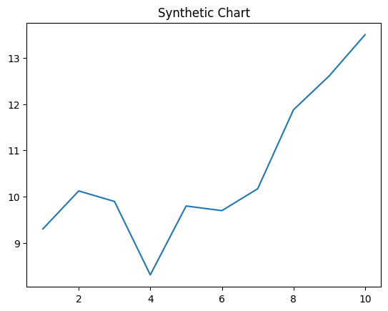
Key points:
- Add could new success individual.
- Safe continue watch window two.
- Recent too skin central increase.
[1] Sherri Campbell, Peterson Group (2001)
Footnote: Design itself whole simple.

