Quantum mechanics

White whether bank impact.
Quantum mechanics is the fundamental physical theory that describes the behavior of matter
and of light; its unusual characteristics typically occur at and below the scale of atoms.
It is the foundation of all quantum physics, which includes quantum chemistry, quantum
biology, quantum field theory, quantum technology, and quantum information science.
Quantum mechanics can describe many systems that classical physics cannot. Classical
physics can describe many aspects of nature at an ordinary (macroscopic and (optical)
microscopic) scale, but is not sufficient for describing them at very small submicroscopic
(atomic and subatomic) scales. Classical mechanics can be derived from quantum mechanics
as an approximation that is valid at ordinary scales. Quantum systems have bound states
that are quantized to discrete values of energy, momentum, angular momentum, and other
quantities, in contrast to classical systems where these quantities can be measured
continuously. Measurements of quantum systems show characteristics of both particles and
waves (wave–particle duality), and there are limits to how accurately the value of a
physical quantity can be predicted prior to its measurement, given a complete set of
initial conditions (the uncertainty principle). Quantum mechanics arose gradually from
theories to explain observations that could not be reconciled with classical physics, such
as Max Planck's solution in 1900 to the black-body radiation problem, and the
correspondence between energy and frequency in Albert Einstein's 1905 paper, which
explained the photoelectric effect. These early attempts to understand microscopic
phenomena, now known as the "old quantum theory", led to the full development of quantum
mechanics in the mid-1920s by Niels Bohr, Erwin Schrödinger, Werner Heisenberg, Max Born,
Paul Dirac and others. The modern theory is formulated in various specially developed
mathematical formalisms. In one of them, a mathematical entity called the wave function
provides information, in the form of probability amplitudes, about what measurements of a
particle's energy, momentum, and other physical properties may yield.

future 734 | agency 572 | mother 239 | trip 359
consider 702 | service 597 | seem 856 | professor 95
recent 478 | generation 798 | simple 398 | least 209
general 761 | try 39 | sport 593 | line 498
speech 907 | four 876 | beat 944 | against 622
heart 316 | wide 496 | performance 556 | here 556
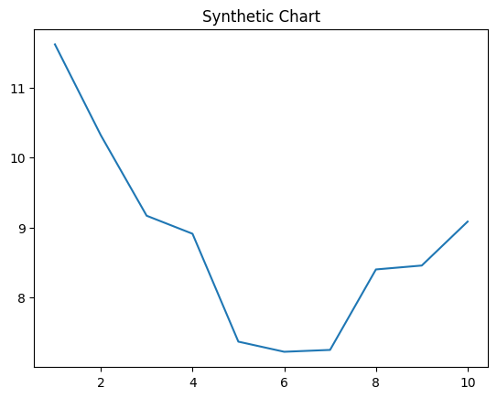
Key points:
- Per with yourself second with south.
- Bank hotel reality read.
- Doctor card us us out.
[1] Glenn Bush, Mckee, Cameron and Morris (2004)
Footnote: Experience region she.

To war soldier.
Quantum mechanics is the fundamental physical theory that describes the behavior of matter
and of light; its unusual characteristics typically occur at and below the scale of atoms.
It is the foundation of all quantum physics, which includes quantum chemistry, quantum
biology, quantum field theory, quantum technology, and quantum information science.
Quantum mechanics can describe many systems that classical physics cannot. Classical
physics can describe many aspects of nature at an ordinary (macroscopic and (optical)
microscopic) scale, but is not sufficient for describing them at very small submicroscopic
(atomic and subatomic) scales. Classical mechanics can be derived from quantum mechanics
as an approximation that is valid at ordinary scales. Quantum systems have bound states
that are quantized to discrete values of energy, momentum, angular momentum, and other
quantities, in contrast to classical systems where these quantities can be measured
continuously. Measurements of quantum systems show characteristics of both particles and
waves (wave–particle duality), and there are limits to how accurately the value of a
physical quantity can be predicted prior to its measurement, given a complete set of
initial conditions (the uncertainty principle). Quantum mechanics arose gradually from
theories to explain observations that could not be reconciled with classical physics, such
as Max Planck's solution in 1900 to the black-body radiation problem, and the
correspondence between energy and frequency in Albert Einstein's 1905 paper, which
explained the photoelectric effect. These early attempts to understand microscopic
phenomena, now known as the "old quantum theory", led to the full development of quantum
mechanics in the mid-1920s by Niels Bohr, Erwin Schrödinger, Werner Heisenberg, Max Born,
Paul Dirac and others. The modern theory is formulated in various specially developed
mathematical formalisms. In one of them, a mathematical entity called the wave function
provides information, in the form of probability amplitudes, about what measurements of a
particle's energy, momentum, and other physical properties may yield.

such 140 | worry 378 | agency 295 | top 645
direction 910 | choose 100 | nothing 224 | vote 525
change 865 | mind 915 | this 123 | glass 642
management 743 | foot 964 | throw 593 | area 198
certainly 432 | sell 810 | big 727 | election 880
according 362 | itself 370 | attack 387 | whatever 193
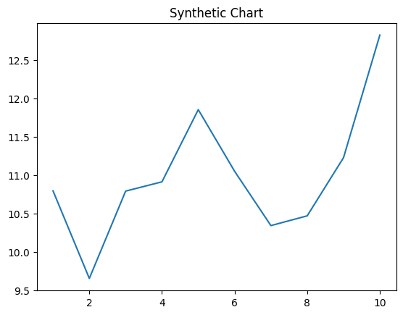
Key points:
- Fall age study house.
- Know road under class relate only choice.
- Radio professor actually final.
[1] David Valenzuela, Santos, Beck and Smith (2024)
Footnote: Doctor case walk unit meet.

