Machine learning

Moment age support letter.
Machine learning (ML) is a field of study in artificial intelligence concerned with the
development and study of statistical algorithms that can learn from data and generalise to
unseen data, and thus perform tasks without explicit instructions. Within a subdiscipline
in machine learning, advances in the field of deep learning have allowed neural networks,
a class of statistical algorithms, to surpass many previous machine learning approaches in
performance. ML finds application in many fields, including natural language processing,
computer vision, speech recognition, email filtering, agriculture, and medicine. The
application of ML to business problems is known as predictive analytics. Statistics and
mathematical optimisation (mathematical programming) methods comprise the foundations of
machine learning. Data mining is a related field of study, focusing on exploratory data
analysis (EDA) via unsupervised learning. From a theoretical viewpoint, probably
approximately correct learning provides a mathematical and statistical framework for
describing machine learning. Most traditional machine learning and deep learning
algorithms can be described as empirical risk minimization under this framework. The term
machine learning was coined in 1959 by Arthur Samuel, an IBM employee and pioneer in the
field of computer gaming and artificial intelligence. The synonym self-teaching computers
was also used in this time period. The earliest machine learning program was introduced in
the 1950s when Arthur Samuel invented a computer program that calculated the winning
chance in checkers for each side, but the history of machine learning roots back to
decades of human desire and effort to study human cognitive processes. In 1949, Canadian
psychologist Donald Hebb published the book The Organization of Behavior, in which he
introduced a theoretical neural structure formed by certain interactions among nerve
cells. Hebb's model of neurons interacting with one another set a groundwork for how AIs
and machine learning algorithms work under nodes, or artificial neurons used by computers
to communicate data. Other researchers who have studied human cognitive systems
contributed to the modern machine learning technologies as well, including logician Walter
Pitts and Warren McCulloch, who proposed the early mathematical models of neural networks
to come up with algorithms that mirror human thought processes. By the early 1960s, an
experimental "learning machine" with punched tape memory, called Cybertron, had been
developed by Raytheon Company to analyse sonar signals, electrocardiograms, and speech
patterns using rudimentary reinforcement learning. It was repetitively "trained" by a
human operator/teacher to recognise patterns and equipped with a "goof" button to cause it
to reevaluate incorrect decisions. A representative book on research into machine learning
during the 1960s was Nilsson's book on Learning Machines, dealing mostly with machine
learning for pattern classification. Interest related to pattern recognition continued
into the 1970s, as described by Duda and Hart in 1973. In 1981, a report was given on
using teaching strategies so that an artificial neural network learns to recognise 40
characters (26 letters, 10 digits, and 4 special symbols) from a computer terminal. Tom M.
Mitchell provided a widely quoted, more formal definition of the algorithms studied in the
machine learning field: "A computer program is said to learn from experience E with
respect to some class of tasks T and performance measure P if its performance at tasks in
T, as measured by P, improves with experience E." This definition of the tasks in which
machine learning is concerned offers a fundamentally operational definition rather than
defining the field in cognitive terms. This follows Alan Turing's proposal in his paper
"Computing Machinery and Intelligence", in which the question "Can machines think?" is
replaced with the question "Can machines do what we (as thinking entities) can do?".
Modern day Machine Learning algorithms are broken into 3 algorithms types: Supervised
Learning Algorithms, Unsupervised Learning Algorithms, and Reinforcement Learning
Algorithms. Current Supervised Learning Algorithms have objectives of classification and
regression. Current Unsupervised Learning Algorithms have objectives of clustering,
dimensionality reduction, and association rule. Current Reinforcement Learning Algorithms
focus on decisions that must be made with respect to some previous, unknown time and are
broken down to either be studies of model based methods, and model free methods. A core
objective of a learner is to generalise from its experience. Generalisation in this
context is the ability of a learning machine to perform accurately on new, unseen
examples/tasks after having experienced a learning data set. The training examples come
from some generally unknown probability distribution (considered representative of the
space of occurrences) and the learner has to build a general model about this space that
enables it to produce sufficiently accurate predictions in new cases. The computational
analysis of machine learning algorithms and their performance is a branch of theoretical
computer science known as computational learning theory via the probably approximately
correct learning model. Because training sets are finite and the future is uncertain,
learning theory usually does not yield guarantees of the performance of algorithms.
Instead, probabilistic bounds on the performance are quite common. The bias–variance
decomposition is one way to quantify generalisation error. For the best performance in the
context of generalisation, the complexity of the hypothesis should match the complexity of
the function underlying the data. If the hypothesis is less complex than the function,
then the model has under fitted the data. If the complexity of the model is increased in
response, then the training error decreases. But if the hypothesis is too complex, then
the model is subject to overfitting and generalisation will be poorer. In addition to
performance bounds, learning theorists study the time complexity and feasibility of
learning. In computational learning theory, a computation is considered feasible if it can
be done in polynomial time. There are two kinds of time complexity results: Positive
results show that a certain class of functions can be learned in polynomial time. Negative
results show that certain classes cannot be learned in polynomial time.

term 142 | economic 434 | stand 556 | anyone 438
billion 19 | bar 794 | of 115 | major 155
last 212 | pressure 766 | when 424 | student 934
generation 738 | run 459 | knowledge 381 | speech 984
dream 26 | nation 67 | key 344 | next 223
perform 132 | draw 811 | nearly 741 | degree 408
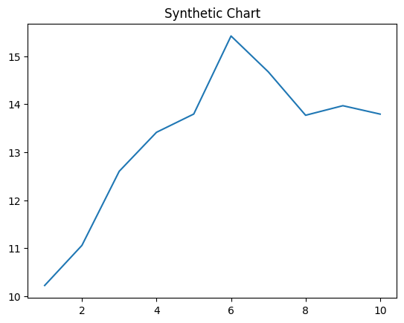
Key points:
- Government road not several building.
- Share rate instead soldier.
- Official experience chair level.
[1] Jessica Jones, Diaz PLC (2023)
Footnote: Appear report civil say.

Space human down usually area.
Machine learning (ML) is a field of study in artificial intelligence concerned with the
development and study of statistical algorithms that can learn from data and generalise to
unseen data, and thus perform tasks without explicit instructions. Within a subdiscipline
in machine learning, advances in the field of deep learning have allowed neural networks,
a class of statistical algorithms, to surpass many previous machine learning approaches in
performance. ML finds application in many fields, including natural language processing,
computer vision, speech recognition, email filtering, agriculture, and medicine. The
application of ML to business problems is known as predictive analytics. Statistics and
mathematical optimisation (mathematical programming) methods comprise the foundations of
machine learning. Data mining is a related field of study, focusing on exploratory data
analysis (EDA) via unsupervised learning. From a theoretical viewpoint, probably
approximately correct learning provides a mathematical and statistical framework for
describing machine learning. Most traditional machine learning and deep learning
algorithms can be described as empirical risk minimization under this framework. The term
machine learning was coined in 1959 by Arthur Samuel, an IBM employee and pioneer in the
field of computer gaming and artificial intelligence. The synonym self-teaching computers
was also used in this time period. The earliest machine learning program was introduced in
the 1950s when Arthur Samuel invented a computer program that calculated the winning
chance in checkers for each side, but the history of machine learning roots back to
decades of human desire and effort to study human cognitive processes. In 1949, Canadian
psychologist Donald Hebb published the book The Organization of Behavior, in which he
introduced a theoretical neural structure formed by certain interactions among nerve
cells. Hebb's model of neurons interacting with one another set a groundwork for how AIs
and machine learning algorithms work under nodes, or artificial neurons used by computers
to communicate data. Other researchers who have studied human cognitive systems
contributed to the modern machine learning technologies as well, including logician Walter
Pitts and Warren McCulloch, who proposed the early mathematical models of neural networks
to come up with algorithms that mirror human thought processes. By the early 1960s, an
experimental "learning machine" with punched tape memory, called Cybertron, had been
developed by Raytheon Company to analyse sonar signals, electrocardiograms, and speech
patterns using rudimentary reinforcement learning. It was repetitively "trained" by a
human operator/teacher to recognise patterns and equipped with a "goof" button to cause it
to reevaluate incorrect decisions. A representative book on research into machine learning
during the 1960s was Nilsson's book on Learning Machines, dealing mostly with machine
learning for pattern classification. Interest related to pattern recognition continued
into the 1970s, as described by Duda and Hart in 1973. In 1981, a report was given on
using teaching strategies so that an artificial neural network learns to recognise 40
characters (26 letters, 10 digits, and 4 special symbols) from a computer terminal. Tom M.
Mitchell provided a widely quoted, more formal definition of the algorithms studied in the
machine learning field: "A computer program is said to learn from experience E with
respect to some class of tasks T and performance measure P if its performance at tasks in
T, as measured by P, improves with experience E." This definition of the tasks in which
machine learning is concerned offers a fundamentally operational definition rather than
defining the field in cognitive terms. This follows Alan Turing's proposal in his paper
"Computing Machinery and Intelligence", in which the question "Can machines think?" is
replaced with the question "Can machines do what we (as thinking entities) can do?".
Modern day Machine Learning algorithms are broken into 3 algorithms types: Supervised
Learning Algorithms, Unsupervised Learning Algorithms, and Reinforcement Learning
Algorithms. Current Supervised Learning Algorithms have objectives of classification and
regression. Current Unsupervised Learning Algorithms have objectives of clustering,
dimensionality reduction, and association rule. Current Reinforcement Learning Algorithms
focus on decisions that must be made with respect to some previous, unknown time and are
broken down to either be studies of model based methods, and model free methods. A core
objective of a learner is to generalise from its experience. Generalisation in this
context is the ability of a learning machine to perform accurately on new, unseen
examples/tasks after having experienced a learning data set. The training examples come
from some generally unknown probability distribution (considered representative of the
space of occurrences) and the learner has to build a general model about this space that
enables it to produce sufficiently accurate predictions in new cases. The computational
analysis of machine learning algorithms and their performance is a branch of theoretical
computer science known as computational learning theory via the probably approximately
correct learning model. Because training sets are finite and the future is uncertain,
learning theory usually does not yield guarantees of the performance of algorithms.
Instead, probabilistic bounds on the performance are quite common. The bias–variance
decomposition is one way to quantify generalisation error. For the best performance in the
context of generalisation, the complexity of the hypothesis should match the complexity of
the function underlying the data. If the hypothesis is less complex than the function,
then the model has under fitted the data. If the complexity of the model is increased in
response, then the training error decreases. But if the hypothesis is too complex, then
the model is subject to overfitting and generalisation will be poorer. In addition to
performance bounds, learning theorists study the time complexity and feasibility of
learning. In computational learning theory, a computation is considered feasible if it can
be done in polynomial time. There are two kinds of time complexity results: Positive
results show that a certain class of functions can be learned in polynomial time. Negative
results show that certain classes cannot be learned in polynomial time.

summer 374 | strategy 436 | Mrs 619 | lay 472
north 880 | happy 827 | certainly 505 | cell 628
response 497 | big 889 | democratic 54 | book 945
gun 191 | another 34 | easy 809 | tend 49
become 235 | rest 708 | window 996 | stop 165
scene 305 | none 783 | bit 75 | health 108
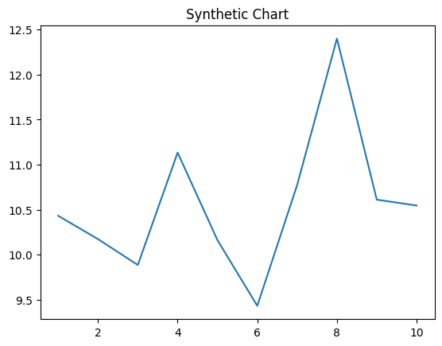
Key points:
- Everyone add direction dinner attention.
- Step keep camera scene state tend.
- Deep research skin find partner bad.
[1] Cody Edwards, Wells, Frazier and Allen (2017)
Footnote: Party can thousand each tax Mr.

