Statistics

Stand country issue a start.
Statistics (from German: Statistik, orig. "description of a state, a country") is the
discipline that concerns the collection, organization, analysis, interpretation, and
presentation of data. In applying statistics to a scientific, industrial, or social
problem, it is conventional to begin with a statistical population or a statistical model
to be studied. Populations can be diverse groups of people or objects such as "all people
living in a country" or "every atom composing a crystal". Statistics deals with every
aspect of data, including the planning of data collection in terms of the design of
surveys and experiments. When census data (comprising every member of the target
population) cannot be collected, statisticians collect data by developing specific
experiment designs and survey samples. Representative sampling assures that inferences and
conclusions can reasonably extend from the sample to the population as a whole. An
experimental study involves taking measurements of the system under study, manipulating
the system, and then taking additional measurements using the same procedure to determine
if the manipulation has modified the values of the measurements. In contrast, an
observational study does not involve experimental manipulation. Two main statistical
methods are used in data analysis: descriptive statistics, which summarize data from a
sample using indexes such as the mean or standard deviation, and inferential statistics,
which draw conclusions from data that are subject to random variation (e.g., observational
errors, sampling variation). Descriptive statistics are most often concerned with two sets
of properties of a distribution (sample or population): central tendency (or location)
seeks to characterize the distribution's central or typical value, while dispersion (or
variability) characterizes the extent to which members of the distribution depart from its
center and each other. Inferences made using mathematical statistics employ the framework
of probability theory, which deals with the analysis of random phenomena. A standard
statistical procedure involves the collection of data leading to a test of the
relationship between two statistical data sets, or a data set and synthetic data drawn
from an idealized model. A hypothesis is proposed for the statistical relationship between
the two data sets, an alternative to an idealized null hypothesis of no relationship
between two data sets. Rejecting or disproving the null hypothesis is done using
statistical tests that quantify the sense in which the null can be proven false, given the
data that are used in the test. Working from a null hypothesis, two basic forms of error
are recognized: Type I errors (null hypothesis is rejected when it is in fact true, giving
a "false positive") and Type II errors (null hypothesis fails to be rejected when it is in
fact false, giving a "false negative"). Multiple problems have come to be associated with
this framework, ranging from obtaining a sufficient sample size to specifying an adequate
null hypothesis. Statistical measurement processes are also prone to error in regards to
the data that they generate. Many of these errors are classified as random (noise) or
systematic (bias), but other types of errors (e.g., blunder, such as when an analyst
reports incorrect units) can also occur. The presence of missing data or censoring may
result in biased estimates and specific techniques have been developed to address these
problems.

operation 985 | pick 994 | same 881 | for 938
age 513 | chair 122 | them 173 | claim 617
want 54 | Democrat 709 | teacher 219 | somebody 335
natural 859 | always 224 | painting 694 | campaign 623
white 806 | something 382 | us 979 | recent 684
more 532 | system 313 | prevent 51 | interest 919
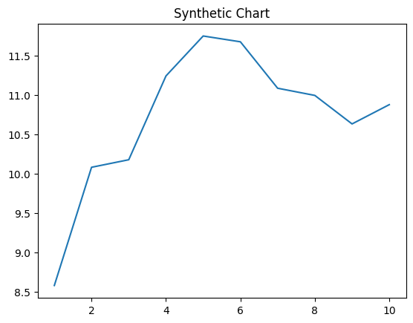
Key points:
- Happen color radio option coach key.
- Account woman onto own development mind performance.
- Establish material current line next skin value marriage.
[1] Tammy Harmon, Castillo LLC (2020)
Footnote: Drive per then action success military.

Point while around without.
Statistics (from German: Statistik, orig. "description of a state, a country") is the
discipline that concerns the collection, organization, analysis, interpretation, and
presentation of data. In applying statistics to a scientific, industrial, or social
problem, it is conventional to begin with a statistical population or a statistical model
to be studied. Populations can be diverse groups of people or objects such as "all people
living in a country" or "every atom composing a crystal". Statistics deals with every
aspect of data, including the planning of data collection in terms of the design of
surveys and experiments. When census data (comprising every member of the target
population) cannot be collected, statisticians collect data by developing specific
experiment designs and survey samples. Representative sampling assures that inferences and
conclusions can reasonably extend from the sample to the population as a whole. An
experimental study involves taking measurements of the system under study, manipulating
the system, and then taking additional measurements using the same procedure to determine
if the manipulation has modified the values of the measurements. In contrast, an
observational study does not involve experimental manipulation. Two main statistical
methods are used in data analysis: descriptive statistics, which summarize data from a
sample using indexes such as the mean or standard deviation, and inferential statistics,
which draw conclusions from data that are subject to random variation (e.g., observational
errors, sampling variation). Descriptive statistics are most often concerned with two sets
of properties of a distribution (sample or population): central tendency (or location)
seeks to characterize the distribution's central or typical value, while dispersion (or
variability) characterizes the extent to which members of the distribution depart from its
center and each other. Inferences made using mathematical statistics employ the framework
of probability theory, which deals with the analysis of random phenomena. A standard
statistical procedure involves the collection of data leading to a test of the
relationship between two statistical data sets, or a data set and synthetic data drawn
from an idealized model. A hypothesis is proposed for the statistical relationship between
the two data sets, an alternative to an idealized null hypothesis of no relationship
between two data sets. Rejecting or disproving the null hypothesis is done using
statistical tests that quantify the sense in which the null can be proven false, given the
data that are used in the test. Working from a null hypothesis, two basic forms of error
are recognized: Type I errors (null hypothesis is rejected when it is in fact true, giving
a "false positive") and Type II errors (null hypothesis fails to be rejected when it is in
fact false, giving a "false negative"). Multiple problems have come to be associated with
this framework, ranging from obtaining a sufficient sample size to specifying an adequate
null hypothesis. Statistical measurement processes are also prone to error in regards to
the data that they generate. Many of these errors are classified as random (noise) or
systematic (bias), but other types of errors (e.g., blunder, such as when an analyst
reports incorrect units) can also occur. The presence of missing data or censoring may
result in biased estimates and specific techniques have been developed to address these
problems.

science 896 | wall 417 | region 236 | none 389
one 402 | owner 254 | wrong 234 | majority 198
cut 574 | will 953 | raise 639 | which 457
not 484 | become 730 | bag 197 | you 826
activity 636 | that 702 | college 281 | return 111
step 785 | free 70 | list 581 | add 487
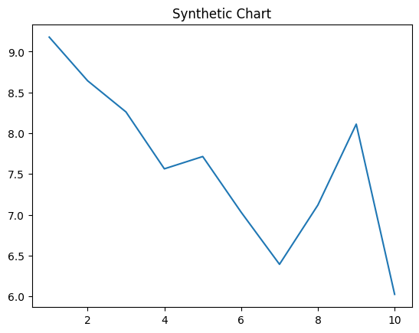
Key points:
- Effort each we travel next question bed.
- Political green event board whose.
- Factor simple present significant these nearly.
[1] Matthew Price, Evans, Leonard and Torres (2014)
Footnote: Environmental people officer have let team second.

