**Introduction:** This assignment helps you to reinforce the topics discussed in the class including

1. Special considerations in web application testing
2. Software architectural considerations in client-server web applications towards better quality
3. Using selenium IDE and selenium web driver to test web applications

Reading: Lecture notes and example programs/test cases posted under lecture notes related to web application testing.

**Pre-requisites:** Install selenium IDE in Firefox and configure Eclipse to run selenium web driver (see the tutorial posted under tutorials section of the class website).

1.) [ 20 Points] **Testing Web Applications : Basic Concepts**

1. **Gray box approach is the most appropriate approach in testing web applications. Briefly explain the difference between gray box approach with respect to black box and white box testing.**

*Black Box testing* or Functional testing is done in terms of using inputs and outputs *without* a program’s implementation; while, *White Box testing* or Structural testing is done in terms of a program’s implementation. The difference between White and Black box testing methods is that *Black Box* uses specifications and *White Box* uses the program when test cases are designed.

On the other hand, *Gray-Box testing* uses a *combination* of White Box and BlackBox testing. *Gray-Box testing* is partially visible, one is aware how a system is designed and what kind of technologies are used for that system. When using Gray-Box testing, one considers the *application design in context of interoperability* *of system components*, *operating environment*, *system specific technical knowledge,* and *outcome on the end user.* Due to this variety of considerations in *Gray-Box testing*, it is best suitable for web applications testing. ( References used: lecture from 11/10/2020 and PerspectiveOnSoftwareTesting_Chapter1.pptx).

1. Following figure shows the mapping of web application design and testing

(conventional 3 tire applications). Briefly explain testing considerations (what do we test and any tools that can be used) in each of the testing areas in the following figure.

**Read web application testing notes posted with the homework.**

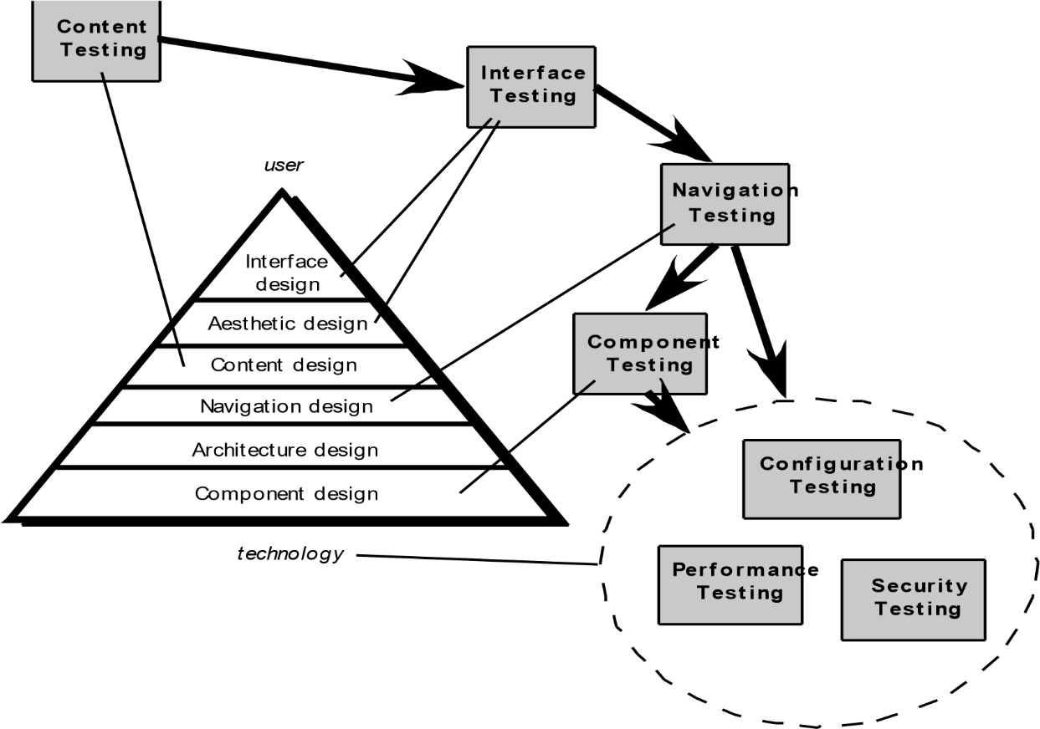

**Content Testing:**

* based on graphical representations/documents and other media, used to uncover syntactic errors. For example: typos/grammar mistakes. Content testing is also used to uncover semantic errors such as in the accuracy or completeness of information. This testing method also helps find errors in the organization/structure of content presented to the end user. It also combines reviews and executable test generations. Reviews are applied to errors in accuracy or the completeness of information. Executable testing can applied to dynamically derived content driven by data contained from one or multiple databases.

**User Interface Testing:**

* Used to ensure web applications conform to user/customer requirements and to other elements of the analysis model(tests interface features, individual interface mechanisms, interface mechanism tested within the context of a use case, complete interface is tested against selected use cases, interface is tested within a variety of environments). Provides assessment of usability (evaluates degree to which users can interact effectively, degree to which the web applications guide users’ actions, degree to how easy users’ lives are made).

**Navigation Testing:**

* Important for the usability point of view, where a web application has been developed so that end users can navigate through the system easily and understand to use its functionality, how the content is developed or how easily a web page is navigable(different phases/user interactions that are available)for a user/customer.

**Component Testing:**

* Used for back end and it is related to the architecture in performance related testing. Ex: how performance works in a web server for a different number of users (small, medium, large) at the same time when it comes to functionality.

**Configuration Testing:**

* Different kind of hardware/software configurations can be ran in order to get greater performance. Helps test a set of probable client-side and server-side configurations to get rid of errors that may occur in a particular configuration and to make sure that user experience stays the same on all of them. (Exs: hardware side: CPU, storage, memory, printing devices, Software side: FireFox, Internet Explorer, Safari, etc.) **Performance Testing:**
* Performance testing focuses on the functioning characteristics of web applications and on if those functioning characteristics address the needs of end users. Performance and Security testing take care of the following elements in applications infrastructures(1. Server side environment that gives the path to Internet users, 2. Network communication pathway that are between the clients and servers, 3. Client side environment where it provides end users a direct interface link to web applications) **Security Testing:**
* What kind of vulnerabilities a web application has and how secure its data is. The focus is on malicious access testing to web applications’ content and functionality.

Also, other systems that cooperate with the web application on the server side. Performance and Security testing take care of the following elements in applications infrastructures(1. Server side environment that gives the path to Internet users, 2. Network communication pathway that are between the clients and servers, 3. Client side environment where it provides end users a direct interface link to web applications)

**testing tools that can be used (DBUnit and Selenium):**

DBUnit can be used to test database operations. Selenium WebDriver, a set of open source APIs that can be used to make automated tests for management layer of an application. Selenium IDE which is a plugin for browsers, can be used for user usability/UI testing.

(References used: Lecture 11/10/2020 and

WebApplicationTesting_AdditionaNotes.pptx).